Concrete Technology Paper
Abrar Nasib Afridi ID 16137 Sec A 2nd Semester

Q.1. Which step is taken to prevent flash setting of cement? Also, write steps to prevent false setting of concrete.
Ans If inadequate amounts of gypsum are added to the cement, flash set can occur a rapid development of rigidity in freshly mixed Portland cement paste, mortar, or concrete. Further mixing can’t dispel this rigidity, and a large amount of heat is produced in the process.
Calcium sulfate source, such as gypsum, are intentionally added to Portland cement to regulate early hydration reactions to prevent flash setting, improve strength development, and reduce drying shrinkage.
Rapid development of rigidity can also be caused by false set. But in this case, little heat is generated. False set occurs because of some of the gypsum dehydrated as a result of contacting hot clinker or high temperatures in the grinding mill and creates gypsum and stiffen the concrete.
Q. 2. Draw a graph showing the strength development of pure compounds of cement?
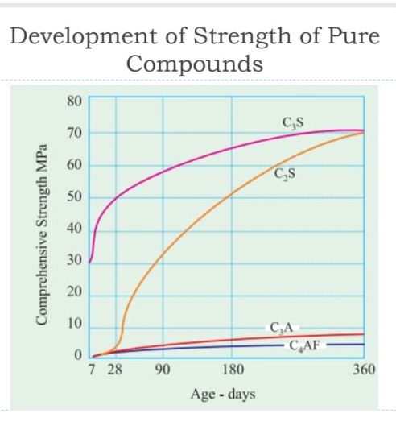
Ans

Q.3. why type III cement is rapid hardening and type IV low heat producing? Draw a graph showing the development of heat of hydration of different cement types?

Ans Type III cement classified as a rapid hardening cement, it is finer than type I and has a higher C3S content and sulfite level. It also gains 28 days: strength in 7 days. Useful where the formwork must be quickly stripped or areas that allow traffic early on the road surfaces.
Usually Type IV cement low heat Portland cement develops less heat of hydration during setting and curing. This is helpful in mass concrete placements since large volumes of concrete retains and develop high temperature during hydration without a mechanism for releasing the heat.
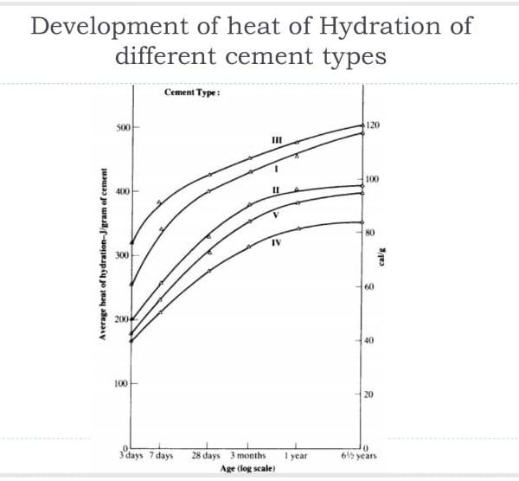

Q.4. what is the effect of compaction on entrapped air of concrete? What will be the effect on strength if concrete is not compacted sufficiently? Explain with graph.
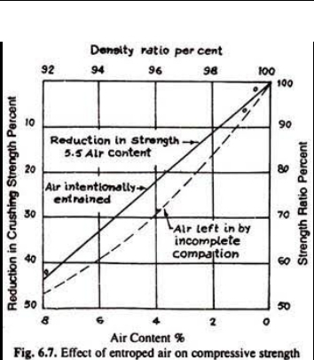

Ans compaction is the process which expels entrapped air from freshly placed concrete and packs the aggregate particles together so as to increase the density of concrete. It increases significantly the ultimate strength of concrete and enhances the bond with reinforcement.

Q.5. what is the percentage of gypsum added to cement limited to 5% only?
Ans gypsum is often added to Portland cement to prevent early hardening or “Flash sets”, allowing a longer working time. Gypsum slows down the setting time of cement so that cement is adequately hardened. This is also called setting of concrete.

Q.6. what is the effect of following on the bond strength of concrete?
Ans 1) shape of aggregate
Particles shape is principally affects the water cement ratio by its effect on water demand and amount of paste required for workability of a given mixture.
2) Size of aggregate
The smaller the size of aggregates the higher is the strength of the concrete and less will be workability. It is so because smaller aggregates consequence less attention of stress that causes due to dissimilar elastic module of paste and aggregates, around particles.
3)Texture of aggregate
The surface texture of aggregate can be either smooth or rough. A smooth surface can improve workability, yet a rougher surface generates a stronger bond between the paste and aggregate creating a higher strength.
4) Bleeding
Bleeding in concrete may be as the physical migration of water towards the top surface. Concrete bleeding can have multiple negative repercussions on a project. It can prolong construction, cause poor bonding between layer of poured concrete and make the mixture harder to pump. Bleeding can be reduce by increasing fineness.

Q.7. what is the effect if following on workability of concrete?

Ans 1) Porosity and absorption
Porosity is the number of pores in a material for instance in certain concrete. Porosity usually expelled in volume percent. Furthermore, the high surface water absorption only decreased compressive strength of cover concrete.
2) Air entraining agent
The general effect of air entrainment is freeze-thaw resistance along with increase workability, decrease strength, reduce bleeding and segregation.
3) Course aggregate to fine aggregate ratio
Fine particles require more water for a longer surface, hence aggregate with finer particles need more water to make it workable, on the other hand, and higher particles have less surface area, demand less water for wetting surface and require less amount of paste for lubricating.
4) Grading of aggregate
If grading of aggregate is varied, it also changes cement paste content, workability of the mix, also well graded aggregates result in least amount of voids in a given volume.

Q.8. what is the effect of fineness of cement on the following.

Ans 1) Strength of concrete
The fineness of cement affects hydration rate, and in turn, the strength. Increasing fineness causes an increased rate of hydration, high strength and high heat generation.

2) Rate of heat of evolution during hydration
Increasing the fineness increases the rate of hydration of cement, which increases the rate of gain in strength and also the rate at which heat is liberated as in type III compared with type I.

3) Total heat of hydration
The size of cement particles directly affects the hydration, setting and hardening, strength and heat of hydration. The finer the cement particles are, the larger the total surface area is and the bigger the area contacting with water is.

4) Workability of concrete
When fineness of cement increases buoyed a certain particles size, the particles of cement itself starts acting as lubricants in the concrete. Therefore, the particles flow and less work is required for compaction.
I.e. the water demand decreases to obtain the same degree of workability.

Q.9. Which step can be taken during transportation and placement of concrete to prevent segregation of concrete?

Ans concrete placement is important process in the construction that determines the success of the structure and its life. Technical and environmental conditions are taken into strict consideration while the concrete is transported, poured, vibrated, matured, and cured.
Method of concrete transportation is mortar pan, wheel barrow/hand cart, bucket and rope way, truck mixer and damper, and belt conveyor etc.
Segregation of concrete can be prevented by correctly proportionating the mix and using the recommended water cement ratio, so as to prevent using excess water care should be taken while handling, placing, transporting, compacting, and also at the finishing stages.

