Hajra fazal
I'd 16279
DPT : 2nd semester
Subject: Anatomy II Total Marks 50
Final Term Assignment. Semester: DPT 2nd.

Q:1 Enumerate muscles in the posterior compartment of the lower leg with clinical significances also write action and innervation of each posterior compartment muscle.
Answer:
The posterior compartment of the leg contains seven muscles, organised into two layers – superficial and deep. The two layers are separated by a band of fascia.

The posterior leg is the largest of the three compartments. Collectively, the muscles in this area plantarflex and invert the foot. They are innervated by the tibial nerve, a terminal branch of the sciatic nerve.

In this article, we shall look at the attachments, actions and innervation of the muscles in the posterior compartment of the leg.

Superficial Muscles
The superficial muscles form the characteristic ‘calf’ shape of the posterior leg. They all insert into the calcaneus of the foot (the heel bone), via the calcaneal tendon. The calcaneal reflex tests spinal roots S1-S2.

To minimise friction during movement, there are two bursae (fluid filled sacs) associated with the calcaneal tendon:

Subcutaneous calcaneal bursa – lies between the skin and the calcaneal tendon.
Deep bursa of the calcaneal tendon – lies between the tendon and the calcaneus.
Gastrocnemius
The gastrocnemius is the most superficial of all the muscles in the posterior leg. It has two heads – medial and lateral, which converge to form a single muscle belly.

Attachments: The lateral head originates from the lateral femoral condyle, and medial head from the medial femoral condyle. The fibres converge, and form a single muscle belly. In the lower part of the leg, the muscle belly combines with the soleus to from the calcaneal tendon, with inserts onto the calcaneus (the heel bone).
Actions: It plantarflexes at the ankle joint, and because it crosses the knee, it is a flexor there.
Innervation: Tibial nerve.
Plantaris
The plantaris is a small muscle with a long tendon, which can be mistaken for a nerve as it descends down the leg. It is absent in 10% of people.

Attachments: Originates from the lateral supracondylar line of the femur. The muscle descends medially, condensing into a tendon that runs down the leg, between the gastrocnemius and soleus. The tendon blends with the calcaneal tendon.
Actions: It plantarflexes at the ankle joint, and because it crosses the knee, it is a flexor there. It is not a vital muscle for these movements.
Innervation: Tibial nerve.
Soleus
The soleus is located deep to the gastrocnemius. It is large and flat, named soleus due to its resemblance of a sole – a flat fish.

Attachments: Originates from the soleal line of the tibia and proximal fibular area. The muscle narrows in the lower part of the leg, and joins the calcaneal tendon.
Actions: Plantarflexes the foot at the ankle joint.
Innervation: Tibial Nerve.
Deep Muscles
There are four muscles in the deep compartment of the posterior leg. One muscle, the popliteus, acts only on the knee joint. The remaining three muscles (tibialis posterior, flexor hallucis longus and flexor digitorum longus) act on the ankle and foot.

Popliteus

Fig 1.1 - Muscles in the deep layer of the posterior leg.
Fig 2 – Muscles in the deep layer of the posterior leg.

The popliteus is located superiorly in the leg. It lies behind the knee joint, forming the base of the popliteal fossa.

There is a bursa (fluid filled sac) that lies between the popliteal tendon and the posterior surface of the knee joint. It is called the popliteus bursa.

Attachments: Originates from the lateral condyle of the femur and the posterior horn of the lateral meniscus. From there, it runs inferomedially towards the tibia and inserts above the origin of the soleus muscle.
Actions: Laterally rotates the femur on the tibia – ‘unlocking’ the knee joint so that flexion can occur.
Innervation: Tibial nerve.
Tibialis Posterior
The tibialis posterior is the deepest out of the four muscles. It lies between the flexor digitorum longus and the flexor hallucis longus.

Attachments: Originates from the interosseous membrane between the tibia and fibula, and posterior surfaces of the two bones. The tendon enters the foot posterior to the medial malleolus, and attaches to the plantar surfaces of the medial tarsal bones.
Actions: Inverts and plantarflexes the foot, maintains the medial arch of the foot.
Innervation: Tibial nerve.
Flexor Digitorum Longus
The FDL is (surprisingly) a smaller muscle than the flexor hallucis longus. It is located medially in the posterior leg.

Attachments: Originates from the medial surface of the tibia, attaches to the plantar surfaces of the lateral four digits.
Actions: Flexes the lateral four toes.
Innervation: Tibial nerve.
Flexor Hallucis Longus
The flexor hallucis longus muscle is found on the lateral side of leg. This is slightly counter-intuitive, as it is opposite the great toe, which it acts on.

Attachments: Originates from the posterior surface of the fibula, attaches to the plantar surface of the phalanx of the great toe.
Actions: Flexes the great toe.
Innervation: Tibial nerve.

Q:2 Explain the following
- Foot drop:
Foot drop, sometimes called drop foot, is a general term for difficulty lifting the front part of the foot. If you have foot drop, the front of your foot might drag on the ground when you walk.

Foot drop isn't a disease. Rather, foot drop is a sign of an underlying neurological, muscular or anatomical problems.

Sometimes foot drop is temporary, but it can be permanent. If you have foot drop, you might need to wear a brace on your ankle and foot to hold your foot in a normal position.
Cause:
Foot drop is caused by weakness or paralysis of the muscles involved in lifting the front part of the foot. Causes of foot drop might include: Nerve injury. The most common cause of foot drop is compression of a nerve in your leg that controls the muscles involved in lifting the foot (peroneal nerve).
Symptoms:
People who have foot drop may drag their toes when they walk. They may also have to lift their knees higher than usual to avoid dragging their toes. Other symptoms include muscle weakness and “tingling” feelings in the leg.
Treatment:
Illustration of foot drop and brace
Foot drop Open pop-up dialog box
Treatment for foot drop depends on the cause. If the cause is successfully treated, foot drop might improve or even disappear. If the cause can't be treated, foot drop can be permanent.

Treatment for foot drop might include:

Braces or splints. A brace on your ankle and foot or splint that fits into your shoe can help hold your foot in a normal position.
Physical therapy. Exercises that strengthen your leg muscles and help you maintain the range of motion in your knee and ankle might improve gait problems associated with foot drop. Stretching exercises are particularly important to prevent the stiffness in the heel.
Nerve stimulation. Sometimes stimulating the nerve that lifts the foot improves foot drop.
Surgery. Depending upon the cause, and if your foot drop is relatively new, nerve surgery might be helpful. If foot drop is long-standing, your doctor might suggest surgery that fuses ankle or foot bones or a procedure that transfers a working tendon and attached muscle to a different part of the foot.Deep venous thrombosis
Deep veins:
Deep vein thrombosis (DVT) occurs when a blood clot (thrombus) forms in one or more of the deep veins in your body, usually in your legs. Deep vein thrombosis can cause leg pain or swelling, but also can occur with no symptoms.

Deep vein thrombosis can develop if you have certain medical conditions that affect how your blood clots. It can also happen if you don't move for a long time, such as after surgery or an accident, or when you're confined to bed.
Deep vein thrombosis can be very serious because blood clots in your veins can break loose, travel through your bloodstream and lodge in your lungs, blocking blood flow (pulmonary embolism).

Symptoms

Deep vein thrombosis signs and symptoms can include:

Swelling in the affected leg. Rarely, there's swelling in both legs.

Pain in your leg. The pain often starts in your calf and can feel like cramping or soreness.
Red or discolored skin on the leg.
A feeling of warmth in the affected leg.

Sudden shortness of breath
Chest pain or discomfort that worsens when you take a deep breath or when you cough
Feeling lightheaded or dizzy, or fainting
Rapid pulse
Coughing up blood

Treatment :

After DVT is diagnosed, the main treatment is tablets of an anticoagulant medicine, such as warfarin and rivaroxaban. You will probably take the tablets for at least 3 months. If anticoagulant medicines are not suitable, you may have a filter put into a large vein – the vena cava – in your tummy.
DVT, your leg may be swollen, tender, red, or hot to the touch. These symptoms should improve over time, and exercise often helps. Walking and exercise are safe to do, but be sure to listen to your body to avoid overexertion.

Q:3 Explain blood supply of thigh and gluteal region with the help of diagram.
Answer:
In the Thigh and Gluteal Region
Femoral Artery
The main artery of the lower limb is the femoral artery. It is a continuation of the external iliac artery (terminal branch of the abdominal aorta). The external iliac becomes the femoral artery when it crosses under the inguinal ligament and enters the femoral triangle.

In the femoral triangle, the profunda femoris artery arises from the posterolateral aspect of the femoral artery. It travels posteriorly and distally, giving off three main branches:

Perforating branches – Consists of three or four arteries that perforate the adductor magnus, contributing to the supply of the muscles in the medial and posterior thigh.
Lateral femoral circumflex artery – Wraps round the anterior, lateral side of the femur, supplying some of the muscles on the lateral aspect of the thigh.
Medial femoral circumflex artery – Wraps round the posterior side of the femur, supplying its neck and head. In a fracture of the femoral neck this artery can easily be damaged, and avascular necrosis of the femur head can occur.
After exiting the femoral triangle, the femoral artery continues down the anterior surface of the thigh, via a tunnel known as the adductor canal. During its descent the artery supplies the anterior thigh muscles.

The adductor canal ends at an opening in the adductor magnus, called the adductor hiatus. The femoral artery moves through this opening, and enters the posterior compartment of the thigh, proximal to the knee. The femoral artery is now known as the popliteal artery.

Other Arteries of the Thigh
In addition to the femoral artery, there are other vessels supplying the lower limb.

The obturator artery arises from the internal iliac artery in the pelvic region. It descends via the obturator canal to enter the medial thigh, bifurcating into two branches:

Anterior branch – This supplies the pectineus, obturator externus, adductor muscles and gracilis.
Posterior branch – This supplies some of the deep gluteal muscles.
The gluteal region is largely supplied by the superior and inferior gluteal arteries. These arteries also arise from the internal iliac artery, entering the gluteal region via the greater sciatic foramen.

The superior gluteal artery leaves the foramen above the piriformis muscle, the inferior below the muscle. In addition to the gluteal muscles, the inferior gluteal artery also contributes towards the vasculature of the posterior thigh.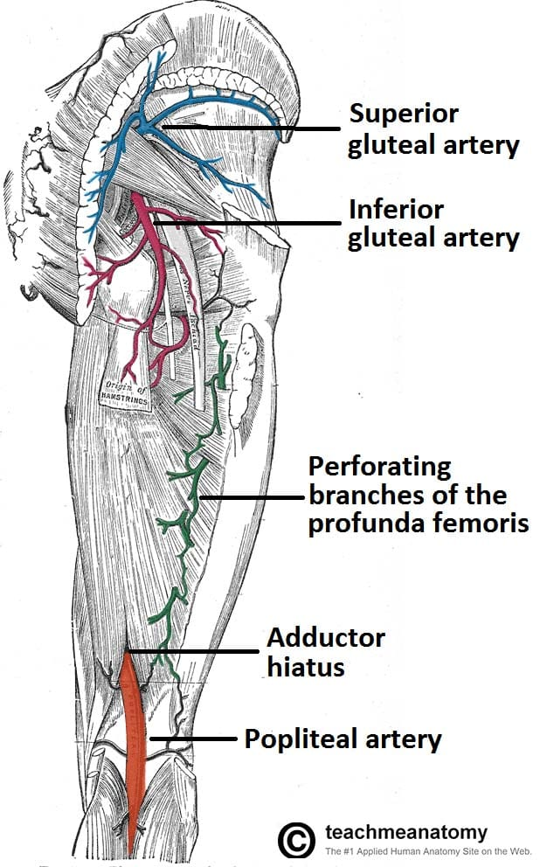
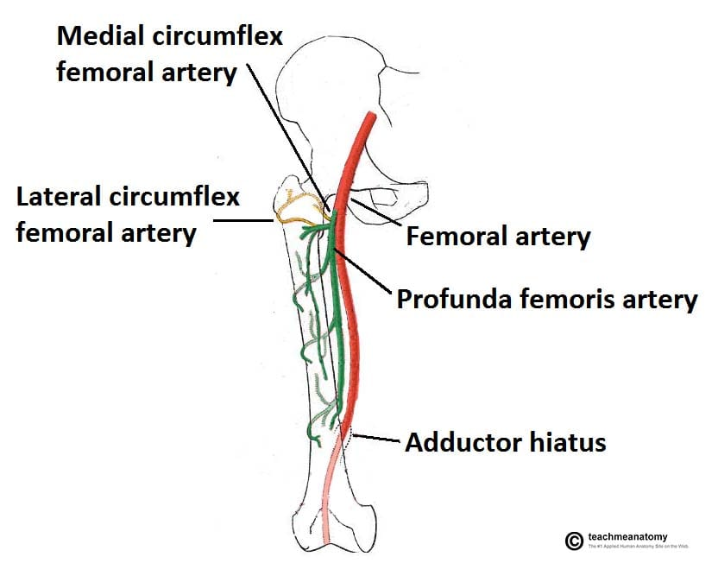

Q 4: Describe anatomical course, motor and sensory function of Sciatic Nerve
Answer:
The sciatic nerve supplies sensation to the skin of the foot, as well as the entire lower leg (except for its inner side). Sensation to skin to the sole of the foot is provided by the tibial nerve, and the lower leg and upper surface of the foot via the common peroneal nerve.

The sciatic nerve also innervates muscles. In particular

Via the tibial nerve, the muscles in the posterior compartment of the leg and sole of the foot (plantar aspect).
Via the common peroneal nerve, the muscles in the anterior and lateral compartments of the leg.

The sciatic nerve, also called the ischiadic or ischiadic nerve, is a large nerve in humans and other vertebrate animals which is the largest branch of the sacral plexus and runs alongside the hip joint and down the lower limb. It is the longest and widest single nerve in the human body, going from the top of the leg to the foot on the posterior aspect. The sciatic nerve has no cutaneous branches for the thigh. This nerve provides the connection to the nervous system for the skin of the lateral leg and the whole foot, the muscles of the back of the thigh, and those of the leg and foot. It is derived from spinal nerves L4 to S3. It contains fibers from both the anterior and posterior divisions of the lumbosacral plexus.
Q 5: Enumerate Muscles of the medial compartment of thigh, what is tarsal tunnel syndrome?
Answer:
Muscles of the Medial Thigh
Adductor Magnus
The adductor magnus is the largest muscle in the medial compartment. It lies posteriorly to the other muscles.

Functionally, the muscle can be divided into two parts; the adductor part, and the hamstring part.

Attachments
Adductor part – Originates from the inferior rami of the pubis and the rami of ischium, attaching to the linea aspera of the femur.
Hamstring part – Originates from the ischial tuberosity and attaches to the adductor tubercle and medial supracondylar line of the femur.
Actions: They both adduct the thigh. The adductor component also flexes the thigh, with the hamstring portion extending the thigh.
Innervation: Adductor part is innervated by the obturator nerve (L2-L4), the hamstring part is innervated by the tibial component of the sciatic nerve (L4-S3).
Adductor Longus
The adductor longus is a large, flat muscle. It partially covers the adductor brevis and magnus. The muscle forms the medial border of the femoral triangle.

Attachments: Originates from the pubis, and expands into a fan shape, attaching broadly to the linea aspera of the femur
Actions: Adduction of the thigh.
Innervation: Obturator nerve (L2-L4).
Adductor Brevis
The adductor brevis is a short muscle, lying underneath the adductor longus.

It lies in between the anterior and posterior divisions of the obturator nerve. Therefore, it can be used as an anatomical landmark to identify the aforementioned branches.

Attachments: Originates from the body of pubis and inferior pubic rami. It attaches to the linea aspera on the posterior surface of the femur, proximal to the adductor longus.
Actions: Adduction of the thigh.
Innervation: Obturator nerve (L2-L4).
Obturator Externus
This is one of the smaller muscles of the medial thigh, and it is located most superiorly.

Attachments: It originates from the membrane of the obturator foramen, and adjacent bone. It passes under the neck of femur, attaching to the posterior aspect of the greater trochanter.
Actions: Adduction and lateral rotation of the thigh.
Innervation: Obturator nerve (L2-L4).
Gracilis
The gracilis is the most superficial and medial of the muscles in this compartment. It crosses at both the hip and knee joints. It is sometimes transplanted into the hand or forearm to replace a damaged muscle.

Attachments: It originates from the inferior rami of the pubis, and the body of the pubis. Descending almost vertically down the leg, it attaches to the medial surface of the tibia, between the tendons of the sartorius (anteriorly) and the semitendinosus (posteriorly).
Actions: Adduction of the thigh at the hip, and flexion of the leg at the knee.
Innervation: Obturator nerve (L2-L4).
Tarsel tonel:
The tarsal tunnel is located on the inside of the ankle, and is formed by the ankle bones and the band of ligaments that stretches across the foot. Many of the blood vessels, nerves and tendons that provide movement and flexibility to the foot travel through the tarsal tunnel.

Tarsal tunnel syndrome (TTS) is caused by compression of the posterior tibial nerve as it travels through the tarsal tunnel. Compression of the posterior tibial nerve can cause pain, tingling or numbness in the foot.
Tarsal tunnel syndrome (TTS) is caused by compression of the posterior tibial nerve as it travels through the tarsal tunnel. Compression of the posterior tibial nerve can cause pain, tingling or numbness in the foot.

