Subject: Human Anatomy II
Instructor: Dr. Arooba.
Section: B
June 22nd, 2020. Total marks: 50
Attempt the following questions. Add diagrams where needed.
Each carries 10 marks.
Name : Najeeb Ullah ID: 16561
- What are the major features of intracranial fossae of the skull?
- Write note on the cranial nerves.
- Write note on the salient features of norma frontalis and norma occipitalis of skull.
- What do you know about the muscles of hip and knee?
- Write a comprehensive note on the femoral triangle.
Answer no :2
Cranial nerves
ccnn | Name |  | Sensoryor motor | Major function |  | Location of cells whose axons form the nerve
1 | Olfactory nerve |  | sensory | sense of smell |  | nasal epithlium
2 | Optic nerve |  | sensory | vision |  | retina
3 | Oculomotor nerve |  | motor | eye movements pupillary Constriction and accommodation: muscle of upper eyelid . |  | Oculomotor nucleus in mid brain; edinger – westphal nucleus in midbrain.
4 | Trochlear nerve |  | Motor | Eye movements (intorsion, downward gaze. |  | Trochlear nucleus in midbrain
5 | Trigeminal nerve |  | Sensory and motor | Somatic sensation form face, mouth, cornea;muscles of mastication |  | Trigeminal motor nucleus in pons; trigeminal sensory ganglion (the gasserian ganglion)
6 | Abducens nerve |  | Motor | Eye movements(abdution or lateral movements |  | Abducens nucleus in pons
7 | Facial nerve |  | Sensory and motor | Controls the muscles of facial expression teste form anterior longue ; lacrimal and salivary gland. |  | Facial motor nucleus in pons; superior salivatory nuclei in pons; geniculate ganglion
8 | Vestibulocochlear (auditory)nerve |  |  | Sensory | Hearing;sense of balance |  | Spiral ganglion; vestibular(scarpa`s)ganglion
9 | Glossopharyngeal nerve | Sensory and motor |  |  | Sensation form posterior tongue and pharynx; taste form posterior tongue; carotid barorecptors and chemoreceptors ; salivary gland |  | Nucleus ambiguus in medulla;inferior salivatory nucleus in pons ; glossopharyngeal ganglia
10 | Vagus nerve |  |  | Sensory and motor | Autonomic functions of gut; cardiac inhibition ; sensation form larynx and pharynx ; muscles of vocal cords ; swallowing |  | Dorsal motor nucleus of vagus ; nucleus ambiguous ; vagal nerve ganglion
11 | Spinal accessory nerve |  |  | Motor | Shoulder and neck muscles |  | Spinal accessory nuclus in superior cervical cord
12 | Hypoglossal nerve |  |  | Motor | Movement of tongue |  | Hypoglossal nucleus in medulla

Answer no ;4
Hip muscle :
The psoas is the primary hip flexor assisted by the iliaus .the peectineaus, the adductors longus brevis ,and meangnus,as well as the tensor fasciae latae are also involved in flexion . the gluteus maximus is the main hip extensor, but the inferior portion of the adductor magnus also plays a role.
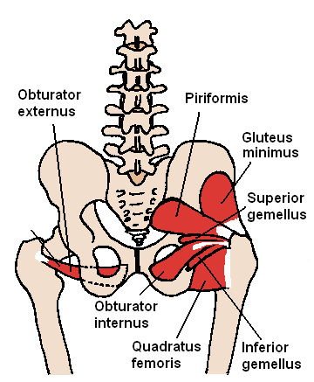

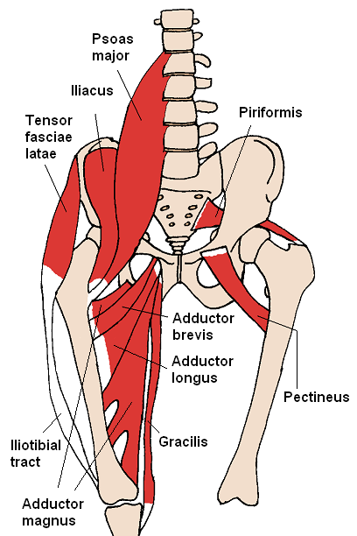

Knee muscle
The quadriceps femoris muscle group (rectus femoris vastus lateralis, vastus medius, and vastus intermadius)crosses the knee via the patella and acts to extend the leg . the hamstring group muscles
(semitendinosus ,semimembranosus,and biceps femoris) flex the knee and extend the hip.
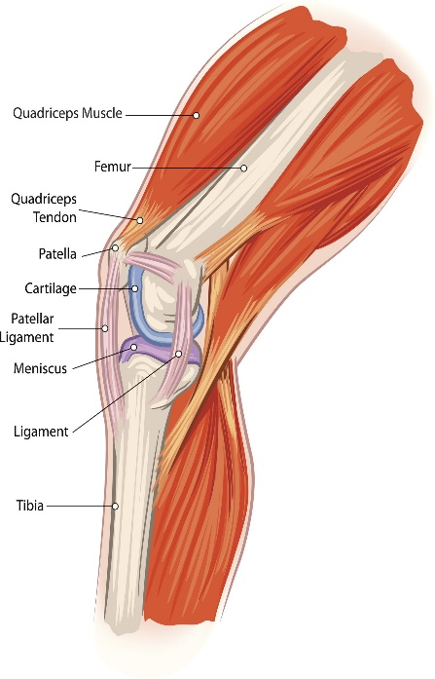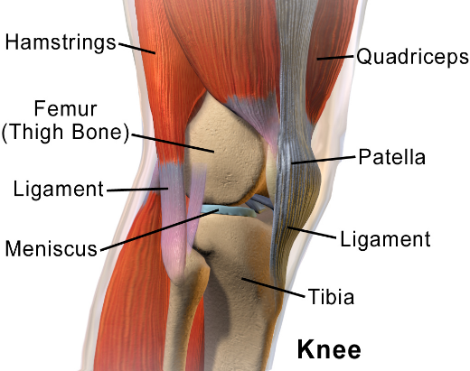
Answer no 3:
Norma occipitalis of skull:
  - Most of the occipital bone can be seen. the lamda is where the lambdoid and sagittal sutures intersect.
  - The posterior pole of the skull which is the part theat will hit the found first when falling backwards is located below the lambda.
Posterior fontanelle :
  - In the newborn skull, sagittal and lambdoid sutures do not quite meet and there is a triangular posterior fontanelle.
  - This is much smaller than the anterior fotanelle and it closes earlier before the end of the first year.
External occipital protuberance
  - a projection located below the lambda can be felt by running a finger up to the midline groove at the back of the neck.
Nuchal lines
  - Stretching laterally from the external occipital protuberance are the superior nuchal lines and , below them the inferior nuchal lines.
Inferior nuchal lines
  - The surface landmark for the attachment of the tentorium cerebelli . which straddles the transverse venous sinus.
  - Superior nuchal lines
  - The inion
  - Mastoid emissary foramen salient features of norma
  - The anterior view of the skull
  - Presents an irreqular surface with 3 excavations.
  - 1: one nasal cavity • 2: two orbital cavities
Six regions of norma frontalis
  - Frontal region
  - Orbital region
  - Nasal region
  - Zygomatic region
  - Maxillary region
  - Mandibular region
Boundaries:
  - Superior
Top of the skull
  - Inferior
Orbits and root of the nose
Frontal process of the maxillae
  - Laterally
Frontal process of the zygomatic bone
Characteristics features
  - Frontal tuberosity or eminence
  - Superciliary arch
  - Glabella
  - Nasion
  - Supraorbital margin • Supraorbital notch
Bones involved
  - Masilla
  - Zygomatic bone
  - Sphenoid bone
  - Frontal bone
  - Palatine bone
  - Ethmoid bone
  - Lacrimal bone
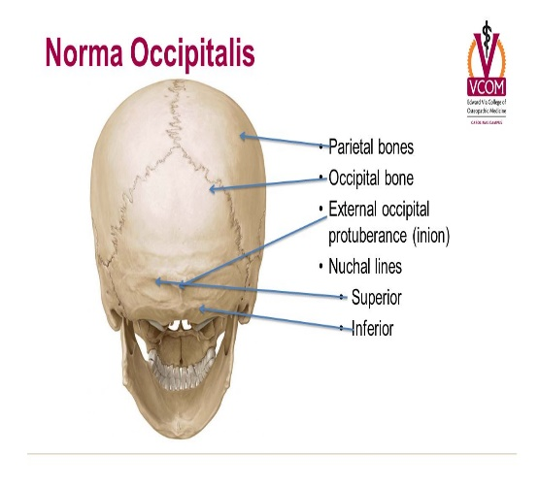A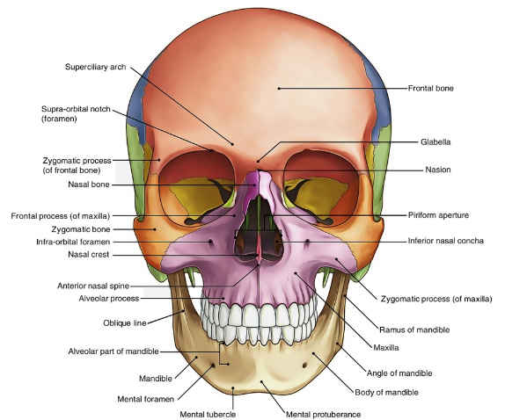nswer no ;1
Answer no ;1
Intracranial fossae have
- paired bones frontal and temporal
- unparied ethmoid, sphenoid and occipital
Intracranial fossae (superior view )
- Anterior cranial fossa
- Middle cranial fossa
- Posterior cranial fossa
The anterior cranial fossa the frontal bone turns sharply back to the large part of the roof of the orbit.
this part of the bone is therefore called the orbital plate of the frontal bone which is the largest contributor to the anterior fossa. It is convex and ridged in roughly H-Shape in conformity with the orbital surface of the frontal lobe of the cerebral hemisphere.
- The frontal love of the brain occupies the anterior cranial fossa.
Anteriorly the groove for the superior sagittal sinus is traceable down as a crest for the flax cerebri, and behind the lower end of the rest is the foramen cecum, which is plugged by fibrous tissue of the flax.
- The posterior boundary of the anterior cranial fossa is made by the lesser wing of the sphenoid.
- Laterally, the lesser wing meets the greater wing and the frontal bone at the pterion.
- Medially, lesser wing of the sphenoid is projected back as the anterior clinoid process.
- In front of the anterior clinoid process, the base of the lesser wing is perforated by the optic canal.
The anterior cranial fossa
- Bonnderies
- Anterolaterally Frontal sinus
- Posteriorly
Lesser wing and body of sphenoid
- Medially
Cribriform plate (horizontal and vertical part).
Crista galli
- Floor
Frontal bone (orbital plates )ethmoid lesser wing and body of sphenoid.
- Relation
Nasal cavity , orbital cavity
- Contents
Frontal lobes of cerebral hemislphere
- Landmarks
Frontal crest=falx cerebri
Ehtmoid = crista galli
Sphenoid = lesser wings, anterior clinoid process= tentorium cerebelli
Name | contents
Cribriform | Olfactory nerve fibers
Anterior ethmoid | Ant, Ethmoid vessels and nerves
Posterior ethmoid | Post, Ethmoid vessels and nerves
Foramen cecum | Origion of superior venous sinus
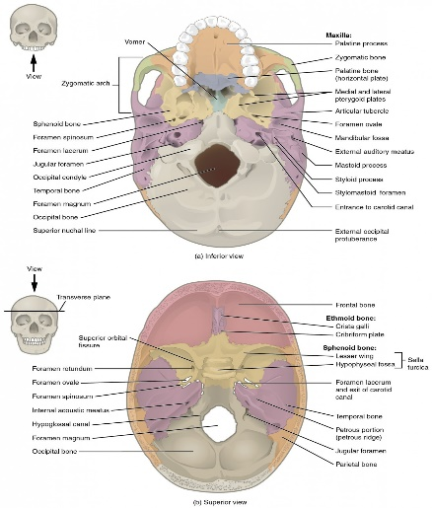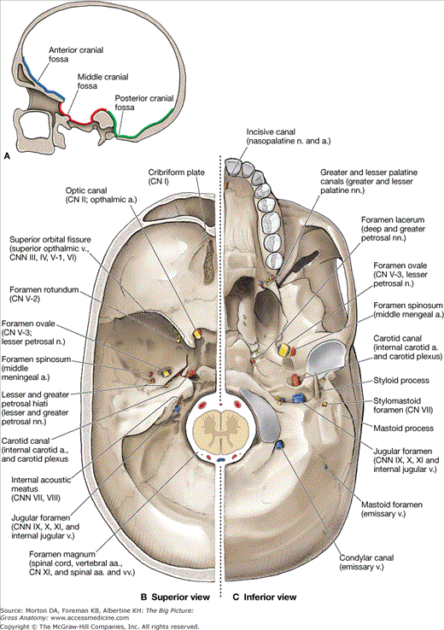
Answer no ;5
The femoral tringle is the hollow area in the anterior thigh . Many large neurouvascular structure pass through this area, and can be accessed relatively easily thus it is an area of bothe anatomical and clinical important. In this article we shall look at the border content and clinical correlation of the femoral tringle.
