IQRA National University
Department of Business Administration
Spring- Semester 2020 (Final- Online Assignment)

Name : Muhammad Ismail
ID : 15845
Course Title : Principles of Marketing
Instructor : Sir Shahzeb Anwar

Question 1:
What is SWOT Analysis? Why companies use it? Develop SWOT Analysis for IQRA National University.
Answer :
Definition
SWOT analysis is a process through which we can understand the current position as well as the upcoming position of a company in a market. The name SWOT comprises of Strength , Weaknesses , Opportunities and last but not the least Threats.
Strengths include internal capabilities, resources, and positive situational factors that may help the company serve its customers and achieve its objectives.
Weaknesses include internal limitations and negative situational factors that may interfere with the company’s performance.
Opportunities are favorable factors or trends in the external environment that the company may be able to exploit to its advantage.
Threats are unfavorable external factors or trends that may present challenge to performance.

SWOT Analysis of Iqra University is As Under:
Strength:
- Easy to acess location in peshawar.
- Provide quality education at affordable price.
- Dedicated and expert faculty.
- Charterd with HEC.
- All Programs under One roof.
- Discipline.
- Saftey measures.
- Foreign Accredition.
- Supportive Staff.
Weakneses:
- Weak Transportation System.
- Distant Hostel.
- Leading Competitors.
- Resistance to change.
- Drop Outs.
- Incomplete liabrary.
- No net facilities.
- Cooling and heating system.

Oppurtunites:
- International scholarships.
- Growth Potential.
- New constructions.
- Introduction of new specialization to attract wider segment of students.
- Strong collaboration with local companies.
Threats:
- Emergence of new business schools .
- Emergence of New Universities.
- Socioeconomical situation of the country.
- Day by day raising expenses.
- Negative public perception.

Question 2:
Discuss New Product Development Process and draw its model.
Answer:
Bringing your vision for an original product to life is frequently one of the biggest hurdles for aspiring entrepreneurs. The product development process can seem almost mysterious, and when you hear the origin stories of other great businesses, the journey to a finished product rarely resembles a straight line.
The new product development process consists of eight stages.

1. Idea Generation
Many aspiring entrepreneurs get stuck on ideation, often because they’re waiting for a stroke of genius to reveal the perfect product they should sell. While building something fundamentally "new" can be creatively fulfilling, many of the best ideas are the result of iterating upon on an existing product.
New-product development starts with idea generation—the systematic search for new product ideas.
2. Idea Screening
Idea screening is a process that evaluates and contrasts new product ideas to get the most promising ones for your business. Not every idea is relevant to your company. The idea screening process helps to reduce the amount of irrelevant ideas into a convenient amount which can further turned into prototypes. The purpose is to eliminate the number of ideas without screening away the potential ones. One marketing expert proposes an R-W-W (“real, win, worth doing”) new-product screening framework that asks three questions.
Is it real? Is there a real need and desire for the product and will customers buy it?
Can we win? Does the product offer a sustainable competitive advantage?
Is it worth doing? Does the product fit the company’s overall growth strategy? Does it offer sufficient profit potential? The company should be able to answer yes to all three R-W-W questions before developing the new-product idea further.
3.Concept Development and Testing
a two-phase stage in the development of a new product in which potential buyers are presented first with the idea or description of the new product (concept testing) and later with the product itself in final or prototype form (product testing), in order to obtain their reaction.
Product concept
A detailed version of the new-product idea stated in meaningful consumer terms.
Concept testing
Testing new-product concepts with a group of target consumers to find out if the concepts have strong consumer appeal.
4. Develop a marketing strategy
Effective marketing starts with a considered, well-informed marketing strategy. A good marketing strategy helps you define your vision, mission and business goals, and outlines the steps you need to take to achieve these goals.Your marketing strategy affects the way you run your entire business, so it should be planned and developed in consultation with your team. Marketing strategies differ from one business to the next and should be customized to suit the needs of the particular company. The development of a marketing strategy involves the isolation of a target market segment, a set of clear-cut goals, a fair amount of consumer research, and the implementation of initiatives aimed at getting the word out.
5. Business Analysis
Business Analysis is a disciplined approach for introducing and managing change to organizations, whether they are for-profit businesses, governments, or non-profits.Business analysis is used to identify and articulate the need for change in how organizations work, and to facilitate that change.
Business analysis involves a review of the sales, costs, and profit projections for a new product to find out whether they satisfy the company’s objectives. If they do, the product can move to the product development stage.
6. Product Development
Product development integrates the results of the feasibility analyses and feedback from beta tests from stage five into the product. This stage consists of turning that prototype or concept into a workable market offering; ironing out the technicalities of the product; and alerting and organizing the departments involved with the product launch, such as research and development, finance, marketing, production or operations.
7. Test Marketing
If the product passes both the concept test and the product test, the next step is test marketing, the stage at which the product and its proposed marketing program are introduced into realistic market settings. Test marketing gives the marketer experience with marketing a product before going to the great expense of full introduction. It lets the company test the product and its entire marketing program—targeting and positioning strategy, advertising, distribution, pricing, branding and packaging, and budget levels.
8. Market entry/commercialization
Commercialization is the stage in which the product is introduced to the target market. All the data obtained throughout the previous seven stages of this approach are used to produce, market and distribute the final product to and through the appropriate channels. The product is now available to everyone and the "product lifecycle" begins. The life of the product is shaped by the reception of the target market, the competition and subsequent enhancements to the product offering.
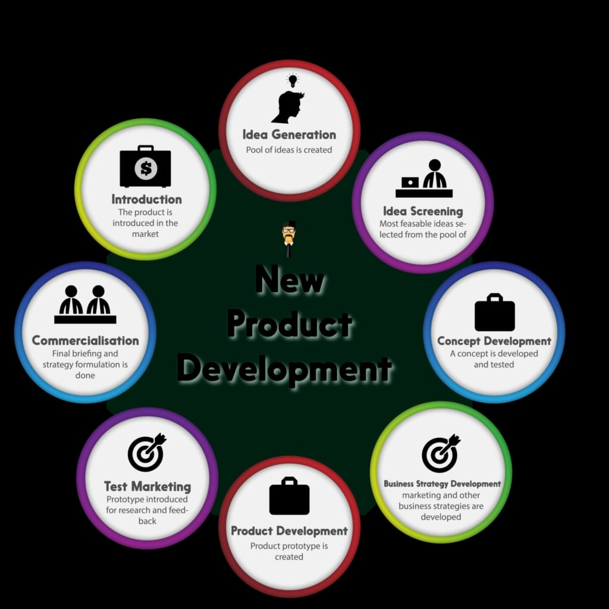
Question 3:
Write briefly about Product Life Cycle and draw its model.
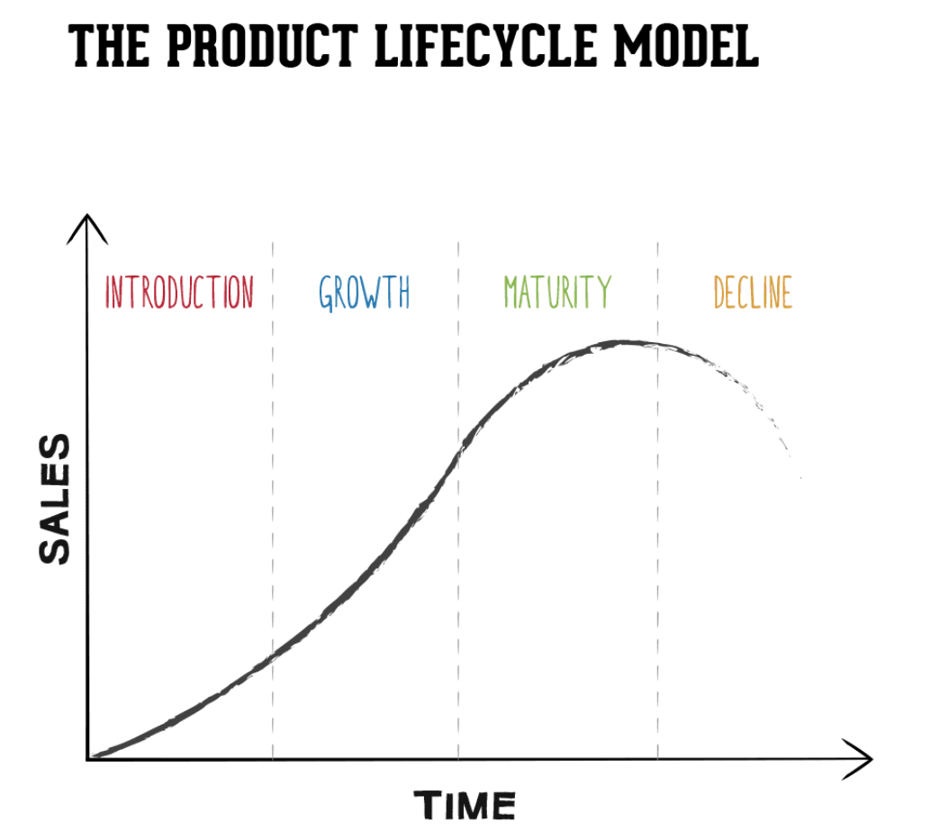

Introduction
The introduction stage is about developing a market for the product and building product awareness. Marketing costs are high at this stage, as it is necessary to reach out to potential customers. This is also the stage where intellectual property rights protection is obtained. Product pricing may be high to recover costs associated with the development stage of the product life cycle, and funding for this stage is typically through investors or lenders.
Growth
Popularity for the product grown, meaning it is being bought in greater numbers and, with volume, the price declines. Distribution increases and promotion focuses on product benefits.
Maturity
At the mature stage, sales will level off. Competition increases, so product features may need to be enhanced to maintain market share. While unit sales are at their highest at this stage, prices tend to decline to stay competitive. Production costs also tend to decline at this stage because of more efficiency in the manufacturing process. Companies usually do not need additional funding at this stage.

Decline
The decline stage of the product life cycle is associated with decreasing revenue due to market saturation, high competition, and changing customer needs. Companies at this stage have several options: They can choose to discontinue the product, sell the manufacturing rights to another business that can better compete or maintain the product by adding new features, finding new uses for the product, or tap into new markets through exporting. This is the stage where packaging will often announce “new and improved.”

Question 4: Write briefly about Branding along with examples.
Answer:
Branding is a marketing technique used by businesses to create a desired image for a product or company in the minds of the consumer. Examples can demonstrate to small business owners how to use branding effectively for their enterprise. Branding should occur before a marketing strategy ever begins. Branding is not the act of pushing out a message. On the contrary, it is the pulling in of a message. It is listening to the consumer, and using that information to build a brand strategy. The brand is not the product. It is not the logo, packaging, or company name. It is how a company's consumers view the company, and it details how the company makes the consumer feel.If one company is selling a particular product, the chances are that another company is selling the same product. The goal of branding is figuring out what makes one company's product better than the other, and using the information to build the brand strategy.
Symbols:- Branding often takes the form of a recognizable symbol to which consumers easily identify, such as a logo. Common examples include the Nike "swoosh," the golden arches of McDonald's and the apple used by Apple Computers. Logos typically appear on all products in some form and are used in advertising and promotional campaigns. The most successful symbols allow consumers to identify a product or company even if the name is not visible.
Slogans
Like symbols, slogans build a brand image. Slogans are successfully used in industries such as insurance to make consumers associate insurers with trust, such as "Nationwide is on your side," "You're in good hands with Allstate" and "Like a good neighbor, State Farm is there." As with well-known logos, successful slogans become ingrained in the minds of consumers and may remain there for as long as the company stays in business.
Differentiation
Companies can use branding to differentiate themselves from the competition. For instance, a business can position itself as being an innovator, indicating that its competitors offer the same products or services it has been providing for years. In a time where environmental concerns are important to consumers, a business can also attempt to brand itself as operating more cleanly and efficiently than the competition. Another common technique is to use branding to create an image of always offering the lowest prices.
User Experience
Branding is also demonstrated by the user experience that companies attempt to create. For example, McDonald's uses its advertising to create an image of being a fun place for parents to take their kids, in addition to being a place to get a quick meal.

