Title Page

Name Muhammad Uqail Nawaz
ID No 13623
Program BS (MLT)
Department Allied Health Sciences
Subject Biostatistics
Instructor name Sir Anwar Shamim
Date 16/04/2020

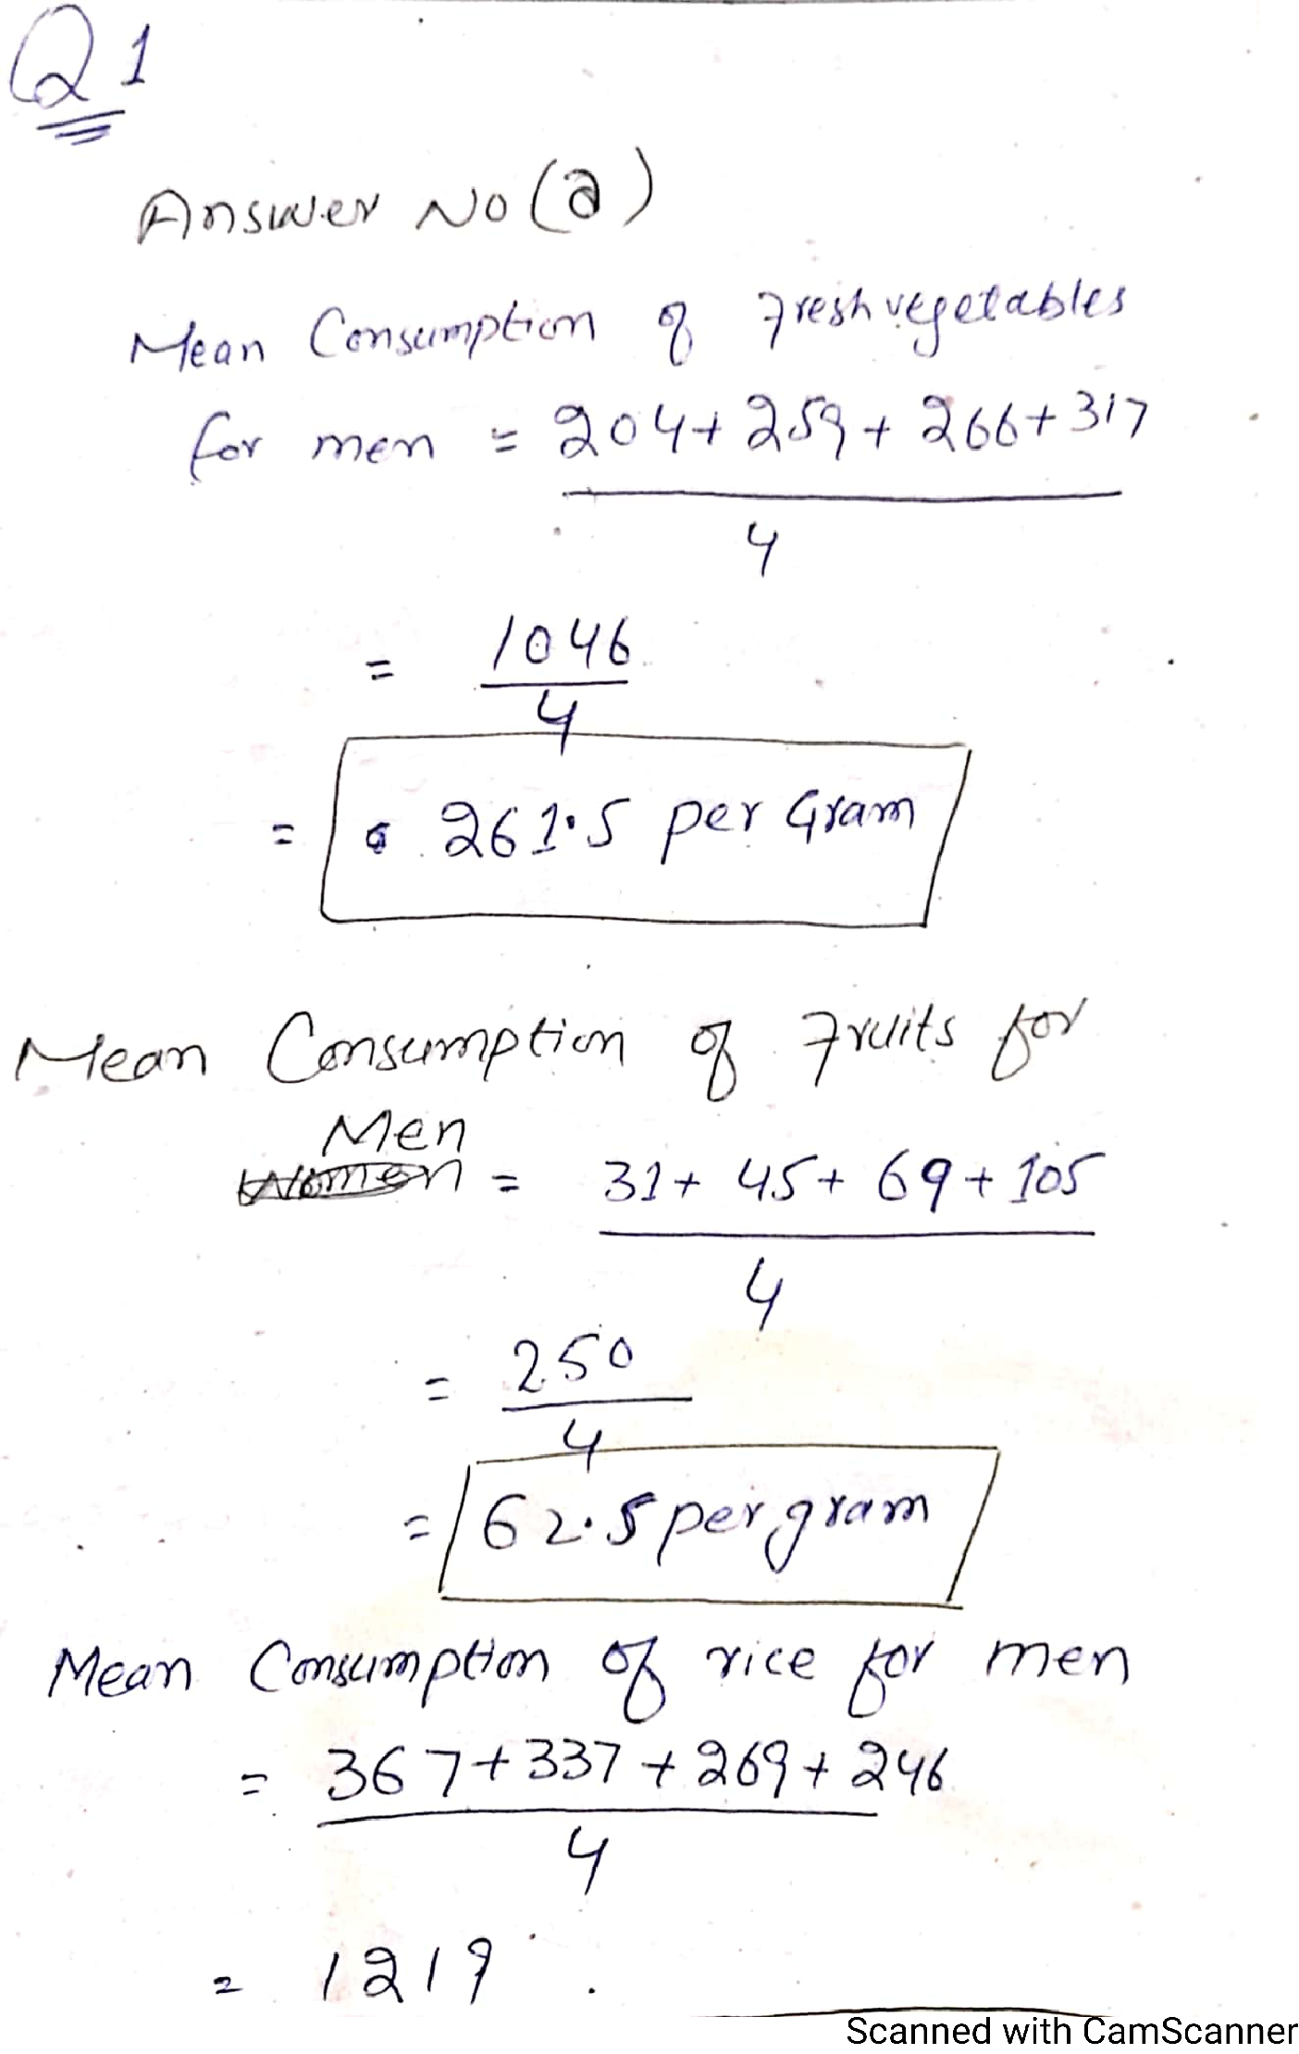

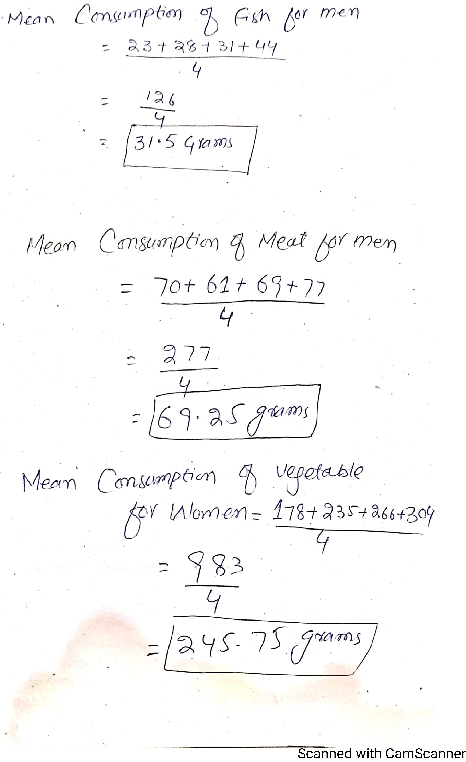

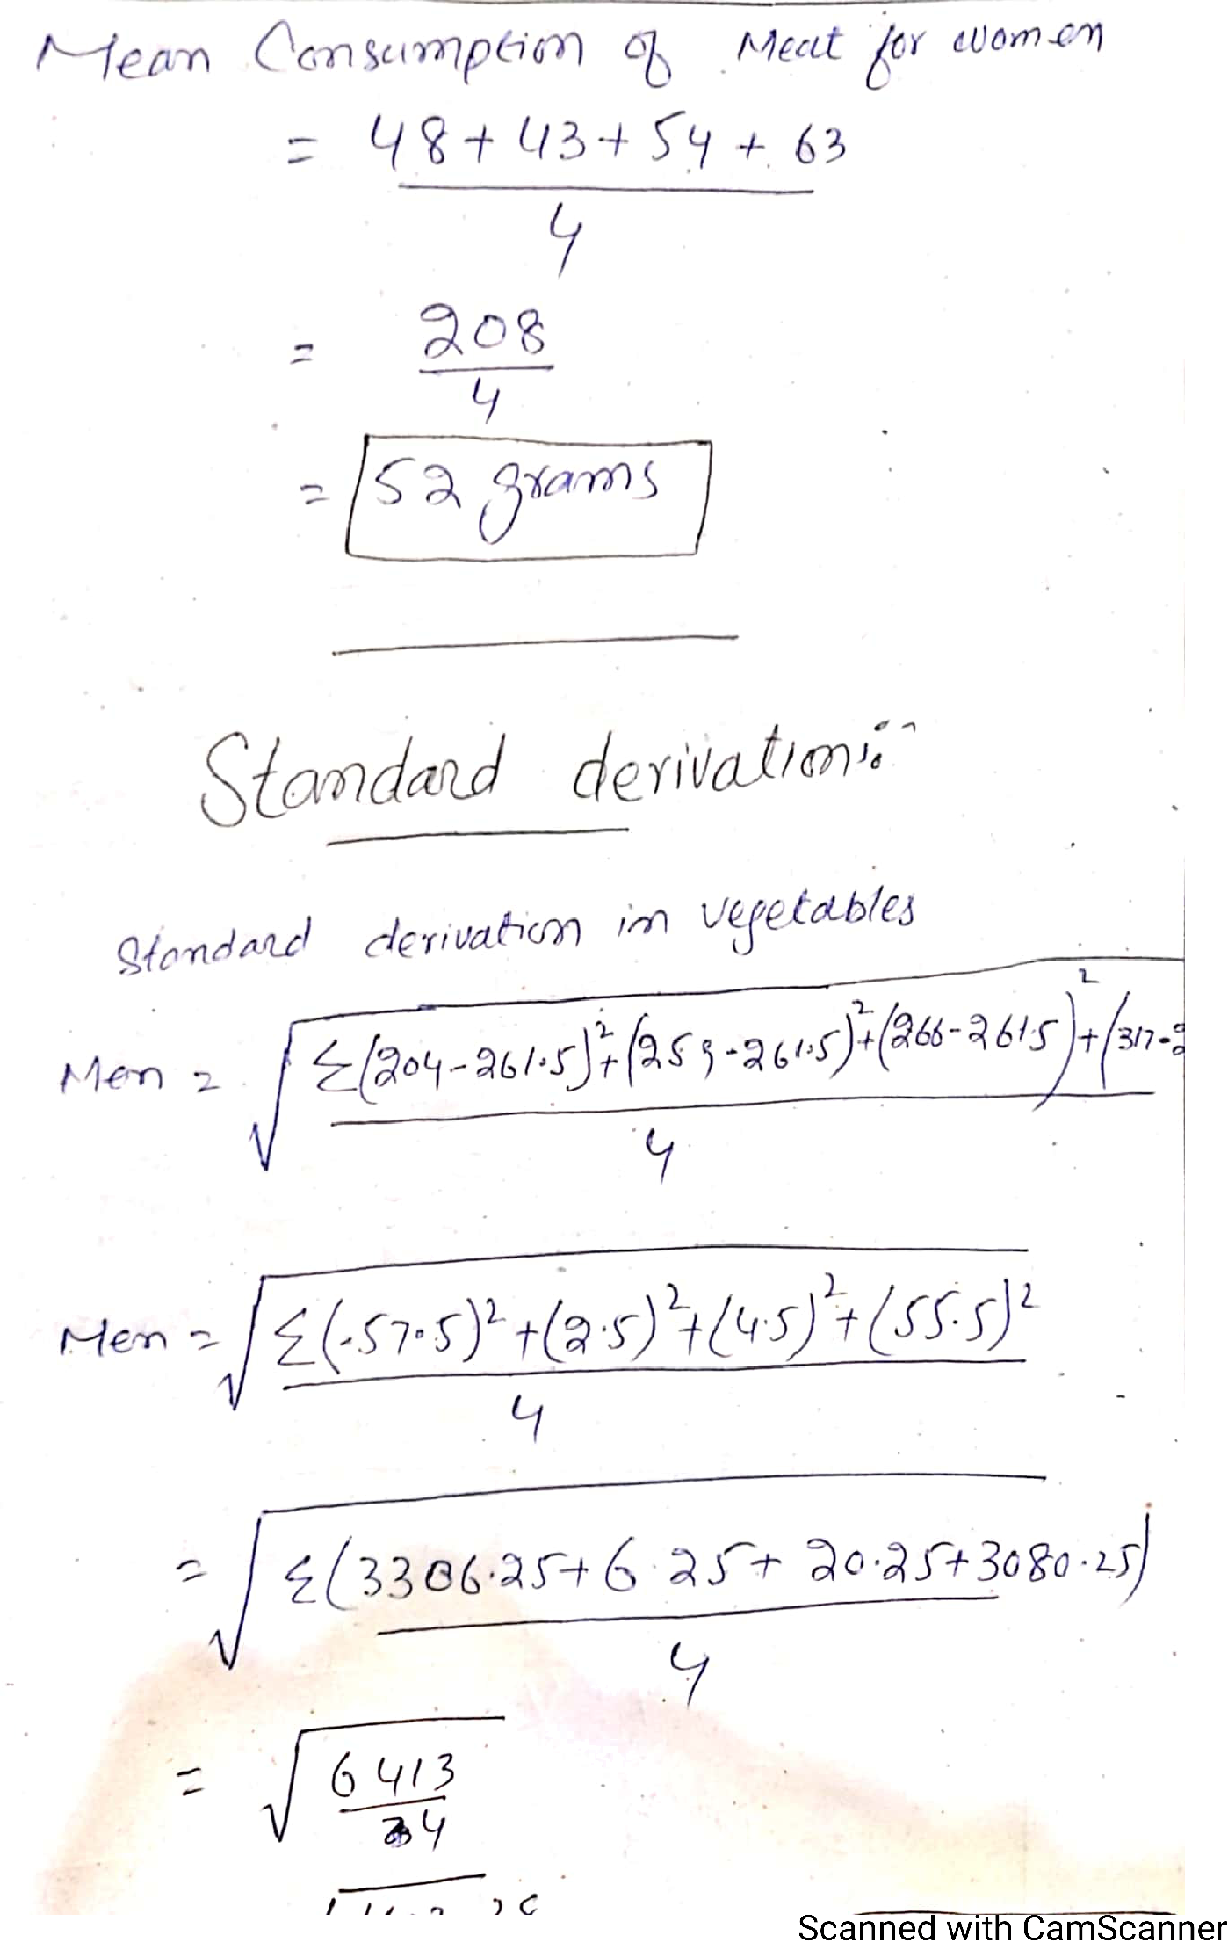

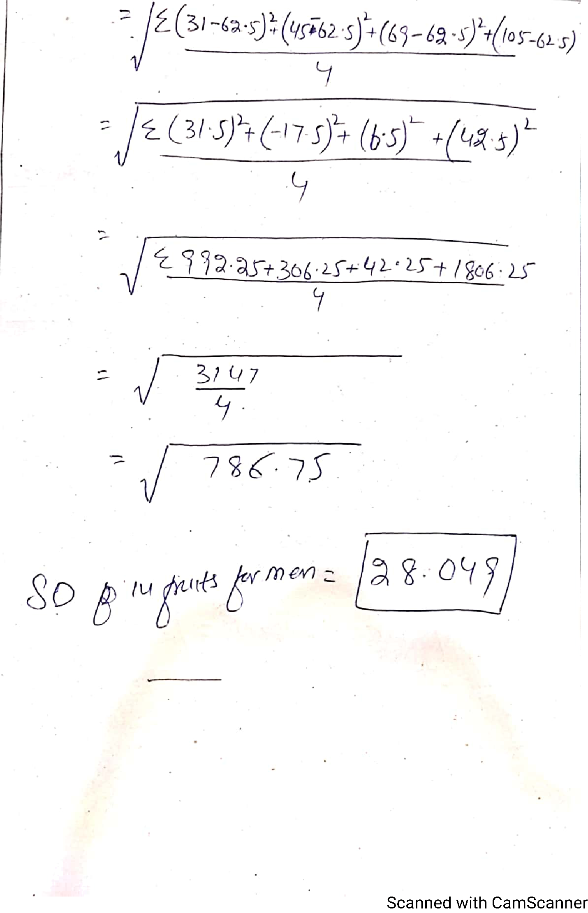

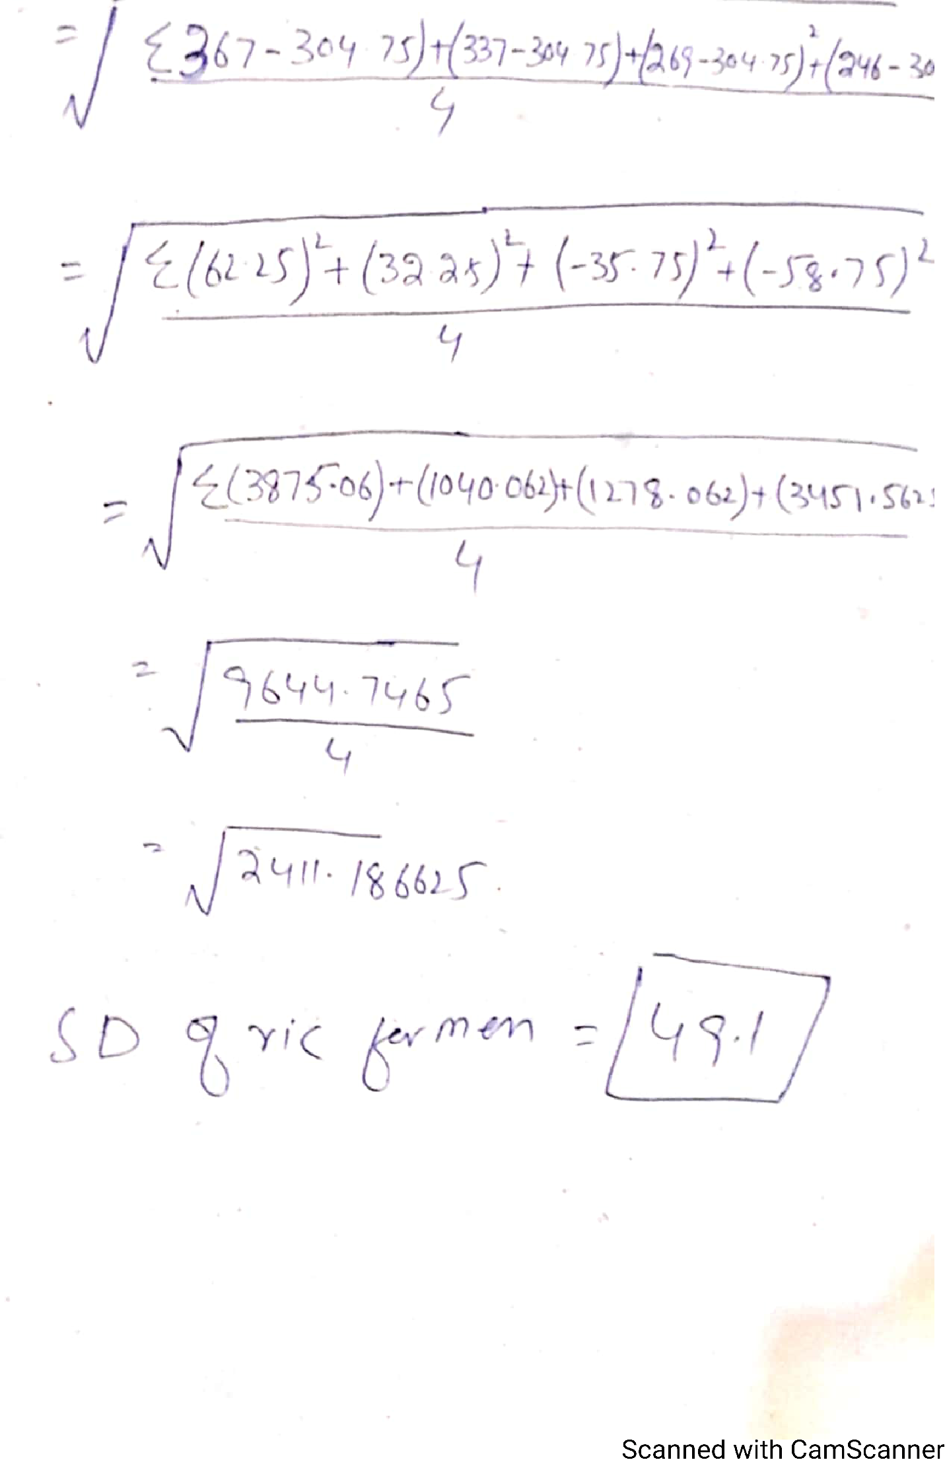

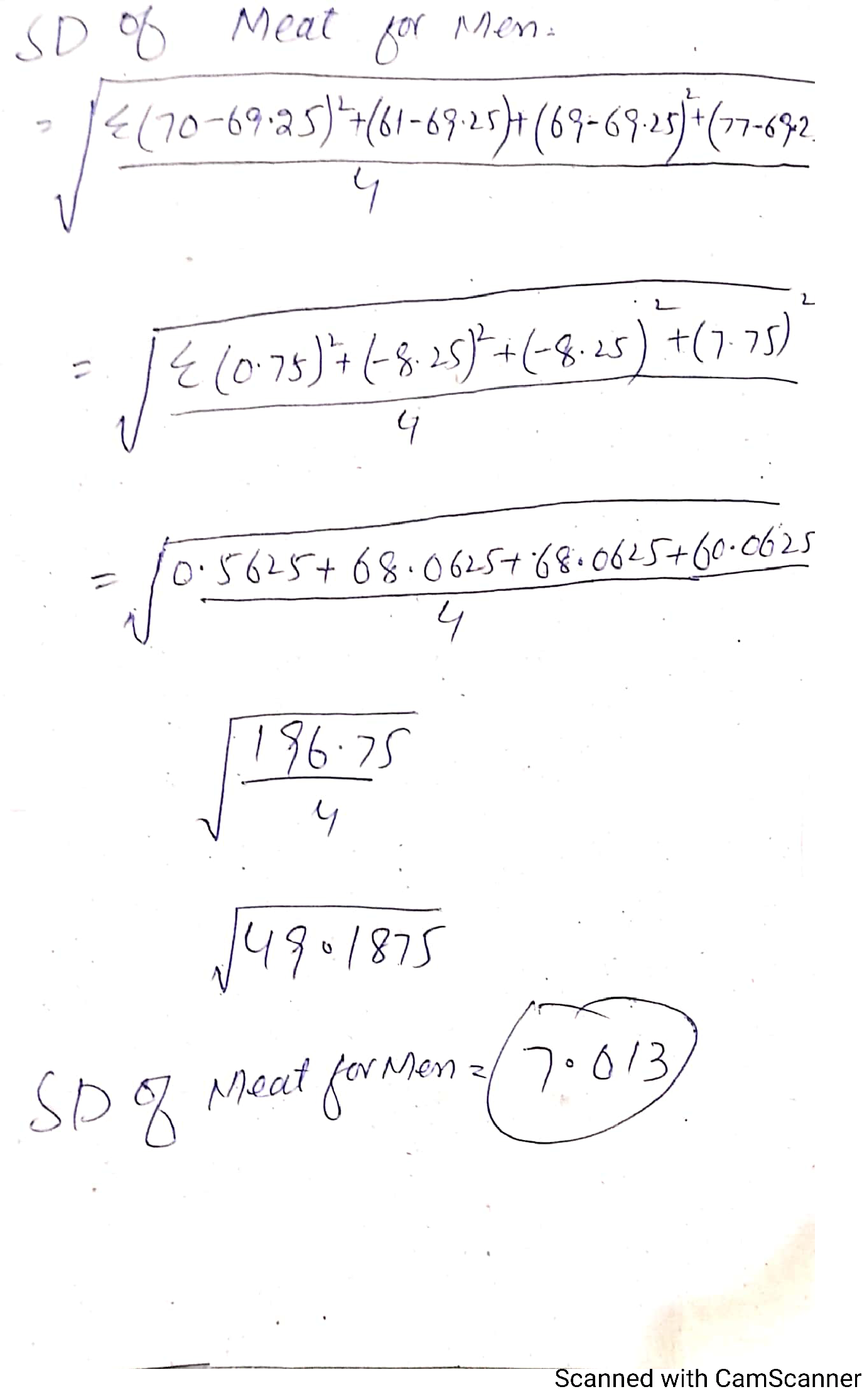

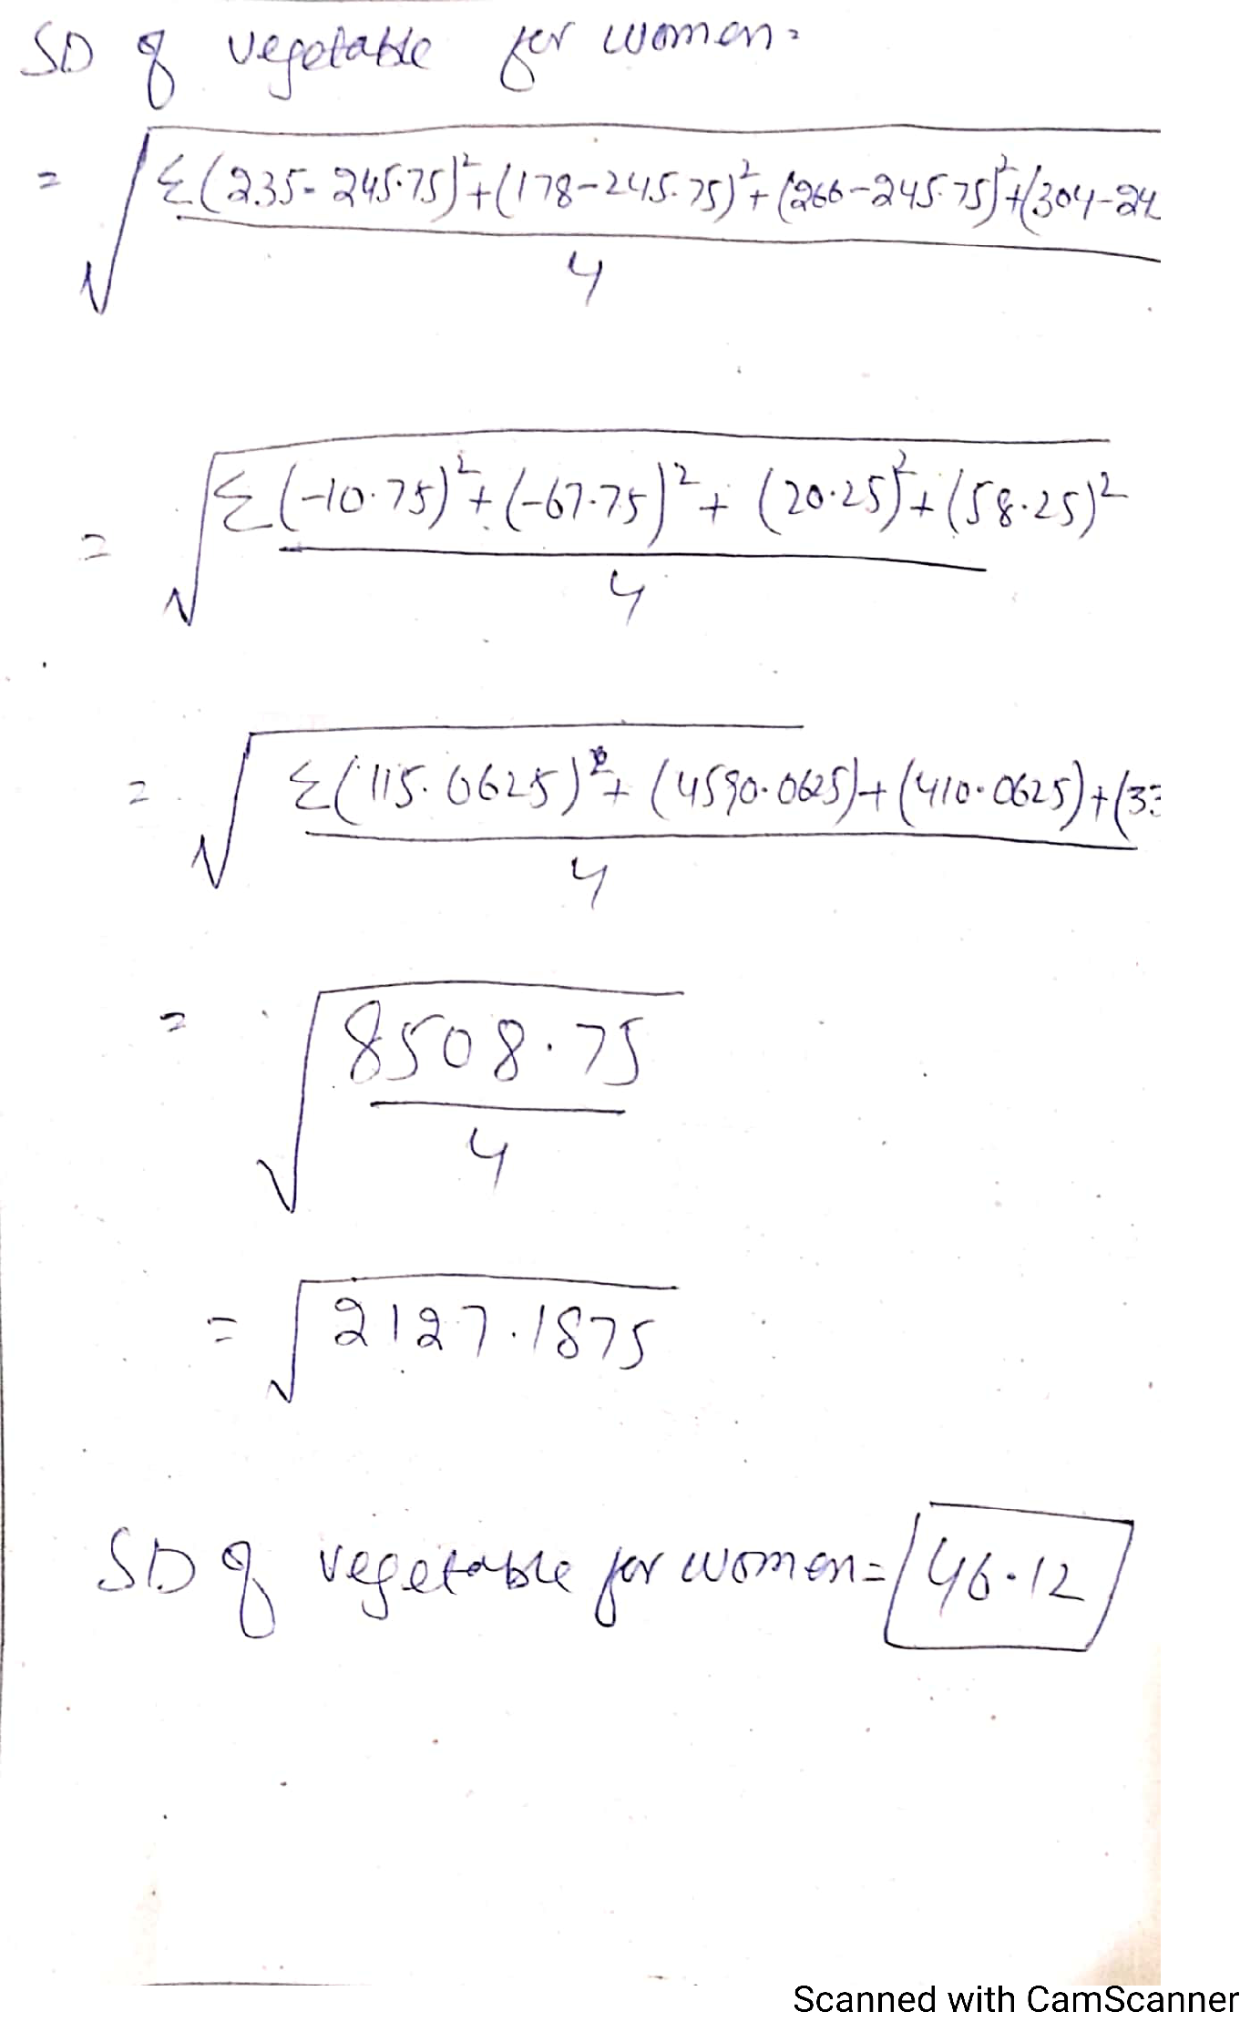

Answer No 1

b) Milk consumption is very low for both men and women in Q1 and Q2 But it rises sharply in Q3 and again in Q4. So those who eat most fresh vegetables consume much more milk than those who eat less fresh vegetables.

c) Rice consumption falls, for men and for women, as fresh vegetable consumption rises It is the only food group to show this pattern.

d) Parallel bar chart, back-to-back bar charts or simple line graphs to compare men and women. (Charts must be appropriate (1), accurate (1), labeled (1) and well executed (1))

e) Divide men’s figures by 1.2 (or multiply women’s figures by 1.2) ( by calculator)

f)
No very large differences in patterns of consumption
(1) But men eat more meat and wheat flour
(1) While women
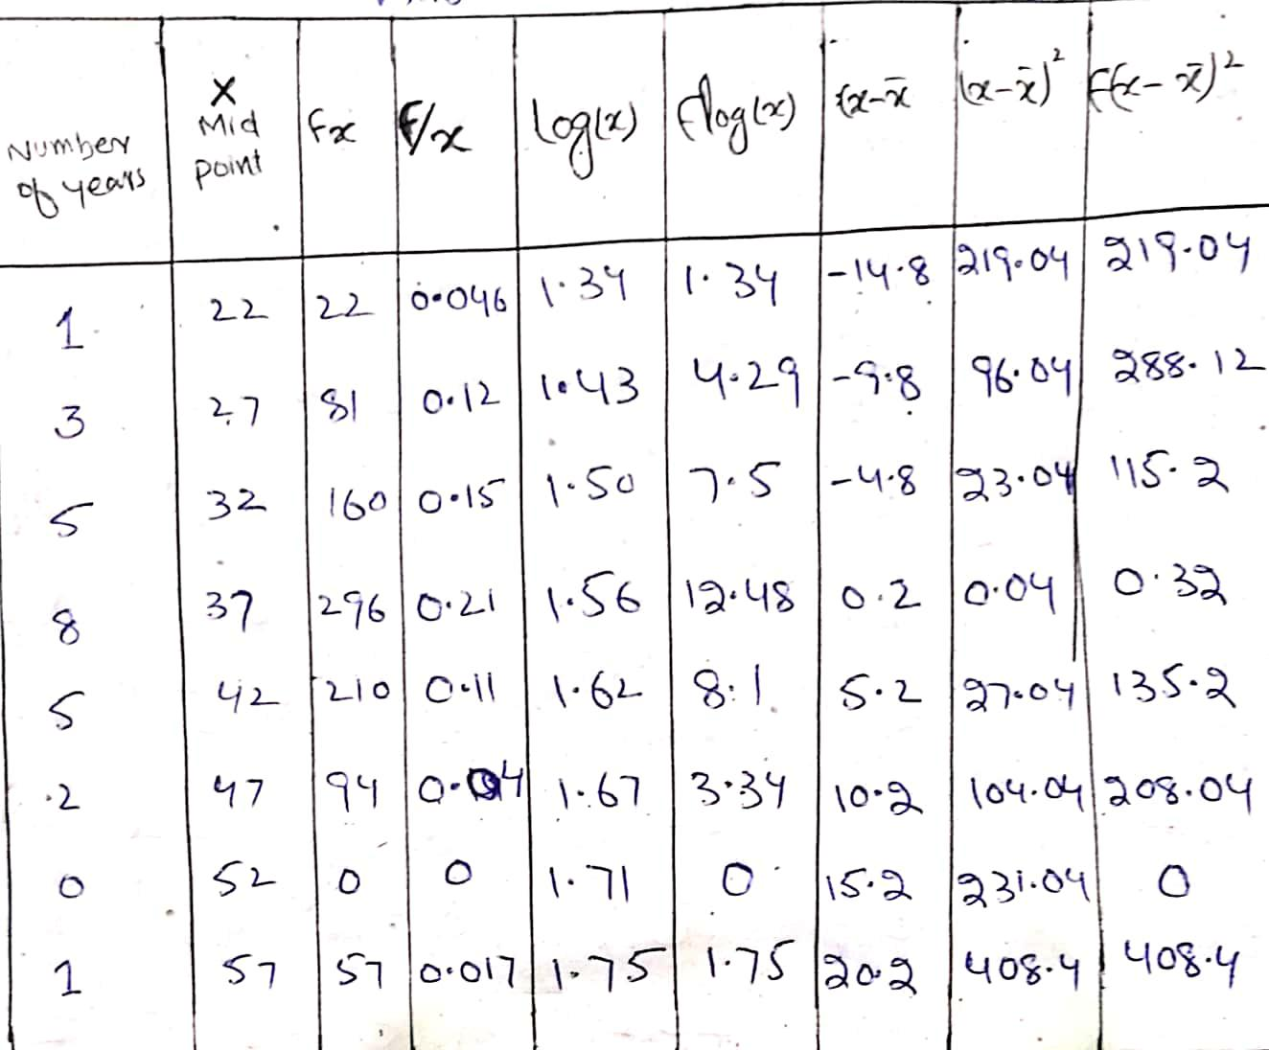
Question No 3

Answer No (a) Find
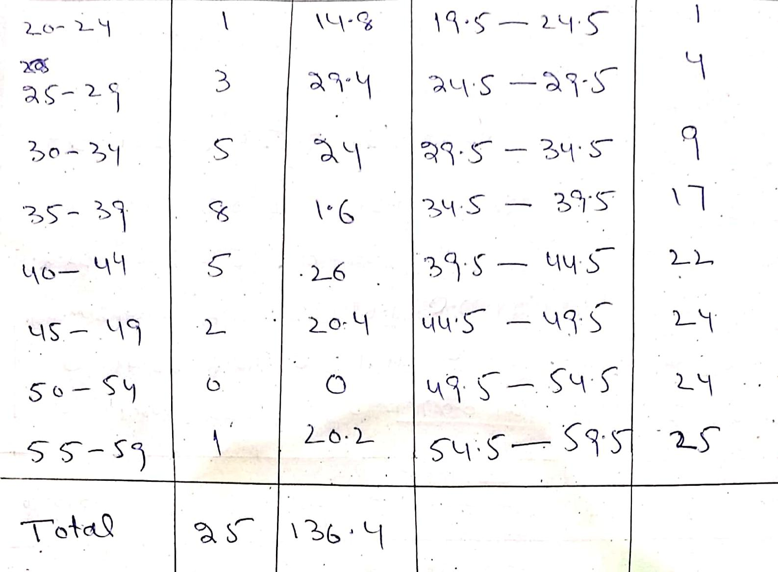

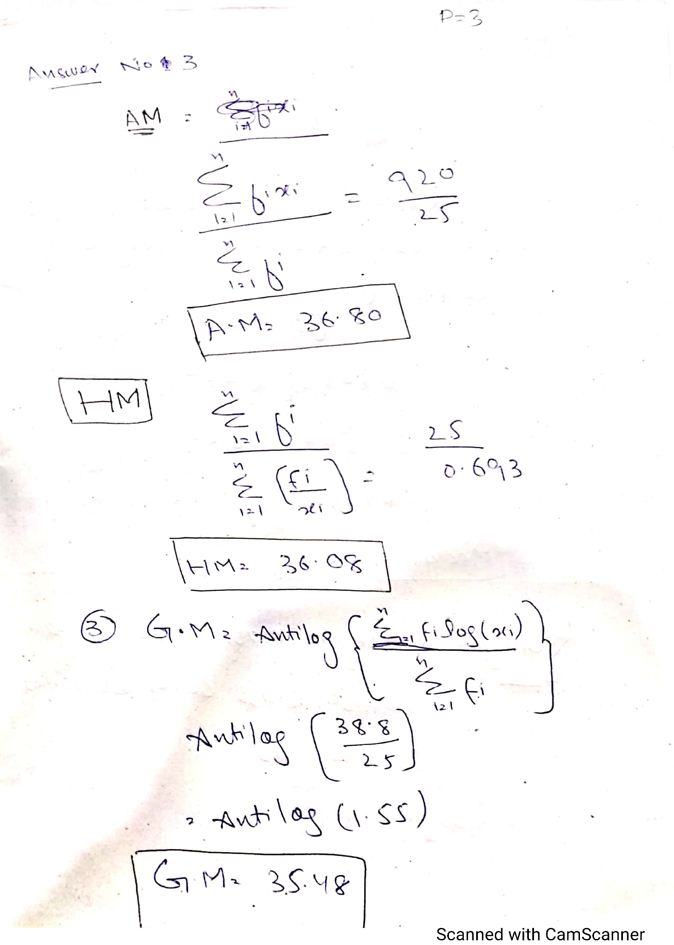
Answer No (A)

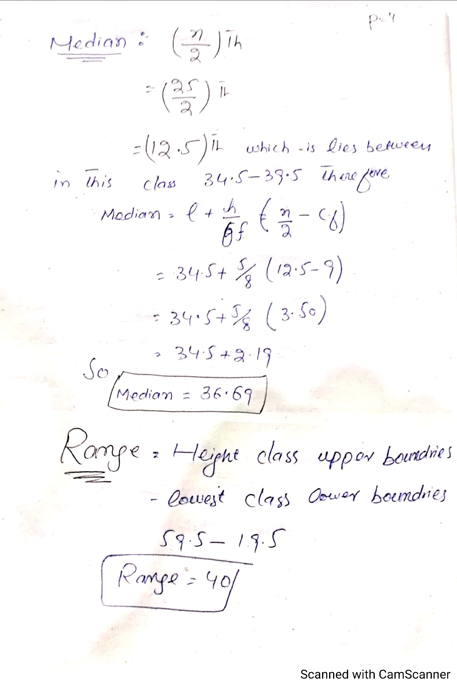

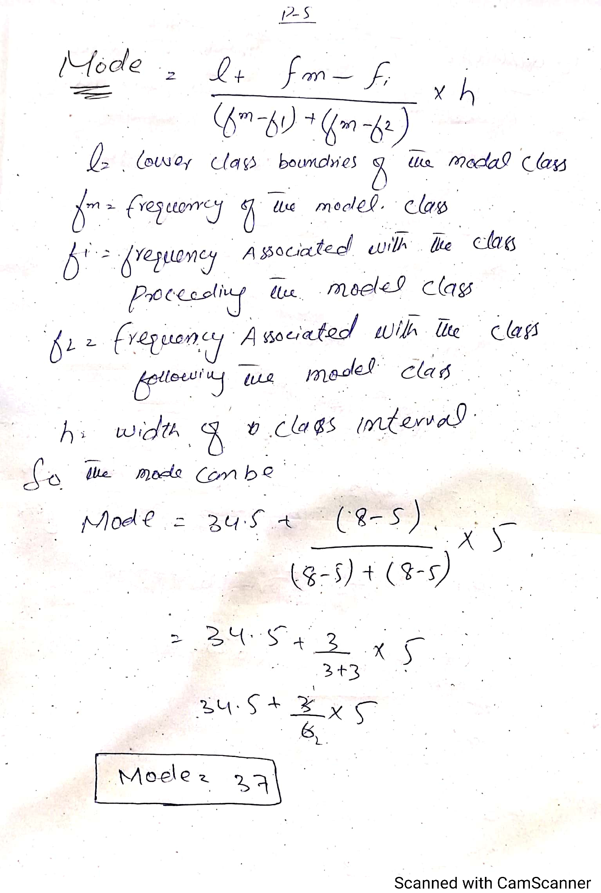

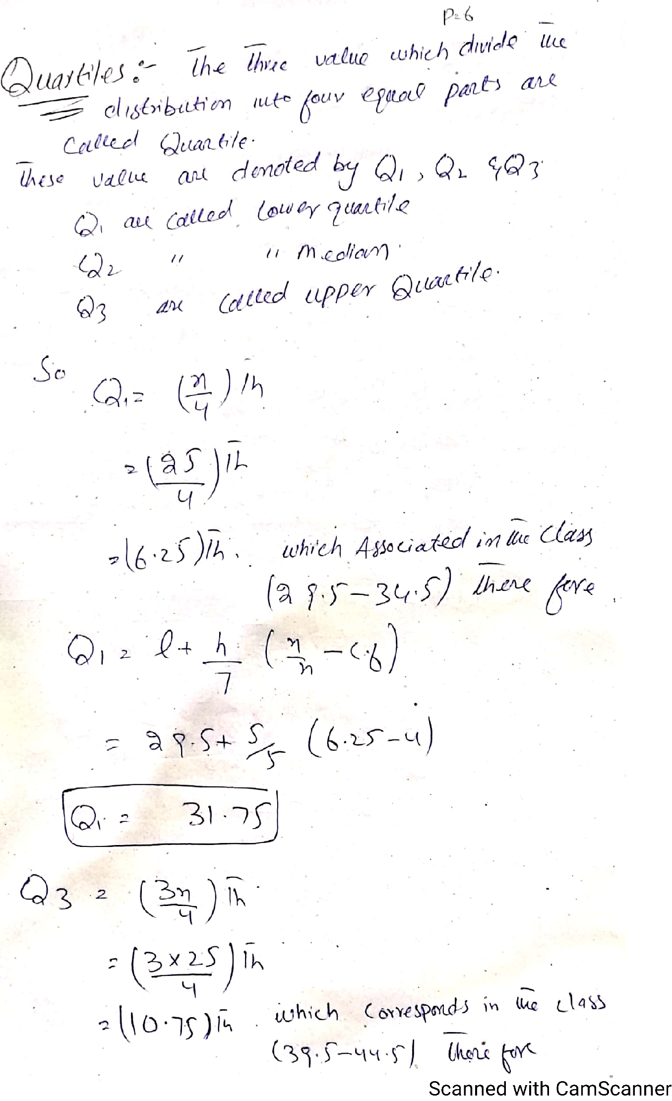

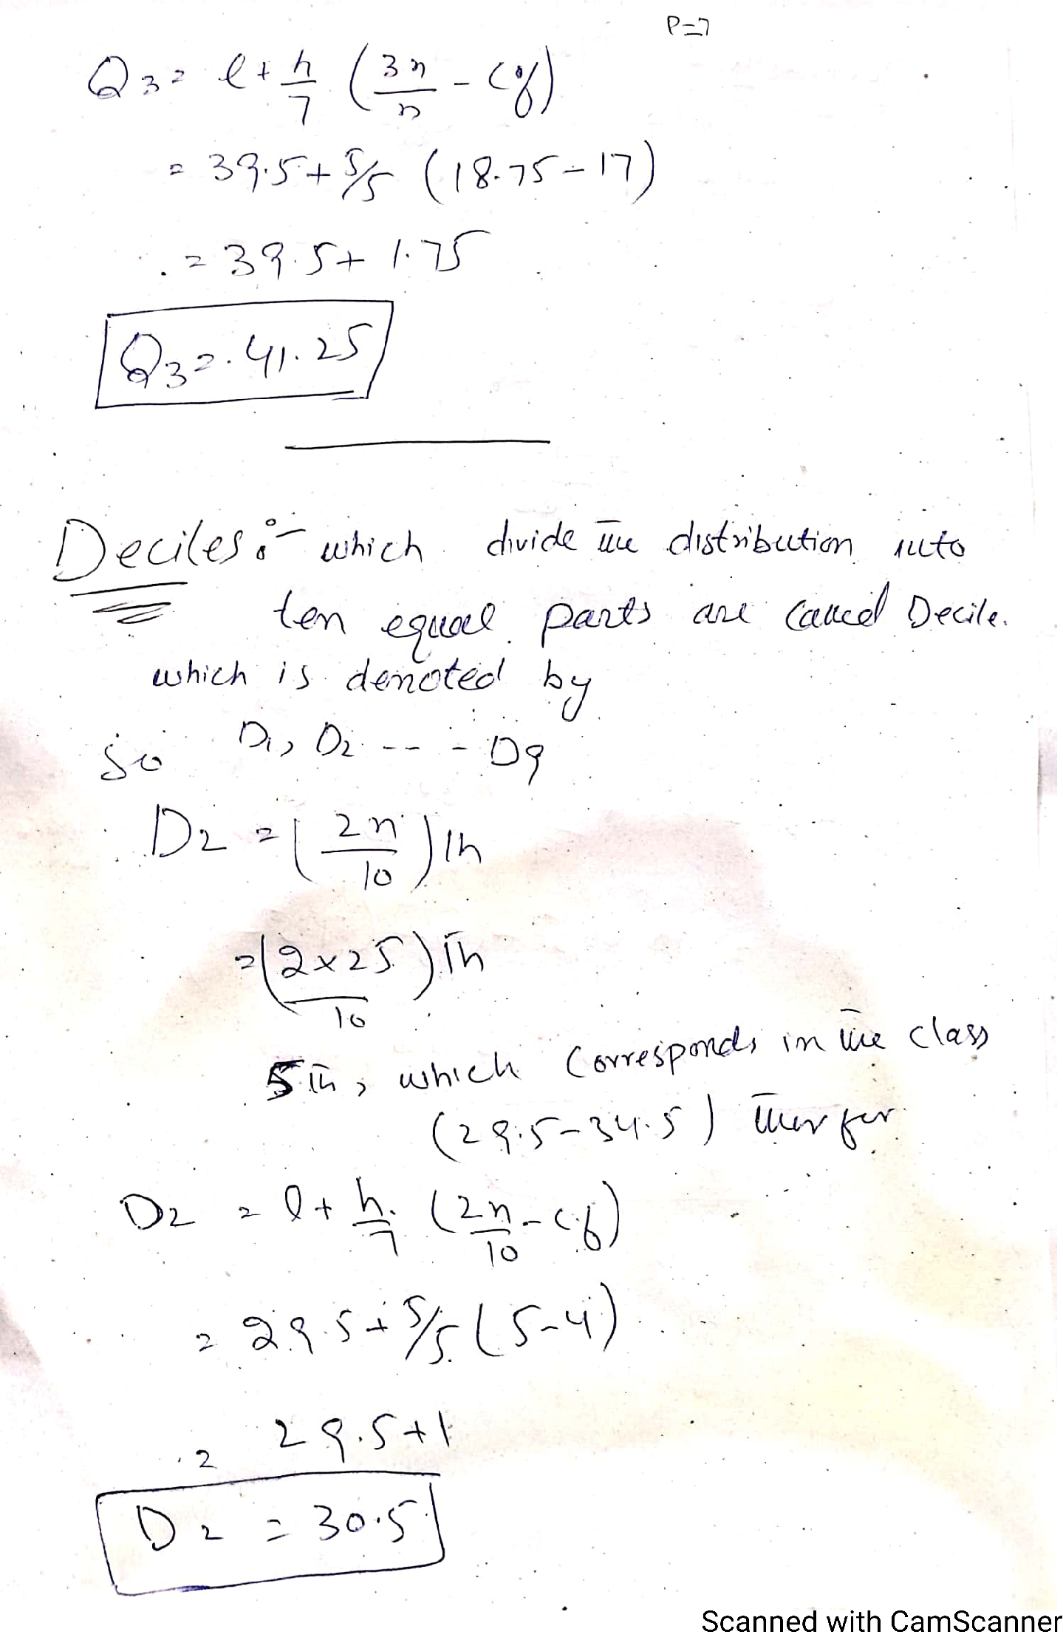

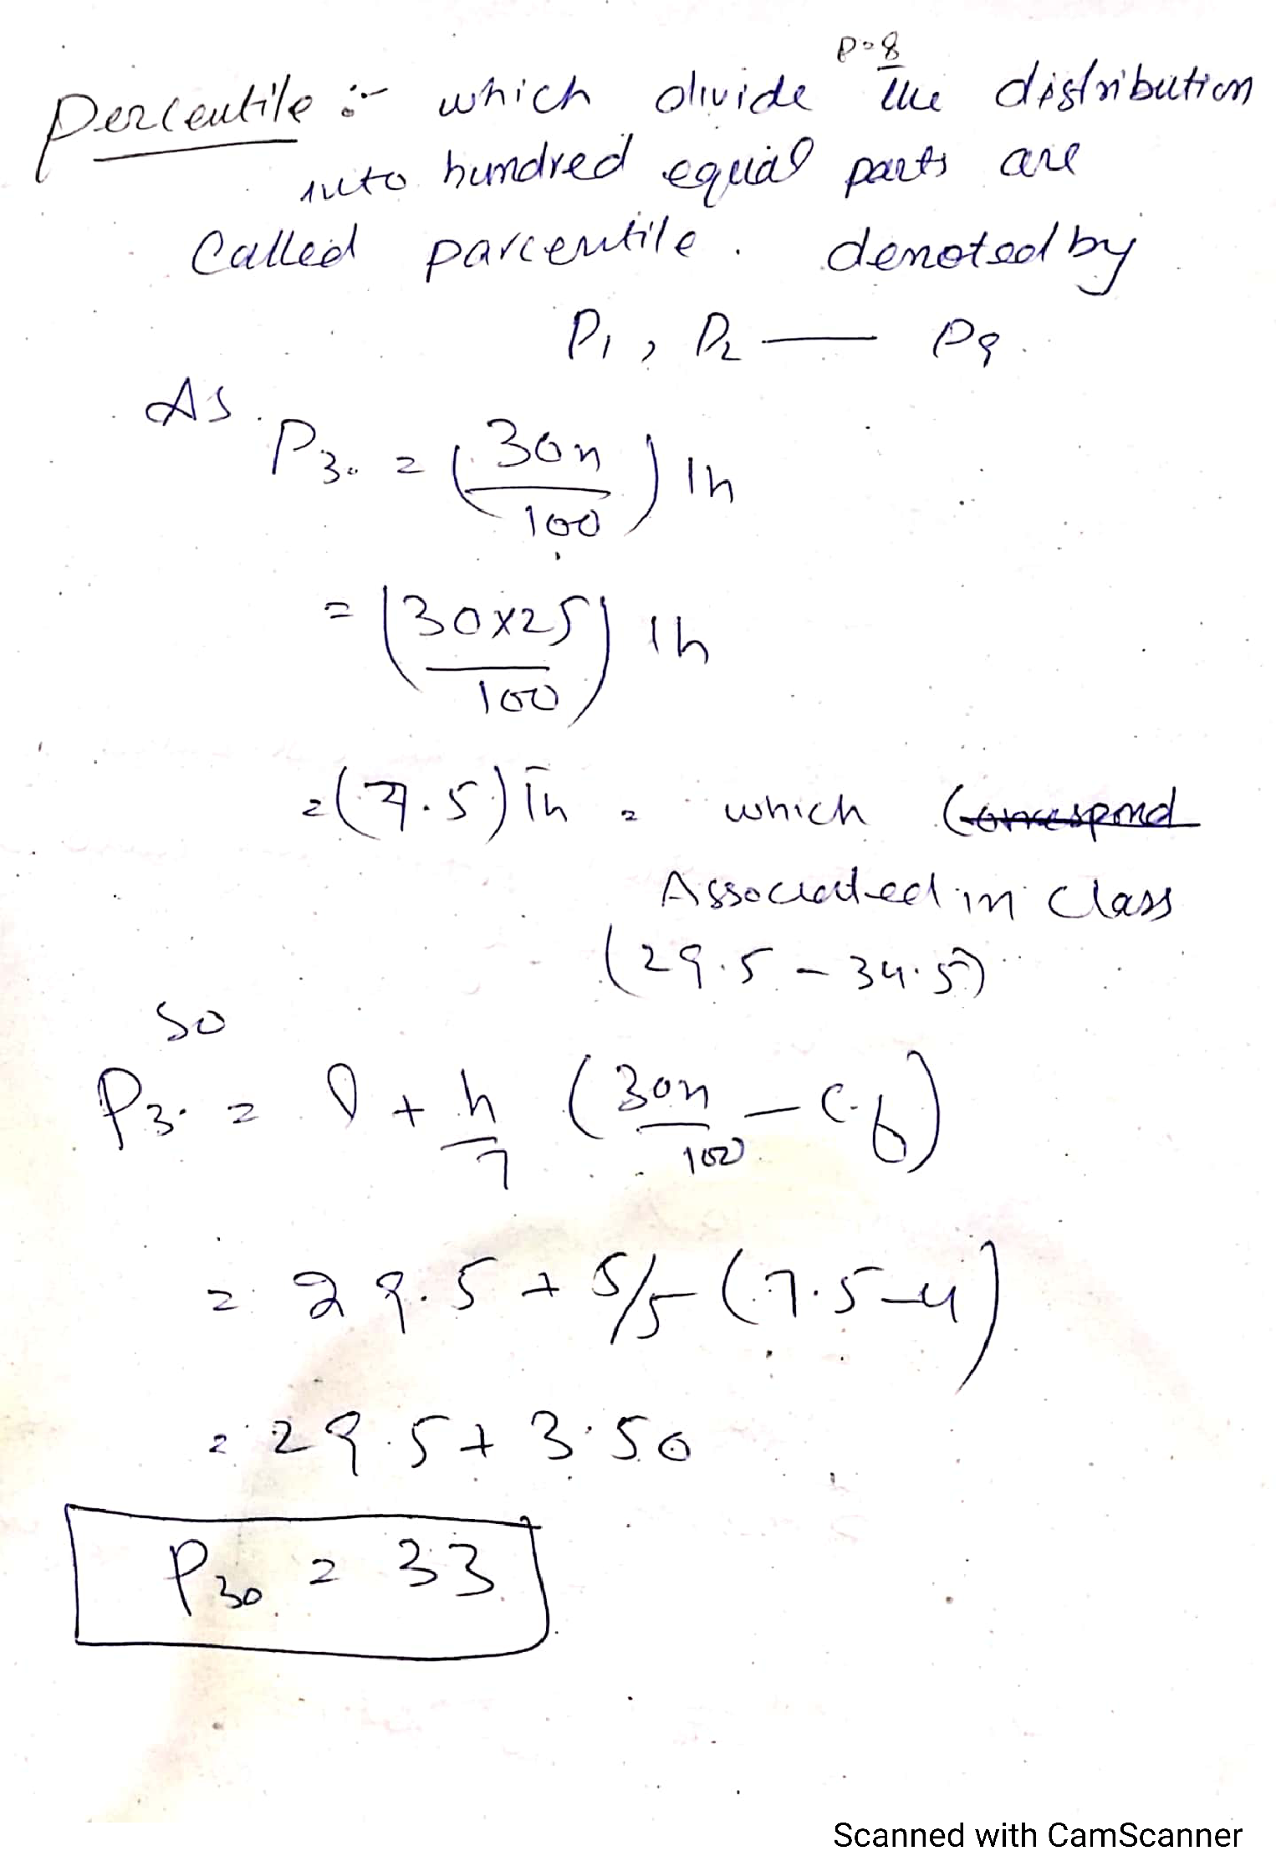

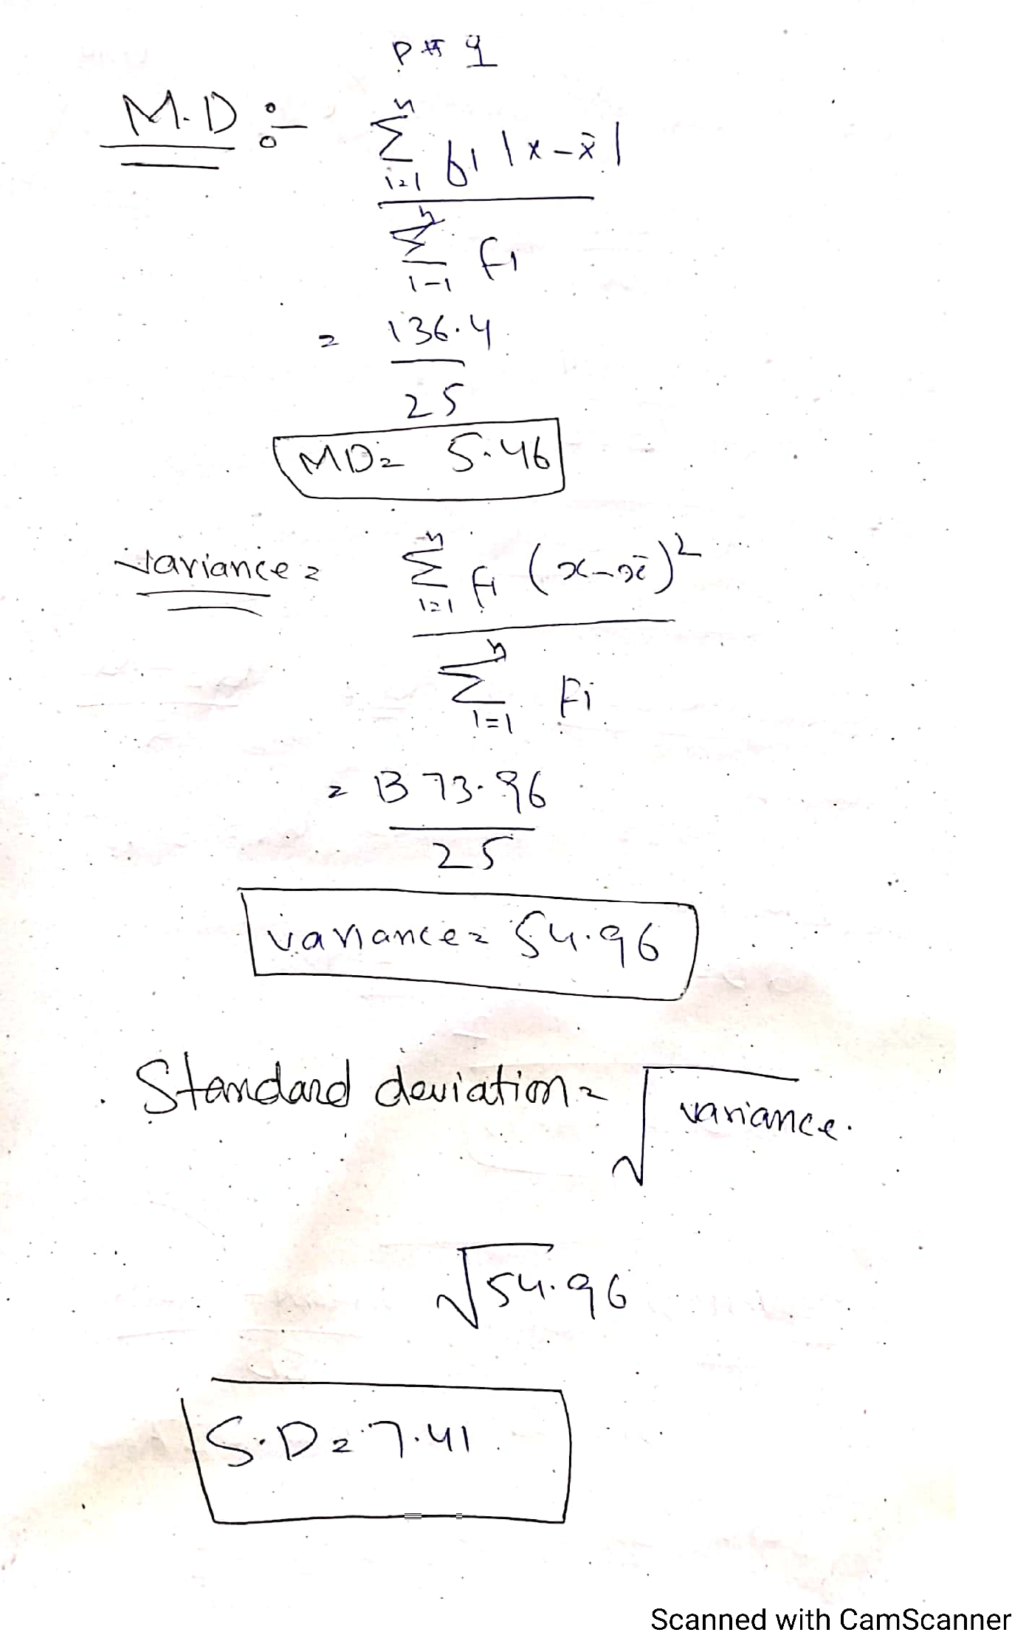

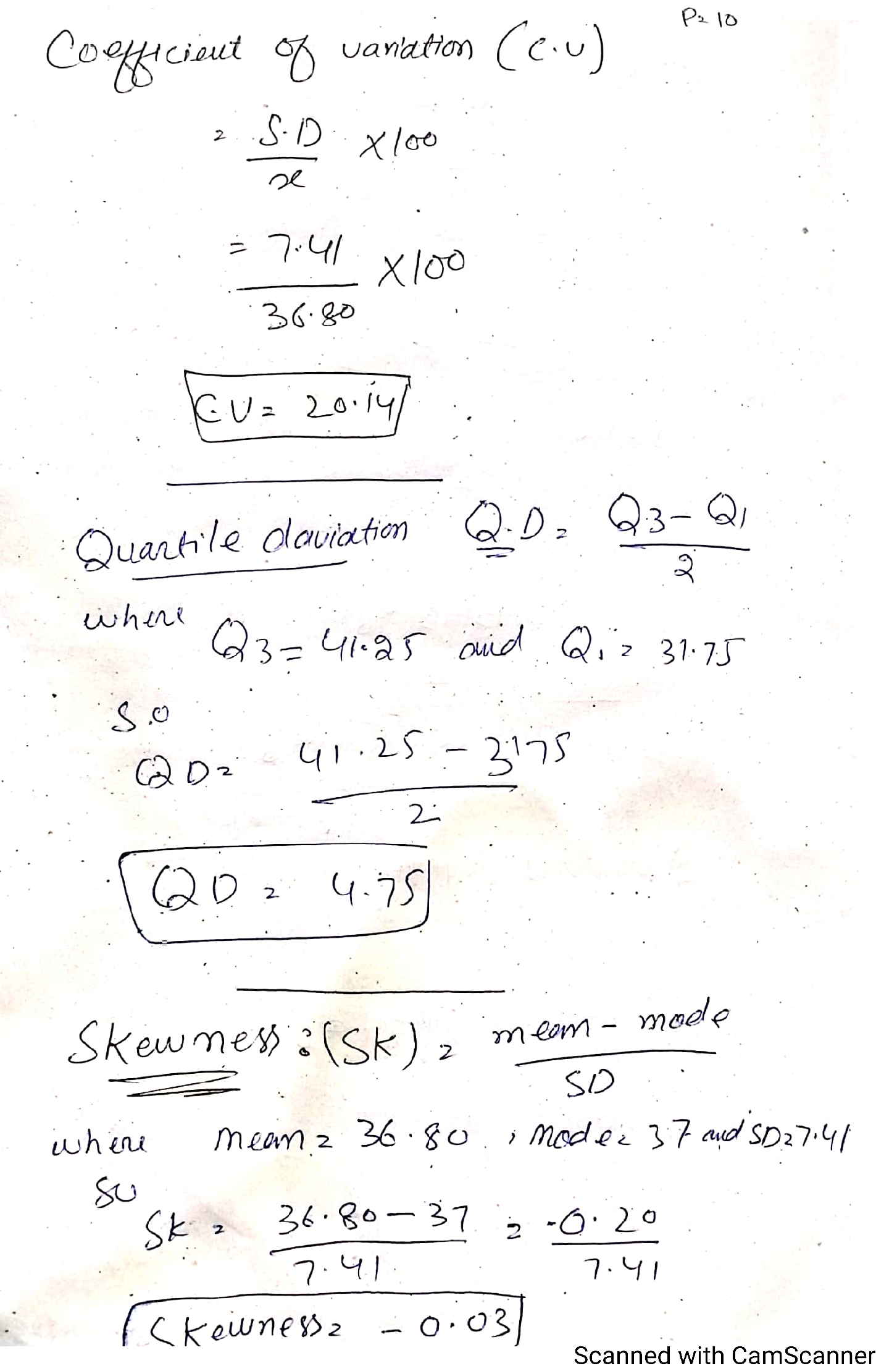

Question No 3

Answer NO (b)
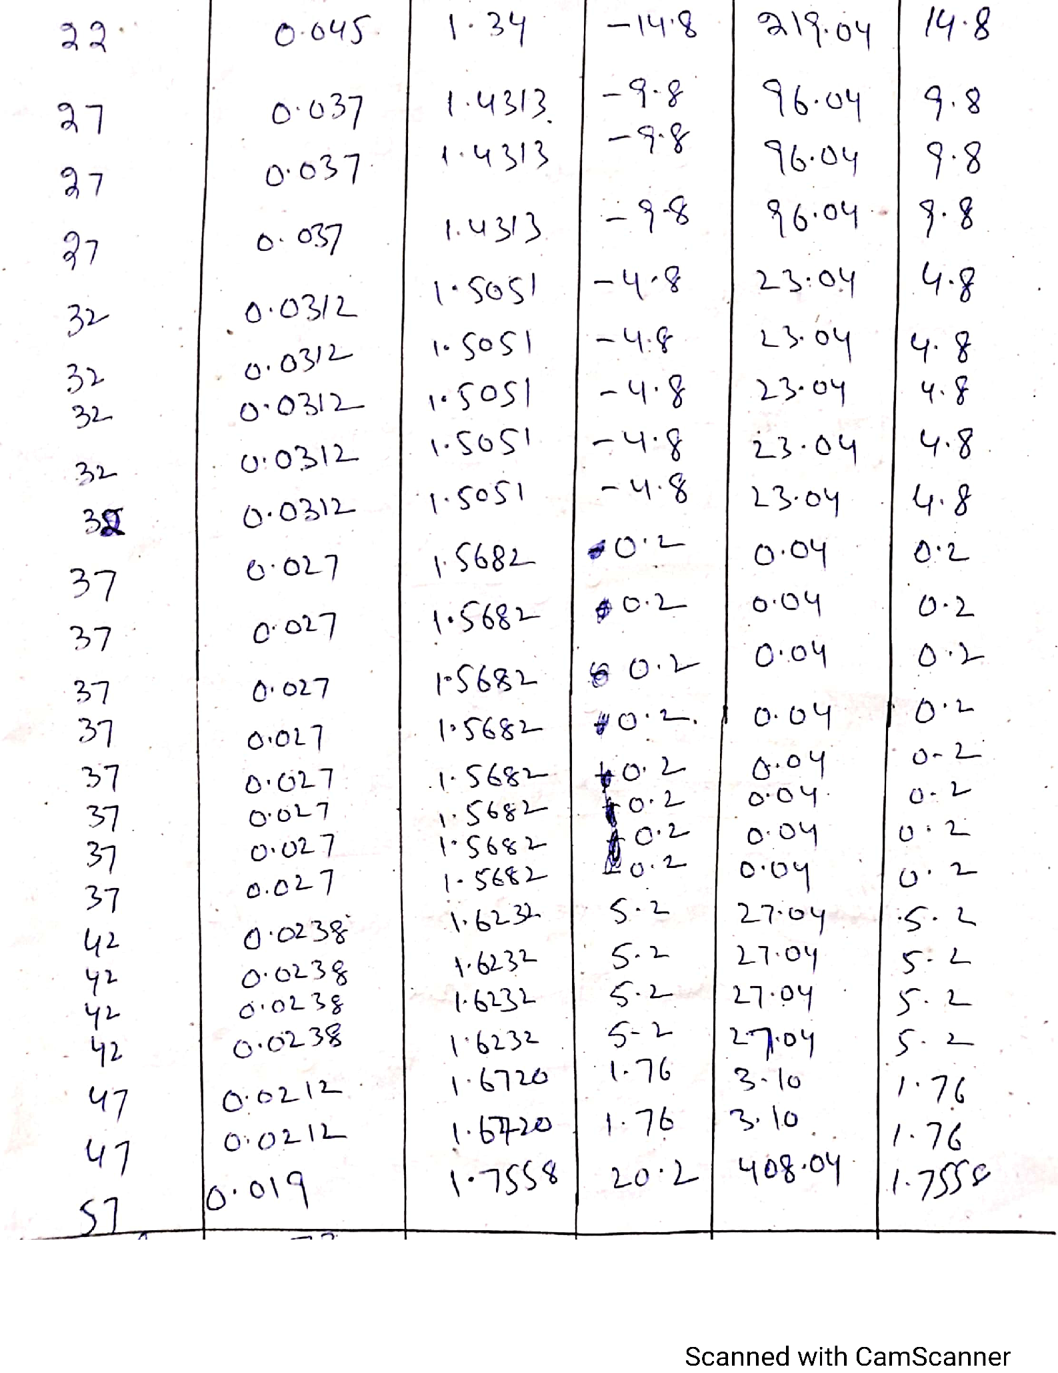

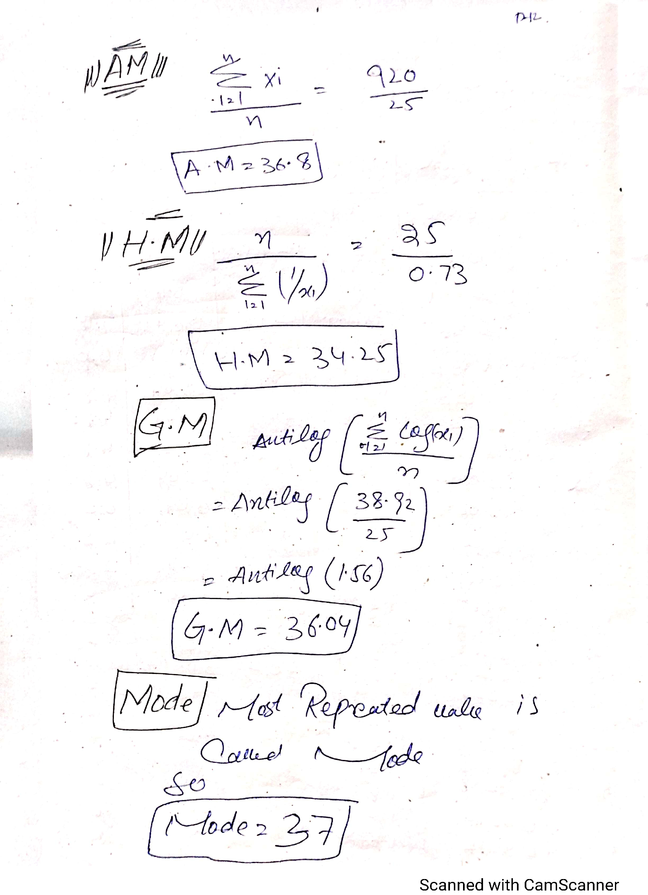

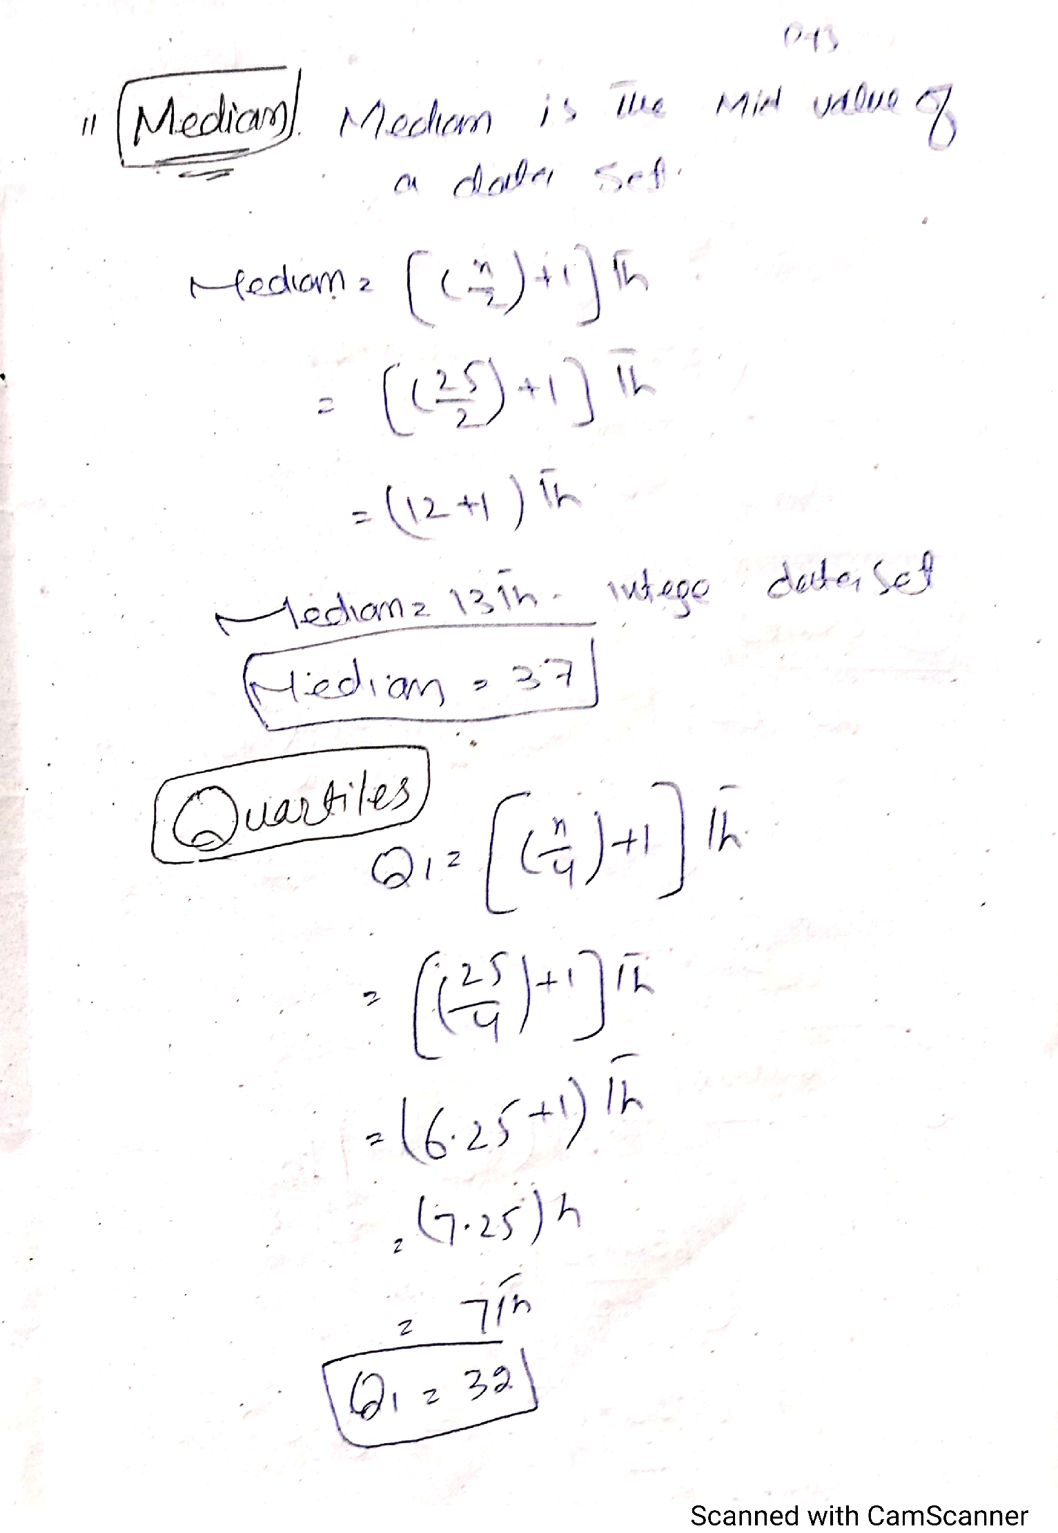

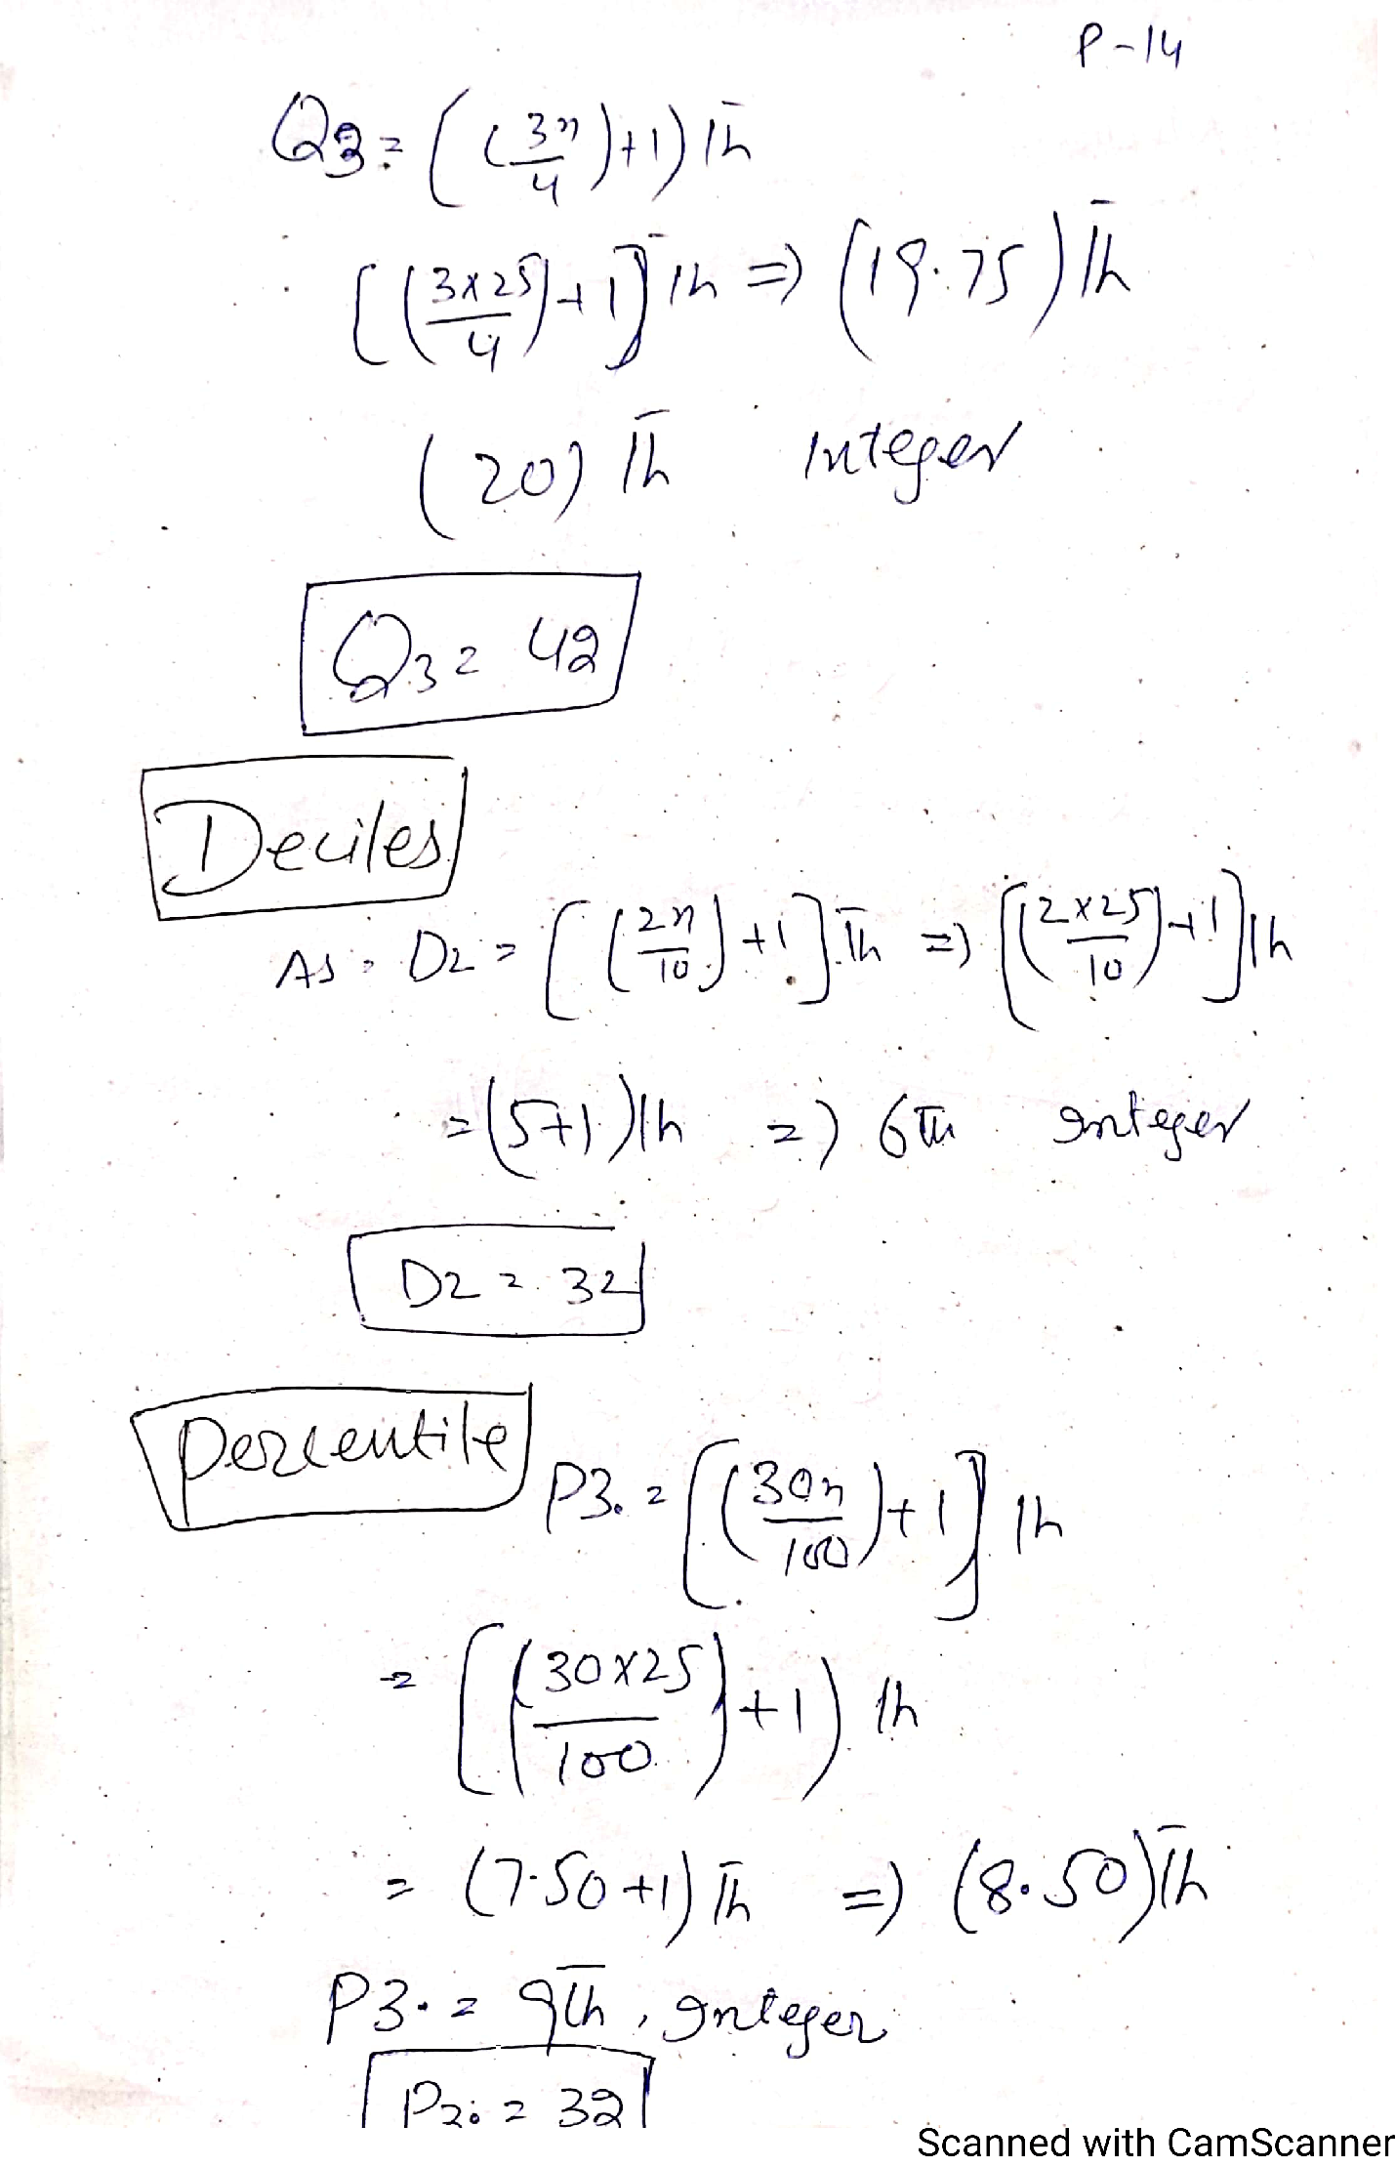

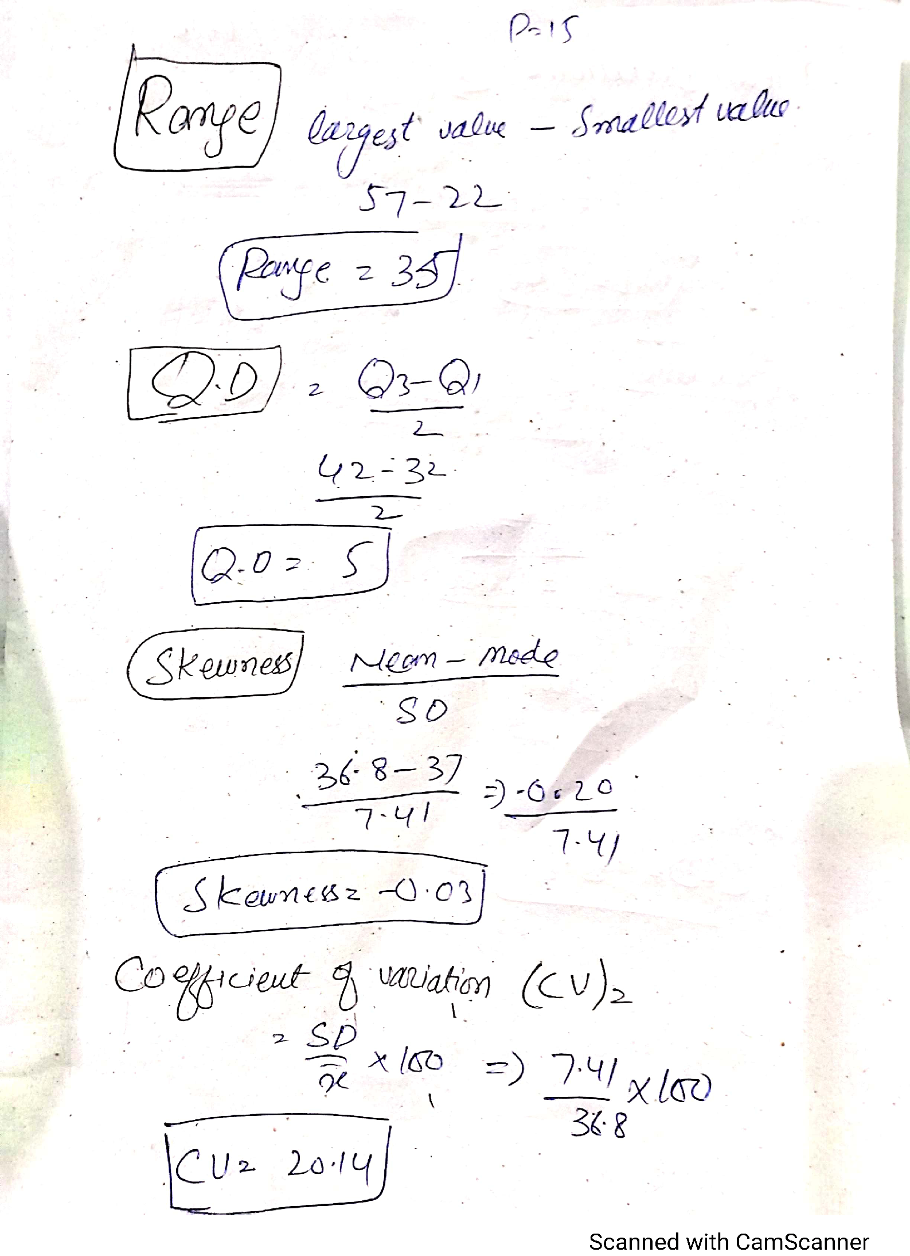

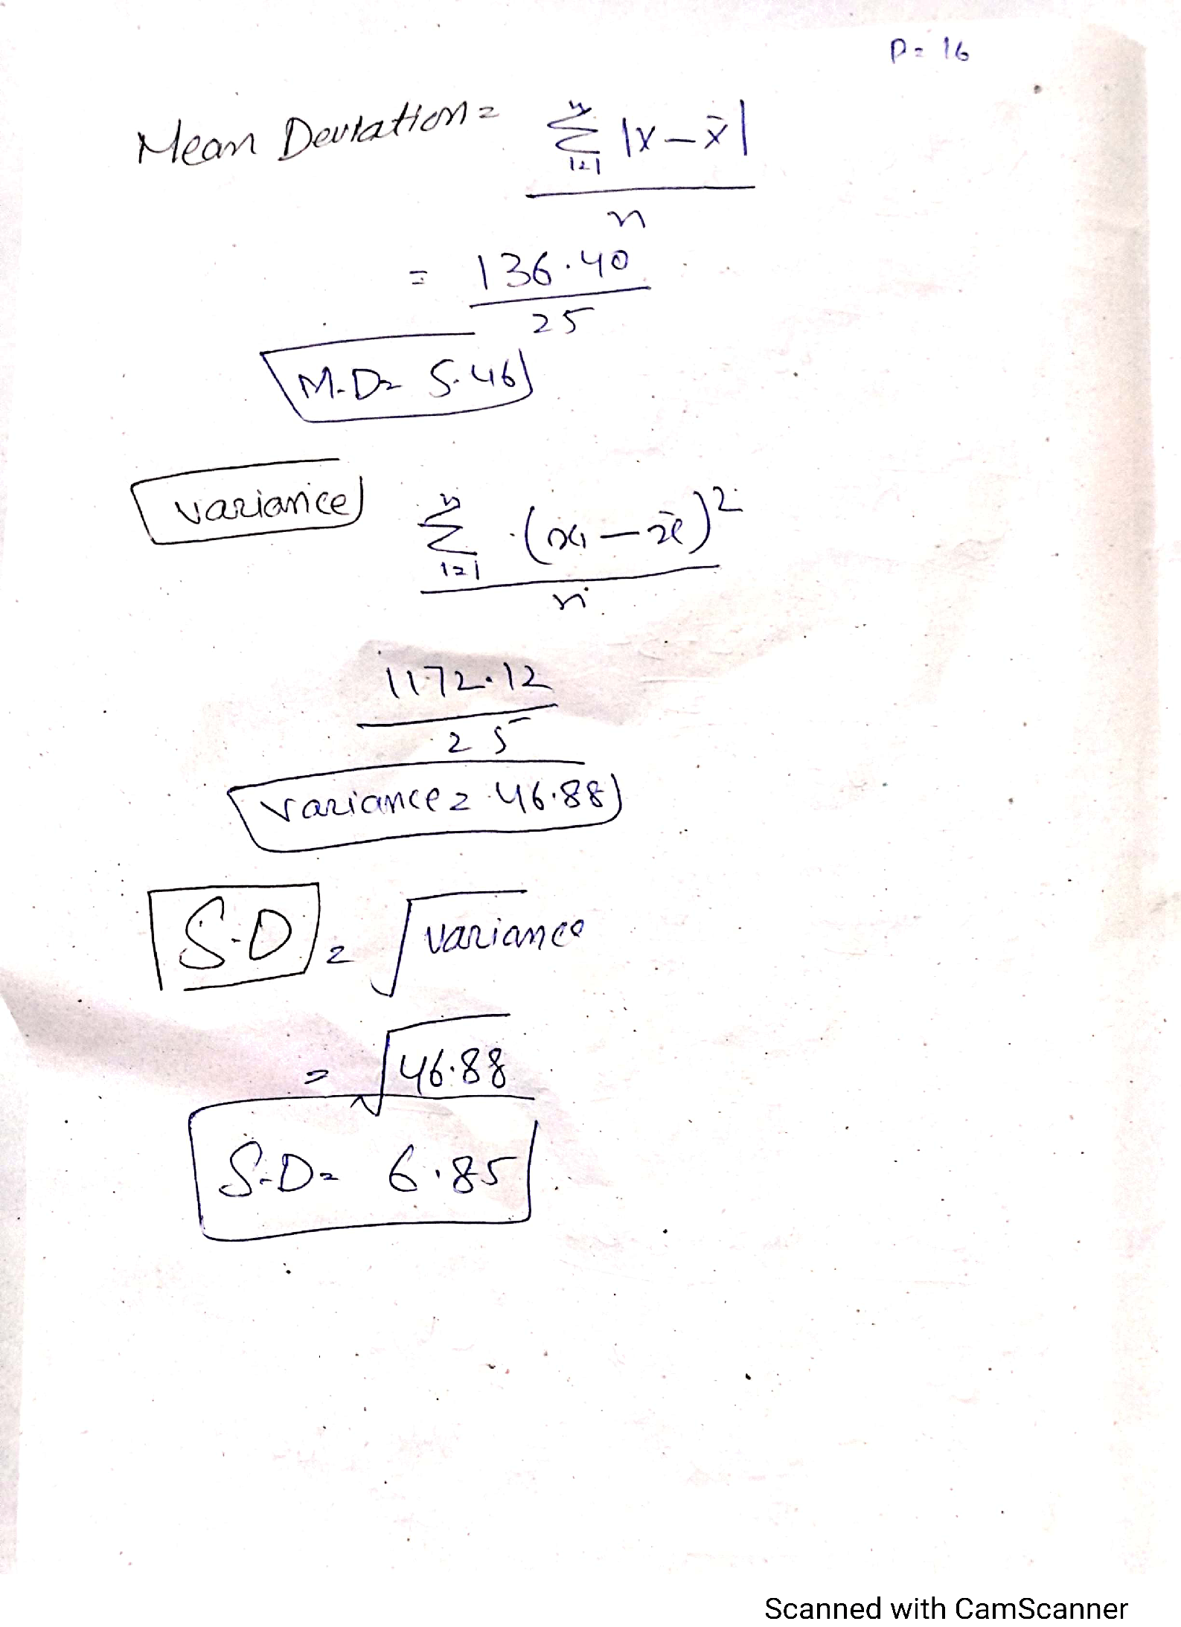

Question No (2)

Answers

A). The purpose of genus is to count the Entire population of a country and in duals at location where the actually lives .Census count the number of living in the home , there Age. Sex and race. Its helps in the forming and important bace for planning policy development and decreacing numbering.

B). In census each Every unit of the population is studies in the sampling . the cenus refer to periodic collection of information about the population from the entire population. It is more sutaible to use census method if population is same in nature.
The cenus survey is much bigger in population compare to sample servay.
Census survey takes more time How ever It is margin for error in sample servay while census servay is more correct.

C).Obviously not having a full problem for the accuracy of census as insufficient data will be collected to know about population and of following base for planning and policy development.

D). Ironic response to the census by the public signify their into word attitude to the servay and their carelessness in following accurate data.
Questers of these types are invalidated with such abuse response.

E). Not all of the population in an Internet Friendly so may be the response rate might be less.
Other area of concern are cost pressure.

F). There may be additional concerns about security of information when it is supplied online.)
Additional information held by government agencies is unlikely to be complete
Record matching in combining databases is a notorious problem .

The End(Thank You)

