Subject Operative Dentistry. instructor: Mr. Usman
Midterm Assignment 30 Marks
Department AHS Semester DT 6th
Name: Gul shad Id:13766
Attempt all questions, all questions carry equal marks.
Q1. Differentiate
• Three quarter crown
• Metal ceramic crown
• Seven eighth crown
Ans: part A:
(Three quarter crown)

The three quarter crown was introduced to the profession in 1901 by Carmichael and is even
today referred to in some schools as ‘The Carmichael Crown’. It has several good features;
• (1) It is easier to seat than a full veneer crown,
• (2) It is possible to check vitality subsequently,
• (3) There is less destruction of tooth tissue,
• (4) Aesthetics are more easily maintained.
The three-quarter crown on a posterior teeth probably one of the most demanding of all tooth
preparations. As with such preparations on other teeth, on a posterior molar it involves the proximal
and lingual surfaces and leaves the facial surface intact.
They are always made of cast metal.

Difference:
1)they cover forth-fifth of the tooth surface buccal surface remain intact.
2)they are retained by grooves on mesial, distal and occlusal surface.
3)they are always made up of cast metal.

Part B:
(Metal ceramic crown) These restorations are made using either a gold or "white"
(silver-colored) dental alloy. They're known for their great
strength and exceptional durability.
Difference:
• Dental porcelain can be bounded to a variety of metal alloy such us
gold,silver,nickel etc.
• It can be tolerate heavy bite force as well as chewing force.
• They are very durable and costly.
• Good aesthetic
PART C:

(Seven eighty crown)
The seven-eighths crown preparation includes, in addition to the
surfaces covered by the three-quarter crown, the distal half of the
buccal surface. Therefore the mesial aspect of this preparation
resembles that for a three-quarter crown; the distal aspect
resembles that for a complete crown.
Difference:
• Cover all the mesial buccal cusp of the upper molar tooth.
• Retained by intercoronal features adhesive techniques.
• Used in maxillary molar and pre-molars it encompasses seven
eight the gingival circumference of the tooth.
Q3. Define veneer, explain direct and indirect veneer technique?
Ans: Veneer:
A veneer is a layer of tooth colour material that is applied to a tooth
to restore localize defect and intransic discoloration .Alternately
known as dental laminate
❖ Direct veneers technique :
These defect can be restore in one visit by light cured.
❖ Steps:
• Cleaning
• Shade selection
• Isolation
• Removal ofthe defect and tooth preparation dept0.5 to 0.7 mm.
• Etching
• Restore of the cavity with composit resin.
❖ Indirect veneer technique:
Two appointments are required for this.
❖ Steps:
1)First appointment
• Veneers preparation procedure.
• Shade selection
• Tooth preparation
• Impression
• Temporary veneers.
2nd appointment
• Remove temporary veneers.
• Clinical try in. • Cementation.
Q5. Briefly explain composite and porcelain veneer?
Ans: composit veneers:
• On visit procedures.
• Less expensive
• Repairs potentials
• Chair-side controll of the anatomy.
• Minimal irriversable lose of the tooth structure.
• Can be built up in the mouth by directly placing it.
• Can be fibricated in the dental laboratories.
Porcelain veneer:
• Esthatic stability
• Stain resistant
• Stronger and durable
• Gum tissur tolerate porcelian well
• The colour of the porcelain veneer can be selected such
that dark teeth appear whiter.
• Veneer offer a conservative approach to change the
tooth colour and shape.
• Can’t be built in mouth.
• Hence fabricated out side and fitted later.
Indications:
• Esthatically compromised anterior teeths
• Poorly shaped ir crooked teeth.
• Closure or diastema.
• Enamel hypoplasia.
• Fractured teeth.
• Approve extreme discoloration such a

➢Tertacyclene staining
➢Flourosis
>Devatilized teeth
• Ability to lengthen anterior teeths.
Contraindications:
• No enamel is present ,full crown should be
considered.
• Central tooth to tooth habit bruring or other para
functional habit such as pencil chewing.
• Certain type of occlusal problem such as class iii.
Q4. Suppose you have a crown that can be virtually
indistinguishable from unrestored teeth and is most
esthetically pleasing, identify the type of crown and write its
advantages and disadvantages and indications.

Ans: Ceremic crown:
• It is the type òf anterior complete crown for vital teeth.
• They are made out of translucent material which give us
a very attrective look to out teeths.
Advantages:
• They are suitedfor those people whohas minimum space
on their teeths.
• They are thinner material to other crowns.
• To stop plaque accumulation. Disadvantage:
• Too much pressure might be break the crown.
• High cost.
• Short duration of time.
Indications:
. Disadvantage:
• Too much pressure might be break the crown.
• High cost.
• Short duration of time.
Indications:
•High esthetic demand.
• Indicated for anterior teeth’s that are destroy,fracture or
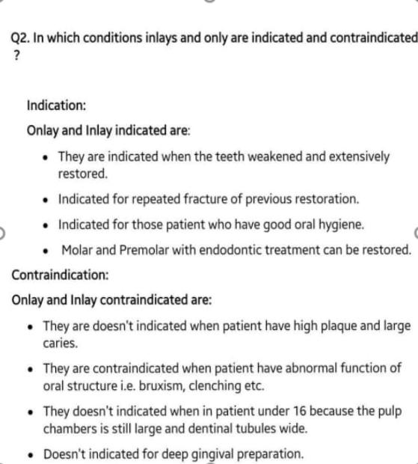
discoloration etc.

