Department of Electrical Engineering
Assignment
Date: 20/04/2020
Course Details

Course Title: | Power System Analysis | Module: | 6th
Instructor: | SIR AMIR AMAN | Total Marks: | 30

Student Details
Name: | FAWAD UR REHMAN | Student ID: | 13820

Q1. | (a) | A 3Φ transformer is connected with a residential load of 28.56 KV; the primary side of a transformer is connected with 130 KV feeder while secondary side is stepped down to 10 KV. The transformer is rated with 30 MVA. Find impedance Z_{b}. | Marks 05
 |  |  | CLO 1
 | (b) | Find the Per Unit equivalent impedence of an 11/132 KV transformer having 10 Ω and 1440 Ω, the equivalent impedence. The primary and secondary currents are 909 Amp and 75.75 Amps respectively. | Marks 05
 |  |  | CLO 1
.Q2 | (a) | Single line diagram of a 3Φ power system is shown in the below figure. Draw an impedance and reactance diagram in P.U.  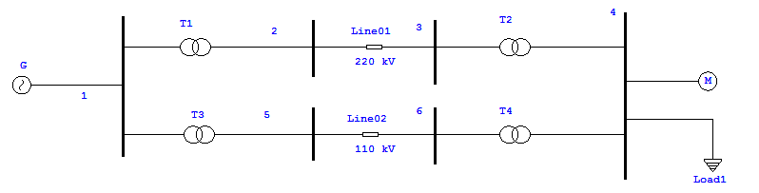 | Marks 10
 |  |  | CLO 2
Q3 | (a) | For the single line diagram shown below, Generators are connected to high tension buses 1 and 2 and supply to load connected at bus 3. Find the reactance diagram, then convert it into equivalent current sources and shunt admittances. Then find the admittance matrix and find the total current.  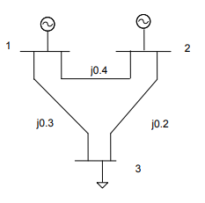 | Marks 10
 |  |  | CLO 2
