Anotamy Assignment For Viva
Name : Noor Razzaq
Student ID : 15187
DpT 4rth semester

Q : Write a note on cerebrospinal fluid, its circulation and absorption ?
Answer :
Cerebrospinal fluid (CSF):
- CSF is the clear,colorless,and transparent fluid that circulate trough ventricals of brain subarchonoid space and central canal of spinal cord .it is the part of extracellular fluid (ECF).
- It is produced by specialised ependymal cells in the choroid plexuses of the ventricles of the brain, and absorbed in the arachnoid granulations. There is about 125 mL of CSF at any one time, and about 500 mL is generated every day. CSF acts as a cushion or buffer, providing basic mechanical and immunological protection to the brain inside the skull. CSF also serves a vital function in the cerebral autoregulation of cerebral blood flow.
- CSF occupies the subarachnoid space (between the arachnoid mater and the pia mater) and the ventricular system around and inside the brain and spinal cord. It fills the ventricles of the brain, cisterns, and sulci, as well as the central canal of the spinal cord. There is also a connection from the subarachnoid space to the bony labyrinth of the inner ear via the perilymphatic duct where the perilymph is continuous with the cerebrospinal fluid. The ependymal cells of the choroid plexuses have multiple motile cilia on their apical surfaces that beat to move the CSF through the ventricles.
Formation of CSF :
- CSF is formed by choroid plexus ,situated with in the ventricals .
- Choroid plexuses are thuft of capillaries present inside the ventricals .
- A large amount of CSF is formed in lateral ventricals.

Substances effecting formation of CSF :
- PILOCARPINE extract of pituatory gland stimulate the secretion of CSF .
- Injection of isotonic saline,also stimulate CSF formation.
- Injection of hypotonic saline increases CSF formation .
- Hypertonic saline decreases CSF formation and CSF pressure .
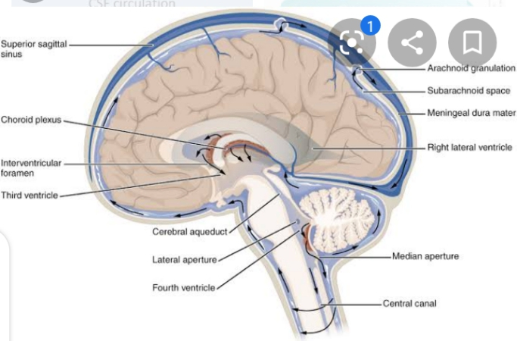

Cerebrospinal Fluid Circulation and Absorption:
Circulation :
- From the third ventricle it flows down a long, narrow passageway (the aqueduct of Sylvius) into the fourth ventricle. From the fourth ventricle it passes through three small openings (foramina) into the subarachnoid space surrounding the brain and spinal cord.
- CSF is formed within the ventricles by small, delicate tufts of spe­cialized tissue called the choroid plexus. The solid arrows in the draw­ing below, Cerebrospinal fluid (CSF) Circulatory Pathway, show the major pathway of CSF flow.
- Beginning in the lateral ventricles, CSF flows through two passageways into the third ventricle. From the third ventricle it flows down a long, narrow passageway into the fourth ventricle.
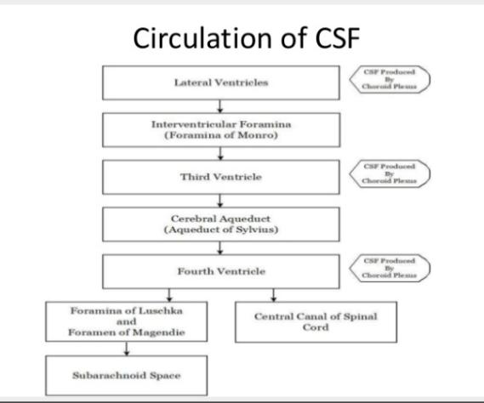
- From the fourth ventricle it passes through three small openings into the subarachnoid space surrounding the brain and spinal cord.

Absorption :
- Mostly absorbed by the archnoid villi into Dural sinuses and spinal viens.Normally 500 ml CsF is formed everyday and equal amount is absorbed .
- CSF is absorbed through blood vessels over the surface of the brain back into the bloodstream. Some absorption also occurs through the lymphatic system. Once in the bloodstream, it is carried away and filtered by our kidneys and liver in the same way as are our other body fluids.
- Some small amounts of CSF are also absorbed into lymphatic channels along the membranes covering the nerves (nerve sheaths) as they leave the brain stem and spinal cord .
Mechanism of absorption of CSF :
- By filtration due to pressure gradient between hydrostatic pressure in subarachnoid space fluid .And the pressure that's exists in the Dural sinuses blood .
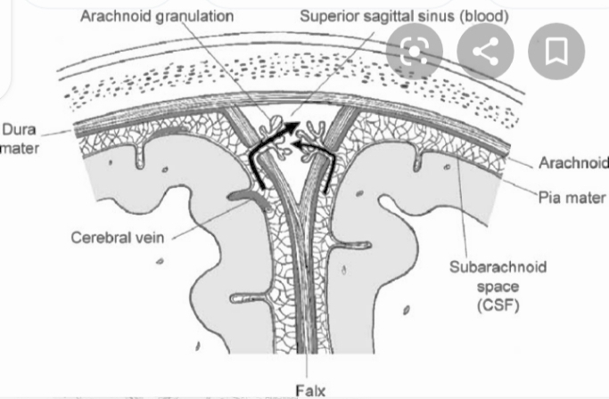
- The colloidal substances pass slowly and crystalloids are absorbe rapidly.

