IQRA NATIONAL UNIVERSITY
DEPARTMENT OF ALLIED HEALTH SCIENCES
Final-Term Examination
DPT 2nd Semester
Course Title: Human Physiology II Instructor: Dr Sara Naeem
Time: 6 Hours
Name = Aleeza
ID = 16673 Max Marks:50

Q1. What would be the total lung capacity (TLC) if expiratory reserve volume ( ERV) is 1000 ml , (RV) residual volume is 1200 ml keeping the inspiratory capacity ( IC) as 3000 ml.
Q2. What is pulmonary edema . Enlist the muscles of inspiration and muscles of expiration.
Q3. Compare the properties of different blood groups. Also mark universal donor and universal recipient.
Q4. Explain respiratory membrane . What are the factors that affect diffusion of gases across the membrane
Q5. What is the difference between anatomical dead space and physiological dead space. What are the clinical manifestations of pulmonary effusion.

Ans 1: Then Total lung capacity (TLC) are 5.8L (5800ml).
Ans 2:
1.Pulmonary edema:-
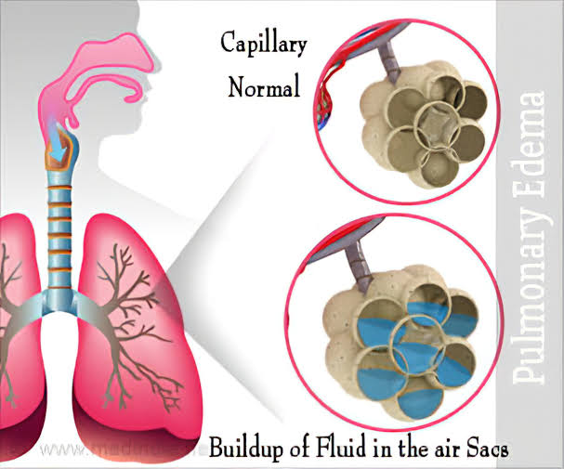
- Pulmonary edema is often caused by congestive heart failure. When the heart is not able to pump efficiently, blood can back up into the veins that take blood through the lungs. As the pressure in these blood vessels increases, fluid is pushed into the air spaces (alveoli) in the lungs.
2.muscles of inspiration:-
- Sternocleidomatoids
- Scalenes
- External intercostals
Muscles of expiration:-
- Internal intercostal
- External oblique
- Rectus abdomins
- Transverse abdomins
- Internal oblique

Ans 3:
Property of different blood group:-
- The difference in human blood are due to the presence or absence of certain protein molecule known as antigens and antibodies
- The antigens are located on the surface of the RBCs and the antibodies are in the blood plasma
- Individuals have different type and combinations of these molecules
- The blood group you belong to depend on what you have inherited from your parents
- There are more than 20 genetically determined blood group system known today
- The ABO and Rhesus RH system are the most important ones used for blood transfusions
- Not all blood group are compatible with each other. Mixing incompatible blood group leads to blood clumping or agglutination, which is dangerous for individuals.
Universal donor and universal receipt:-
- In transfusions of packed red blood cells, individuals with type O Rh D negative blood are often called universal donors. Those with type AB Rh D positive blood are called universal recipients.

Ans 4:
Respiratory membrane:-
- A layer of fluid lining the alveolus and containing surfactant that reduces the surface tension of the alveolar fluid
- Alveolar epithelium composed of thin epithelial cells
- Epithelial basement membrane
- Thin interstitial space between the alveolar epithelium and the capillary membrane
- Capillary basement membrane that in many places fuses with the alveolar epithelial basement membrane
- Capillary endothelial membrane
Factor that effect diffusion of gases across the membrane:-
Factors that effect diffusion of gases across the membrane
(1) the thickness of the membrane
(2) the surface area of the membrane
(3) the diffusion coefficient of the gas in the substance of the membrane
(4) the partial pressure difference of the gas between the two sides of the membrane.

Ans 5:
Anatomic and physiologic dead space
- The method measure the volume of all the space of the respiratory system other than the alveoli and their other closely related gas exchange areas, this space is called the anatomic dead space
- Sometimes some of the alveoli themselves are nonfunctional or only partially functional because of absent or poor blood flow through the adjacent pulmonary capillaries
- Therefore from a functional point of view these alveoli must also be considered dead space – alveolar dead space
- When the alveolar dead space is included in the total measurement of dead space this is called the physiologic dead space
- Physiological = Anatomical + alveolar
- In a normal person the anatomic and physiologic dead space are nearly equal because all alveoli are functional in the normal lung
- Physiological = Anatomical
- But in a person with partially functional or nonfunctional alveoli in some parts of the lungs, the physiologic dead space may be as much as 10 times the volume of the anatomic dead space 1 to 2 liters.
Clinical manifestations of pulmonary effusion:-
- The symptom of a patient with a pleural effusion are to a large extent dictated by the underlying process causing the effusion
- Many patients have no symptoms referable to the effusion when effusion is small
- When symptoms are related to the effusion, they arise either from inflammation of the pleura or from compromise of pulmonary mechanics
- Pleuritic chest pain is the usual symptom of pleural inflammation
- Irritation of the pleural surfaces may also result in a dry, unproductive cough
- With large effusions, dyspnea result from lung compression.

-------------------------------------☆☆☆--------------------------------------------------

