NAME.. HAIDER ALI..
Id • 15905
Sub microeconomics

Q1: (a) Explain the law of demand. Why does a demand curve slope downward? How is a market demand curve derived from individual demand curves?

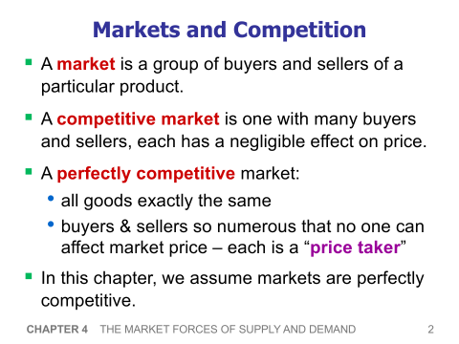
Ans:

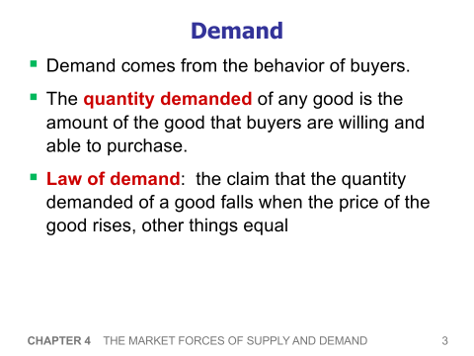

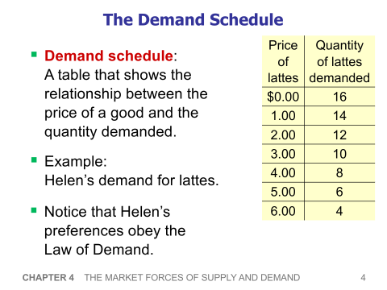

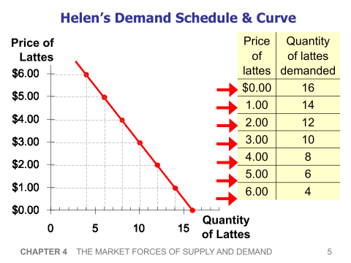

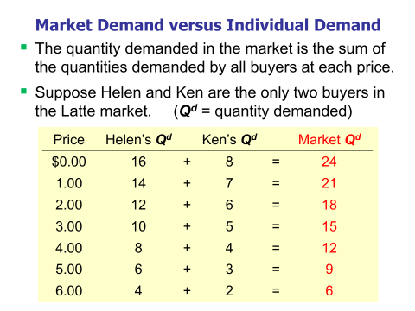

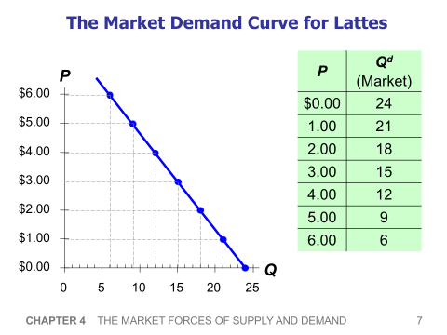

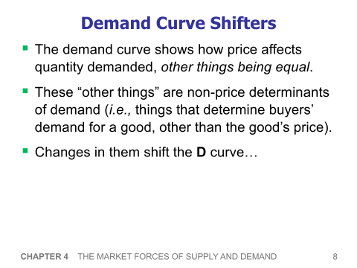

(b) What are the determinants of demand? What happens to the demand curve when any of these determinants change? Distinguish between a change in demand and a change in the quantity demanded, noting the cause(s) of each.

Ans:

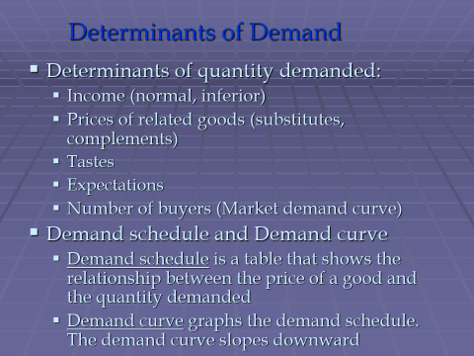

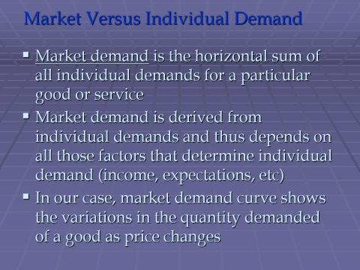

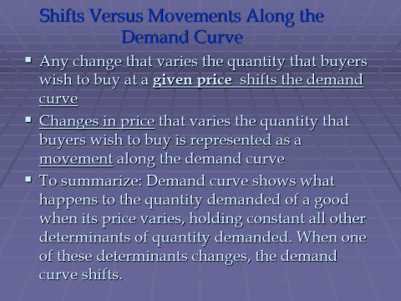

Q2: Suppose that when everyone wakes up tomorrow, they discover that the government has given them an additional amount of money equal to the amount they already had. Explain what effect this doubling of the money supply will likely have on the following:

a. the total amount spent on goods and services
b. the quantity of goods and services purchased if prices are sticky
c. the prices of goods and services if prices can adjust

A: . the total amount spent on goods and services

Ans: Consumer spending is the total money spent on final goods and services by individuals and households for personal use and enjoyment in an economy. Contemporary measures of consumer spending include all private purchases of durable goods, nondurable goods, and services.

B:. the quantity of goods and services purchased if prices are sticky

Ans: What Is Price Stickiness?
Price stickiness (or sticky prices) is the resistance of market price(s) to change quickly despite changes in the broad economy that suggest a different price is optimal. "Sticky" is a general economics term that can apply to any financial variable that is resistant to change. When applied to prices, it means that the prices charged for certain goods are reluctant to change despite changes in input cost or demand patterns.
Price stickiness would occur, for instance, if the price of a once-in-demand smartphone remains high at say $800 even when demand drops significantly. Price stickiness can also be referred to as "nominal rigidity" and is related to wage stickiness.

C. the prices of goods and services if prices can adjust

Ans:
The law of supply and demand is an economic theory that explains how supply and demand are related to each other and how that relationship affects the price of goods and services. It's a fundamental economic principle that when supply exceeds demand for a good or service, prices fall. When demand exceeds supply, prices tend to rise.
There is an inverse relationship between the supply and prices of goods and services when demand is unchanged. If there is an increase in supply for goods and services while demand remains the same, prices tend to fall to a lower equilibrium price and a higher equilibrium quantity of goods and services. If there is a decrease in supply of goods and services while demand remains the same, prices tend to rise to a higher equilibrium price and a lower quantity of goods and services.

Q3: Explain any of the five principles of economics in your own words?

Ans: Five principal of economics

