Department of Computer Science
Final Exam Spring 2020

Subject: Data Sciences
BS (CS,SE) Instructor: M.Ayub Khan

Name Amanullah
Id 14303
Semester 5th
Department BS (SE)

Note:

At the top of the answer sheet there must be the ID, Name and semester of the concerned Student.

Students must have to provide the output of their respective programs. Students have same answers or programs will be considered fail. Programs in Python and codes should be explained clearly.

As this assignment is online so incase of any ambiguity my Whatsapp no. is 034499121116.

Q1. a. Why Functions are used discuss in detail?
b. How arguments are used in function, write a simple program in Python?

Answer 1:
Part (A)
You use functions in programming to bundle a set of instructions that you want to use repeatedly or that, because of their complexity, are better self-contained in a sub-program and called when needed. That means that a function is a piece of code written to carry out a specified task.

Part (B)
b. How arguments are used in function , write a simple program in Python?
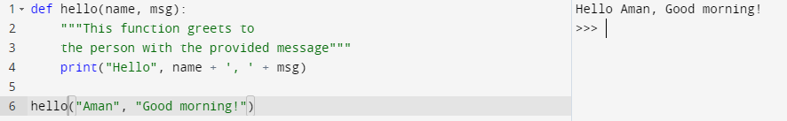

Q2. a. Why .upper (),.lower(),capitalize() and .swapcase() function are used ?
b. Write a program in which the discussed functions are used.
Note: Q2 part a functions.

Answer. 2:
- Part (A)
- Upper Case:Upper function is used to convert all characters in to capital letter.
- Lower Case:Lower function is used to convert all characters into small letter.

Swapcase: The string swapcase() method converts all uppercase characters to lowercase and all lowercase characters to uppercase characters of the given string, and returns it

Part (B)
b. Write a program in which the discussed functions are used.
Note : Q2 part a functions.
Example of uppercase:
Example of Lowercase:
Example of swapcase:

Q3. a. What are the rules for defining the function?
b. Write a suitable program of our defined function in Python?

Answer .3:

Part (A):
- Function blocks begin with the keyword def followed by the function name and parentheses ( ( ) ).
- Any input parameters or arguments should be placed within these parentheses. You can also define parameters inside these parentheses.
- The code block within every function starts with a colon (:) and is indented.

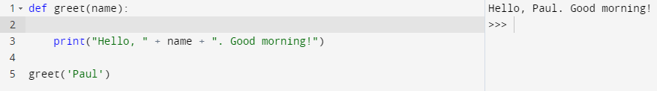
Part (B):

Q4. a. What are the rules for defining the function and Parameter passing to the
Function?
b. Write a suitable program of our defined function by parameter passing in
Python?

Answer .4:

Part (A):
- Step 1: Declare the function with the keyword def followed by the function name.
- Step 2: Write the arguments inside the opening and closing parentheses of the function, and end the declaration with a colon.
- Step 3: Add the program statements to be executed.

- Arguments are passed by value; that is, when a function is called, the parameter receives a copy of the argument's value, not its address. This rule applies to all scalar values, structures, and unions passed as arguments. Modifying a parameter does not modify the corresponding argument passed by the function call

Part (B):
Program which passed parameters to function
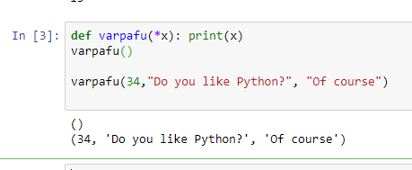

Q5. a. What are return values to a Function discuss in detail?
b. Write a suitable program of a Function with returning value?

Answer. 5:
Part (A):
A return statement ends the execution of the function call and "returns" the result, i.e. the value of the expression following the return keyword, to the caller. If the return statement is without an expression, the special value none is returned.
Part (B):

