Final Term Assignment (2020)
Course Title: Basic Physiology (DT– 2nd) Instructor: Dr. Irfan Ali Khan

Question Paper Time: 48 hours
Class Code. __________________________ Name/Class Rollno: _owais Anwar ID:15802_____________________
Note:
- Attempt all questions from this section.
- Use Blue / Black Ink only. Do not use red color.
- Tick or encircle only one option in each given question.
It’s an open book Conceptual Assignment paper. Time to Use your brain now.

- Briefly explain the process of hematopoiesis along with diagrammatic illustration. (Marks 10)
Ans:Hematopoiesis: hematopoiesis) is the formation of blood cellular components. All cellular blood components are derived from hematopoiesis stem cell.(2) In a healthy adult person, approximately 10¹¹⁻10¹² new blood cells are produced daily in order to maintain steady state levels in the peripheral.
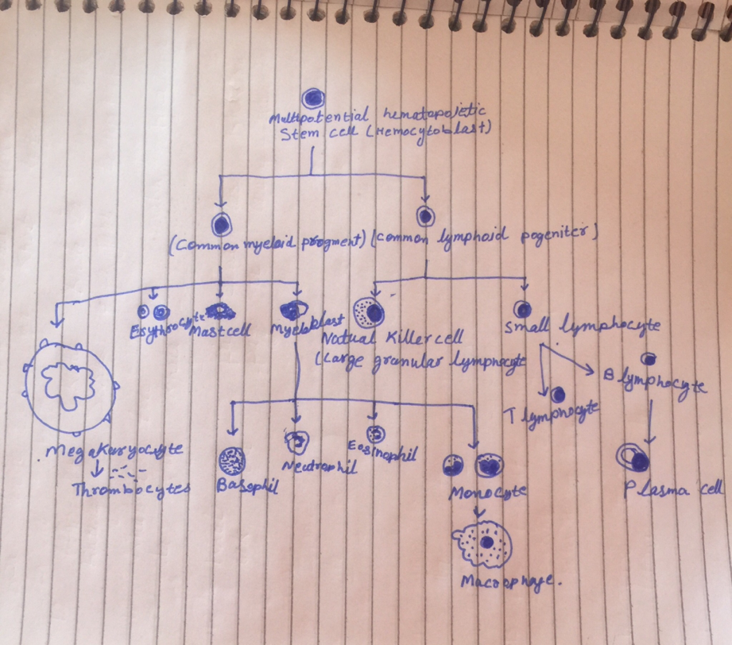

- What are the factors that influence the respiratory rate, explain in detail. (Marks 10)
Ans:There are many factors that affect the respiratory rate: age, gender, size and weight, exercise, anxiety, pain, the effect of some medicines, smoking habits and excitement level are among them. a‘normal’ respiratory rate for a man is about 14 to 18 breaths per minute and for a woman 16 to 20 breaths per minute, but it’s more important to know what is ‘normal’ for the individual, and to assess changes from that level.

- Enlist different layers of skin, write a detailed note on epidermis. (Marks 10)
Ans :skin has three layers:
The epidermis, the outermost layer of skin, provides a waterproof barrier and creates our skin tone.
The dermis, beneath the epidermis, contains tough connective tissue, hair follicles, and sweat glands.
The deeper subcutaneous tissue (hypodermis) is made of fat and connective tissue.
Epidermis:The upper or outer layer of the two main layers of cells that make up the skin. The epidermis is mostly made up of flat, scale-like cells called squamous cells. Under the squamous cells are round cells called basal cells. The deepest part of the epidermis also contains melanocytes. These cells produce melanin. which gives the skin its color.The other main layer of the skin is the dermis, the inner layer of skin, that contains blood and lymph vessels, hair follicles, and glands. These glands produce sweat, which helps regulate body temperature, and sebum, an oily substance that helps keep the skin from drying out. Sweat and sebum reach the skin's surface through tiny openings called pores.

- Define lymphatic system, what are different components of lymphatic system? (Marks 10)
Ans:The lymphatic system, or lymphoid system, is an organ system in vertebrates that is part of the circulatory system and the immune system. It is made up of a large network of lymphatic vessels, lymphatic or lymphoid organs, and lymphoid tissues. The vessels carry a clear fluid called lymph towards the heart.

Lymphatic system Structures. The major complaint of the lymphatic systeminclude lymph, lymphatic vessels , and lymphatic organs that contain lymphoid tissues.lymphatic vessels are structures that absorb fluid that diffuses from blood vessel capillaries into surrounding tissues.

- What is blood pressure? How will you check and record blood pressure of a patient? (Marks 10)
Ans: Blood pressure : blood pressure is the pressure of circulating blood on the walls of blood vessels. Most of this pressure is due to work done by the heart by pumping blood through the circulatory system. Used without further specification, "blood pressure" usually refers to the pressure in large arteries of the systemic circulation

Procedure
To begin blood pressure measurement, use a properly sized blood pressure cuff. The length of the cuff's bladder should be at least equal to 80% of the circumference of the upper arm.
Wrap the cuff around the upper arm with the cuff's lower edge one inch above the antecubital fossa.
Lightly press the stethoscope's bell over the brachial artery just below the cuff's edge. Some health care workers have difficulty using the bell in the antecubital fossa, so we suggest using the bell or the diaphragm to measure the blood pressure.
Rapidly inflate the cuff to 180mmHg. Release air from the cuff at a moderate rate (3mm/sec).
Listen with the stethoscope and simultaneously observe the sphygmomanometer. The first knocking sound (Korotkoff) is the subject's systolic pressure. When the knocking sound disappears, that is the diastolic pressure (such as 120/80).
Record the pressure in both arms and note the difference; also record the subject's position (supine), which arm was used, and the cuff size (small, standard or large adult cuff).
If the subject's pressure is elevated, measure blood pressure two additional times, waiting a few minutes between measurements.

Stay home, stay Safe

