Department of Computer Science
Semester Assignment Spring 2020

ID : 14273
Name :Saeed Ahmad Ahmad
Department : BS(CS) 5th Semester

Subject: Object Oriented Programming
Time: 48hrs (9:00 am Monday (20th April) to 9:00 am Wednesday (22nd April))
BS (CS,SE) Instructor: M.Ayub Khan
There are total 3 questions in this paper. Max Marks: 30
Note:

At the top of the answer sheet there must be the ID, Name and semester of the concerned Student.

Students must have to provide the output of their respective programs. Students have same answers or programs will be considered fail. Programs in Python or codes should be explained clearly.

As this paper is online so incase of any ambiguity my Whatsapp no. is 034499121116.

Each question carry equal marks.
Please answer briefly.

Q1. What is Class and role of object in a Class, explain in detail with the help of a
suitable program ?
Ans: A class is a set of instruction to build a specific type of object. It is a user-defined data type, which holds its own data members and member functions, which can be accessed and used by creating an instance of that class.

Object determines the behavior of the class. From a programming point of view, an object can be a data structure, a variable or a function. It has a memory location allocated. The object is designed as class hierarchies.

Example:
import java.util.Scanner;

//creating first class
public class ClassObject {

public static void main(String[] args) {

int Value;
//creating new object for second class
Second object = new Second();

// output of calling object
System.out.println(object.w);

}

}

//creating second class for calling object
class Second{

//define a Value for output
int w=89;
}

OUTPUT
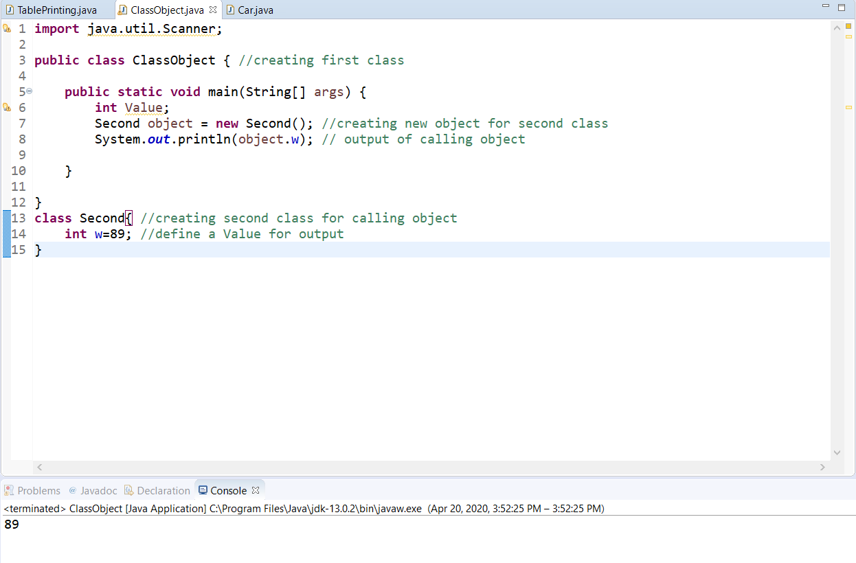

Q2. Write a program about table printing which takes input from the user on the
basis of OOP and explain in detail.

Ans:
import java.util.Scanner;

public class TablePrinting {

public static void main(String[] args) {
//Here we create an object of class
Scanner obj = new Scanner(System.in);
//Here we print the output of taking user input
System.out.println("Enter the Value =");

int x = obj.nextInt(); //Read the User input

for(int y=1;y<=10;y++)
{
//Table printing of entered user
System.out.println(x+"x"+y+"="+x*y);
}
}
}
OUTPUT

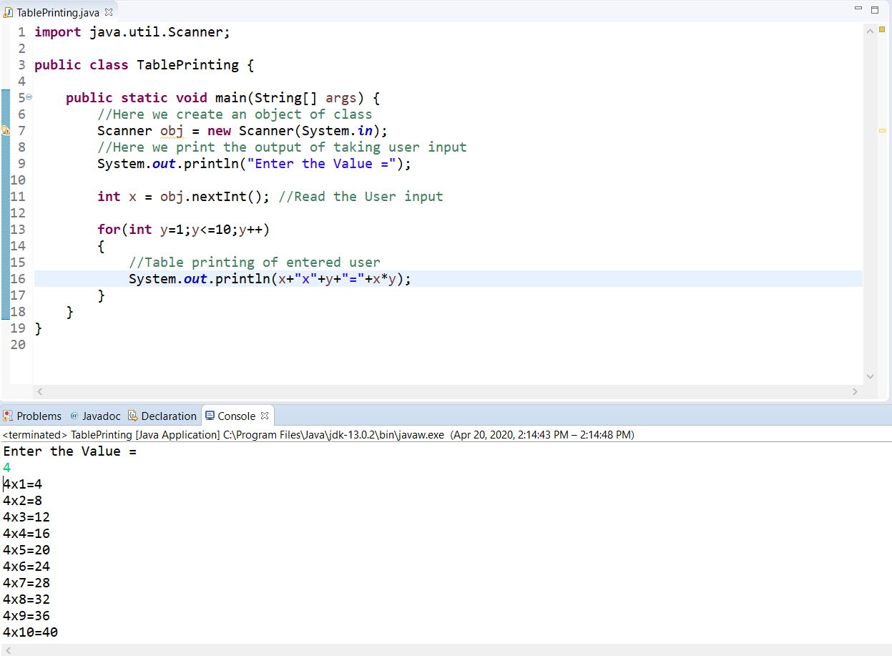

Q3. Write a program about any 2 cars which can calculate the performance of
both of them and explain in detail.

public class Car {

public static void main(String[] args) {
//we create object of both class ferrari and fordCar
Ferrari fer = new Ferrari();
FordCar ford= new FordCar();

//Here we comapare all atributes for ferrari if ferrari attributes is high
if(fer.MaxSpeed>ford.MaxSpeed && fer.Engine>ford.Engine && fer.suspension>ford.Engine)
{
System.out.println("Ferrari is the fastest");
System.out.println("And Ford is slower than Ferrari");
}

//Here we comapare all atributes for ford if ford attributes is high
if(fer.MaxSpeed<ford.MaxSpeed && fer.Engine<ford.Engine && fer.suspension<ford.Engine)
{
System.out.println("Ford is the fastest");
System.out.println("And Ferrari is slower than Ford");
}

}

}

class Ferrari{ //Here we add some data of first car
int MaxSpeed = 251;
double Engine = 2.7;
double suspension = 57;
}
class FordCar{ //Here we add some data of Second car
int MaxSpeed = 250;
double Engine = 2.6;
double suspenson = 56.1;
}

OUTPUT
