IQRA National University

Communication Skills
AHMAD SHINWARI
13911

Difference between Interpersonal, Intrapersonal, Mediated and Mass Communication

- Interpersonal Communication

Interpersonal Communication came to being when people began to exchange ideas and thoughts to one another. Interpersonal Communication is a kind of communication in which people communicate their feeling, ideas, emotions and information face to face to each other. It can be in verbal or non-verbal form. Interpersonal communication is not only about what is said and what is received but also about how it is said, how the body language used, and what was the facial expression.

Interpersonal communication consists of four basic elements
Sender
Message
Medium
Receiver
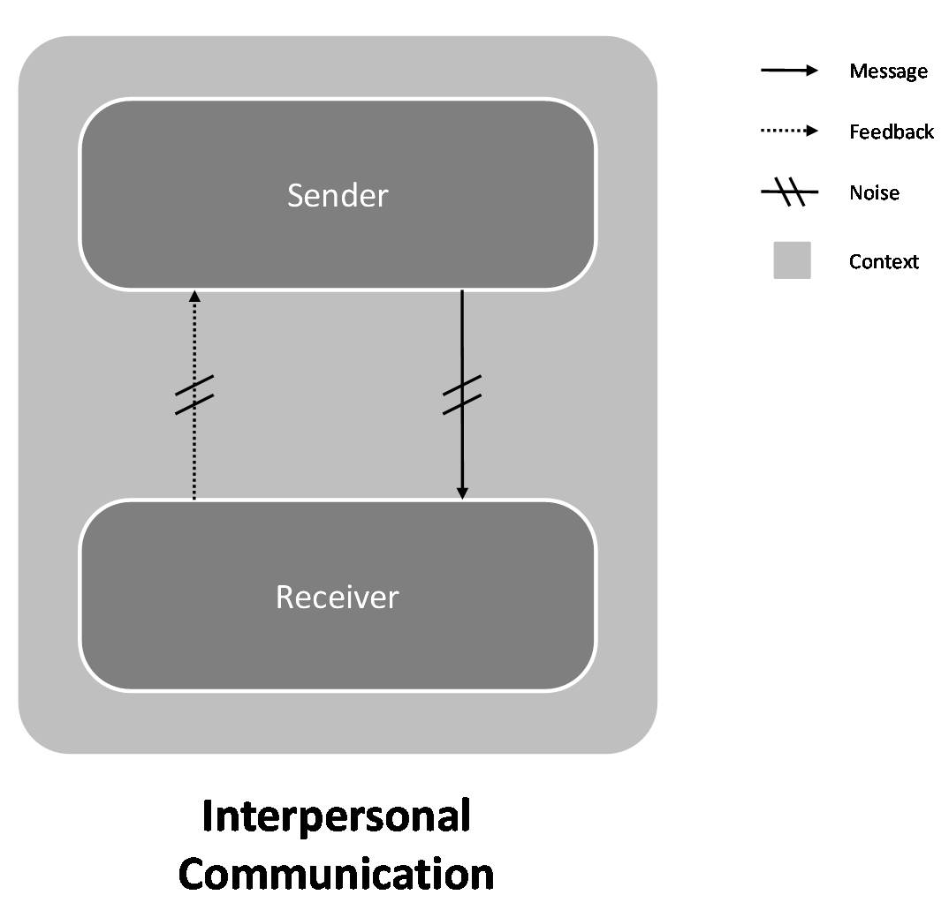

2. INTRAPERSONAL COMMUNICATION
Intrapersonal communication is the communication that is within an individual. An individual uses this type of communication for various purposes such as analyzing situations, clarifying concepts, and reflecting upon phenomena. There are three elements that govern intrapersonal communication, self-concept, perception and expectation. An individual employs certain methods to communicate within themselves and these are internal discourse where thinking, concentration and analyzing occur, solo vocal communication which involves speaking out aloud to oneself, and solo written communication that encompasses writing not intended for others.

"Intra" means "within." We have intramural sports. This means that the sports are "within the walls" of the school. They are sports played against teams from within the same school. Similarly, we have intrapersonal issues which exist only within one person.
INTRAPERSONAL COMMUNICATION

3. MASS COMMUNICATION
Through Mass Communication a person, group of people, or an organization sends a message through a channel of communication to a large group of anonymous and heterogeneous people and organizations. You can think of a large group of anonymous and heterogeneous people as either the general public or a segment of the general public .The Medium of communication include broadcast television, radio, social media, and print. The sender of the message is usually a professional communicator that often represents an organization. Mass communication is an expensive process. Unlike interpersonal communication, feedback for mass communication is usually slow and indirect. Is a process in which a person, group of people, or an organization sends a message through a channel of communication to a large group of anonymous and heterogeneous people and organizations. You can think of a large group of anonymous and heterogeneous people as either the general public or a segment of the general public. Channels of communication include broadcast television, radio, social media, and print. The sender of the message is usually a professional communicator that often represents an organization. Mass communication is an expensive process. Unlike interpersonal communication, feedback for mass communication is usually slow and indirect.

A source sends a message through a medium (TV) to a receiver (audience) producing some effect.
If message is entertainment: effect is to get entertained, If message is news: effect is to get informed.

MASS COMUNNICATION

4. MEDIATED COMMUNICATION

Mediated communication or mediated interaction refers to communication carried out by the use of information communication technology and can be contrasted to Face to face communication. While nowadays the technology we use is often related to computers, giving rise to the popular term Computer mediated communication, mediated technology need not be computerized as writing a letter using a pen and a piece of paper is also using mediated communication. Thus, Mediated communication is the use of any technical medium for transmission across time and space.

Using a medium to transmit a message.
What you are using the thing for distinguishes difference of mass or mediated.
*Analyze Medium.

MEDIATED COMMUNICATION

-----------------------------------------------------------------------------------------------------------

