Subject: Anatomy II Total Marks 50
Final Term Assignment. Semester: DPT 2nd.

Q:1 Enumerate muscles in the posterior compartment of the lower leg with clinical significances also write action and innervation of each posterior compartment muscle.
The muscles of the posterior compartment of lower leg are divided into superficial muscles and deep muscles. There are total seven muscle in the posterior compartment of the leg.
SUPERFICIAL MUSCLES;
The gastrocnemius muscle has two heads the medial head arises from the depression of medial condyle of femur and joining popliteal surface of femur and the lateral head arises from the lateral condyle of the femur. The lateral and the medial head joins together. It also connects to soleus muscle. The tendon of gastrocnemius muscle joins with the tendon of soleus muscle to form a common tendon which is called tendo calcaneus and inserts into the calcaneus of the foot.
GASTROCNEMIUS MUSCLE:
The gastrocnemius muscle has two heads, one is medial and second is lateral, arises from the medial and lateral condyles of the femur. It is the most superficial of all the muscles.
ANTIONS: plantar flexes at the ankle joint.
INNERVATION: Tibial nerve.
PLANTARIS:
The plantaris is a small muscle with a long tendon. This tendon passes between the gastrocnemius and soleus muscle. It is absent in 10% of the people.
ACTIONS: It plantarflexes at the ankle joint. It is not avital muscle for these movements.
IVVERVATION: Tibial nerve.
SOLEUS:
It is a large and flat named soleus due to its resemblance of a sole (a flat fish). It is located deep to the gastrocnemius muscle.
ACTIONS: Plantarflexes the foot at the ankle joint.
INNERVATION: Tibial nerve.
DEEP MUSCLES:
In deep muscles there are four muscles. The three muscles (flexor hallucis longus, tibialis posterior, flexor digitorum longus) acts on the ankle of foot. The forth popliteus muscle acts on the knee joint.
POPLITEUS:
The popliteus muscle originates from the lateral condyle of the femur and outer margin of the lateral meniscus and inserts at the posterior surface of the shaft of the tibia.
ACTION; Unlocking the knee joint by lateral rotation of femur on tibia for flexion.
INNERVATION: Tibial nerve.
FLEXOR DIGITORUM LONGUS:
Originates from the tibia and inserts in the opposite side to supply the lateral toes.
ACTION: Plantar flexion of foot at ankle joint.
INNERVATION: Tibial nerve.
FLEXOR HALLUCIS LONGUS:
Originates from the lateral part of the fibula and inserts in the second layer of the sole to the opposite side to reach the big toe.
ACTION: plantar flexion of the ankle joint.
INNERVATIONS: tibial nerve.
TIBIALIS POSTERIOR:
Arises from both the bones tibia and fibula and inserts into navicular tuberosity and also the other tarsals bones except the tallus.
ACTION: plantar flexion of ankle joint.
INNERVATION: Tibial nerve.
CLINICAL RELEVANCE:
- Rupture of the calcaneal tendon refers to a partial or complete tear of the tendon. It is more likely to occur in people with a history of calcaneal tendinitis (chronic inflammation of tendons).
- The injury is usually sustained during forceful plantarflexion of the foot. The patient will be unable to plantarflex the foot against resistance, and the affected foot will be permanently dorsiflexed. The soleus and gastrocnemius can contract to form a lump in the calf region.
- Treatment of a ruptured calcaneal tendon is usually conservative except in those with active lifestyle.

Q:2 Explain the following
FOOT DROP:
Foot drop is gait abnormality in which the dropping of the forefoot happens due to weakness, irritation or damage to the common fibular nerve including the sciatic nerve or paralysis of the muscles in the anterior portion of the lower leg. It is usually a symptom of a great problem, not a disease in itself. Foot drop is characterized by inability or impaired ability to raise the toes or raise the foot from the ankle which is also called dorsiflexion. It may be temporary or permanent, depending on the extent of muscle weakness or paralysis and it occur in one or both feet. It can also be caused by nerve damage alone or by muscle or spinal cord trauma, abnormal anatomy, atoxins, or some disease. It can interfere walking as the affected limb can drag along the ground. The unopposed pull of the plantar flexor produces permanent plantarflexion.
DEEP VENOUS THROMBOSIS:
Deep venous thrombosis (DVT) is a serious condition that occurs when a blood clot forms in a vein located deep inside the body. A blood clot is a clump of blood that is turned into a solid state. Deep vein blood clots typically form in your thigh or lower leg, but it can also develop in other areas of your body.
CAUSES:
DVT is caused by a blood clot. The clot blocks a vein, preventing blood from properly circulation in the body. Clotting may occur for several reasons;
- Genetic predisposition of blood clots.
- Limited blood flow due to injury or immobilization.
- Long periods of inactivity, airplane rides, trips in the car etc.
- Being overweight or obese.
- Cancer and some cancer treatments.
SYMPTOMS:
- Swelling in the affect3d leg.
- Pain in your leg. The pain often starts in your calf and feels cramping or soreness.
- Red or discolored on your leg.
- A feeling of warmth in the affected area.
- DVT’s can also occur without noticeable symptoms.
Q:3 Explain blood supply of thigh and gluteal region with the help of diagram.
INTRODUCTION:
The blood supply of the thigh directly comes from the external iliac artery. The external iliac artery becomes the femoral artery after it passes beneath the inguinal ligament and enter the femoral triangle.
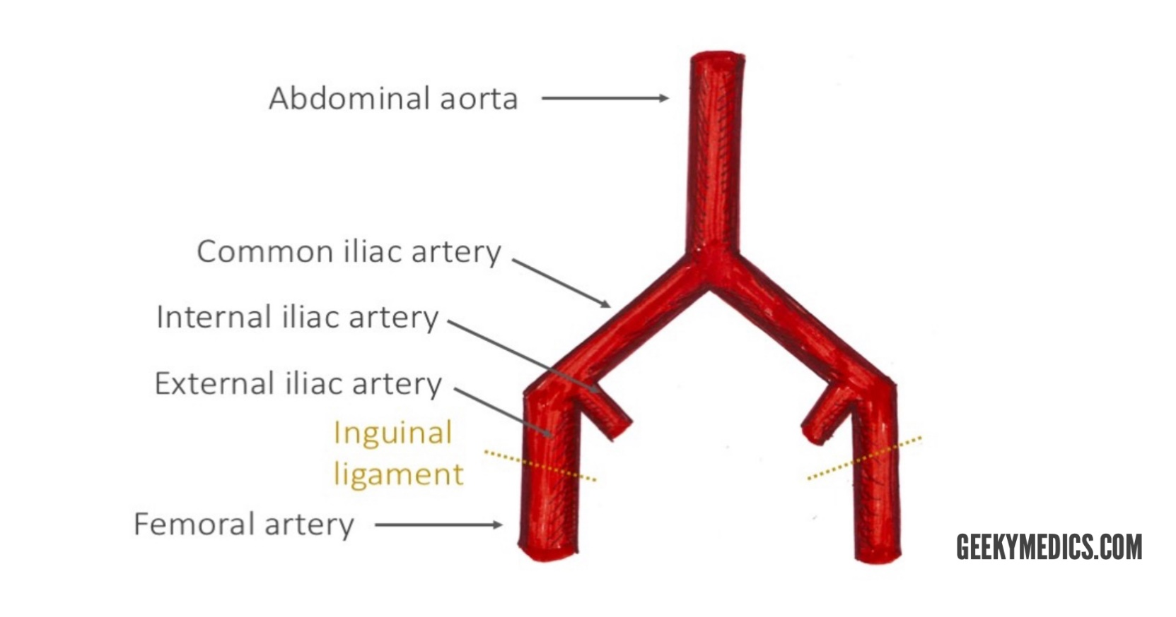
FEMORAL TRIANGLE:
The femoral triangle is a useful anatomical landmark. This triangular depression is located inferiorly to the inguinal ligament. Three important structures run through the femoral triangle
- Femoral nerve
- Femoral artery
- Femoral vein
At the apex of the femoral triangle, the femoral artery and vein enter the adductor canal.
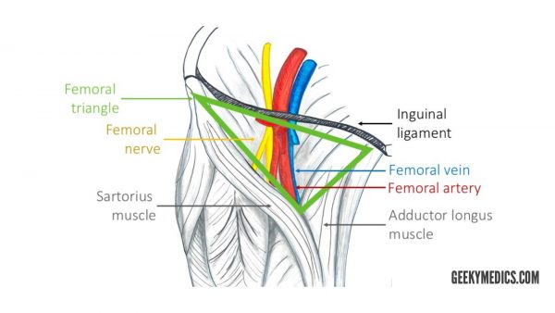

ARTERIES OF THE THIGH:
The femoral artery runs in the middle of the femoral triangle. It supplies the anterior and anteromedial aspects of the thigh.
The profunda femoris artery is the largest branch of the femoral artery. This vessel is also known as the deep artery of the thigh and has three main branches;
- Medial circumflex femoral artery (MCFA)
- Lateral circumflex femoral artery (LCFA)
- Perforating branches – three to four branches supplying the posterior and anterolateral muscles of the thigh (adductor magnus, hamstrings, vastus lateralis). They run laterally across the muscles.
The femoral artery then enters the adductor canal, which terminates the adductor hiatus. The adductor hiatus is the gap between the adductor and hamstring heads of the adductor magnus muscle. This is where the femoral artery becomes the popliteal artery.
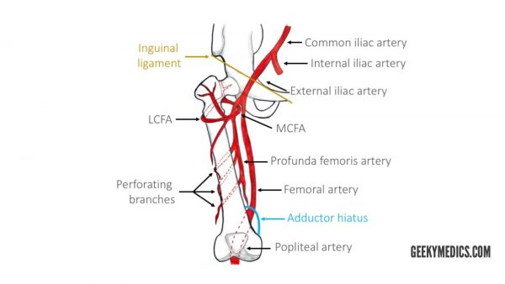
ARTERIES OF THE GLUTEAL REGION:
The main arteries of the gluteal region are the superior gluteal and inferior gluteal arteries. They arise from the internal iliac artery.
The superior gluteal artery is the largest branch of the internal iliac artery and arises from its posterior division. It has superficial and deep branches which supply the gluteus maximus, gluteus medius, gluteus minimus and tensor fasciae latae muscles.
The inferior gluteal artery originates from the anterior division of the internal iliac artery. This artery supplies blood to the gluteus maximux, piriformis, internal obturator, gemellus superior and inferior and quadratus femoris muscle. It also gives of a branch to the sciatic nerve.
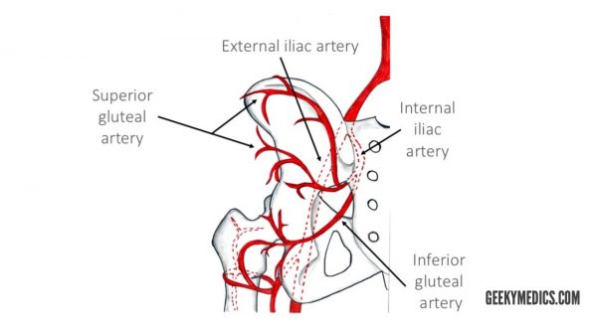

Q 4: Describe anatomical course, motor and sensory function of Sciatic Nerve
SCIATIC NERVE:
ANATOMICAL COURSE:
The sciatic nerve is derived from the lumbosacral plexus. After its formation it leaves the pelvis and enters the gluteal region via great sciatic foramen. It emerges inferiorly to the piriformis muscle and descends in an inferolateral direction. As the nerves moves through the gluteal region, it crosses the posterior surface of the superior gemellus, obturator internus, inferior gemellus and quadratus femoris muscles. It then enters the posterior thigh by passing deep to the long head of the biceps femoris. Within the posterior thigh, the nerve divides into the branches to the hamstring muscles and adductor magnus. When the sciatic nerve reaches the apex of the popliteal fossa, it terminates by bifurcating into the tibial and common fibular nerves.
SENSORY FUNTIONS:
The sciatic nerve does not have any direct cutaneous functions. It does provide indirect sensory innervation via its terminal branches;
- TIBIAL NERVE: Supplies the skin of the posterolateral leg, lateral foot and the sole of the foot.
- COMMON FIBULAR NERVE: Supplies the skin of the lateral leg and the dorsum of the foot.
MOTOR FUNCTIONS:
The sciatic nerve directly innervates the muscles in the posterior compartment of the thigh, and the hamstring portion of the adductor magnus. The sciatic nerve also directly innervates several other muscles, via its two rweminal branches;
- TIBIAL NERVE: The muscles of the posterior leg (calf muscles), and some the intrinsic muscle of the foot.
- COMMON FIBULAR NERVE: The muscles of the anterior leg, lateral leg, and the remaining intrinsic foot muscles.
In total the sciatic nerve innervates the muscles of the posterior thigh, entire leg and entire foot.
Q 5: Enumerate Muscles of the medial compartment of thigh, what is tarsal tunnel syndrome?
MUSCLES OF THE MEDIAL THIGH:
There are five muscles in the medial compartment of thigh. They are collectively known as the hip adductors.
- ADDUCTOR MAGNUS:
The adductor magnus is the largest muscle in the medial compartment. It lies posteriorly to the other muscles.
- ADDUCTOR LONGUS:
The adductor longus is a large, flat muscle. It partially covers the adductor brevis and magnus. The muscle forms the medial border of femoral triangle.
- OBTURATOR EXTERNUS:
This is one of the smaller muscles of the medial thigh, and it is located most superiorly.
- ADDUCTOR BREVIS:
The adductor brevis is a short muscle, lying underneath the adductor longus. It lies in the anterior and posterior division of the obturator nerve. Therefore, it can be used as an anatomical landmark to identify the aforementioned branches.
- GRACILIS:
The gracilis is the most superficial and medial off the muscles in this compartment. It crosses at both the hip and knee joints. It is sometimes transplanted into the hand or forearm to replace a damage muscle.

TARSAL TUNNEL SYNDROME:
Tarsal tunnel syndrome (TTS) is a compression, or squeezing, on the posterior tibial nerve that produces symptoms anywhere along the path of the nerve running from the inside of the ankle into the foot. Tarsal tunnel syndrome is similar to carpal tunnel syndrome, which occurs in the wrist. Bothe disorders arise from the compression of a nerve in a confined space.
CAUSES:
- A person with flat feet is at risk of developing TTS because the outward titling of the heel that occurs with fallen arches can produce strain and compression of the nerve.
- An enlarged or abnormal structure that occupies space within the tunnel can compress the nerve.
- An injury, such as an ankle sprain.
- Systemic disease, such as diabetes or arthritis.
SYMPTOMS:
- Tingling.
- Burning.
- Sensation similar to an electric shock.
- Numbness.
- Pain, including shooting pain.

