Name : Ahmed Adil
Id : 16586
Section : B
Paper : concrete technology

- Which step is taken to prevent flash setting of cement? Also, write steps to prevent false setting of concrete.
Answer. We added gypsum to prevent flash setting of cement. False setting. Continuous mixing the past then prevent the concrete.
- Draw a graph showing the strength development of pure compounds of cement.
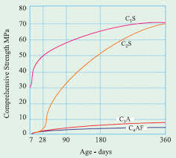
Answer.

- Why Type III cement is Rapid Hardening and Type IV Low Heat producing? Draw a graph showing the development of heat of hydration of different cement types.
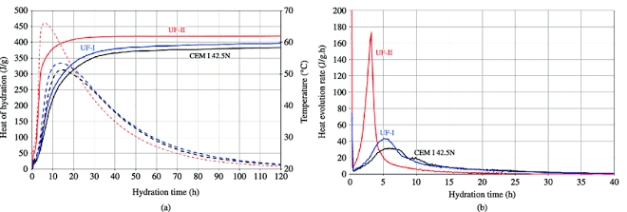
Answer. The rate of strength gain occur due to increase of C3S compound, and due to finer grinding of the cement clinker .and type 4 cement has low heat produce because of lesser amount of C3S.
- What is the effect of compaction on entrapped air of concrete? What will be the effect on strength if concrete is not compacted sufficiently? Explain with graph.
Answer . Wet concrete is a flowable liquid and cannot be be “compacted” into a smaller space. Concrete can contain large unacceptable voids or honeycombing. Voids and honeycombing are different than entrained air.
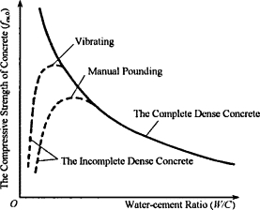
Lose of strength through incomplete compaction.
- Why is the percentage of gypsum added to cement limited only to 5%?
Answer. A small amount of gypsum is introduced during the final grinding process. Gypsum is added to control the setting of cement. That’s why gypsum is added only 5 percent.
- . What is the effect of following on the bond strength of concrete?
- Shape of aggregate
- Size of aggregate
- Texture of aggregate
- Bleeding
Answer. Factors effecting bond strength of concrete.
  - Shape of aggregates.
The larger surface area of more angular Aggregate provides a greater bond Compared to rounded aggregate
  - Size of aggregates.
Bond strength is greater than fine aggregate compared to coarse aggregate .
  - Texture of aggregate.
A rough ughes texture results in a greater adhesion or bond between the particles and the Cement matrix Compared to Smooth texture.
  - Bleeding.
Bleeding reduces the bond Strength of concrete.
- What is the effect of following on workability of aggregate?
- Porosity and absorption
- Air entraining agent
- Coarse aggregate to fine aggregate ratio
- Grading of aggregate
Answer. Porosity and absorption
Porous and non porous aggregate will required more water than a non porous and saturated aggregate. The workability of farmer is less then the later.
- Air Entraining Agent
Workability also increases with addition of air entraining agents which produce well disposed air bubbles.
- Coarse aggregate to fine aggregate ratio.
High ratio of coarse and fine aggregate will result in a lower workability.
- Grading of aggregate.
Better the grading the less is a viods and higher workability.
- What is the effect of fineness of cement on the following?
- Strength of concrete
- Rate of heat evolution during hydration
- Total heat of hydration
- Workability of concrete
Answer. The Effect of Fineness of Cement .
  - Rate to heat evolution during hydration. :
Rate heat evolution increases with increase in fineness of Cements
  - Total heat 0f hydration:
Higher Fineness provides a greater Surface area to be welted, resulting in an acceleration to the reaction between Cement and water. This cause an increase in the date of heat liberation at early ages, but many not influence the total amount of heat developed over Several weeks.
  - Strength of Concrete.
The compressive strength of concrete increase with increase of cement fineness
  - Workability of concrete.
An increase in fineness of cement result in increases workability of concrete.
9.What steps can be taken during transportation and placement of concrete to prevent segregation of concrete?
Answer. A properly proportioned mix, properly mixed and agitated, with the correct slump and retarding water reducer infused, should be just fine.
The end.

