ASSIGNMENT

Name: Syed Haider Hussain Shah

Id: 16072

Sec: A

Sem: 2nd

Subject: Architecture and Town Planing

Mughal Architecture

Timeline:
It was started in 1569 and ended in 1574.

Location:
It was located in south Asia India and Pakistan.
Mughal Architecture is mostly described by arches, minarets, domes,
valuated roof and has no parallel embellishment.
Impressive structure and highly detailed ornamental art work represent the
Mughal architecture the best and except able.
In the Mughals period the formation of bricks was on its culmination. White
marble, red stones and glazed tiles were used as overlays and coating
over the brick.

Materials used in building:
- Red sandstone
- White marble
- Precious stones
- Arches sparingly

Reasons for the materials used in buildings:

Red sandstone:
It is used because it is soft. It is easy to cut. It oppose the
weathering and construction from it is easy. It is easy to make a curve in it.

White marble:
It is brighter. It is highly durable. It is completely natural. It
is having Insulation properties so it can save money. It is affordable. It can be
used for both indoors and out doors purposes.

Precious stones:
It was used for decoration purposes on walls. It provides attraction to the people.

Arches sparingly:
It is used for high strength provided to the structure.
It support a lot of weight.

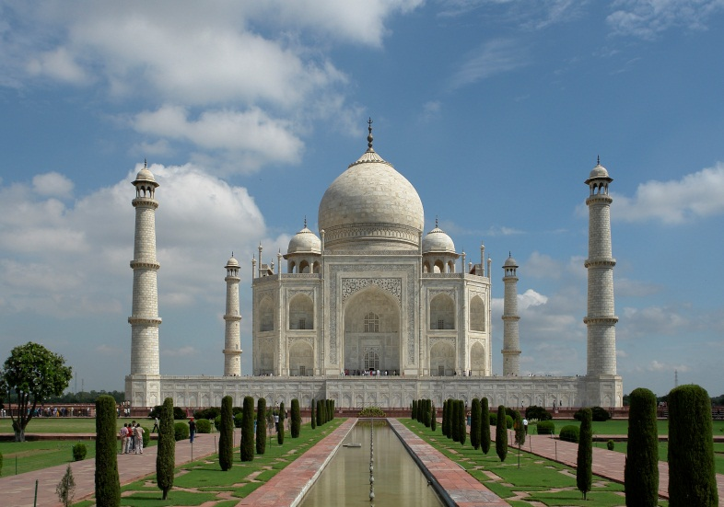

Mughal architecture is the combination of the Indo-Islamic architecture style.
Mughals. A uniform pettern is shown in both aspects structure and character
in Mughal buildings. It is a signally decorative and symmetrical blend Indian,
Persian and Turkish architecture.
Some famous leaders of Mughal participated in building architecture

Babur
He started the construction of a mosque in Rohikhand and Panipat in
1526 AD. As a leader his time period was very small.

Humayun
He achieved the desired the aim from the Babur but as a leader
his period was so tough and full in struggle. Persian style architecture was
famous in his time.

Sher Shah Suri
He built some famous buildings which are listed below
- Quila-e-Quanah in Delhi.
- Rohtas Fort in Pakistan.
- Sher Shah Masjid in Patna.

Mostly he use red sand and grey stone.

Akbar
He captured the throne of Dehli in 1556. The use of red stone was
important at that time. First he started the use of Tudor arch.
He built some famous buildings which are listed below
- Moti Masjid
- Diwan-i-aam
- Diwan-i-khas
- Jahangir Mahal
- Sheesh Mahal

Jahangir
Mostly he focused on painting and other art forms
He built some famous buildings which are listed below
- Tomb of Jahangir
- Begum Shahi Mosque
- Shalimar Gardens

Common features
The main common features of Mughal architecture
are that buildings are having huge and round domes, a thin minarets with
cupolas surrounded from the corners, having large halls and with enormous
gateways and buildings were in very fine texture. The interior of domes were
decorated with pietra dura, geometric patterns on pillars and walls. The
balconies were supported with carved brackets. Mostly the buildings were
surrounded by pool, fountains and gardens.
The two famous buildings are listed below
- Badshahi Mosque
- Wazir Khan Mosque

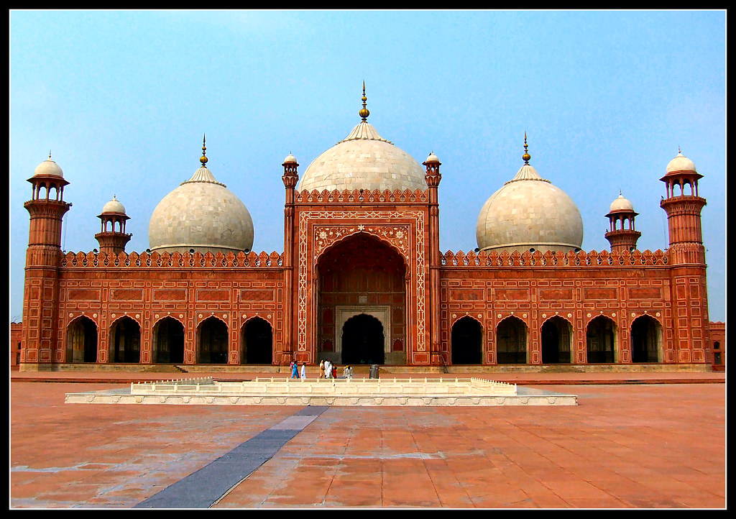

Badshahi Mosque
It is located in Lahore Pakistan. The construction was
Started in 1671 by the Emperor Aurangzeb and ended in 1673. It is having
three domes. It is having eight minaret ( four major and four minor minarets).
The height of minarets is 176 feet 4 inch. It is having the capacity of hundred
thousands persons at a time. It is the second largest mosque in Pakistan.

Architecture of the Badshahi Mosque
The mosque is constructed
from red sand stone and white marble in lay. The entrance of mosque was
two story which was from red stone which is fully decorated and framed.

Prayer Hall
The main prayer hall was also built from red sand stone and decorated with white marble.
Each side of the main chamber carry rooms which were specifically utilize
unique. The minarets which are surrounded from the mosque are made of
red stones and the height of minarets is 196 feet (60 m) and the outer
circumference is 67 feet and with eight and half feet inner circumference.
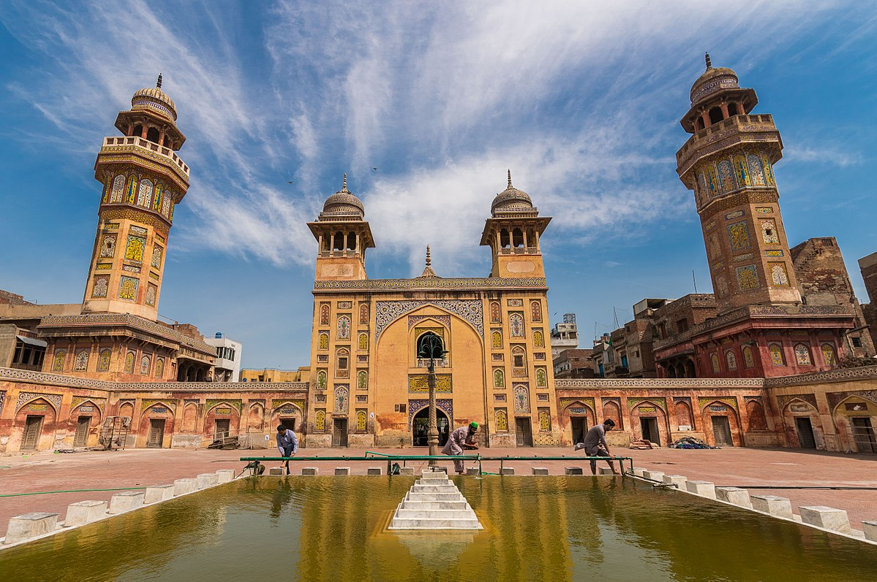

Wazir Khan Mosque
It is located in Lahore Pakistan. The construction
of the mosque was started in 1634 and completed in 3 December 1641.

Architecture of Wazir Khan Mosque
It is having five domes and four
minaret. The height of is 107 feet (33 m). This mosque is considered as the
most decorated mosque. The mosque is famous for its detailed faience tile
work which is recognized as kasha-kari. The ceiling of the mosque is heavily
decorated with frescoes. The wall’s intramural of the mosque is adorned and
plastered with much detailed buon frescoes and decorated with Arabic and
Persian script . The architectural work of the mosque is unique to everyone.
It is built from bricks and placed in kakad lime.The main prayer hall is fully
decorated with Mughal frescoes. The main portion of the prayer hall is
cover with 31 feet tall tomb and its diameter is 23feet recline up on four
arches which shape a square pavilion which is a type of Persian architecture
which is known as Char Taq. The enclosures of the masque carry a pool
which is usually use for Islamic ritual washing.

