Name = Muhammad Jibran
ID NO = 16712
PROGRAM = BS MLT
Mid-Term Assignment (Spring-2020) (BS-MLT 2nd Sec-B)
Instructor: Mr. Fazli Zahir Mian
Course Title: Basic Microbiology

Q1: Fill in the Blanks.
- __Microbe_______are living things which individually are too small to be seen with naked eye.
- The scientific study of algae is called __________phycology_________________________________.
- Diseases causing living organisms are known as __________phatogen_________________________.
- _____Ribosome________________cell organelle is present both in prokaryotic and eukaryotic cell.
- The power house of cell is known as ____________mitochondria________________________________.
- ____Binary fission_____________is the most common method of asexual reproduction in microbes.
- Log period of bacterial growth is also known as ________logrithmic phase___________________________.
- __Log _________phase of microbial growth is metabolically active and is for industrial purposes.
- Shrinkage of cell’s plasma membrane caused by osmotic loss of water is called ___plasmolysis_______.
- For synthesis of cellular material nitrogen and sulfur is needed for ___green_________ synthesis.
section B
Q:2 Ans: 1 MITOCHONDRIA
*Mitochondria is the power house of the cell. usually depicted as stiff, eloagated sylinder is of 0.5_1.0 (micro meter) diameter.
*Mitochondria are in the both plant & animal cell
*make ATP energy from sugar+o2
*general organisation of mitochondria consists of foure components : the matrix , inner and outer membrane, the inter-membrane space.
*mitochondria contain DNA which spcecifies part of the machinery essential for function
STRUCTURE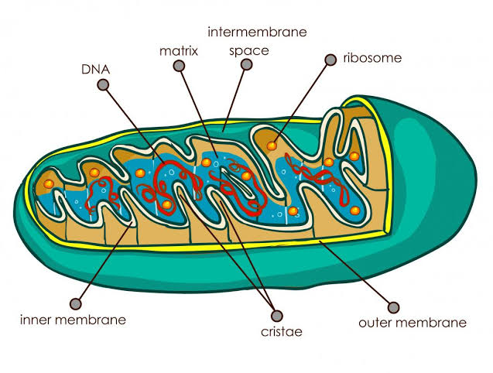
its bounded by double membrane.
FUNCTION
make ATP energy from cellular respiration
sugar+O2 =ATP
fuels the work of life
2 NUCLUS
The term, nuclus, was coined by Robert Brown in8131.
*nuclus is double membrane bound dense protoplasmic body.
*it encloses the genetic information of the cell which means that the genetic material (DNA or RNA) is present in it.
*it is absent in prokaryotes and mature RBCs in case of eukaryotes.
*The otermost double layered covering of nuclus is called nuclear membrane or karyotheca or nuclear envelope.
*the nuclear envelop consist of many pores called nuclear porse.
STRUCTURE
-nuclearmembrane 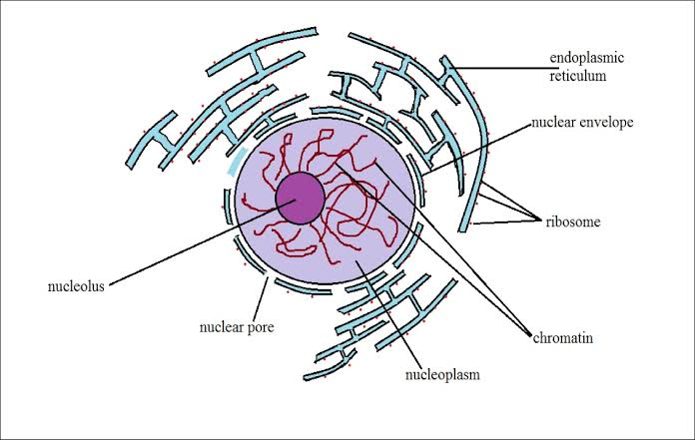
-nucleolus
-ribosomes factory
-DNA
-chromosomes
FUNCTION
-control center of cell
-protects DNA
-intruction for bulding proteins

3 BUDDING
Budding is a type of asexual reproduction in which a new organism devlops from an out growth or bud due to cell division at one particular site..
organism such as hydra use regenerative cells for reproduction in the process of budding
the small bulb-like projection coming out from the yeast cell is called a bud.
since the reproduction is asexual, the newly createdorganism is aclone and excepting mutations is genatically identical to the parent organism. 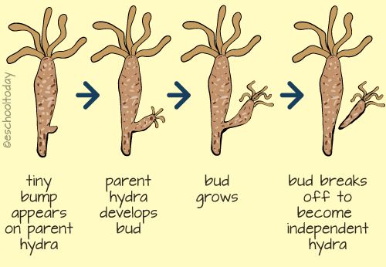
in hydra, a bud develops as an outgrowth due repeated cell divsion at one specific site
these buds develop into tiny individuals and, when fully mature, detach from the parent body and become new independant individuals.

4.CULTURE MEDIA
A culfure media is a special medium used in a microbiological laboreoties to grow different kinds of microorganisms. A growth or a culture medium is composed of different nutrients that are essential for microbial growth.
since there are many types of microoganisms, each having unique properties and requiring specific nutrients for growth, there aremany types based on what neutrients they contain in what function the play in the growth of micro organisms.
A culture may be solid or liquid. the solid culture media is composed of a brown gelly like substane known as agar. different nutrients and chemical are added to it to allow the growth of different microorganisms
TYPES OF CULTURE MEDIA
1: The preservation culture Media
2: The enrichment culture Media
3: Selective culture Media
4: Differential culture Media
5: Resuscitation culture Media
6: General purpose Media
7: Isolation culture Media
8: Fermentation Media

5. GROWTH FACTOR
A growth factor is a naturally occurring substance capable of stemulating cellular growth, [1] proliferation, healing, and cellular differentiation. usually it is a protein or a steroid bormone. growth factor or important for regulating a variety of cellular processes.
growth factors tipically asct as signaling molecules between cells. examples are cytokines and hormones thet bind to specific receptors on the surface of their target cells.
the often promote cell differentiation and maturation, which varies between growth factors. for example, epidermal growth (EGF) enhances ostegenic differentiation, [2] while fibroblast growth factors and vascular endothelial growth factors stimulate blood vessel differentiation (angiogenesis)

Q :3: Ans BACTERIAL GROWTH
Bectrial growth is proliferation of bacterium into two daughter cells, in a prosses called binary fission. providing no events occures, the resulting daughter cells or genetically identical yo the orignal cell. hence, bectrial growth occures.
Both daughter cell from the division do not necessarily survive. how ever, if the number surviving exceeds unity on avrage, the bacterial population undergose exponential growth the measurement of exponential becterial growth curve in batch culture was traditionally a part of the training of all micro biologist, the basic means requries becterial enumeration (cell counting) by direct and individual ( microscopic, flow sytometry 1), direct and bulk (biomass), inderect and bulk (most proabable number, turdity, nutrient uptake) methods. models reconcile theory with the measurements [2].

PHASES OF BECTRIAL GROWTH
a) LAG PHASE
During log phase, bactria adapt themselves to growth codition. it is the period where the individual bactria are maturing and not yet able to devide . during the lag phaase of the bacterial growth cycle, synthesis of RNA, enzymes and other molecules occurs. during the lag phase cell change very little becuse the cells do not immediately reproduce in a new medium. this period of little to know cell division is called the lag phase in can loss for one houre several dayes. during this phase cells are not dormont [4]
b) EXPONTIAL PHASE
(sometimes called tbe logarithmic phase or the expontial phasee)
is a period characterized by cell doubling [5].the number of new bectria appearing per unit time is proproportional to the present poplotion. if growth is not limitted doubling will continoue at a constant rate so both the number of cell and the rate of poplotion increase doubles with eache consecutive time period. For this type of exponential growth, plotting the natural lograthim of cell number against time producea straight line.
c) STATIONARY PHASE
The stationary phase is often due to growth_limiting factor such as the depletion of an essential nutrient, and/or the formation of an inhibitory product such as an organic acid. Stationary phase results from a situtation in which growth rate and death rate are equal. The number of new cells created is limited by the growth factor and as a result the rate of cell growth matches the rate of cell death. The result is a "smooth" horizental linear part of the curve during the stationary phase. Mutation can occurs during stationary phase.
d) DEATH PHASE
This is also called declined phase. This could be caused by lack of nutrients, environmental temprature above or below the tolerance band for the spiecies, or other in injurious conditions.
The basic batch culture growth model draws out and emphasizes aspects of bacterial growth which made differ from the growth of macrofauna. It emphasizes clonality, as sexual binary division, the short development time relative to replication itself, the seemingly low death rate, the need to move from a domant state to a reproductive state or to condition the media, and finaly the tendency of lab adopted strains to exhaust there nutrients. In reality, even in batch culture, the four phases or not will define. the cells do not reproduce in synchrony without explicit and continual prompting(as in experiments with stalked bacteria) and there exponential phase growth is often not ever a constant rate, but instead the slowly decaying rate, a constant stochastic response to pressures both to reproduce into dormant in the phase of declining neutrient concentration in increasing waste concentration.
Near the end of the logarithmic phase of a batch culture, competence for natural genetic transformation may be induce, as in bacillus subtilis and in other bacteria. Natural genetic transformation is a form of DNA transfor that apears to be an adoptation for reapiaring DNA demages.
Liquid is not the only laboratory inviroment for bacterial growth. Spatially structured inviroments such as biopilms or agar sufaces present additional complex growth models.
THE END

