Final-Term Assignment

Course Title: Human Physiology II
Rad 2nd semester section A
Instructor: Dr. M .Shahzeb khan (PT)
Name: Sahab Hussain khan
Id # 16362
Marks: 50

Note:
- Attempt all questions, all questions carry equal marks.
- Answer Briefly and to the point, avoid un-necessary details

Q1: (A) How stimulus of smell moves from nostril to brain? Make a Diagram as well

Q 2: (A) What is difference between Haemostasis, Haematopoiesis and Homeostasis?
(B) What is Erythroblastosis fetalis?

Q3: (A) What is Immunity? Explain different types of immunity
(B) What is difference between Antigen and Antibody?

Q4: (A) Write down different functions of Antibody
(B) Write difference between Primary and secondary response to an antigen

Q5: Write difference between cell mediated and Antibody Mediated Immunity

Question no.1 (a)
Answer :
Physiology of Smell:
- Olfactory nerve involve in this process
- It is 1st cranial nerve
- it's function is, sense of smell
- They called chemical sense because it detect many chemicals of the environment .
- Odour molecules come through air to the nostril, binds with receptors and combine with the mucus of the nose.
- The signals travels from Sensory neuron to olfactory bulb present back side of the nose, it is present in temporal lobe of the brain.
- It helps in detecting different odours.
- The olfactory receptors transmit the signals to the olfactory bulb ( collection of neural masses) which detects smell.
- The olfactory bulb then carries impulses ( signals) via olfactory tarct to the temporal lobe of the brain.
- This center of the brain detects smell as an olfactory sensation.
- Like; brain detects the smell of cooking food, smell of perfume etc.

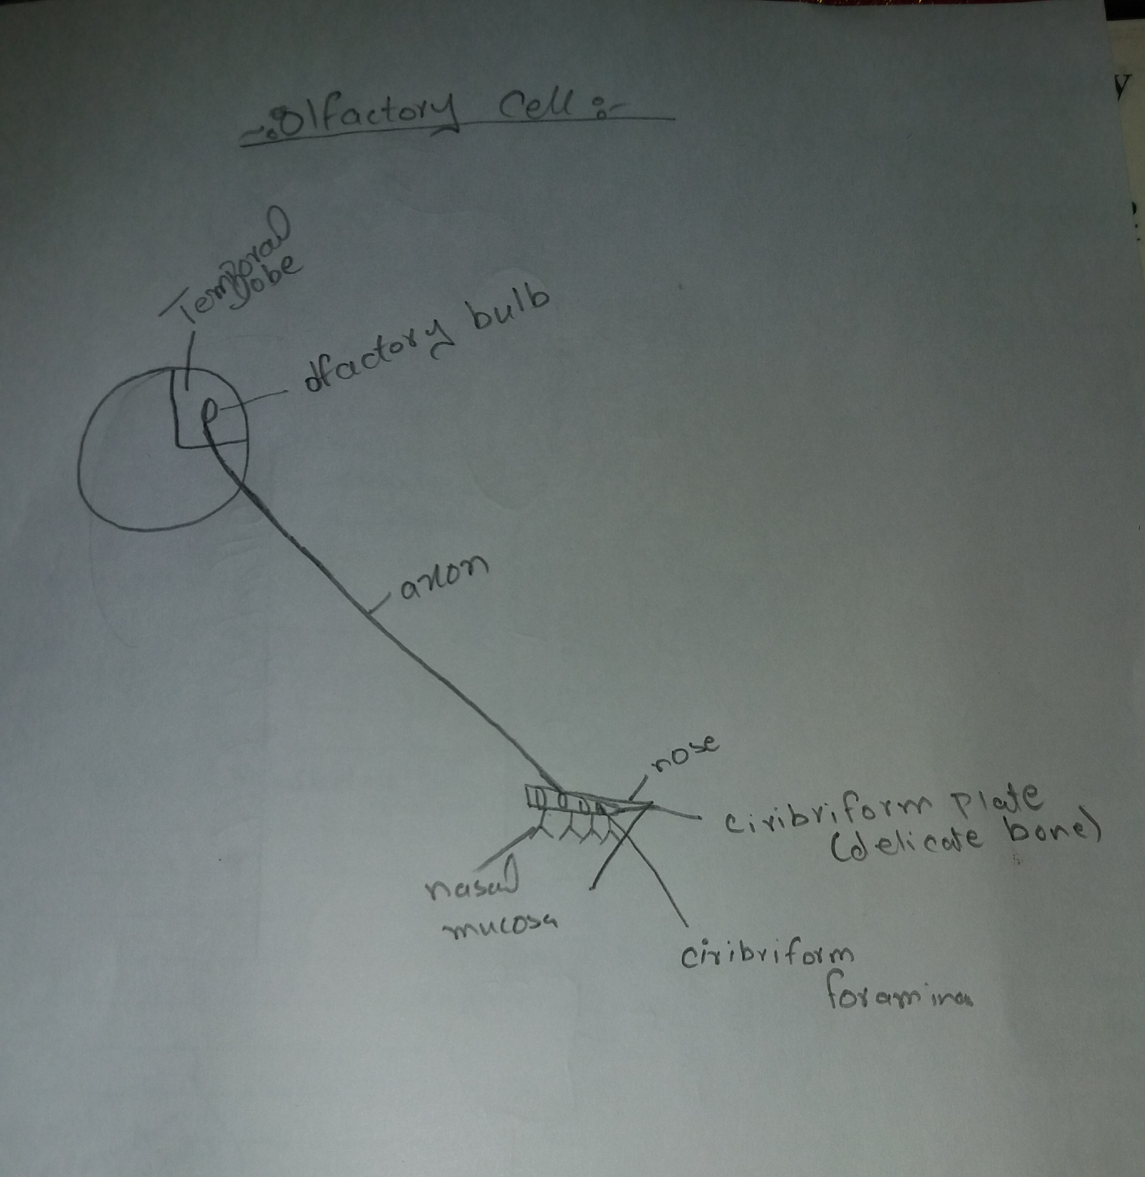

Question no.2(a)
Differences Between Heamostasis, Heamatopoiesis, and homeostasis :

1. Heamostasis :
Heamostasis means the rebuff of the bleeding.

Stages of Heamostasis :
For example when blood vessels become injured, the bleeding is rebuff which is resulting in heamostasis.
The stages are as under:
1. Vassoconstriction :
- In Vassoconstriction the blood vessels become more narrow
- It results in the contraction of the walls of the blood vessels
- It occurs when smooth muscles of blood vessels walls become tight, and do not give passage to the blood flow, as opening of the blood vessels become smaller.

2. Platelets plug formation :
- It is also called platelet thrombus
- It is the collagen of injured blood vessels, which secrete Adenosin Di Phosphatas (ADP) and thromboxin -A.
- In earlier stage of heamostasis it is the aggregation of platelets, due to injury

3. Coagulation of blood :
- Coagulation ( cloting of blood ) is the process in which the blood becomes jelly like.
- It is the process in which liquid blood converts into jel, which forms the blood clots.

Heamatopoiesis :
- The formation of blood cells is called Heamatopoiesis.
- For example the formation of RBCs, WBCs, and platelets.
- The site where Heamatopoiesis occurs is called hemopoitic tissues and organs.
- For example it occurs in spleen, liver and bone marrow.

Homeostasis:
- Homeostasis means to keep the body temperature at normal range.
- The normal body temperature is 37° degrees or 98.6° degree Fahrenheit.
- At this temperature body can maintain the normal functions.

Question no.2
(B) Erthroblastosis fetalis :
- The abnormal process of erthroblasts in blood.
- It occurs when the RH factor of mother's blood group is negative and the RH factor of father's blood group is positive.
- When the blood of the mother mixes with the baby's blood in pregnancy, antibodies react against the immune system.
- It caus the agglutination of red blood cells in body
- It cause the breakdown of red blood cells.

Symptoms :
- Swollen
- Pale or jaundiced after birth
- Enlarge spleen
- Enlarge liver
- Edima
- Difficulty in breathing

Question no.3(A)
Immunity :
- Immunity is the ability of the body against foreign antibodies or pathogens ( like; viruses, bacteria, fungi etc. ) to protect our body.
- It is also called disease resistant, because it protects us from many diseases
- Lack of immunity is called susceptibility.
It is divided inti 2 Types :
1. Innate immunity
2. Acquired immunity

Innate immunity :
- It is a natural immunity
- It is the quick response if microbes
- It comes from genetics
- It functioning like the 1st line of defense

Types of Innate immunity :
1. Species immunity
2. Racial immunity
3. Individual immunity

1. Species immunity
- Those immunity which shows by all the species against microbes and pathogens
- Anatomic , metabolic and physiological variation between species.

2.Racial immunity
- Those immunity which shows variation of resistance to diseases
- It is that type of immunity which shared by all members of a various race.

3. Individual immunity
- Those immunity which are specialized for every specie.
- Resistance individually against different diseases of same race.

Acquired Immunity :
- Those immunity that develops by host.
- It eliminates the pathogens by preventing their growth.

Types of Acquired Immunity :
1. Active immunity
2. Passive immunity
1. Active Immunity:
Those immunity which products against particular organism after exposure.
(a) Natural active immunity :
- Those immunity which produce naturally against infections.
- Like; The immunity against small pox.

(b) Artificial active immunity
- Artificial active immunity refers to any immunization with antigen.
- Many types of vaccines uses; Polio vaccine against polio virus and cholera vaccine against cholera infections.

Passive Immunity :
This is the process in which passively Acquired an immunized donor to a non immunize recipients.

(a) Natural passive immunity :
- This is the process in which the antibodies transferred by natural processes from donor to recipients.
- Like; Transformation of antibodies to her baby.

(b) Artificial passive immunity :
- This is the process in which the transfer of the antibodies Artificially, from donor to recipients.

Question no.3 (B)
Difference between Antigens And Antibodies :
Antigens :
- It is a specific immune response
- It is molecule that stimulates the immune response
- Antigens are usually proteins, peptides and polysaccharides.
It classified into:
1. Exogenous Antigens:
- It enters the body from out side
- It enters through breathing and injections

2. Endogenous Antigens :
- It is formed in the cells
- It helps in noraml metabolism

3. Autoantigens:
- These are proteins
- Sometimes it maybe DNA or RNA.

Characteristics of Antigens :
- It makes strong immune system
- It has the ability to bind antibodies
- It has complete and incomplete antigens
- Incomplete Antigen known as hapten.

Antibodies :
- Antibodies are formed in serum and tissue fluid
- It is the response to antigens
- They are also known as Immunoglobulin
- It contains 20-25% serum proteins.

Question no.4 (A)
Functions Of Antibodies :
The functions of antibodies are as under :
- Antibodies have specific functions with antigens
- It makes the complement activation, which destroy the bacterial cells
- Antibodies bind with foreign substances like pathogen and toxin etc.
- It neutralize the infectivety
- It protects us from fungal infections
- It protects us from bacterial infections
- It protacting against the cancer cells.
- It is response to antigens

Question no.4 (B)
Difference Between Primary & Secondary Response To Antigens :
- Primary Immune Response :
- Primary immune response to any immune system ti the production of antibodies
- This ocuur in the primary contact of antigen
- Responding cells native B cells and T cells
- Lag phase is long {4-7 days}
- It takes more time for the establishment of immune response
- Large amount of lgM and small amount of lgG
- Only few antibodies are formed
- It appears in spleen and lymph nodes
- Affinity of antibodies is lower
- Antibodies level decline rapidly.

- Secondary Immune Response :
- It occurs in response to subsequent exposure to antigen
- Occur in response to second and subsequent antigen
- Responding memory B cells to Antigens
- Lag phase is shor ( 1-4 days )
- Take short time for establishment
- Large amount of lgG and small amount of lgM produce
- 100 to 1000 time antibodies are processed
- Appear in bone marrow, spleen and then lymph nodes
- Antibodies remain high for long period

Question no.5(A)
Differences between cell mediated and antibody mediated immunity :
- Cell mediated immunity :
- It is second line of defense
- The cell mediated immunity refers to the component of adaptive immunity, which maintains by antigen specific T cells
- Mediated by T cells
- mediated by T cells natural killer cells, and macrophages
- Involve TCR receptors
- CD2, CD3 , CD4 , CD8 , CD28 and intergins are the accessory receptors
- Antigens is processed by MHC
- T cells secreted cytokines
- Acts tumer cells and transplant
- A delyad Type hypersensitivity

- AntiBody Mediated Immunity :
- It is also called humoral immunity
- It refer B cells secrete antibodies which circulates in the body as soluble protein .
- Mediated by B cells
- Mediated by T cells , B cells and macrophages
- Involves BCR receptors
- lg alpha, lg beta, CD46, CD21 and FC are accessory receptors
- Recognize unprocessed antigens
- Plasma B cells secrete antibodies
- Does not act on tumar cells or transplant
- Rapid process.

