Object Oriented Software Analysis & design Mid Term Assignment
Student Name: Aamir Saleem
Student ID: 12290
Instructor Name: Sir Faheem
Date of Submission: 24th April 2020

Ql: Draw Use Case diagram
At the beginning of each semester, students may request a course catalog containing a list of course offerings needed for the semester. Information about each course, such as instructor, department. and prerequisites are included to help students make informed decisions.
• The new system will allow students to select four course offerings for the corning semester. In addition. each student will indicate two alternative choices in case a course offering becomes filled or is canceled. No course offering will have more than ten students or fewer than three students. A course offering with fewer than three students will be canceled. Once the registration process is completed for a student, the registration system sends information to the billing system so the student can be billed for the semester.
• Professors must be able to access the online system to indicate which courses they will be teaching, and to are which students signed up for their course offerings.
• For each semester, there is a period of time that students can change their schedule. Students must be able to access the system during this time to add or drop courses.
Answer: Diagram is on the next page, as it did not fit here.
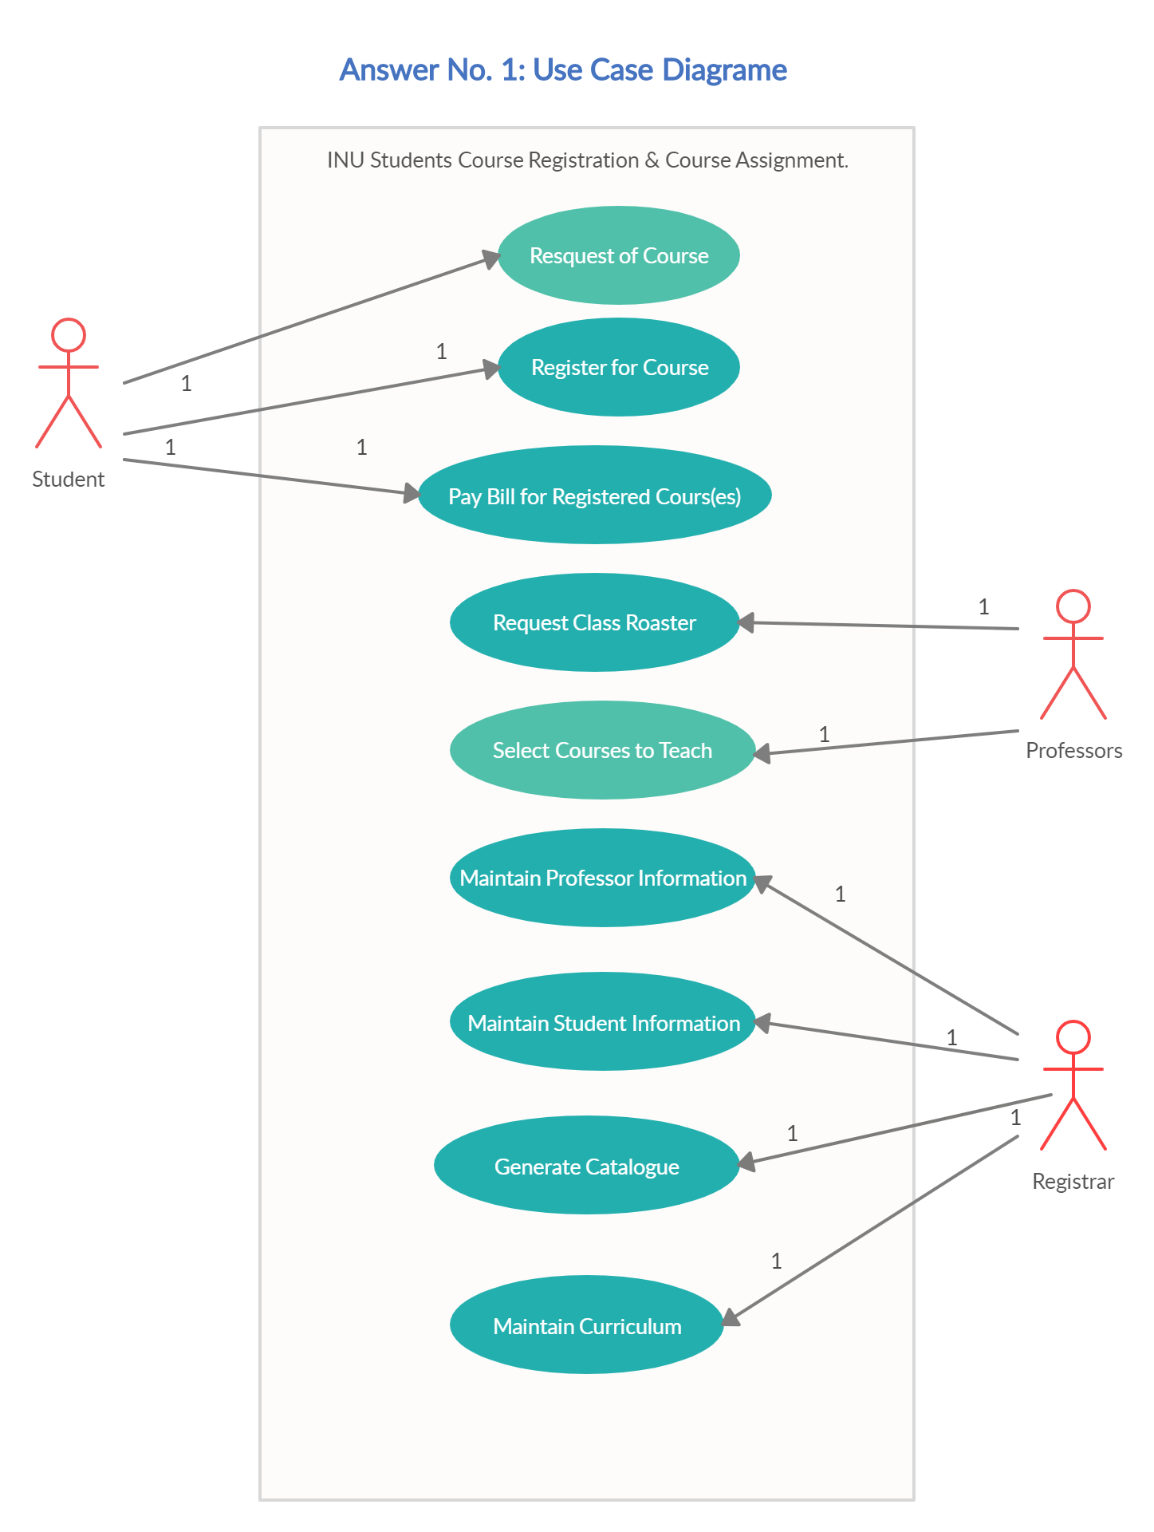

Q2: Draw Class Diagram 10 Marks
A hockey league is made up of at least four hockey teams. Each hockey team is composed of six to twelve players, and one player captains the team. A team has a name and a record. Players have a number and a position. Hockey teams play games and each other. Each more has a wore and a location. Teams are sometimes lead by a coach. A coach has a level of accreditation and a number of years of experience, and can coach multiple teams. Coaches and players are people, and people have names and addresses.
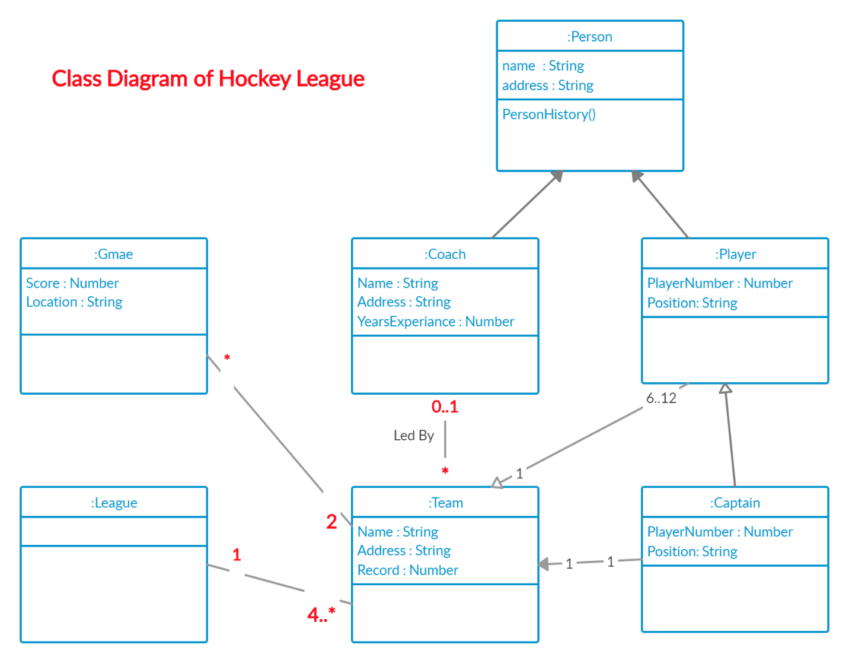
Q3: Draw Activity Diagram 10 Marks
• IQRA National University (PU) is intending to develop a Project Deliverable Submission System (a web application) for INU students. Project Supervisors, and the Project Office team. System will work well for both Internet Explorer as well as Google Chrome.
• Every final year student will be assigned a UniquelD (based on his RolINO) and the password. When the students logs in to the system. project schedule and deadlines are visible. Project Deliverable templates for both types i.e. research projects and the development project, are also available in downloads section_

• After completing the deliverable, student can then upload the deliverable content and all group members working on the project would be notified. In case of several instances of the submitted deliverable, group leader would wt one of the deliverables as final version. When the student submits the final version, date and time of submission is recorded. Project supervisor of the group is also notified about the submission. For every late submission 5% deduction is made.
• When the student submits the deliverable, his deliverable is evaluated. For each project, marks are assigned for each individual student (either by the project office teachers or by respective supervisor)
Answer:
