PHYSIOLOGY ASSIGNMENT
NAME: IRSA IJAZ
ID # : 16228
1)what is blood ? Write the function and composition of blood ?
Ans)DEFINITION:
Blood is a body fluid in humans and other animals that delivers necessary substances such as nutrients and oxygen to the cells and transports metabolic waste products away from those same cells. In vertebrates, it is composed of blood cells suspended in blood plasma.
COMPONENTS:
It has four main components:
- plasma,
- red blood cells,
- white blood cells,
- platlets.
FUNCTION:
Blood has three main functions:
- Transport
- Protection
- Regulation
- TRANSPORT:
Blood transports the following substances:
- Gases, namely oxygen (O₂) and carbon dioxide (CO₂), between the lungs and rest of the body.
- Nutrients from the digestive tract and storage sites to the rest of the body
- Waste products to be detoxified or removed by the liver and kidneys
- Hormones from the glands in which they are produced to their target cells
- Heat to the skin so as to help regulate body temperature
PROTECTION
Blood has several roles in inflammation:
- Leukocytes, or white blood cells, destroy invading microorganisms and cancer cells
- Antibodies and other proteins destroy pathogenic substances
- Platelet factors initiate blood clotting and help minimise blood loss
REGULATION
Blood helps regulate:
- pH by interacting with acids and bases
- Water balance by transferring water to and from tissues
COMPOSITION OF BLOOD:
Blood is classified as a connective tissue and consists of two main components:
- Plasma: which is a clear extracellular fluid ,
Formed elements, which are made up of the blood cells
- platelets
The formed elements are so named because they are enclosed in a plasma membrane and have a definite structure and shape. All formed elements are cells except for the platelets, which are tiny fragments of bone marrow cells.
Formed elements are:
- Erythrocytes, also known as red blood cells (RBCs)
- Leukocytes, also known as white blood cells (WBCs)
- Platelets
BLOOD IN HUMAN BODY:
- Approximately 8% of an adult’s body weight is made up of blood.
- Females have around 4-5 litres, while males have around 5-6 litres. This difference is mainly due to the differences in body size between men and women.
- Its mean temperature is 38 degrees Celcius.
- It has a pH of 7.35-7.45, making it slightly basic (less than 7 is considered acidic).
- Whole blood is about 4.5-5.5 times as viscous as water, indicating that it is more resistant to flow than water. This viscosity is vital to the function of blood because if blood flows too easily or with too much resistance, it can strain the heart and lead to severe cardiovascular problems.
- Blood in the arteries is a brighter red than blood in the veins because of the higher levels of oxygen found in the arteries.
- An artificial substitute for human blood has not been found.

2)Explain the physiology of cardiovascular system?
Ans)Definition:
The cardiovascular system can be thought of as the transport system of the body.
COMPONENTS:
This system has three main components:
- heart
- blood vessel
- blood
CARDIOVASCULAR SYSTEM:
The heart is the system’s pump and the blood vessels are like the delivery routes. Blood can be thought of as a fluid which contains the oxygen and nutrients the body needs and carries the wastes which need to be removed. The following information describes the structure and function of the heart and the cardiovascular system as a whole.
CARDIAC CYCLE:
DEFINITION:
The cardiac cycle is the sequence of events that occurs in one complete beat of the heart
SYSTOLIC:
The pumping phase of the cycle, also known as systole, occurs when heart muscle contracts.
DIASTOLIC: The filling phase, which is known as diastole, occurs when heart muscle relaxes.
SEQUENCE OF THE EVENTS:
- Carotid arteries, which take blood to the neck and head
- Coronary arteries, which provide blood supply to the heart itself
- Hepatic artery, which takes blood to the liver with branches going to the stomach
- Mesenteric artery, which takes blood to the intestines
- Renal arteries, which takes blood to the kidneys
- Femoral arteries, which take blood to the legs
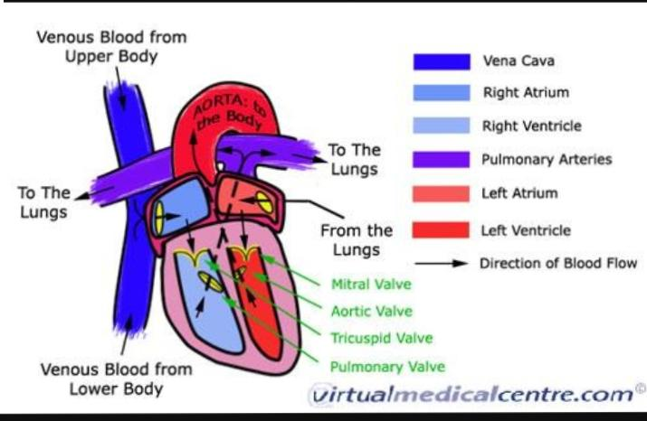
3) explain the physiology of pulmonary system circulation?
Ans)DEFINITION:
The pulmonary system consists of upper and lower pulmonary structures, bronchial/systemic circulation, and gas exchange at the level of the lungs and tissue cells.
FUNCTION:
The human respiratory system is a series of organs responsible for taking in oxygen and expelling carbon dioxide
Primary organs:
The primary organs of the respiratory system are the lungs, which carry out this exchange of gases as we breathe
PROCESS:
the four processes of respiration. They are:
- BREATHING or ventilation
- EXTERNAL RESPIRATION, which is the exchange of gases (oxygen and carbon dioxide) between inhaled air and the blood.
- INTERNAL RESPIRATION, which is the exchange of gases between the blood and tissue fluids.
- CELLULAR RESPIRATION
In addition to these main processes, the respiratory system serves for:
- REGULATION OF BLOOD pH, which occurs in coordination with the kidneys, and as a
- DEFENSE AGAINST MICROBES
- Control of body temperature due to loss of evaporate during expiration

