NAME: FAHAD AFZAL
ID# 13653
PROGRAM: BBA (6TH SEM)

PROJECT MANAGEMENT

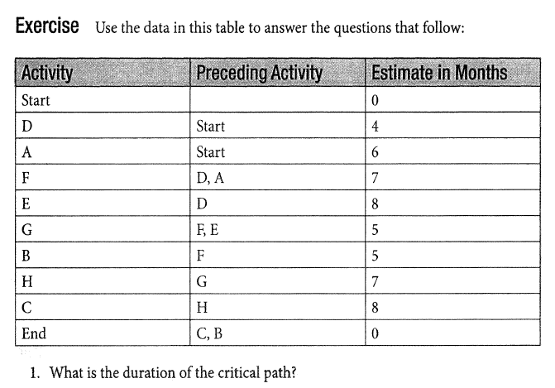

ANS:

