TANEEM HIDAYAT
16643
FASHION CONCEPT
FINAL EXAMS
23 JUNE, 2020

QUESTION NUMBER 1:
Fill in the blanks
- Applied.
- Fashion draping
- Pricing
- Flaws
- Croquis
- Geographic
- Infants
- Darts
- Marketers
- Designer wear

QUESTION NUMBER 2:
Choose the correct answer
- Mannequin
- 1960s
- Old people
- Summer
- Haute couture

QUESTION NUMBER 3:

True and false:

- True
- False
- False
- True
- False
- True
- False
- False
- False
- True

QUESTION NUMBER 4:
Answer the following questions:
PART A
Define the difference between draping and flat pattern with examples?
ANSWER:
DRAPING:
The meaning of draping is to arrange the cloth loosely or casually with folds on or around something. Since 18th century, Fashion draping is the ancient technique which is used and considered to be an important part in fashion designing. Fashion Draping is the process of placing and pinning fabric on a standard size dress form to advance the structure of a garment design. It is usually done on mannequins.

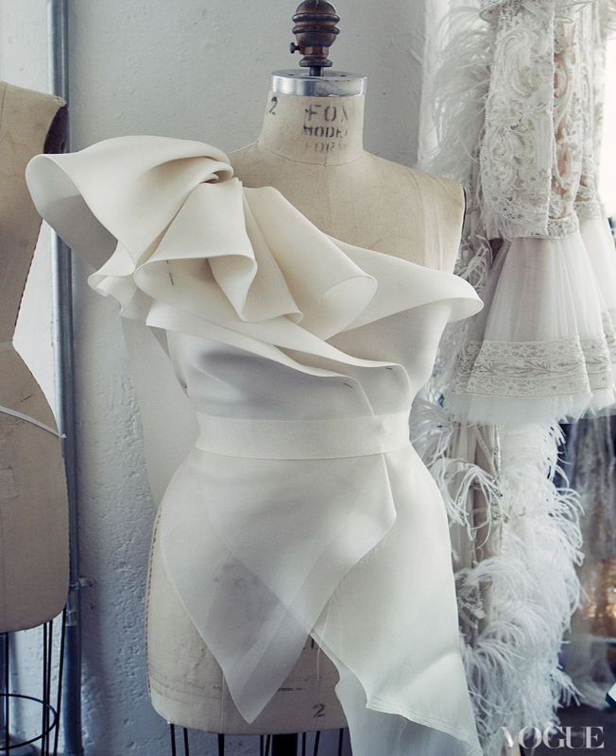

A dress can be draped using a design sketch as a basis, or a fashion designer can play with the way fabric falls to create new designs at the start of the dress design process.
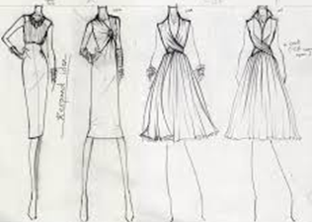

After draping, the toile fabric is removed from the dress form which was used to create the sewing draped pattern for making fashionable dress to suit an individual. It has the appearance of flares and falling fabric.

TOILE AND MUSLIN FABRIC:

In U.S.A. designers use very light weight fabrics, which is called as 'toile', and U.K. designers call it as 'muslin' cloth.

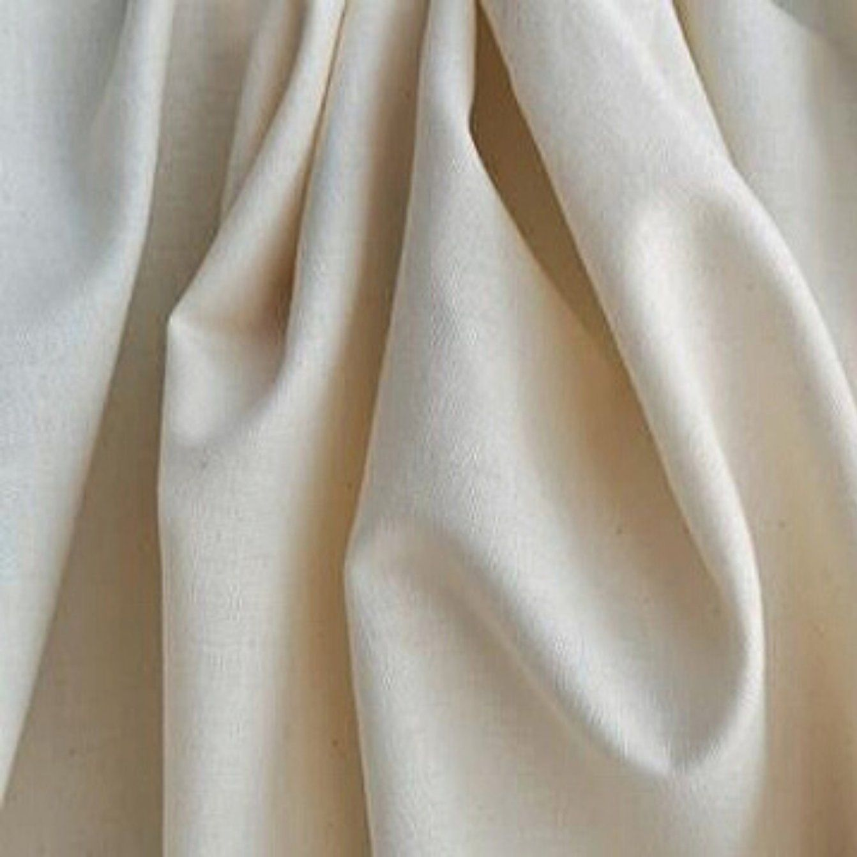

The techniques for draping fabric require the knowledge of the fabric's characteristics. Designers/drapers must have the knowledge to distinguish among different fabrics which will enable them to select the most suitable fabric for flow and line of each design. Designers must devote time to collect swatches while shopping and catalogue them by width content.

Fabrics used for Draping:
Fabrics and clothes must relate to our lifestyles and our active lifestyles are made of many different fabrics. The process starts with the choice of fabric that you wish to choose to drape. Considering the traditional and old fashion industry, muslin was used for toiles or even for the fitting samples. The reason for choosing muslin over the years could be that it comes in a huge variety of fabric and is an inexpensive fabric as compared to the other ones in the market. Drape ability plays an important role in making sophisticated draped garments. Mostly, very light weight to medium weight fabric is suitable for draped garments such as:
  - Stretchy knitted fabrics
  - Chiffon
  - Georgette
  - Organza
  - Sheer cottons
  - Voile
  - Lightweight silk fabrics

These all are most suitable for fashion draping purpose.

Muslin Types:
There Are 4 (Four) Types of Muslin Fabric.
- Soft Muslin
- Medium-Weight Muslin
- Coarse Muslin.
- Canvas Muslin.

- Soft muslin will simulate the draping quality of natural or synthetic silk and knitted cloth.
- Medium-weight muslin will simulate the draping quality of wool and medium-weight cottons.
- Coarse muslin will simulate the draping quality of heavy weight wool and cottons.
- Canvas muslin will simulate the draping qualities of heavy weight fabrics such as denim or imitation fur.

INSTRUCTION OF DRAPING:
Consider the large collection of fabrics accessible before beginning any draping steps. The fabric selected for a garment drape greatly impacts the finished look.
Evaluate and understand the structure and characteristics of the fabric to create the proper ease, hand feel and balance of the garment or pattern drape. Approach each design with a positive attitude and a clear fashion sense. This is the standard rule when fitting and draping any type of garment. In simple words, draping technique means the way a fabric hangs in a dress form as well as on the human body.

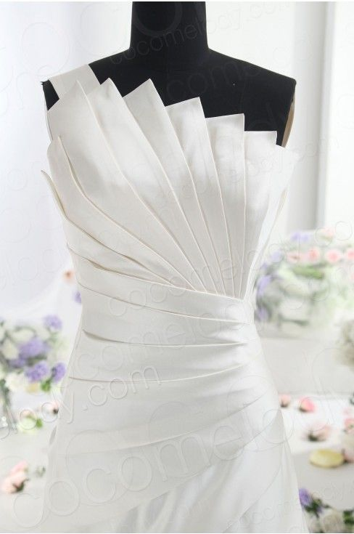

Tools used for Draping:
Dress form with sizes and can be chosen according to the requirement.

- Draped-cloth
- Scissors
- Arm hole curve
- Graduated-square
- Pins
- Marking-chalk
- Pencils
- Sharpeners
- Notches
- French-curves
- Foot-ruler
- Dark colored twill tape
- Measuring tape
- Hip curve
- Sleeve curve
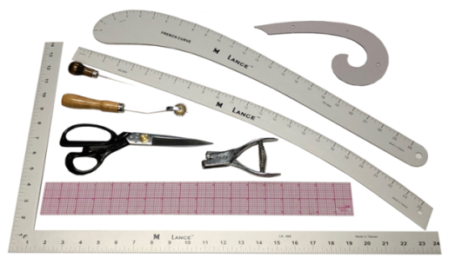

The important points that should be taken care of when draping the fabrics on dress forms are:
- GSM of the Fabric (Weight)
- The bias, selvage of the fabric
- Pattern, texture and muslin mock-ups
- Darts, seam location, finishing

The Tearing:
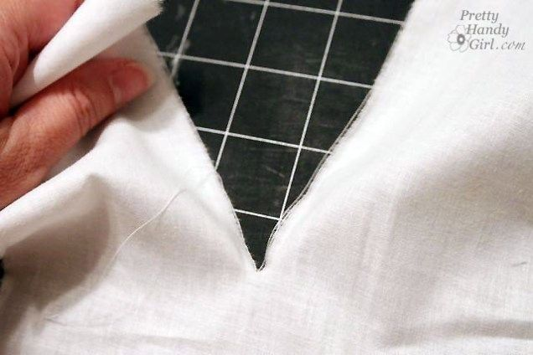
This is the step where you have to estimate how much muslin is compulsory, also in view of a reasonable amount of extra fabric needed as peruse for the ease, seaming allowance and fashion styling. The next step is to cut the extra edge of the muslin fabric with the use of scissors and then tear the fabric grain with the required pressure to break the fabric yarns successfully. Then, make sure that crosswise true grain or the lengthwise true grain is forming the edge of the muslin that will be used for the drive of draping. It is because when the selvage is tightly and closely woven, it has a tendency to hold in the muslin fabric by often throwing the weave off. Therefore, always make it a point that the center, back and front of the costume is carefully planned.

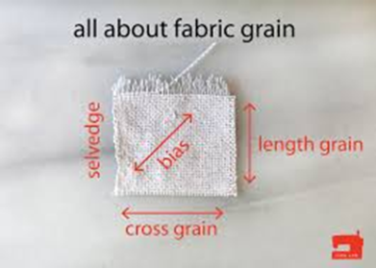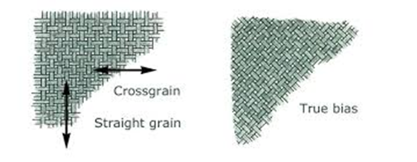

Blocking:
It may happen that there rises a need to reshape the muslin fabric so that proper shape and angles are been given to the crosswise and true lengthwise yarns and grains to give the perfect edge to the dress. For reshaping the muslin, you can pull the edges of the fabric diagonally till the fabric is all squared.

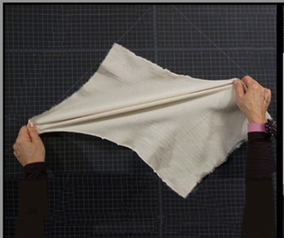
Pressing:
Here it is required to set the exact location of the yarns with the aid of steam and the heat of the pressing. Always make it a point to press in the precise directions of the crosswise and lengthwise grains.

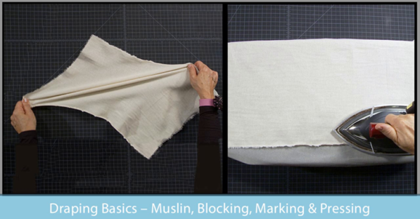
Seam Allowances:
In draping then add 1-inch seam allowance on all the straight streams by also including the side seams, the waistline seams and the underarm seams.

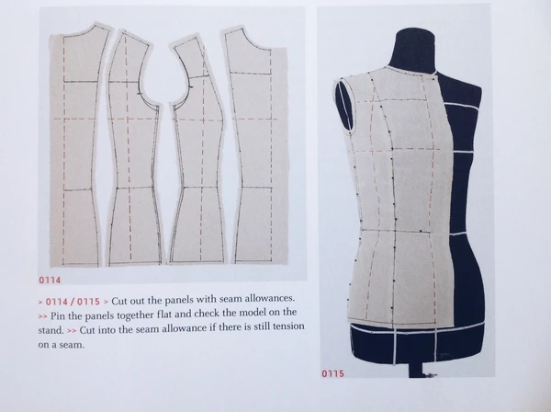

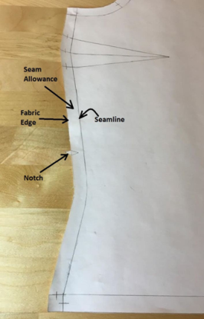

Taping:

This process is done on mannequin before start of draping. Taping is done according to basic measurement to get a customize dress.

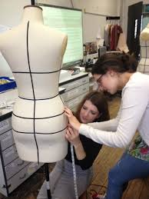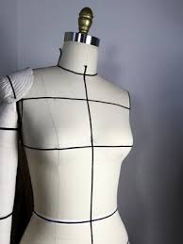

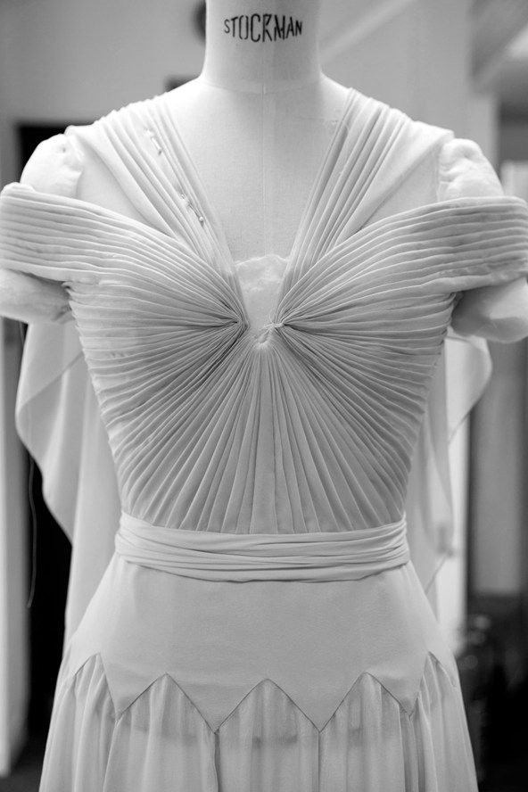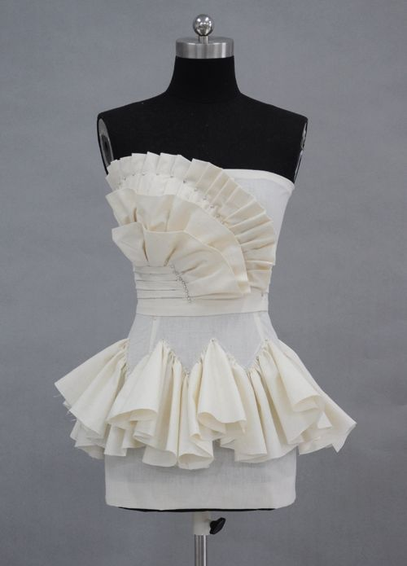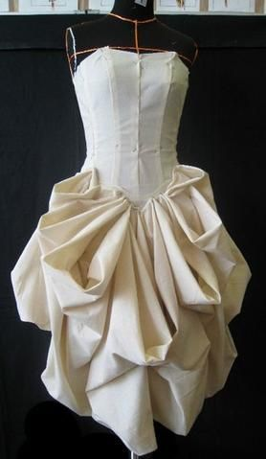

EXAMPLES OF DRAPE GARMENTS:
Chitons, Sarees, Ponchos, Cloaks, Stolas, Togas.

Flat Pattern Making

PATTERN MAKING
Pattern making is an art. It is the art of operating and shaping a flat piece of fabric to imitate to one or more curves of the human figure. Pattern making is a bridge function between design and production.

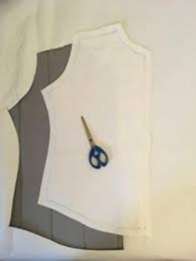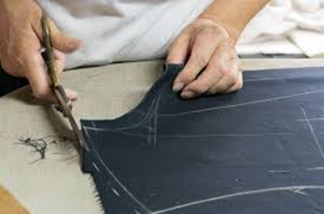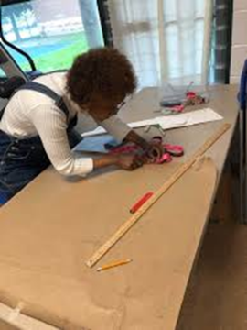

A sketch can be turned into a garment through a pattern which infers the design in the form of the garment components. Now a day’s erudite software programs are used for pattern making.

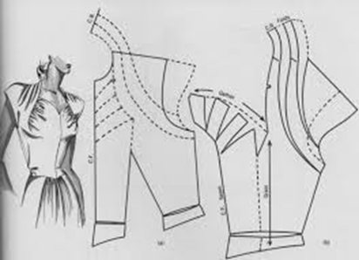

BASICS OF PATTERN MAKING
A pattern is flat while the body is not. The body has height, width and depth. Darts are the basis of all pattern making. They convert the flat piece of cloth into a three-dimensional form, which fits the bulges of the body. A patternmaker typically makes a pattern from a flat sketch with measurements or a two-dimensional fashion illustration.

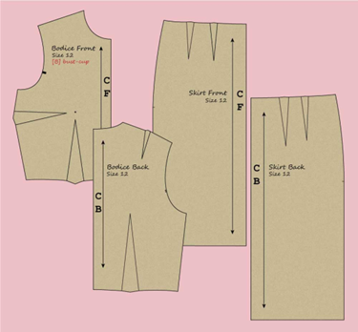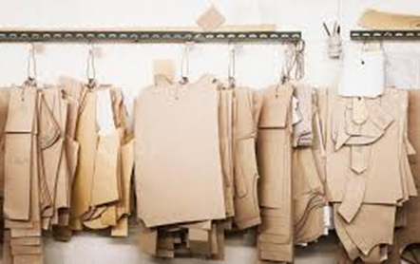

The basic pattern is the very foundation upon which pattern making, fit and design are based. The basic pattern is the starting point for flat pattern designing. It is a simple pattern that fits the body with just enough ease for movement and comfort.

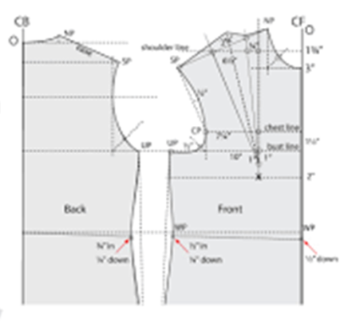

FLAT PATTERN MAKING:
- In Flat Pattern Making, we take the accurate measurements from a dress form or a figure and then measurements are turned into a pattern using paper.
- In today's world flat pattern making has become essential for a fashion designer to make garments of different body sizes. Flat pattern making is quite interesting and important, it helps the people of any age groups to infer the designs and understand the design with technical ability.
- The right fit is a key to gaining consumer confidence and loyalty.
- Once a brand’s target fit has been defined, it must be wielded intelligently to maintain a competitive advantage.
- Flat pattern making, when done correctly, provides the code to this integral part of a brand’s DNA and helps ensure keenness in a challenging market place.
- Working pattern is derived from the flat method or modeling. Each and every pattern is laid on the board paper to copy the block pattern. Then sewing allowance, trimming allowance, Button hole, button attaching, dart, pleat, Notch, shrinkage of the fabric, etc. are added with the copied pattern.

- A sloper is a pattern that has no seam allowances or style lines.
- From a sloper a myriad of garment styles can be generated.
- The patternmaker creates a new style by adding design details such as a collar, pocket and pleats.

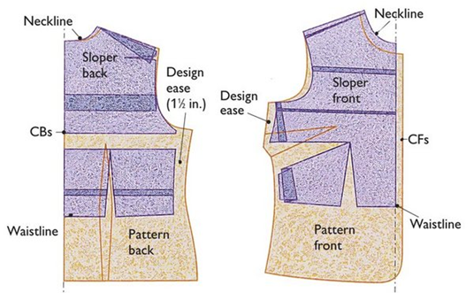

- The rapid output of new flat pattern designs, facilitated by slopers, is a useful skill for any fashion designer.
- Flat pattern can be used as a means of developing original ideas effectively and efficiently.
- Flat pattern is use of the three basic slopers:
- Waist
- Sleeve and skirt
- Some popular variations of these such as the kimono waist, raglan sleeves and pants.

- The flat pattern method uses twelve basic pattern slopers that are manipulated by the patternmaker to achieve a desired style or design.

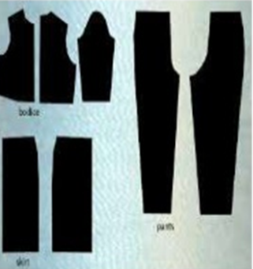
Steps of Flat pattern making:

- Block pattern:

Block pattern or basic block indicates the original pattern. Block Pattern is made based on the specific and standard body measurement without any design or style.

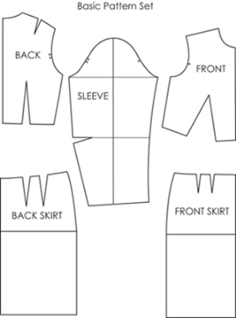

- Working pattern:

Working pattern is derived from the flat method or modeling and it is further used for stylization in basic block pattern.
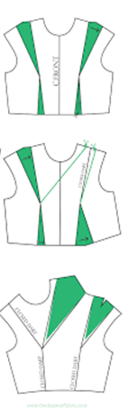
Five basic pattern pieces are used for women's clothing. They include:
- a snug-fitting bodice front
- bodice back with darts
- a basic neckline
- a sleeve
- a fitted skirt front and back with darts.
Nevertheless, as fashion changes frequently women's styles alter recurrently. These basic slopers are then manipulated to create fashions.

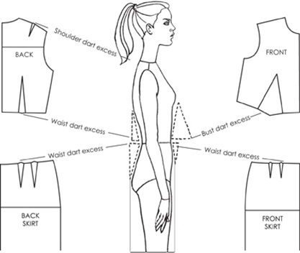

- "Patternmaking" is the process of creating all the correctly sized pieces needed to make a complete garment.
- For many smaller manufacturers, pattern making is still done on paper because the cost of computerized systems remains prohibitive.
- The flat patternmaking method is widely used in the ready-to-wear market because it is fast and accurate.
- Although pattern making is becoming increasingly computerized, patternmakers still must learn the manual method because making patterns manually develops an advanced understanding of garment construction, knowledge that cannot yet be replaced by a computer.

BASIC TOOLS FOR FLAT PATTERN MAKING
Having the right tools for making a pattern is a super important place to start. Most tools are not expensive and are easy to get.

1) Large scale paper
2) Clear Gridded Ruler
3) Flexible Design Rule
4) Hip/Arm Curve (Styling Design Ruler)
5) Pencil and a good Eraser
6) Large pins
7) Cork panels
8) Flexible Measuring Tape
9) Basic sewing book
10) Tracing Wheel
11) Tailor’s chalk
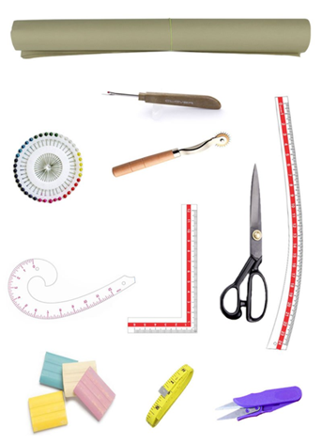

PATTERN MAKING IN TODAY’S WORLD:

- Pattern making today has become an easy job with the use of the computers.
- Now-a-days different soft wares are available in the market to meet the needs of the manufacturers.
- The different soft wares used are Gerber, Lectra, Tukatech, OptiTex etc.
- These softwares have made the job of the Pattern master easier.
- They have made the process of pattern making more economical and less time consuming.
- Pattern-making software enables you to input your measurements and draft out a pattern. These soft wares draft patterns to fit your measurements specifically, eliminating much fitting trial and error in the sewing room.

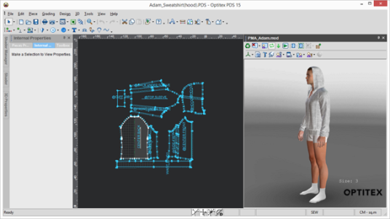

EXAMPLES OF FLAT PATTERNING:
Kimono waist, raglan sleeves, and pants.

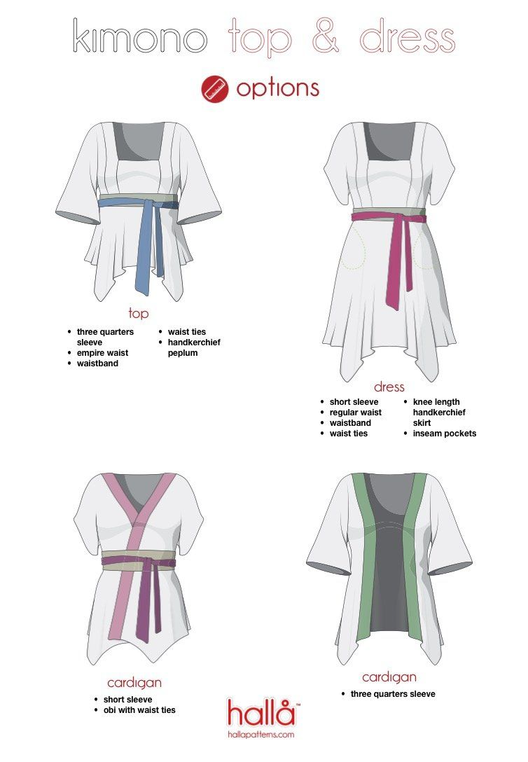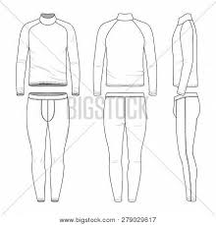
Kimono shirts and raglan shirt and pants.

PART B:

Explain types of qualification required for career of fashion designer?

ANSWER:

To start a career as a fashion designer, two types of qualifications are required, that is, natural and acquired.

Natural:

- This skill set would embrace of a decent aesthetic sense, color expertise, good taste and sense of trends and fashion.

- An eye for detail, knowledge of fabrics and so on is a big plus for those serious about a career as a fashion designer.

Acquired:

- Acquired skills would be a qualification from a decent, recognized fashion Institute.
- You can enroll for either a full-time course or a part time certificate course. Students usually take these up after their 10+2 level.
- Not that the courses are not just available for graduates or people with higher qualification.
- There are several short-term certificate courses that are offered by the same fashion institutes for super specialization, on part-time basis.
- These courses train you with technical and creative thinking skills.

Besides, fashion students can also pursue following careers
- Fashion designers.
- Pattern maker.
- Stylist.
- Fashion buyers.
- Teachers.
- Overall dress makers.
- Illustrators (who make sketches) they sit around the ramp.
- Fashion forecast expert.
- Fashion journalists.
- Alterationist (mostly in boutiques).
- Wardrobe consultants
- Fashion advisor.

PART C:
What is meant by four P’s of marketing?
ANSWER:
consists of our basic marketing strategies known as the four P’s of marketing.
1. Product
2. Place
3. Price
4. Promotion
These are the basic elements to satisfy a customer’s needs and wants.

Product
- Which company is offering for sale to customers to satisfy their needs and wants.
- includes goods and/or services
- Strategies that include producing, packaging, and naming a product.
- Ex. jeans, sweaters, jewelry, hairstyling
Place
- The way products are distributed and their systems of delivery
- Getting the product to consumers and the steps of distribution
- How and where a product will be distributed
- Where the customer will purchase the item
- When the product will be distributed
Price
- the amount of money consumers will pay for a product
- have to determine how much consumers are willing to pay
- Depends on the price of producing the item, the markup, and the customer demand.
- Goal: Business must make a profit.
Promotion
- Any form of communication that a business or organization uses to inform, persuade, or remind people to buy its product
- Inform customer about the features of the product and convince to make a purchase

