VIVA ASSIGNMENT
Subject Maxillofacial surgery
Name Abid Khan
Id 13763
Bs DT 6TH
Submitted To : MA’AM NATASHA KAMRAN

Q: which tooth is most commonly involved in impaction?
Ans : The wisdom teeth (third molars) are frequently impacted because they are the last teeth to erupt in the oral cavity. Mandibular third molars are more commonly impacted than their maxillary counterparts.
An impacted tooth is one that fails to erupt into the dental arch within the expected developmental window. Because impacted teeth do not erupt, they are retained throughout the individual's lifetime unless extracted or exposed surgically. Teeth may become impacted because of adjacent teeth, dense overlying bone, excessive soft tissue or a genetic abnormality. Most often, the cause of impaction is inadequate arch length and space in which to erupt. That is the total length of the alveolar arch is smaller than the tooth arch (the combined mesiodistal width of each tooth)

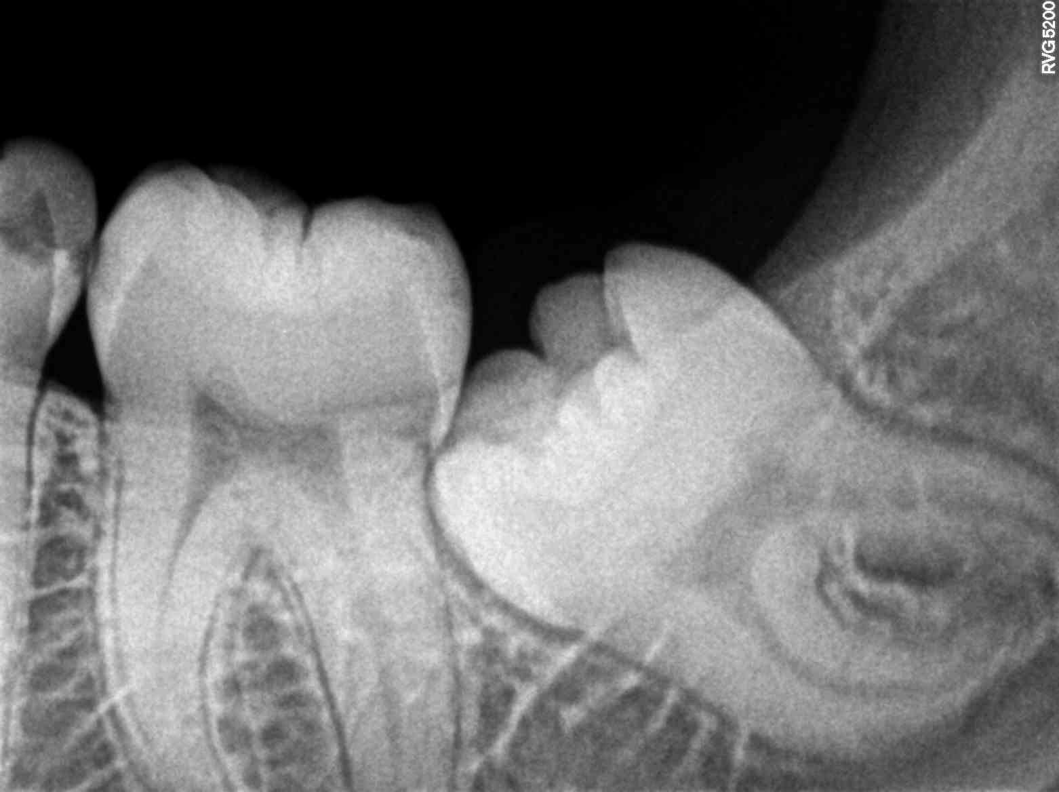

Impacted wisdom teeth is a disorder where the third molars (wisdom teeth) are prevented from erupting into the mouth. This can be caused by a physical barrier, such as other teeth, or when the tooth is angled away from a vertical position.[1] Completely unerupted wisdom teeth usually result in no symptoms, although they can sometimes develop cysts or neoplasms. Partially erupted wisdom teeth can develop cavities or pericoronitis. Removal of impacted wisdom teeth is advised in the case of certain pathologies, such as nonrestorable caries or cysts.[2]
Wisdom teeth likely become impacted because of a mismatch between the size of the teeth and the size of the jaw. Impacted wisdom teeth are classified by their direction of impaction, their depth compared to the biting surface of adjacent teeth and the amount of the tooth's crown that extends through gum tissue or bone. Impacted wisdom teeth can also be classified by the presence or absence of symptoms and disease. Screening for the presence of wisdom teeth often begins in late adolescence when a partially developed tooth may become impacted. Screening commonly includes clinical examination as well as x-rays such as panoramic radiographs.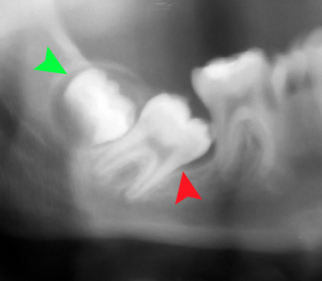

What is the management of root displacement?
The tooth root can be displaced into the maxillary sinus. If this occurs, the surgeon must make several assessments to prescribe the appropriate treatment. First, the surgeon must identify the size of the ‘root lost into the sinus. It may be a root tip of several millimeters, an entire tooth root, or the entire tooth. The surgeon must next assess if there has been any infection of the tooth or periapical tissues. If the tooth is not infected, management is easier tharr if the tooth has been
acutely infected. Finally, the surgeon must assess the preoperative condition of the maxillary sinus. For the patient who .has a healthy maxillary sinus, it is easier to manage a displaced root than if the sinus has been chronically infected. If the displaced tooth fragment is a small (2 or 3 mm) root tip and the tooth and sinus have no.preexisting infection, the surgeon should make a
minimal attempt at removing the root. First, a radio graph of the fractured tooth root should be taken to document its position and. Size. Once that has been accomplished, the surgeon should irrigate through the small opening in the socket’ apex and then suction the irrigating solution from the sinus via the socket. This occasionally flushes the root apex from the sinus through the socket. The surgeon should check the suction solution and confirm radio graphically That the root has
been removed.

Local anesthetic agent :
Following are the local anesthetic agent which are given below:
Ester type:
• Procaine Short
• Chloroprocaine Short
• Benzocaine Short
• Tetracaine Long
Amide type:
• Lidocaine Intermediate
• Prilocaine Intermediate
• Mepivacaine Intermediate

