Name= Safi ur rahman ID*14659 Assignment submit to=Mem Nadra khaleeq Subject= PHARMOCOLOGY MLT Date= 26th September 2020 Time = 3:00 pm Exam = Final Term
Student of = Allied Health Science MLT Subject failed in= 2nd sem.

Course Title: General Pharmacology
Student Name: Safi ur rahman
Student ID: 14659

Note:
- Paper is divided into 5 questions
- Each question carry equal marks (10) with grand total of 50 marks
- Each question is composed of specific parts, pay attention to each part of question or otherwise it will lead to mark deduction
- Avoid copy paste from slides, your answer may got canceled if it found a total copy

- Define drug receptors, enumerate different receptor families and explain the receptor that shows its effect through second messenger system.

- Define drug interactions, enumerate its various types, and explain pharmacokinetic drug interactions and its factors with examples.

- Differentiate between general and local anesthesia, explain stages of anesthesia in detail

- What does heart failure means, explain the pathophysiology of heart failure
- Classify the drugs used for the treatment of heart failure, explain along with mechanism.

- Differentiate between broad spectrum and narrow spectrum antibiotics, classify antibiotic drugs
- Explain briefly the mechanism of action of antiviral agents

Q.1
Answer

Drug Receptors:
The drug can make the effects through interacting with the target bimolecular, they are proteins.
With the functional proteins can be targets the drug action and divided or together in four catagories,
- Enzyme
- Ion channels
- Transporters
- Receptors
Those proteins perform functions,
- Enzyme
There are proteins that can change the chemical reaction rate and not required the external energy to change themselfs.
so enzymes is more essential target for the drug action.

- Plays an important role in drug action.
- A human body involved thousands of enzymes.
- While those enzymes have PH and optimum temperature.
- Enzymes can be act or reactions on the certain substances, which is known as substrates.

Like, when subtrates attaches to enzyme and producing the product-A, and when inhibitor attachés so they have no product or no-functions.

- Ion Channel,
These are proteins and founds/located on cell membrane.
- Those proteins can be creates the tinny openings in membrane.
- They only allows to passing through the specific ions.
- Those proteins functioning as to regulates the intracellular ions composition an be participating the signaling in transmembrane.

Example,
Sodium channel (Na+ch)quinidine blocks.

Like,if you see in picture,
When blocker enter to ion channel ,so ions not come to inside biological membrane.
When opener attaches to ion channel,ion channel opening and sodium ,calcium ion ,easily enter inside the biological membrane.

- Transporters,
These are also protens and it have ability to transfer /moves the substrates in the cell membrane.
- And also some substrates translocated across membrane by attaching to the specific transporters and facilitate diffusion direction of concentration gradient and also pumps as metabolite/ion inserted ,of concentration gradient and required the metabolic energy.

E.g.,
When substrate attaché to transporter ,so the transporter can move and substrate will be biological membrane.
When inhibitor attaché to transporters, then no substrates come to inside the biological membrane.

- Receptors,
Those are also some proteins ,so those proteins are macromolecule or attaching site founded on the effectors above o inside on effectors cell.
- Those proteins functioning as to serve the signal molecule of dosafe,
- It inhibiting response ,
- And it have no others functions except itself.

To describe the drugs receptors interactions ,following term can be used,
- Agonists,
When agonists attached to receptors inside the biological membrane produce the effecter.
_ when com-antagonistic attaches inside the receptors ,so no effecter inside the biological membrane.
And also when non-compitive antagonist attaches ,so no transducer & and no effecter produce ,inside biological membrane in the cell.

- Enzyme Inhibitor Process,
Here some having metals, strong acids,phenol and lkalies etc.
Those chemicals as no selectively inhibit both the enzymes and also denaturing the proteins.

Competitive & Non-Competitive Inhibitor,

- Competitive,
Here attaches to active site and also preventing the substrate to not attaching.

- Non-Competitive
Through the adjacent site the inhibitor be reacts only,
Here not be reacted as the catalytic areas.
And enzymes be altering.

Receptor Families And effected by 2nd messenger system

Those receptors can be divided into four families,

1.Ligand Gated Ion Channel:
It is the first family of receptor ,it have responsibility to regulates the ions flows,as across the cell membrane.
-Here by attaching of ligand and channel be activated & regulation is by to attach the ligand with channel .
-And take fewmiliseconds in process.

Example,
Acetylcoline > can be stimulate >nicotic receptor & may result sodium influx.
>The concentration activation is be in skeletal muscle.

2.G-Protein Coupled Receptors ,
Those receptors involed of peptide and those are spinning regions and seven membranes.
While those receptors binded to G proteins and leaving some three subnits.
- A subnit
- B subnit
- Y subnit

3.Enzyme Linked Receptors,
It can be attaching to ligand of an extracellular domain.
And here inhibition the acitivity of cytosolic enzyme and be activated .
So the response duration take minutes to hours.
Example,
Those given are more common as liked –enzyme receptors are,
- Insulin
- Natrueretic peptide
- Edpedermal growth
- Derived growth factor of platelate and son on.
Are enzymes linked factors and those are common.

4.Intracellular Receptor,
It have sufficient lipid solubility and those response is to transfer across the target of the cell membrane.
This receptor constrainted as in ligand chemical property and as well as physical property.\
Those are lipid soluble ligand receptors. And they can be transfer in the body and be binding to plasma protein.
Like, Albumins.
Example,
Like to exert the action in the target cells by steroid harmones.
The attachments of ligand for receptors and following patterns.
And due to dissociation of small repressor peptide,so receptor be activate.
And ligand receptor be convert to neucleus here.
And then attaches to DNA sequences.
And many results to regulates expressions of the gene.
So, the duration of its response and activation take more times as from above discussions takes.
It takes hours to days for response to be activated due to synthesis of proteins and gene to be expresses or others.
So ,this receptor is most greater than others as above discussed receptors.

Q.2
Answer

Drug Interactions:
This sequence means to inter the drug to body and then perform any actions.is the drugs interactions.

Introducing of drug interactions:
It is the movement of the drug with substance that can be effected the drug activity when they both administered.
So they be applied as in tow types of actions,
One is synergestic action and the other is antagonistic.

Synergistic:
The effects of the drug can be high/increase here with synergistic action.
While,

Antagonistic:
Here the effects of the drug become low/dicreases.
As in antagonistic action.
(and also new another action be producing by itself.)
This action is be due to occurred than in tow situations.
Which is pharmacokinetic and the 2nd is pharmacodynamic .

The pharmacconynatic is like the absorption of alterations and in excretion, distribution and drug metabolism as well.

Drug interaction Introducing:
When drug enter to the body then perform tow actions,
That what is drug do with the body?(it is also known as pharmococynatic )
Means response from the body is important for drug to be action.
When we take the drug then absorbed in the body,after absorption ,they go into liver and convert it to active form or some time inactive form.
They must be follows the process of absorption, distribution, metabolism and elimination.
And
The effects of the body on the drug known as pharmocodynamic(like what does drug do with the body)
@Drug may be show positive effects, or no effects. and also some time due to drugs occurs the negative infants.
(when they interacted with other dosage or food etc).

Drug Interaction Types:
There is some process when drug to be interacts in the body and give different responses.

- Drug to Drug Interaction:
Here when drug is interacts with other drugs in the body ,so it may causes as side effects as unexpected.
Here the side of whole body or one side be effected when entered.
Like,
The addition of codeine and paracetamol (so due to this analogesic effects become high)
And high bleeding will cause because by Aspiren+Warfarein synergism.
And also antibiotics effects become high through clavulanic acid+amoxicillin synergism.

- Food And drug Interaction:
This situations occurred when you eats any foods that medicines ingredients that you was taken. now that medicine unable to do action for your problem.

Example,
Benzodiazephines,\
In grape fruits that effects enzyme which belongs to into metabolism of drug.
And
Tetracyclines
+calcium
Due to drug absorption become reducing.

- Disease And Drug Interaction:
It is the condition as in some situations drug be helpful for patient or at some situation of the drug be harmful of the body. like,
Beta-blocker are used for patient with for high BP patient or any heart problems.so but dangerous for patients with diabetes have low blood sugar.

Pharmacokinetic,
The pharmacconynatic is like the absorption of alterations and in excretion, distribution and drug metabolism as well.

Pharmacokinetic Interactions:
The GIT(gastro intestinal tract )altered.
+PH be altered.
+bacteria flora be altered.
+the drug chelates formation .
+mucosal damage be induce by the drug .
+And also GIT motility is altered.

The PH Altered:
It is the most lipid soluble and double and drugs non-ionized type.
Like dissolution of ketonozole of tablet become low as acidic (which antiacids).
It is more absorb from GIT as except ionized type.
At least tow hours as H2 antagonists drugs can be separated ,when both are administered.

Intestinal Bacteria Flora Altered:\
To administered as 40% digoxin or more and can be metabolizes the dosage through intestinal flora.
And a large number of normal can be killed through antibiotics into intestine.
And toxicity and doxcin concentration be decreasing.

Complication:
Milk or prepared iron be interacts with tetracycline and be complex unabrsopable.
/Ca2+/
Low absorption of ciproflacin because of chelation through 85 & by alumenium & megnisium.

- Drug Induces Mucosal Damage:
The absorption of some drugs like digoxin be inhibited by by,
Vincristine:procarbazine:cyclophasmid
(they are antineuplast agents)

Motility Altered:
Cyclosprine absorption become high by metaclopramid because stomach emitting increased and time that increases cyclosporine toxicity.

Displacement Protein Attachment:
It depends on the drug affinity of plasma proteins,here bounded drugs be able to displace the others.
Due to highest affinity extra drugs become high through displacement.
Like high attached to plasma protein as be 90%.
Warfarin is 99% and 96% is tulbotamide.

Sulfonamides,
Aspirin and phenylbutazone those agents can be displaces by drugs

Metobolism Altered:
The major site of metabolism is the liver.
Here drug be effects on metabolism of another drugs.
And also perform action in the skin,White blood cells(WBC),
Gastro intestinal tract(GIT),and lungs as well,those are organs.

We have some examples for drugs to effected on metabolism rates on others,
- Enzyme induction
&
- Enzyme Inhibition

Enzyme Induction:
Here enzymes have essential for metabolism of its own or some other drugs ,so a drug may cause to induced those enzyme.
Likely,itself metabolism be increased by Carbamazepine (those drugs are antipeliptic)
Or
Hepatic metabolism of theophyline be increased by phenytion.
Inhibition Of Enzymes:
Here drugs metabolism rates be decreased by others,so due to this,the concentration of target drug and toxicity become higher.
To become onset than take 24 hours.
Enzyme inhibited because of competition on attaching areas.
Inhibitor effects by prodominent,when (Carbamazephine)be administered before.

Q.3
Answer

Anesthesia,
It is used for medical purposes, which means loses of awareness or sensation .
Or,
Anesthetic is a Greek word which means (no-sensation_)
It is medical aims to that patient not to feels pain at time of surgery or other operations with given of Anesthesia.
Here they used drugs for Anesthesia that for loss of awareness or sensation but as tampririaly.

The term Anesthesia have two classes,
*General Anesthesia
*Local Anesthesia

- General Anesthesia ,
Here in this your whole body be conscious and not be feels pain and looks like you are sleeping.
Here your full body is sleeps and lost sensation as tamperiroly.
It used for serous operations or surgery.
Here patient be inactive as full body for tamperiroly.

- Local Anesthesia,
Here just one part or point or area of your body be conscious and not feels pain as full area or point where drugs be entered by surgical doctor.
You not feels pain as temporarily in the part of body with Anesthetics.
Here in this type of anesthetics, patient is active but one part of the body be inactive or conscious for given time where drugs entered.

Local Anesthesia,
It can be divided into tow classes,
Surface Anesthetics
&
Inject able Anesthetics

Inject able Anesthetics:
Here in this class,the drugs can be injects as with different injectable routes of the body.like,

Inject able Anesthetic Classification,
It could be divided into three classes,
A/Short duration acting:
Its examples are,
+Chloroprocaine
+Procaine

Duration acting as intermediates,
Its examples are,
Prilocaine
+lidocaine
+mepivacaine
+Articaine etc.

Long duration acting,
Examples are,
Tetracaine
+Dibucaine
+Rupivaciane etc.

Local Anesthetic Mechanism of Action:
It attach into sodium channels as directly, and then locks the channel closely,
And then results as action potential propagation and entering of sodium be prevented here within channel.
Local Anesthesia Diagram.
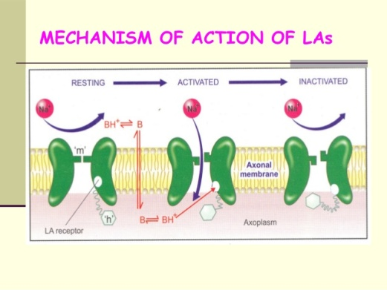

By hand written local Anesthesia, Mechanism of action 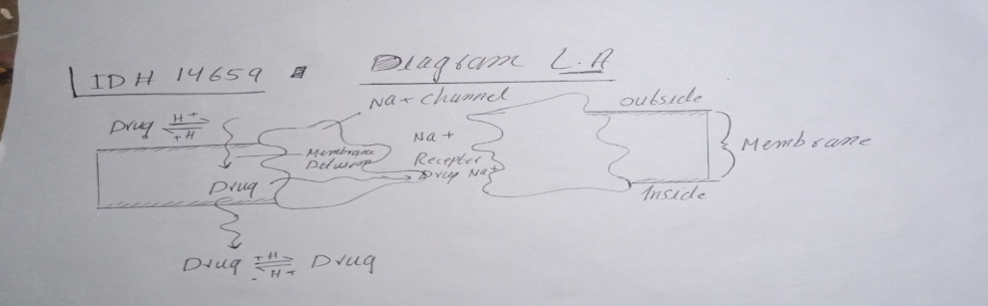
___________________________________________________________________
Q.4(a)
Answer

- Heart Failure & phathophysiology

Introduction Heart Failure:
It is the condition, in which heart can not pumps the quantities of blood that required for peripheral tissues.

Symptoms showing in condition as ,
Physical activities tolerance.
&
Occurred the peripheral edema.

Pathophysiology
Here I discussing the pathophysiology of heart failure in picture below, 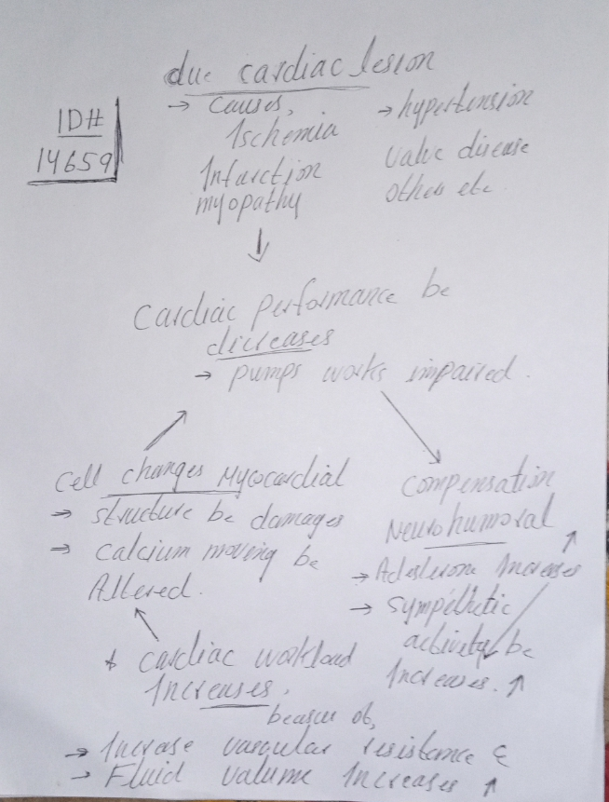

Strategies,
(decrease & increases effects with failure below discussing )
Performance of the cardiac contractile be high and provides inotrophic effects as positively.
Inotropic is a muscle contraction force.

The drug Applicable for Inotropic effects is ;
“Cardiac Glycosides”
Cardiac workload be low by effects on the peripheral vasculature and heart or through fluid volume controlled.
The benefits in congestive heart failure,
So enzyme inhibitors, vassodiators and diuretics and also beta blockers are changed by Angeotensin.

Drugs Used For Failure Of Heart:
Cardiac Glycosides:
Are the positive inotropic drugs, while those drugs have ability to increasing heart contractility and can high Ca+.

Beta Agonists : (Dubutamine)
Is the inotropic positive drugs ,while those drugs can exerts positive inotropic and able to for beta 1 recepter can stimulates in mycocardium.

Inhibitors PDE : ( Milrinone)
Those are inotropic positive drugs ,those are agents and can be effects as medicated cAMP,so here intracellular be high by this and into mycocardial ,the force of construction be high.

Nitrorusside:
It is vasodilator and here on the vascular smooth muscles ,throughout blocked receptor beta-1 then performed vasodilatation.

Diuretics:
It is for chronic failure ,and miscellaneous. From nephran .
It can inhibits the sodium reabsorption .so, amount of water become low and excretion of H20 be high.

Spironolactone:
Beta blockers:
Are the chronic failure miscellaneous drugs and have ability to be normal the heart syphethatic stimulation.
Here the heart rate be reducing by those of the drugs.
Also negative inotropic and negative chronotropic effects and as well mycocardial normalize by them.

Q.4(b)
Answer

- Heart Failure Treatment &
Mechanism:

Cardiac Glycosides:
Are the positive inotropic drugs, while those drugs have ability to increasing heart contractility and can high Ca+.

Beta Agonists : (Dubutamine)
Is the inotropic positive drugs ,while those drugs can exerts positive inotropic and able to for beta 1 recepter can stimulates in mycocardium.

Inhibitors PDE : ( Milrinone)
Those are inotropic positive drugs, those are agents and can be effects as medicated cAMP,so here intracellular be high by this and into mycocardial ,the force of construction be high.

Nitrorusside:
It is vassodiator and here on the vascular smooth muscles ,throughout blocked receptor beta-1 then performed vasodilation.

Diuretics:
It is for chronic failure, and miscellaneous. From nephran .
It can inhibit the sodium reabsorption .so, amount of water become low and excretion of H20 be high.

Spironolactone:
Beta blockers:
Are the chronic failure miscellaneous drugs and have ability to be normal the heart syphethatic stimulation.
Here the heart rate be reducing by those of the drugs.
Also negative inotropic and negative chronoscopic effects and as well myocardial normalize by them.

Q.5(a)
Answer

- Broad Spectrum Antibiotics
&
Narrow Spectrum Antibiotics

Broad Spectrum Antibiotics
All the gram negative and gram positive bacteria be effects this agents ,like (Tetracycline)

While ,

Narrow Spectrum Antibiotics,
Here the agents just be effective with ionized bacteria .
,microlides, penicillin’s G and also tuberculosis bacillus bacteria.

Bactericidal:
It the agents which destroys and removes the bacteria.

Biocteriostatic:
Here the bacteria can be limits the proliferates of the growths through the bacteriostatic agents.

Antibacterial Spectrum :
Gram negative:
The cell wall is made by peptidoglycan as thick,
While ,
In the ,Gram positive ,cell wall be made by thin peptidoglycan.

Antibiotic Drugs:
Cell wall;
Drugs used for this are,
- Monobactames
- Penicilines
- Vancomycine
- Bacitracin
- Cephalosporines etc.

Plasma Membrane;
Drugs are,
- Polymyxines
- Daptomycin
- Colistin
- And lipopetide etc .are dosage used for plasma membrane.

Metabolic pathway;
- Sulfones
- Trimethoprim
- Sulfonamides etc.

Ribosome’s;
- Macrolides
- Oxazolidinones
- Chloramphenicol ,are drug used.

Synthesis of DNA (Deoxi-ribo-neucliac-Acid)
- Ciprofloxacine
- Moxifloxacin
- &
- Levofloxacin

While for RNA ( Ribo-Neucleiuc –Acid) drugs are;
- Rifampin
- &
- Rifamycins

____________________________________________________________

Q.5(b)
Answer

B > Antiviral Agents >
Mechanism of Action

Here the enfuvride ,palivazumab,docosano and maraviroc through blocked it. and also blocked by rimantadine and amintadine.
So then after the entered and attached it viral,
Then penetrating after the penetration,so uncoates it ,and then synthesis the proteins as early, which blocked by foscamet and asyclovir.

Then synthesis the nucleic acid process, so late protein synthesis ,that blocked the protease inhibitors,(which is HIV).
The packaging and assembly, that blocked through>neuramidase inhibitors, and release as vrialy.

Antiviral Agents:
The most small microorganism, that virus, which involved nucleic acid core and that presented by sides through protein shell, that is antiviral agents,.

___________________________________________________________________
The End of Final >Pharmacology >Assignment MLT 2nd semester.
__________________________________________________________

