NAME :NOUMAN ALI
SUBMITTED TO:MAM ALINA BABAR
ID:7462
SUBJECT:TOWN PLAINING
PROG:BEC
EXAM:FINAL TERMS
DATE:23 JUNE 2020

Q#01

ANS:

Slums:

Introduction .

Urban slums are present in most of the major cities in Pakistan. These urban slums have
desperate living conditions. For example, In Karachi (being the largest city in Pakistan) about
half of the residents of the city lives in the urban slums
1
. It is reported that the living conditions
in these slums are miserable. The various problems include poor sanitation, waste disposal and
lack of safe drinking water. About one fourth of the city residents have no water supply facility.
These poor water, sanitation and hygiene spread many diseases including Hepatitis A, Hepatitis
E, Typhoid, Cholera and polio. In Karachi, every year outbreaks of dengue and cholera occur
(Pappas, 2010).

The city of Peshawar has received a bulk of population from various part of Khyber
Pakhtunkhwa and toward over population. Low income families have accommodated their selves
in the surrounding areas of the city in the form of slums. These include Gharib Abad (camp I)
and Gujar camp (Camp II). These are the target slum areas for study. This has got negative
effects on the surrounding as well as on their health (Tariq. et. al., 2007). To identify such
problems various researchers have suggested various mitigation measures for various

the term slum is a singular word used for settlement like decayying inner cities areas.shant
1
The term slums is a singular word used for settlements like decaying inner cities areas, shanty
towns, informal settlements and squatter settlement. The term slum also having other meaning of
settlements with miserable and indecent living conditions. Slums are named as informal
settlements because they have substandard housing, illegal settlements and disrespecting
building laws and planning regulations (Marva, A.K, 2011)

environment and health related problems(Muzafar. et.al., 2013). Such as sanitation, solid waste
management, health care, safe water supply etc. Besides, they must have proper access to
education, health facilities, transports and other welfare opportunities (Kjellstromand Mercado,
2008).

Peshawar City is the largest cityof Khyber Pakhtunkhwa(Fig. 1) with 2.02 million populations
(Razzak. et. al. 2008). Peshawar city district is also the most urbanized district of Khyber
Pakhtunkhwa province. The urban population in Peshawar district was 0. 98 million (48.69 %)
while the rural population in Peshawar District was 1.04 million (51.31 %) according to 1998
census (Razzak. et. al. 2008 &Ahmad, et al., 2010).
The total area of the district is 1257 kilometers square. Being as a major business center, most of
the people from the surrounding districts are shifting for jobs, education and health. In 1981 the
total population was 1.113 million (Razzak. et. al. 2008).This population exceeds 3.6 million in
2014 (Bureau of Statistics, Khyber Pakhtunkhwa. 2015)

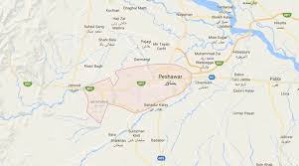

Map of study area:peshawar

The heavy shift has got negative impacts on environmental resources such as soil, water,
and agriculture. The land prices are increasing and it is not possible for a common person to
afford accommodation. In early eighties University town, Hayatabad town were planned with the
idea to accommodate the major migrant to the city district, but was not sufficient. It present
about ten housing schemes have been developed. Which are either expensive or not convenient
and people searching cheap land for accommodation in the surrounding of Peshawar City. This
has created extra burden on the environmental resources and also contributing to various
environmental problem in the surrounding.
This study is an attempt to study the slum areas with the objective to identify environmental and
health problems for remedial measures.
Problem Statement
The living conditions in the unplanned slums in the surroundings of Peshawar City may be very
unhygienic and congested. It is therefore required to study the present condition of water,
Sanitation and hygiene. If these problems were not identified or ignored, it is expected that these
problems will be aggravated further and may results health and other environmental problems.
Most of the dwellers in these slums are poor and migrants. These People are compelled to live in
these areas and may not be in position to afford basic facilities like cleanwater, proper sanitation
and other infrastructure facilities &municipal services.
Objectives
• To conduct a comprehensive survey in Gharibabad Camp I and II and identify the major
problems faced by the residents of slums areas.
• To assess the existing situation of water and sanitation in study area.
• To study the solid waste disposal and its management facilities.
Methods and Techniques
The baseline information will be collected from primary sources as per work plan (fig. 2).
1. Criteria for Slums identification.
The criteria for selecting the slums areas is the homogenous nature of socio-economic
conditions in the house holds in addition to the poor or non-availability of infrastructure
and basic facilities in the neighbor hood. So slums areas having similarity in the domestic
environment and also having similar local environmental problems. Like for example
4

lack of drainage system, no solid waste managementsystem,unpaved streets, congested
housing and dwellings and poor hygienic conditions.
2. Survey
Preliminary survey: To identify different slum area in the surroundings of Peshawar
City District, a preliminarysurvey was conducted.
Two different slums areas (Gharib Abad Camp I and II) were identified and selected from
the slums areas.
Questionnaire Survey: A questionnaire survey will be conducted in Camp I & II of
Gharib Abad. For this, questionnaire will be designed and pre-tested. 30 questionnaires
will be distributed in Camp-I and 40 in Camp-II @ 10% of the total households of 300,
and 400 respectively.
3. GIS data base: will be developed for further analysis and interpretation. For this Google
earth image will be used as base map. Global positioning system (GPS) will be used for
lat/long and map creation. The base map will be linked with data collected through
questionnaire for further analysis.
4. For water quality, samples will be collected from different sources such as tube-well,
dug-well for bacteriological and physio-chemicalanalysis in the study area

Q#02
ANS:

THE MASTER PLAN OFISLAMABAD
The master plan provided an outlineand a broadframework ofconcepts and visionfor futuredevelopment.Constantine A.Doxiadis, prior to being tasked with thework for Islamabad,had been trying to findout the mechanism ofgrowth of cities and the processes which shaped human settlements. He believed that the solution to our contemporary and future settlements lies in
Ekistics
, which he described as the science of human settlements. Doxiadis believed that there aretwo basic elements ofhuman settlements,the content and thecontainer, which can be further sub-dividedinto five basicelements, which were Nature, Man, Society,Shell, and Network.
1
While the carefulorganization andmanagement of theseelements produces
Figure 3-2: Khawaja Zaheer ud Din Chief townplannerof CDAexplaining the master plan of administrative area to visitingforeign minister of CanadaFigure 3-1: The Master Plan of Islamabad
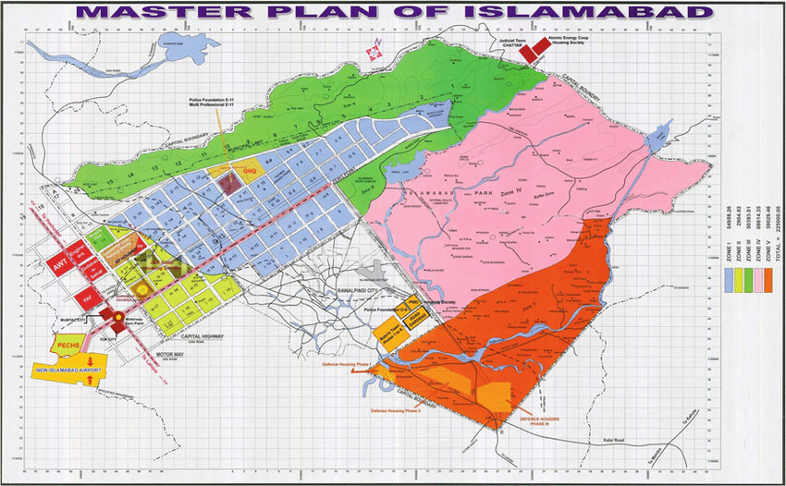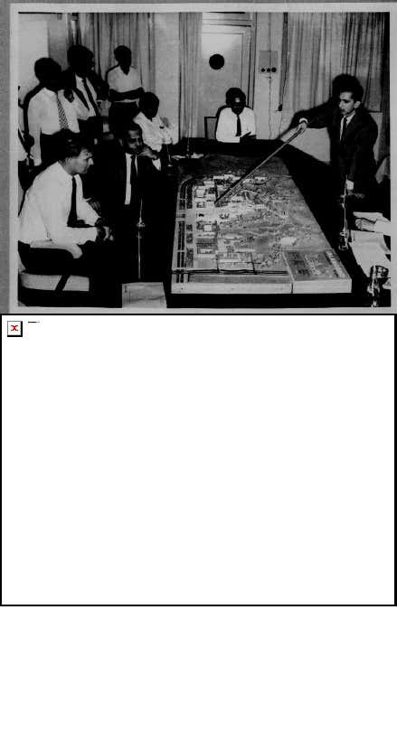

52
viable and meaningful settlements, a combination of these elements produces variable-sized settlements, determined by the number of peopleliving in it. The size of a settlement may range from a one-man settlementto settlements of tens, hundreds, thousands, millions, and lately, even tensof millions of people.Doxiadis gave a lot of importance to nature and this he expressed as
―Nature provides the foundation upon which the settlements are created
and the frame within
which they function.‖ He further elaborated this pointwith reference to the city of the future in the following words: ―The surface
of the city will allow the flora to spread again, beginning from the smallgardens within the cells, to major zones of forests above the tunnels of thenetwork, to big farming areas and natural reserves where man will find the
rough conditions which he also needs.‖
2
The element of Nature can definethe size of the settlement by the extent of space, which is covered, either bythe whole settlement, or by the intensively developed part of it. Similarly,the element of shell may define the physical dimensions, which can beexpressed in area or in volume. The activity and the function of asettlement can be defined by the sway of its dimensions. A settlement canshow a small or large degree of economic activity, it can be the center of acertain degree of productive activity, an administrative center of certainadministrative importance, and so on.Doxiadis analyzed a number of cities and towns throughout the world. He believed that the ideal solution for city planning lies in the concept of
dynapolis
. It is a dynamically growing city, whose dimensions can rangefrom the small ones of the past to the large ones of the present, providedthe city has not become a multi-nuclei metropolis. A basic difference between the
polis
(city) and the metropolis is not only one of dimensions,which are larger in the metropolis, but the city also has one major nucleusand some subordinate ones. In comparison, the metropolis has several othernuclei as well, which, although less important than the central one, have acertain independence because of their history and other reasons.
Dynapolis
permits its natural growth, especially that of its center, without allowing thenew additions to destroy the existing pattern.

53
The basic structure of Islamabad‘s Master Plan provides for a dynamic and
parallel development of several functions within the Metropolitan Area ofIslamabad and Rawalpindi. The layout concept has been devised so that itshould be able to face the future problems arising out of its proximity withthe expanding city of Rawalpindi. The basic idea was that Islamabadshould be served by Rawalpindi and yet should remain free fromintermingling with it. The plan was designed to help the simultaneous andcoordinated, but not necessarily equal growth, for both Islamabad andRawalpindi.
3
In this way the twin cities would retain their individualcharacter, while at the same time, they would become part of the sameMetropolitan Area.The proposed Master Plan was based on a system of four highwaysdefining the overall structure of the Metropolitan Area.The first major highway connecting the site with the rest of the country isthe Islamabad Highway. It originates to the southeast of Islamabad, on theGrand Trunk Road near Rawat, and terminates at the Margalla Hills, thus passing in-between two lakes on one side and an existing internationalairport on the other, which was supposed to serve the new capital as well.The terrain along this road from Rawat is rugged but it still had variationsup to the Shakarparian Hills but these minor contours were flattened whileconstructing this highway.Murree Highway was the second important highway defining the directionfor the future growth of the city. It follows the natural contours from thenortheast to the southwest along valleys formed by series of hills running inthe same direction. This highway separates the residential area ofIslamabad from the low-density National Park and other institutional areas.
Margalla Highway, is the third axis of the city which defines the city‘s
limits in the direction of the Margalla Hills, It originates from the existingvillage of Nur Pur Shahahan and continues in the southwest direction

Finally, the Soan Highway tothe extreme south of the city,follows the course of the SoanRiver. The area lying in- between the Soan and theMurree Highways contains LoiBher and Soan Lake, andtherefore, has been designatedfor agro-farming, recreation,sports, and research institutionsof national importance. Theseroads and axes were determined by the existing landscape andare the fundamental elements inthe organization of space andurban structure of the city.
The system of ―
------- axes running approximately parallel to each otherand parallel to the (Margalla) Hills; after eliminating curves and the basicaxes by designing them perpendicular to each other, a rational design is proceeded too. The system of co-ordinates allows consideration of a gridsystem which will form the main network of the Metropolitan region. Thedimensions of the road-grid system must be subjected to the need of a
rational organization of the area into communities of various classes.‖
4
The system of axes demarcates and divides the whole area into threedistinct parts with specific functions

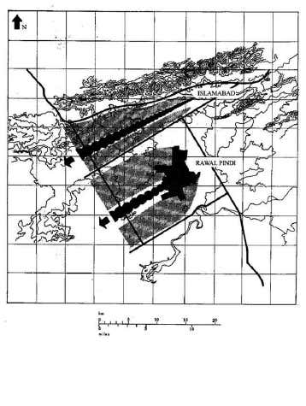

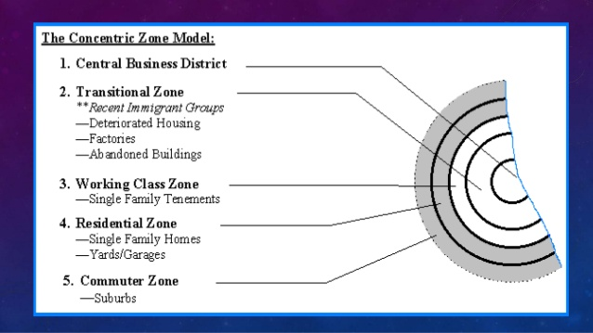
Q#3
ANS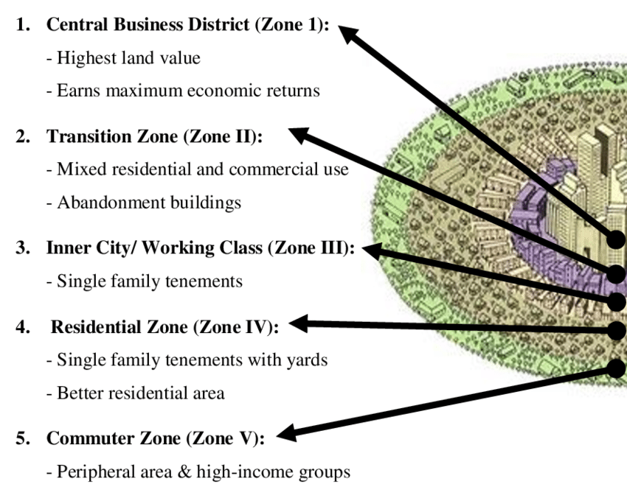

Sector Road Map 1.
Sector Performance, Problems, and Opportunities 1. Peshawar is the capital of the province of Khyber Pakhtunkhwa in Pakistan, and serves as the administrative center of the Federally Administered Tribal Areas. The city is in a valley between the Iranian plateau and the Indus River, and is 140 kilometers (km) west of Islamabad and 230 km east of Kabul, Afghanistan. The Peshawar district covers a total area of 1,257 square km. Due to its proximity to the Khyber Pass and its history as one of the oldest urban settlements on the subcontinent, Peshawar has played a notable role in the region’s history. Its population, currently estimated at 1.8 million, is projected to reach 2.6 million by 2030. 1 The city’s population growth has been intensified by Afghan refugee migration and internal displacement, with approximately 280,000 Afghan refugees and 100,000 internally displaced persons currently residing in Peshawar. 2 As these refugees have limited resources and opportunities, the city and provincial governments are facing considerable pressure to deliver infrastructure and public services in terms of housing, education, healthcare, and transport. 2. Poverty and security are the principal social concerns across the city. Poverty is widespread, most notably in the 18 informal settlements housing the majority of the internally displaced and international refugees. Overall, 44% of Khyber Pakhtunkhwa’s inhabitants are classified as poor. A lack of gender equity also defines workforce and economic opportunities. While approximately 90% of men are employed, only an estimated 10% of women are. 3 Public security is also a principal determinant of how residents move around and interact in the city; for example, women’s movements are highly restricted due to the risk of harassment, and all residents are affected by the ongoing threat of terrorism. Peshawar has been a focal point of violence and terrorist attacks, including acts by groups such as the Taliban. In December 2014, an attack on a local school resulted in the deaths of 132 children. 3. Peshawar is directly linked to Islamabad (and beyond) by a dual carriage highway that feeds into the main city arterial road known as the Grand Trunk Road (GTR). The city also has a rail link serving national destinations, including three daily passenger train services between Peshawar and Islamabad. Although inter-city rail is a popular way to travel in Pakistan, it has lost passengers to road transport, largely due to improved road infrastructure and the improved passenger bus services now plying intercity routes. Urban public transport in Peshawar is exclusively served by various road transport modes. Peshawar also has an international airport mainly serving the Middle East, as well as regular domestic flights to other cities in Pakistan. 4. Various forms of paratransit and public vehicles dominate the urban transport subsector in Peshawar, accounting for an estimated 60%–70% of trips. 4 The public transport fleet consists of large, medium-sized, and mini-buses; Suzuki utility vehicles; all-terrain vehicles; station wagons; and pickup trucks. However, this current fleet of disparate vehicle types is in a general state of decay. Although public transport vehicles are legally required not to exceed a maximum age of 10 years, much of the fleet dates to the 1980s and 1990s. Government agencies lack the resources to oversee effectively or enforce compliance regarding safety, emissions, and maintenance standards. Surveys conducted for this project’s pre-feasibility study indicated tha

The Model[edit]
The model describes the layout of a city, based on Chicago. It says that even though a city may have begun with a central business district, or CBD, other smaller CBDs develop on the outskirts of the city near the more valuable housing areas to allow shorter commutes from the outskirts of the city. This creates nodes or nuclei in other parts of the city besides the CBD thus the name multiple nuclei model. Their aim was to produce a more realistic, if more complicated, model. Their main goals in this were to:
- Move away from the concentric zone model
- To better reflect the complex nature of urban areas, especially those of larger size
The model assumes that:
- Land is not flat in all areas
- Even Distribution of Resources
- Even Distribution of people in Residential areas
- Even Transportation Costs^{[2]}
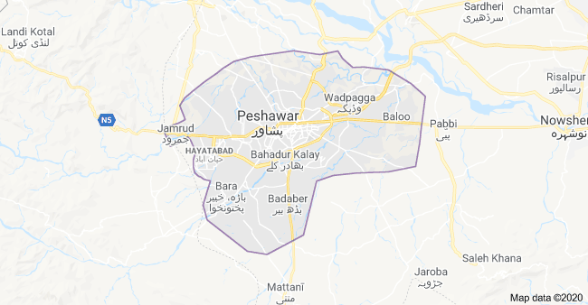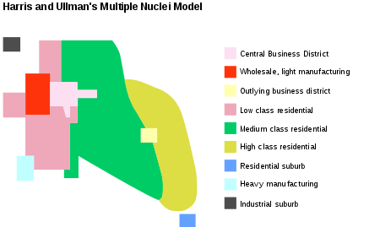
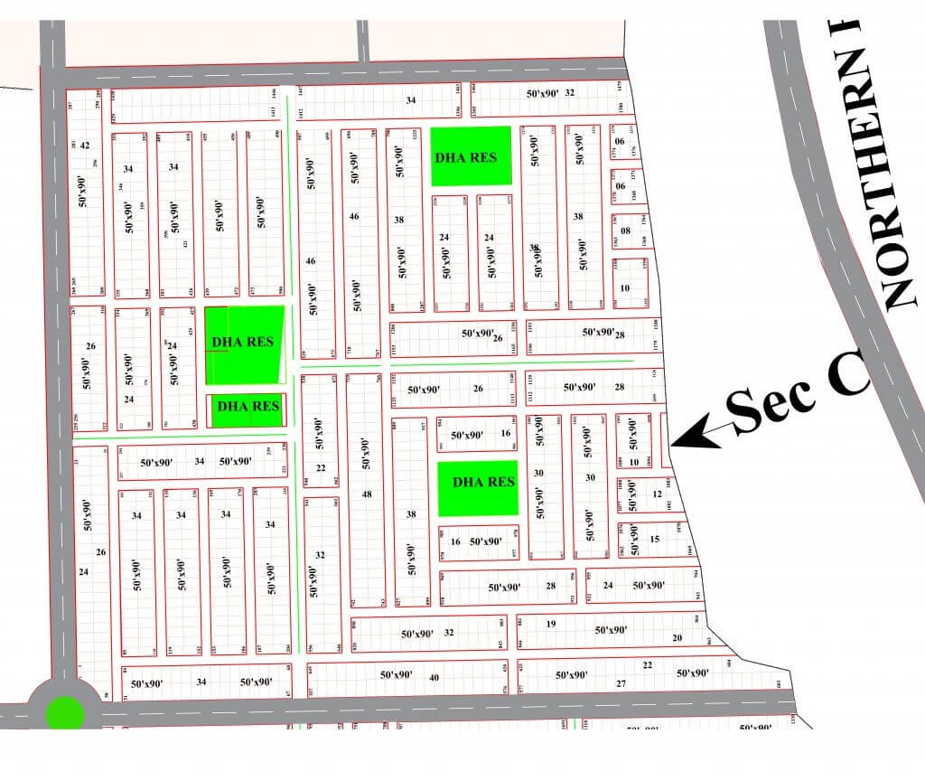
Sector model sketch

