NAME: ALAM ZEB

ID=14481

SECTION:BS(SE-4)(A)

SUBJECT:PRINCIPLE OF MANAGEMENT

Question1:Being visionary leaders how are they managing the staff? Find out how airlines are maintaining the staff salaries .
Answer: PAKISTAN INTERANTIONL AIRLINES
As the novel coronavirus / COVID-19 continues to cause economic and social turmoil across the globe, the airline industry is suffering particularly acute hardships around the world. US carriers, including Delta, American, United and Southwest, have announced plans to cut their international routes by as much as 80% to 90% over the next several months, and domestic capacity is now being reduced by 20%-40%.
In the same way PIA reduces both international and domestic flights . Along with these flight reductions, airlines have grounded fleets of their larger aircraft, instituted hiring freezes and in some cases commenced layoffs. They are also of reduced number of passengers in plane in order to follow SOPS .

Managing Staff:
What PIA need to do now is to do Golden hand shake because of covid-19. This pandemic is hitting airlines industries badly. As you know PIA is already suffering so this is great way to manage and get rid of extra staff.The PIA’s main issue is that you have less planes and more crew. There are almost 500 staff members for one plane; you need 50 to 100 people to run one plane. So you definitely need downsizing. If you want to grow PIA you need to either do downsizing or do golden handshake
In this situation this will be great step because most of the airlines industries are firing employees.
Example:
Thousands of Boeing employees are being laid off because of the impact the coronavirus pandemic has had on the airline industry.On Wednesday, Boeing President and CEO Dave Calhoun said 6,770 of its employees in the U.S. were being notified about the involuntary layoffs, according to a news release.
PIA is managing their salaries by doing cuts in staff salaries. In other words decreasing salaries by certain amount . they also sked government for providing them debt
The Pakistan International Airlines (PIA) has applied an “across-the-board cut” in the salaries of its officers and pilots, with exception to the lowest and non-officer cadre. According to the schedule of pay cuts, 10pc on salary between Rs100,000-200,000; 15pc on salary between Rs200,000-300,000; 20pc on salary between Rs300,000-500,000 and 25pc on salary above Rs 500,000.
“It’s a tough decision but there is no other way. It’s temporary till [normal] operations resume. All other cadres have accepted it,” the PIA spokesperson claimed.

Question 2: Based on ten Managerial roles of Mintzberg, how will an airline manage its operations? Mention all the roles with examples.

10 Roles of MINTZBERG:
- Figurehead.
- Leader.
- Liaison.
- Monitor,
- Disseminator,
- Spokesperson.
- Entrepreneur
- Resource allocator
- Disturbance handler
- Negotiations

ROLES OF MINTZBERG FOLLOWED BY AIR LINE MANAGER TO MANAGE ITS OPEARTIONS WITH EXAMPLE

Leader :
one role of MINTZBERG is of leader. Airline manager leads overall operations. Examples are
An airline operations manager does the interview and hiring of potential staff and crew. He/she makes the schedule for all flights, including schedules of the pilots, flight attendants and the crew. Airline operations managers also oversee the modification done to the airports where their aircrafts are to land. This is for the pilots and crew to be prepared for landing. The airline operations manager must also see to it that all flights comply with the rules, regulations and standards of the FAA.

Liaison officer
Another role of mintzberg that Airline manager follow is of Liaison officer. The liaison maintains a network of contacts outside the work unit to obtain .information. Example is
An airline operations manager also involves himself/herself with researching (outside contacts with different people of industry and outside industry) for making their processes better. They research ( contact) new clients and try to come up with marketing strategies that will help in both developing better airlines as well as getting more business.

Monitor

One of the most important role of mintzberg is that manager should do monitoring.The monitor seeks internal and external information about issues that can affect the organization. Example is
Airline operations managers also oversee the modification done to the airports where their aircrafts are to land.

Figurehead Roles:
The figurehead performs symbolic legal or social duties. All social, inspiration, legal and ceremonial obligations.In this light, the manager is seen as a symbol of status and authority.
Example is when they Manager represent in some ceremonial function e.g airline manager is inivited to iqra university as a chief guest during graduation ceremony.

Spokesperson:
The spokesperson transmits information about the organization to outsiders. Serves in a PR capacity by informing and lobbying others to keep key stakeholders updated about the operations of the organization.
Example is
Recently PIA airline crashed there manager talk to media on it . this is example of spokesperson.

Disturbance handler
The disturbance handler takes corrective action when the organization faces important, unexpected difficulties.
Example is
Whenever there any issue arise in crew or administration he will solve it fairly. This also show role of Leadership.
Question 4: Is the decision making in Airline Business centralized or decentralized? Support your answer with logical reasoning.

Answer:
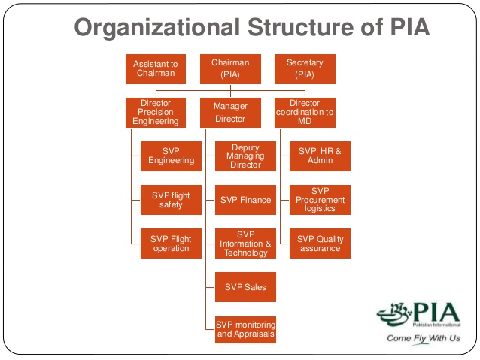
I analyze Pakistan International Airlines . first of all I will define centralized and decentralized.
Centralized organization structures rely on one individual to make decision and provide direction for the
Company while in Decentralized organization rely on a team environment at different levels in the business .Individual at each level in the business may have some autonomy to make business decision .
By looking on this chart we can see that there are very less division occurs and all report to Chairman PIA. The structure of PIA is centralized they follow instruction given by chairmen and reached it to lower level staff. And if there is any problem this channel is followed from bottom to above and when problem reached to chairmen issue is solved. That is the main reason that small problems took long time to solve. If it is decentralized ad middle and lower manager have authority it may not take long time.
Question 5: Looking at the current unstable situation, how will you apply the six steps of decision making to cope with the problem?

Answer:

1. Gathering Information and Establishing Your Objective
Airlines have a high level of fixed costs that negatively impact liquidity and cash flow. In this situation, airlines and airports will need to negotiate and strike new deals that enable them to reduce fixed costs. Operational costs that are variable can be kept low by optimizing resources and achieving operational efficiency with the help of digital solutions, which will also help airlines and airports ramp up operations as demand for air travel grows.
You must collect information about the effect of covid-19 in PIA airline.
- What is the problem that needs to be solved?
- What is affecting the situation as it stands now?
- What is the timeline in which the decision must be made?
- Can anyone else help me make this decision?

2.Identifying Alternatives Without Choosing One
And in second step you must face in a lot of problems that what you can do to solve
What PIA need to do now is to do Golden hand shake because of covid-19. This pandemic is hitting airlines industries badly. As you know PIA is already suffering so this is great way to manage and get rid of extra staff

3. Comparing and Evaluating Alternatives
I third step you must take the decision that you can cut pay from salaries or remove employ from job which one you seen that what way is best that you take to get the situation in your hand.

4. Making a Choice
Making choice in PIA airline that you can take the Airlines have an array of choices to make, and this article outlines a number of actions they can take to respond, recover, and prepare to thrive in the new normal, including.

5. Implementing Your Decision
starting to resume flights amidst the coronavirus pandemic, there is an enhanced focus on identifying new ways to increase revenues to strengthen the aviation business’ financial position.
It is important for organizations to realize the need for advanced planning of their return-to-work strategy to ensure a smooth transition.

6. Checking Your Decision
And the last one that you check your decision that when I take the decision then its help me or not In PIA Airline is starting when you take the decision write United currently requires all passengers to wear a face covering onboard its flights and expects that policy to remain in place for at least the next 60 days. The only exceptions to this policy are individuals who have a medical condition or a disability that prevents them from wearing a face covering.
Question 3: Based on four skills of management, Conceptual, Interpersonal, Technical, Political how will you run airline business.( conceptual answers only)?

Answer:
On the basis of 4 skill in management I will run my business in an effective and efficiently manner . it is very important as a manager to have conceptual skills because we will be needing new ideas regarding our business and a manager should have good communication and decision – making skills . A set of ideas can make your shareholders happy. As in organization the manager should consider all employees because there are diversified employees in organization as a manager you have to communicate with each on them to make employees happy give bonus and other perks . In every organization problem arsis it can be on field or within organization ,so you should have good team players so they can work hard to resolve problems in a less time ,as a airline business you should technical support staff so they improve your quality measures . you should have interpersonal skills to judge the other person behavior and tactics or a marketing strategy of the other organization ,so where there is a set of ideas the employees will communication in a better way and will work within teas or groups , so a person should have good communication and listening for airline business . you should build trust with your employees and competition in the market , you should have influence power regarding anything , you can judge other person thoughts and action in every action if you have these skills so you can run your business effectively and efficiently.

