NAME liaqat Ali
ID 14942
BS DT
4TH SEMISTER
PAPER DENTAL MORPHOLOGY
QUESTION NO : 01
ANSWER NO :01
Palatal aspect
- Outline reserved from the buccal aspect , still trapezoidal.
- Mesiopalatal largest cusp
- Distopalatal smallest cusp ,almost spheroidal.
- Has a palatal pit at the end of the distopalatal groove
- There may be a cusp on the palatal surface of the mesiopalatal cusp.
- This is a fifth cusp called the cusp of carabilli , which is visible in addition to the four cusp on the occlusal surface .
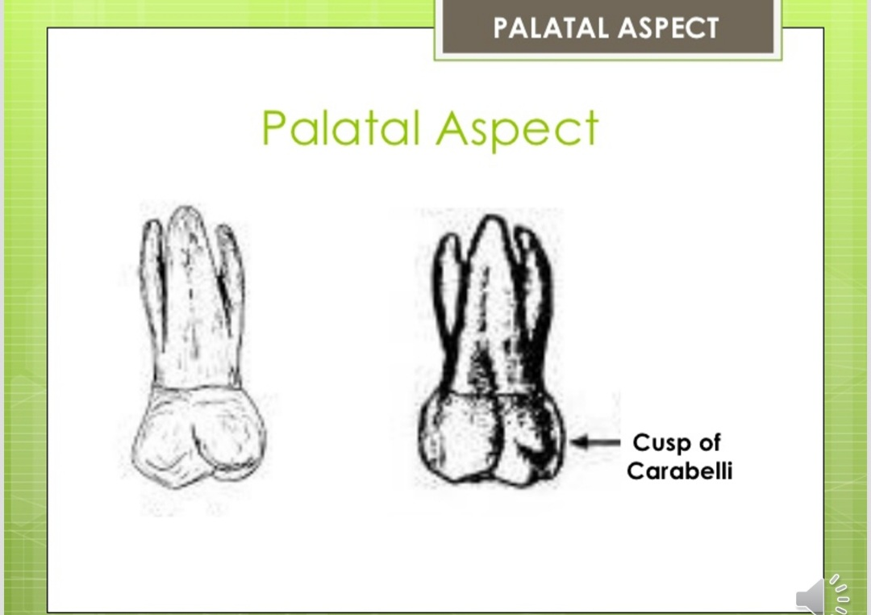

QuestionNO : 02
Answe no :02
Function of permanent maxilliary canine
- The canine function in mastication is mainly tearing and piercing and they also function in esthetics and speech.

Function of permanent maxillary 1st premolar
- In mastication , the first pre molar function basically as a grinding tooth, and contributes to the esthetics and phonetics role as well .

QUESTION NO : 03
ANSWER NO : 03
First evidence of calcification 3-4 months
Crown completion 4-5 years
Eruption 6-8 years
Root completion 9-10 years

QUESTION NO: 04
ANSWER NO: 04
Occlusal aspect of mandibular 2nd premolar
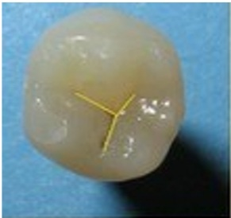
This tooth has three types of occlusal surface on the basis of groove patron as following:
- Y type found in 3 – cusp type most common ,
- H- type found in 2- cusp type
- U-type found in 2- cusp type
Occlusal aspect
Three cusp type : Y type
Outline is roughly square Y pattern is formed by the combination of central and lingual groove .
CUSPS:
Three cusps ; buccal cusp the larger one with four functional inclined plane , mesial cusp and distal cusp the shorter
Occlusal aspect
FOSSAE:
Two triangular fossae ; mesal and distal triangular fossae .bounded by its adjacent cusp ridges .
PITS AND GROOVE : Three pits
- Mesial pit: located at the deepest point of the mesial triangular fossae near the MMR.
THE FOLLOWING groove are joining here :
CENTRAL GROOVE :extent to the distal pit in v shape.
Mesiolingual triangular groove
Mesiobuccal triangular groove
Mesial marginal groove
OCCLUSAL ASPECT

B) Distal pit : located in the deepest point of the distal triangular fossa near the DMR
The following grooves are joining here:
CENTRAL GROOVE.
Distolingual triangular groove
Distobuccal tringyular groove
Distal marginal groove

OCCLUSAL ASPECT
C) Central pit : located at the midway from mesial to distal at the junction of the central groove with lingual groove .
Deepest pit among the three.
Division of the central groove into mesial and distal portion
OCCLUSAL ASPECT
The two cusp type:
Rounded outlines
Mesial and distal outline are some what coverages toward the lingual but not as in the 1st premolar
It has no central pit and lingual groove .

OCCLUSAL ASPECT
CUSP:
Larger buccal cusp the lingual cusp in H types is larger and sharper than that of U type .
OCCLUSAL ASPECT
FOSSAE
Fossae are same as in 1st premolar .
Pit and groove U type ;
U shaped is formed by the union of buccal triangular grooves , central grooves and secondary grooves of buccal cusp.
OCCLUSAL ASPECT
Pit and groove H type :
H shaped pattern is formed by the union of four triangular groove ,central groove and secondary groove of buccal and lingual cusps.
Central groove is run relatively in straight line rather than cresent shape as in u-type
Two type both have the union of four groove discussed in y – type.

QUESTION NO:05
ANSWER NO:05
The sharper teeth can tear food into smaller pieces and the flatter teeth grind food down . wisdom teeth are the flatter kind of teeth called molars .molar are all the way in the back ofb your mouth .the molar are the largest teeth in the maxillary and mandibular arch.
The first molar is largest in size , and the second and third are progressively smaller .
All teeth are gifted of the god and the molar is the main function is masticatory function is grinding.
The main function of the teeth is
- Mastication
- Esthetics
- Phonetics.

