INU Peshawar Date ^{23rd} ^{September}2020
Department | (AHS) MLT
Subject | English-I
Marks | 50
Semester | 1
FinalTerm Assignment | Summers 2020
Instructor | Hajra Iqbal
Fill below blocks.
Student Full Name | Sajjad Hussain
Student Father Name | Sadiq Ahmed
University ID Card Number | 16025
Department | BS MTI
Instructions: Your time starts once you log in. You have only 4 hours to complete and submit your paper on the portal. After 4 hours your time would be automatically expired. Download this paper and save it with your full name and subject. Attempt all the answers on the same page and keep in your mind to click the SAVE after every 10 minutes. When you are done with paper, go through it and UPLOAD your final copy with your name and id on SIC portal.
Note: i. Attempt all five questions. All carry equal marks.

1.Write brief descriptions with examples. ( 5 examples each) /10
a.Homonyms b.Homophones c.Synonyms d.Antynoms
A)Homonyms example
Address - to speak to / location.Air - oxygen / a lilting tune.Arm - body part / division of a company.Band - a musical group / a ring.Bark - a tree's out layer / the sound a dog makes.Bat - an implement used to hit a ball / a nocturnal flying mammal.
B) homophones five example
1)brake/break: When teaching my daughter how to drive, I told her if she didn't hit the brake in time she would break the car's

2)cell/sell: If you sell drugs, you will get arrested and end up in a prison cell.

3)cent/scent: I won't spend one cent on a bottle of perfume until I know that I love the scent.

4)die/dye: If you accidentally drank a bottle of fabric dye, you might die.

5)flour/flower: To bake a flower-shaped cake, you'll need some flour.
C ) synonyms five example
Baffle: confuse, deceive.
Beautiful: attractive, pretty, lovely, stunning.
Bossy: controlling, tyrannical.
Fair: just, objective, impartial, unbiased.
Funny: humorous, comical, hilarious, hysterical.
Happy: content, joyful, mirthful, upbeat.
Hardworking: diligent, determined, industrious,
D) antynoms five example

Examples include: boy - girl, off - on, night - day, entrance - exit, exterior - interior, true - false, dead - alive, push - pull, pass - fail.

2.What is Noun? Define all kinds of Noun with atleast five examples.
/10
NOUNS.
Noun Definition | Meaning
A noun is a naming word. It can be the name of a thing, place, person, animal or feeling.

Examples of Noun
Naming People
It could be a name of any person, for example: John, Fatima, Singh, Michael, Tom and so on.

Naming Places
It could be a name of any place, for example: America, China, Church, Taj Mahal, Paris and so on.

Naming Things
Naming things are like Car, Hat, Bottle, Table, Chair, Ball and so on.

Naming Animals
Dog, Rabbit, Elephant, Chicken, Horse.

Naming Feeling/Qualities/Ideas
Joy, Fear, Beauty, Strength, Anger.

Example Sentences
I live in Australia.
Jenny is my sister.
I love to play with my dog.
The name of this monkey is Boo.
Pacific Ocean is very vast.
Types of Nouns
Proper Noun
Common Noun
Collective Noun
Possessive Noun
Number Noun
Compound Noun
Countable Noun
Uncountable Noun
Masculine Noun
Feminine Noun
Proper Noun
Names of people or places such as your name, your friend's name, your parents' name or the name of your town and country are special naming words. These words are called proper nouns. Special naming words or proper nouns always always begin with a capital letter.

Example Sentences of Proper Noun
My name is Mark.
Her name is Sofie.
Come Tom, let us go for a walk.
Hello Jack! Will you play with me?
My cousin lives in Norway.
These bears are from China.
Albert Einstein was born in Germany.
I visited the Taj Mahal in India.
Fio and Laa are close friends.
Understanding Proper Nouns
The days of the week and the months of the year are proper nouns.

Example Sentences
Every Sunday Mike visits the church.
Christmas comes in the month of December.
My sister was born in March month.
Sam goes for swimming classes every Friday.
The names of festivals and some special days are proper nouns.

Example Sentences
Christmas is my favourite festival.
My mother likes Mother's Day.
We will celebrate New Year's Eve.
The names of buildings, mountains, rivers and seas are also proper nouns.

Example Sentences
I have seen the Great Wall of China.
Last year we visited the Niagara Falls.
Many people have climber the Mount Everest.
River Nile is very long.
Common Noun
Common nouns are naming words that are common to people, places, things and animals etc. Common nouns do not define any particular person, place or thing. They are general names. So, they are not capitalized unless they begin a sentence. For example boy, girl, doctor, town, city, dog, car and so on.

Example Sentences of Common Noun
Teachers teach in school.
Birds live on trees.
I love to read storybooks.
Sally's mother is a doctor.
These chocolates and cakes are so delicious.
Identify and learn about proper nouns and common nouns in the list of sentences below.

Sony produces cameras too.
Alicia and Cathy were playing with a doll.
Sandy is joining school today.
Hens have laid eggs at Todd's farm.
The postman Mr. Robert was carrying postcards.
In above examples the words in purple colour are proper noun whereas words in green colour are common nouns.

Collective Noun
Collective nouns are used to name a group of persons, places, animals or things. A collective noun represents a complete whole. For examples: a library of books, a team of players and a family of four.

Some collective nouns are used to name a group of animals and birds.

A flock of sheep.
A herd of cattle.
A stud of horses.
A gaggle of geese.
A litter of cubs.
A flock of birds.
A shoal of fish.
A pack of wolves.
A swarm of bees.
Some collective nouns define a group of people.

A crew of sailors.
An army of soldiers.
A band of musicians.
A class of pupils.
A troupe of actors.
A panel of judges.
A gang of robbers.
There are some collective nouns that stand for a group of things.

A bunch of keys.
A pile of clothes.
A collection of books.
A string of pearls.
A set of stamps.
A galaxy of stars.
A pack of cards.
An atlas of maps.
A bouquet of flowers.
A bunch of grapes.
Example Sentences of Collective Noun
My maternal aunt bought me a pair of tennis shoes.
At the playground, you get to observe a colony of ants.
A pile of clothes was kept on the bed.
I need to finish an agenda of tasks before I leave.
There is a network of computers in Joseph's office.
Possessive Noun
A possessive noun is a word that names who or what has or owns something. We add an apostrophe and s ('s) to form the possessive of most singular nouns.

Example Sentences of Possessive Noun
This is Bob's skateboard. (Means - The skateboard belongs to Bob)
This is Ian's Coat. (Means - The coat belongs to Ian)
Papa bought a new frame for grandpa's spectacles.
Ted's dream for a bicycle came true on his birthday.
Julia's homework was not checked.
Sometimes we need to show possession for plural nouns or where the owners are more than one. In such cases we add an apostrophe at the end.

A girls' school is located near my house.
We should not harm the birds' nests.
Number Noun
Number nouns denote one or many. There are two kinds of number nouns:

Singular number noun - It stands for one person, animal, thing or place.
Plural number noun - It stands for more than one person, animal, thing or place.
For example: One toy, three balls, two dogs, five cars, nine planets and so on.

Generally, by adding a 's' at the end, we can change a singular noun to a plural noun.

3.Write a Paragraph on “ Health is Wealth ” (20 lines) /10
Answer
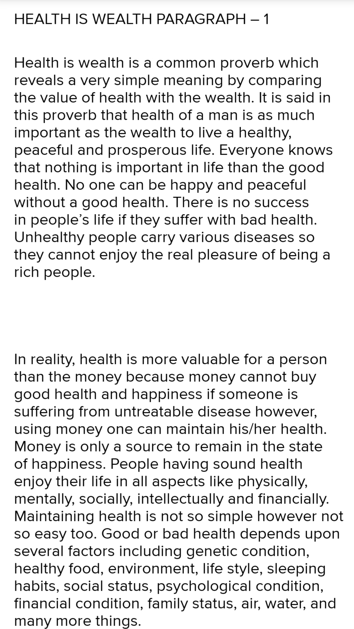
4.Read the following passage and answer the given questions. /10

Education ought to teach us how to be in love and what to be in love with. The great things of history have been done by the great lovers, by the saints and men of science, and artists, and the problem of civilization is to give every man a chance of being a saint, a man of science, or an artist. But this problem cannot be attempted, much less solved, unless men desire to be saints, men of science, and artists. And if they are to desire that continuously and consciously they must be taught what it means to be these. We think of the man of science or the artist, if not of the saint, as a being with peculiar gifts, not as one who exercises, more precisely and incessantly perhaps, activities which we all ought to exercise. It is a commonplace now that art has ebbed away out of our ordinary life, out of all the things which we use, and that it is practiced no longer by workmen but only by a few painters and sculptors. That has happened because we no longer recognize the aesthetic activity of the spirit, so common to all men. We do not know that when a man makes anything he ought to make it beautiful for the sake of doing so, and that when a man buys anything he ought to demand beauty in it, for the sake of beauty. We think of beauty if we think of it at all as a mere source of pleasure, and therefore it means to us ornament, added to things for which we can pay extra as we choose. But beauty is not an ornament to life, or to the things made by man. It is an essential part of both. The aesthetic activity, when it reveals itself in things made by men, reveals itself in design, just as it reveals itself in the design of all natural things. It shapes objects as the moral activity shapes actions, and we ought to recognize it in the objects and value it, as we recognize and value moral activity in actions. And as actions empty of the moral activity are distasteful to us, so should objects be that are empty of the aesthetic activity. But this is not so with most of us. We do not value it; do not even recognize it, or the lack of it, in the work of others. The artist, of whatever kind, is a man so much aware of the beauty of the universe that he must impart the same beauty to whatever he makes. He has exercised his aesthetic activity in the discovery of the beauty in the universe before he exercises it in imparting beauty to that which he makes. He has seen things in that relation in his own work, whatever it may be. And just as he sees that relation for its own sake, so he produces it for its own sake and satisfies the desire of his spirit in doing so. And we should value his work; we should desire that relation in all things made by man, if we too have the habit of seeing that relation in the universe, and if we knew that, when we see it, we are exercising an activity of the spirit and satisfying a spiritual desire. And we should also know that work without beauty means unsatisfied spiritual desire in the worker; that it is waste of life and common evil and danger, like thought without truth, or action without righteousness.

Questions
How to Write a Summary

Proficient students understand that summarizing, identifying what is most important and restating the text (or other media) in your own words, is an important tool for college success.

After all, if you really know a subject, you will be able to summarize it. If you cannot summarize a subject, even if you have memorized all the facts about it, you can be absolutely sure that you have not learned it. And, if you truly learn the subject, you will still be able to summarize it months or years from now.

Proficient students may monitor their understanding of a text by summarizing as they read. They understand that if they can write a one- or two-sentence summary of each paragraph after reading it, then that is a good sign that they have correctly understood it. If they can not summarize the main idea of the paragraph, they know that comprehension has broken down and they need to use fix-up strategies to repair understanding.

Summary Writing Format
When writing a summary, remember that it should be in the form of a paragraph.
A summary begins with an introductory sentence that states the text’s title, author and main point of the text as you see it.
A summary is written in your own words.
A summary contains only the ideas of the original text. Do not insert any of your own opinions, interpretations, deductions or comments into a summary.
Identify in order the significant sub-claims the author uses to defend the main point.
Copy word-for-word three separate passages from the essay that you think support and/or defend the main point of the essay as you see it.
Cite each passage by first signaling the work and the author, put “quotation marks” around the passage you chose, and put the number of the paragraph where the passages can be found immediately after the passage.
Using source material from the essay is important. Why? Because defending claims with source material is what you will be asked to do when writing papers for your college professors.
Write a last sentence that “wraps” up your summary; often a simple rephrasing of the main point.?
2. What is the difference between an ordinary man and an artist?
3. How can we make our lives beautiful and charming?
4. What does the writer actually mean when he says, “Beauty is not an ornament to life”?
5. Do art and beauty affect our practical life and morals? Justify whether you agree or disagree.

5.Look at above passage of
Q.4.Write one third summary of it. /10
How to Write a Summary

Proficient students understand that summarizing, identifying what is most important and restating the text (or other media) in your own words, is an important tool for college success.

After all, if you really know a subject, you will be able to summarize it. If you cannot summarize a subject, even if you have memorized all the facts about it, you can be absolutely sure that you have not learned it. And, if you truly learn the subject, you will still be able to summarize it months or years from now.

Proficient students may monitor their understanding of a text by summarizing as they read. They understand that if they can write a one- or two-sentence summary of each paragraph after reading it, then that is a good sign that they have correctly understood it. If they can not summarize the main idea of the paragraph, they know that comprehension has broken down and they need to use fix-up strategies to repair understanding.

Summary Writing Format
When writing a summary, remember that it should be in the form of a paragraph.
A summary begins with an introductory sentence that states the text’s title, author and main point of the text as you see it.
A summary is written in your own words.
A summary contains only the ideas of the original text. Do not insert any of your own opinions, interpretations, deductions or comments into a summary.
Identify in order the significant sub-claims the author uses to defend the main point.
Copy word-for-word three separate passages from the essay that you think support and/or defend the main point of the essay as you see it.
Cite each passage by first signaling the work and the author, put “quotation marks” around the passage you chose, and put the number of the paragraph where the passages can be found immediately after the passage.
Using source material from the essay is important. Why? Because defending claims with source material is what you will be asked to do when writing papers for your college professors.
Write a last sentence that “wraps” up your summary; often a simple rephrasing of the main point.
Questions 4

Q.4:
Answer 1: The lamented thing in the text is that our education system do not give the abilities to our youngsters to do something practically.
Answer 2:
There is alot of difference between an ordaniry and an artist.An artist can draw while an ordaniry hav'nt any guts.
Ans 3:
We make our lives charming and beautiful by doing some practical and aesthitic actiins in our life.
Ans 4:
The writer actually means that beauty is not in the ornament.it is depend on our thoughts and feelings that how our envirnment is beautiful are.
Ans 5:
Yes, art and beauty affects our practical life and morals.it is having great effect on our thinking that what the nature says us and give a positive image to our mind.

