Spring 2020 Final-Term Assignment
Human Computer Interaction

Submitted By: Daniyal Malik Submitted To: Mr. Shahab ul Islam
ID# 13709 (Lecturer)
BSSE (6th Semester)

Question 1:
Consider the chair given below. Your Employees want to use it as a computer chair. Your task is to write any As HCI Specialist, your job is point out any Five issues in the design of this chair.
Ans. The following are some of the issues of the chair:
- Adjustability- The chair cannot be adjustable in different angles or which angle we want.
- Seat height range - The seat height cannot be adjusted to the height recommended for the worker(s) who will use it, it cannot be adjust.
- Backrest - the backrest is not adjustable and will fail to provide support in both backward and frontward direction.
- Seat surface – The seat surface is not comfortable and sitting on chair for long hour it make pain in back.
- Armrests – The armrests are not provided in chair and cannot support the arms of the user.

Question 2:
What is Paradigm, and what do you mean by paradigm shift?
Ans.
Paradigm:
Predominant theoretical frameworks or scientific world views it is also a is a distinct set of concepts or thought patterns, including theories, research methods, postulates, and standards for what constitutes legitimate contributions to a field.
e.g., Aristotelian, Newtonian, Einsteinian (relativistic) paradigms in physics

Paradigm Shift
A paradigm shift is a major change in the concepts and practices of how something works or is accomplished. A paradigm shift can happen within a wide variety of contexts. They very often happen when new technology is introduced that radically alters the production process of a good or service.
Question3:
Explain Design Rationale. Write and explain the types of design rationale.
Ans.
Design Rationale:
A design rationale is the explicit listing of decisions made during a design process, and the reasons why those decisions were made. Its primary goal is to support designers by providing a means to record and communicate the argumentation and reasoning behind the design process.
Types of design rationale:
Rationale can be classified into several types. These types are not mutually exclusive and some systems may support multiple types of rationales
- Argumentation based - the design rationale is primarily used to represent the arguments that define a design [Garcia, 1993]. These arguments consist of issues raised, alternative responses to these issues, and arguments for and against each alternative.
- History-based - the rationale consists of the design history – the sequence of events that occurred while performing the design [Garcia, 1993]. This information can be stored in many forms. It could be in the form of entries in a design notebook, an archive of e-mail messages, or other types of documents that capture actions taken over time.
- Device-based - a model of the device itself is used to both obtain and present rationale [Gruber, 1990]. The explanations of the design would be produced by using the model to simulate the behavior of the device. It would be possible for the user to view the model and ask questions about its design and behavior.
- Process-based -- the DR capture is integrated into the design process itself which guides the format of the rationale. In Ganeshan, et. al. [1994], the design description is modified only by changes to and refinements of the design objectives, thus capturing the rationale as part of the design process.
- Active document-based - the DR is pre-generated and stored in the system. In these systems, the designer creates the design and the DR system generates the rationale for it based on the system's stored knowledge. For each decision made, the system compares the decision made by the user with the decision that it would have made based in its knowledge. If the actions of the user conflict with the system recommendations, they are given the option of changing their decision or modifying some of the criteria.
Question 4:
Find the web pages that illustrate the principle of consistency. You must provide one good………………….your good and bad example in your answer. To provide the relevant examples browse the internet.
Ans.
Good web page that illustrates the principle of consistency:
URL: https://en.wikipedia.org/wiki/Main_Page
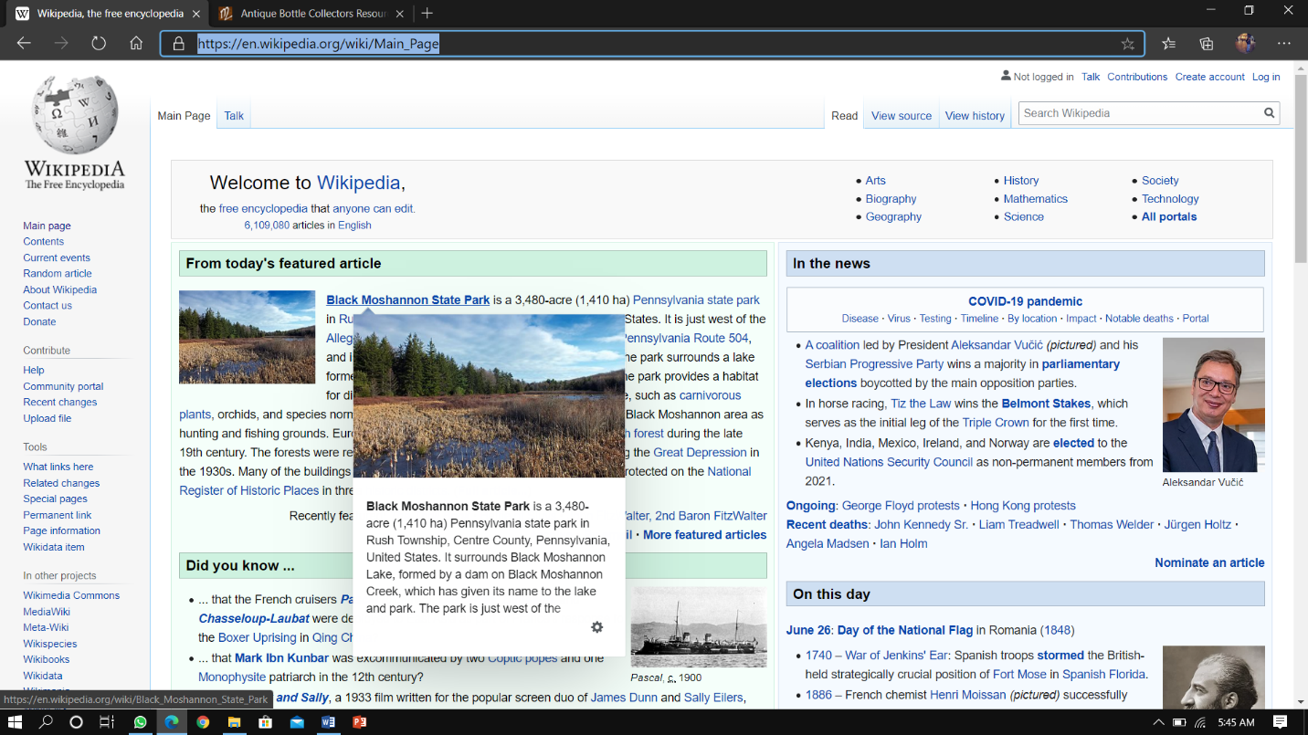
Wikipedia is a free online encyclopedia. Initially launched on January 15, 2001, by Jimmy Wales and Larry Sanger, the website is today’s largest and most popular general reference work on the Internet. Since Wikipedia is a free website, you can find millions of articles in 287 languages there (according to otechworld.com – 45 million pieces) and they are open to being edited by everyone on the internet. Currently, the website Wikipedia is owned by the nonprofit Wikimedia Foundation.

Bad web page that illustrates the principle of consistency:
URL: http://www.mrbottles.com/
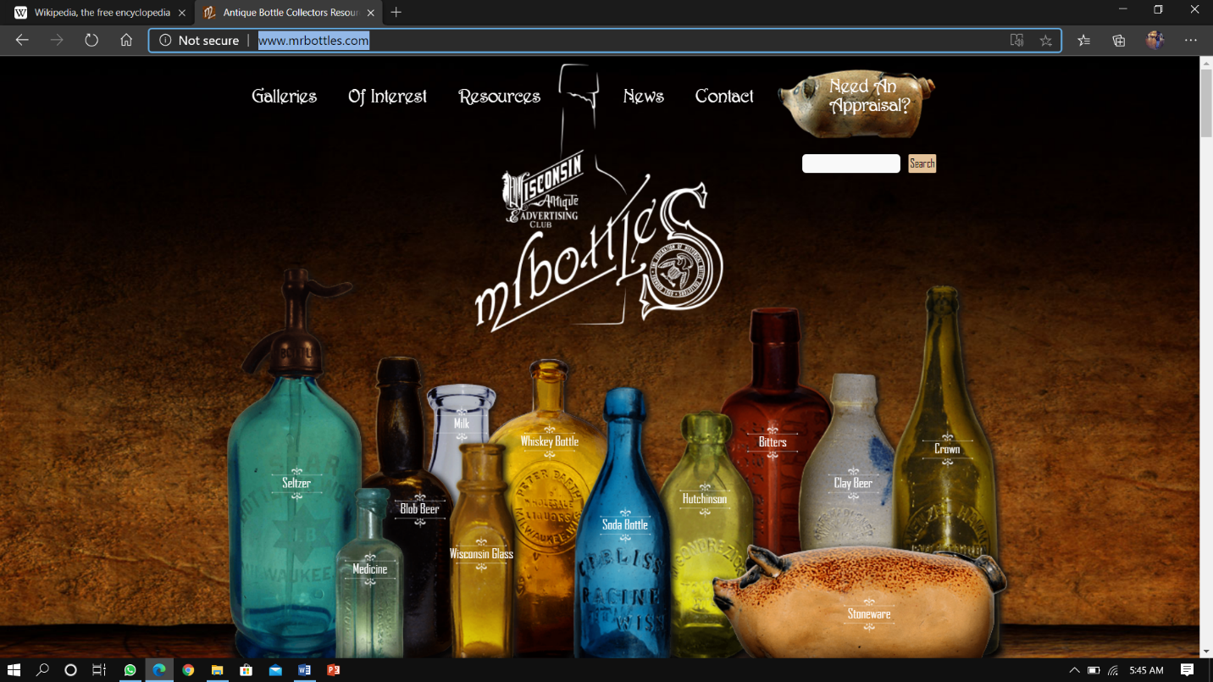
Presumably, bottle collecting enthusiasts the world over already know about Mrbottles.com, the online hub for everything you need to know about your bottle collection. Aside from the pillar-box red typeface clashing with the colourful bottles in the background, there are also some poor quality pictures of happy bottle owners on rotation.

Question 5:
Write the Schneider man’s 8 Golden Rules.
Ans.
1 Strive for consistency.
Consistent sequences of actions should be required in similar situations; identical terminology should be used in prompts, menus, and help screens; and consistent commands should be employed throughout.
2 Enable frequent users to use shortcuts.
As the frequency of use increases, so do the user's desires to reduce the number of interactions and to increase the pace of interaction. Abbreviations, function keys, hidden commands, and macro facilities are very helpful to an expert user.
3 Offer informative feedback.
For every operator action, there should be some system feedback. For frequent and minor actions, the response can be modest, while for infrequent and major actions, the response should be more substantial.
4 Design dialog to yield closure.
Sequences of actions should be organized into groups with a beginning, middle, and end. The informative feedback at the completion of a group of actions gives the operators the satisfaction of accomplishment, a sense of relief, the signal to drop contingency plans and options from their minds, and an indication that the way is clear to prepare for the next group of actions.
5 Offer simple error handling.
As much as possible, design the system so the user cannot make a serious error. If an error is made, the system should be able to detect the error and offer simple, comprehensible mechanisms for handling the error.
6 Permit easy reversal of actions.
This feature relieves anxiety, since the user knows that errors can be undone; it thus encourages exploration of unfamiliar options. The units of reversibility may be a single action, a data entry, or a complete group of actions.
7 Support internal locus of control.
Experienced operators strongly desire the sense that they are in charge of the system and that the system responds to their actions. Design the system to make users the initiators of actions rather than the responders.
8 Reduce short-term memory load.
The limitation of human information processing in short-term memory requires that displays be kept simple, multiple page displays be consolidated, window-motion frequency be reduced, and sufficient training time be allotted for codes, mnemonics, and sequences of actions.

Question 6:
You are familiar with internet explorer. Explain any five usability goals in terms of internet explorer. Justify each goal with example.
Ans. Internet explorer has supported its user from a very long time and was one of the first browsing software in the history. There are five different usability goals of internet explorer which are as follow:
- Effectiveness-it supports users in completing actions accurately.
- Example- when a user searches anything on the internet explorer it completes its search in seconds while giving a large number of options.
- Efficiency-Users can perform tasks quickly through the easiest process.
- Example- The user can easily search anything on the default google search bar.
- Engagement-Users find it pleasant to use and appropriate for its industry/topic.
- Example- The user can engage with others while using its own profile or web page and can use it for digital marketing and online businesses.
- Error Tolerance-It supports a range of user actions and only shows an error in genuine erroneous situations. You achieve this by finding out the number, type and severity of common errors users make, as well as how easily users can recover from those errors.
- Example- The server rarely gives any errors and only after the user types anything wrong and gives suggestions to the user so that he/she can continue their work.
- Ease of Learning-new users can accomplish goals easily and even more easily on future visits.
- Example- the explorer is easy to use it has straight forward commands and can be used by beginners very easily. The user only has to type in the search bar and can program any command they want.

--------------------------------------------------THE END----------------------------------------------------

