Name: Abdullah
ID no: 6960
Program: BS (MLT)
Paper: immunogy and serology
Submitted to: mam saima hadi

Question no1: define the following term?
Answer:
1: Autograpt:
A tissue or organ that transplanted from one part to another part of the body it is known as autograph.
Example: skin taken from another parts of the patient own body.

2: syngeneic graft:
Syngeneic mean genetically identical it may be used something transplanted from an identical twin. Transfer of tissue between genetically identical individuals.
Example: identical twin almost always take permanently.

3: Xenograft:
Xeno mean foreign it is also known as heterologous transplant. It may use for transfer of tissue or organ to different species, genus or family. Such cell tissues or organ are called xenograpt.
Example: common example use of pig heart valves in human.

4: Allograft:
The transplant of an organ or tissue from one individual to another of the same species with a different genotype.
Example: transplant from one person to another but not an identical twin is an allograft.

Question no: 3
Answer: coombs classification of hypersensitivity:
Type1: immediate atopic:
Type 1 hypersensitivity provoked allergic reaction by re exposure to specific antigen. The exposure is direct contact e.g. ingestion, inhalation and injection.
The reaction quickly IgE antibodies produced and quickly release histamine, tryptase and derivatives by mast cell.
Example: allergic asthma, allergic conjunctivitis, anaphylaxis.

TypeII: Antibody Dependent:
In type II hypersensitivity the antibody produced by the immune response bind to antigens on the patient own cell surface.
In acute inflammation generate site of membrane attack complexes cause cell lysis and death. The reaction take hours to a day.
Example: autoimmune hemolytic anemia, transfusion reaction.

Type III- immune complex:
Soluble immune complex form in the blood and are deposited in various tissue. Typically present in skin, kidney, and joints.
Example: rheumatoid arthritis, immune complex glomerulonephritis.

Type IV hypersensitivity:
Type IV hypersensitivity is often called delayed type as the reaction take two three days to develop. It is not antibody but rather is a type of cell mediated response.
Example: contact dermatitis, transplant rejection.
Question: 2:
Answer: A cluster of gene on a particular chromosome that specify major histocompatibility antigen. Major histocompatibility complex is membrane attached protein which work on recognization of antigen between self and non-self-body and antigen presentation.
Classis of MHC protein:
- Classis 1 MHC proteins:
These are glycoprotein found on the surface of virtually all nucleated cell.
- Classis II MHC protein:
These are glycoprotein found on the surface of certain cell including b cell, dendritic cell and Langerhans of the skin.
- Classis III MHC molecule:
The molecule include complement like C2 and C4 and bf.
- Classis IV molecule:
These molecule present on t cell of leukemia as well as immune tymocytes.

HLA:
HLA stand for human leukocyte antigen. HL are protein on most cell in your body. Your immune system uses HLA to recognize which cell belong in your body and which do not.
HLA matching is used to match patient and donor for blood or marrow transplant.
Classis of HLA:
There are six main MHC class II gene in human.
HLA-DPA1, HLA-DPB1, HLA-DQA1, HLA-DQB1, HLA-DRA A and HLA-DRB1. MHC class II gene provide instruction for making protein that are present almost exclusively on the surface of certain immune system cell.
Question: 4:
Answer:
The complement system also known as complement cascade. The complement system consist of 20 protein that are present in normal human and other animal serum. Complement system is part of the immune system that enhance the immune system or produce antibody.
Complement system is an important component of our innate host defense. It is not adaptable and does not change during and individual life time.
The complement system consist of a number of small protein that are synthesized by the liver and circulate in the blood as inactive precursor.

Main function of complement system.
1: bacteria and tumor cell lysis.
2: generation of mediators that participate in inflammation and attract the neutrophil.
3: opsonization enhancement of phagocyotosis.

Alternative pathway:
The alternative pathway is part of the non-specific defence because it does not antibody to initiate the pathway.
The alternative pathway is slower than the classical pathway.

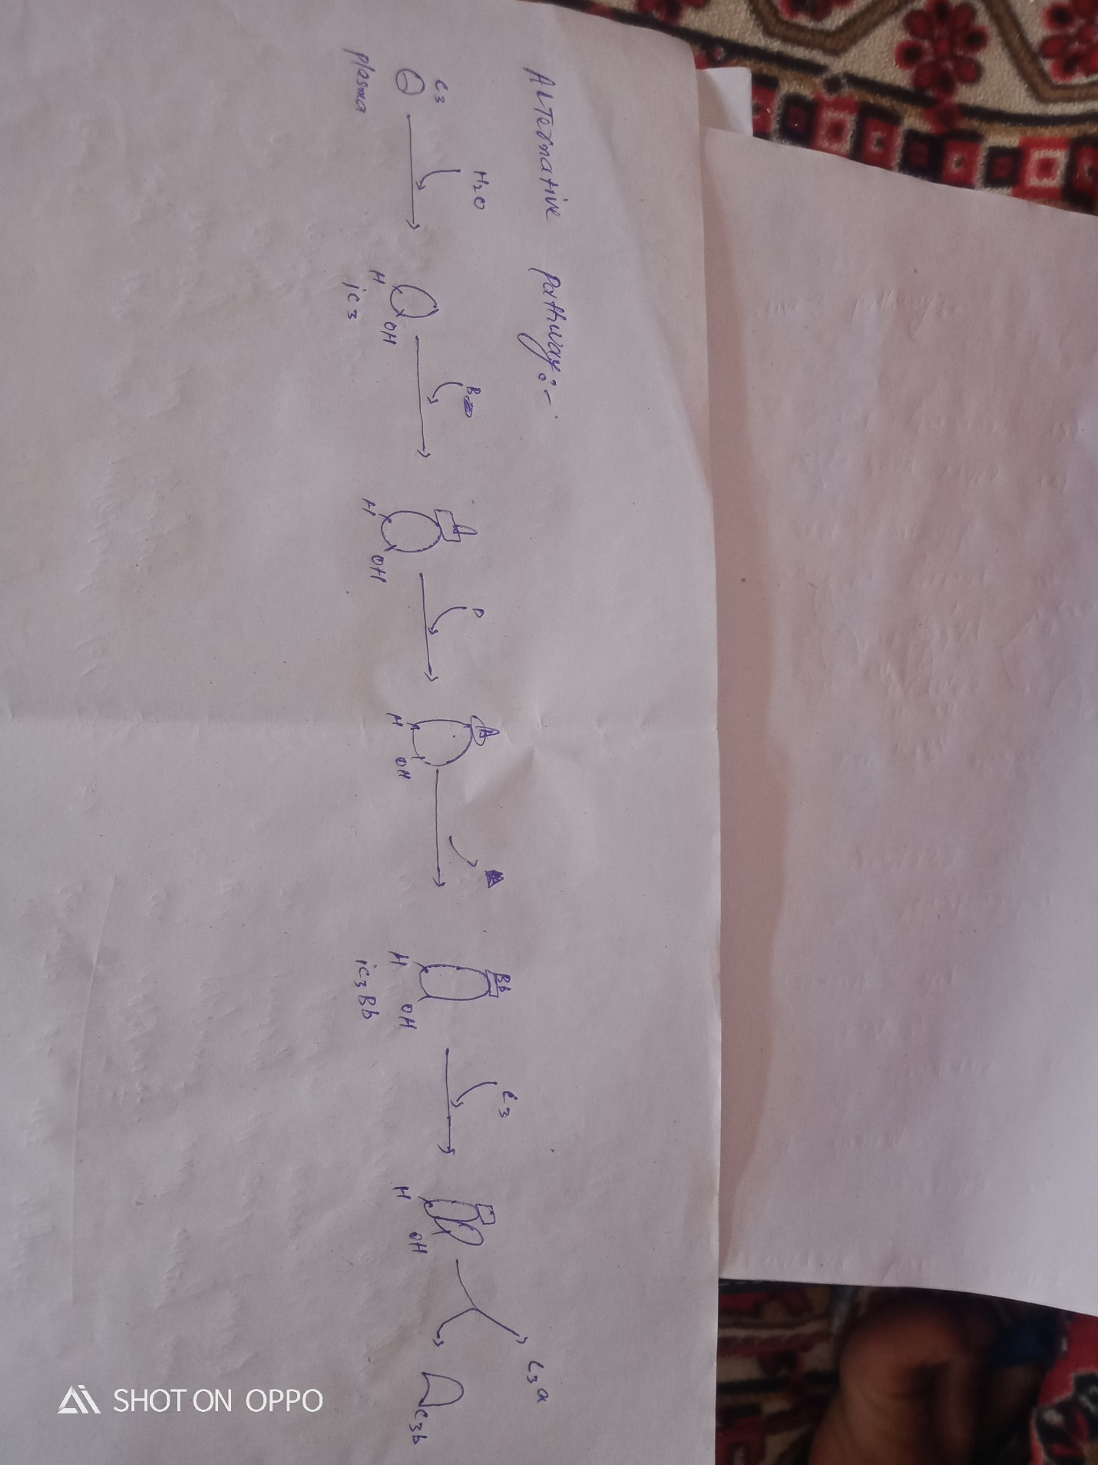

Question 5:
Answer:
The classical complement pathway is one of three pathway which activate the complement
system. The classical complement pathway is initiated by antigen – antibody complexes with antibodies isotopes IgG and Igm.

Draw the classical pathway on next page.
