Physiology II Summer Theory
Final term paper (50 marks)
Mam Kousar shah jehan
Student name: _MUHAMMAD RAEES_____________ roll number___13710_________
Q1. write a note on ABO blood group system?
ABO blood group system, the classification of human blood primarily based on the inherited houses of red blood cells (erythrocytes) as decided through the presence or absence of the antigens A and B, which are carried on the floor of the red cells. Persons may additionally therefore have kind A, kind B, kind O, or kind AB blood. The A, B, and O blood businesses have been first recognized through Austrian immunologist Karl Landsteiner in 1901. See blood group. Blood containing red cells with kind A antigen on their floor has in its serum (fluid) antibodies towards kind B red cells. If, in transfusion, kind B blood is injected into persons with kind A blood, the red cells in the injected blood will be destroyed by using the antibodies in the recipient’s blood. In the equal way, kind A red cells will be destroyed by means of anti-A antibodies in kind B blood. Type O blood can be injected into individuals with kind A, B, or O blood until there is incompatibility with appreciate to some different blood group system additionally present. Persons with kind AB blood can obtain kind A, B, or O blood.
Q2. A patient is AB +, he need blood, which blood group people can give blood to him?

AB positive blood type is known as the “universal recipient” because AB positive patients can receive red blood cells from all blood types.

Q3. write a detail note on CVS with diagram?
The cardiovascular system presents blood supply all through the body. By responding to more than a few stimuli, it can manage the velocity and quantity of blood carried thru the vessels. The cardiovascular system consists of the heart, arteries, veins, and capillaries. The coronary heart and vessels work collectively intricately to supply sufficient blood go with the flow to all components of the body. The regulation of the cardiovascular system happens with the aid of a myriad of stimuli, together with altering blood volume, hormones, electrolytes, osmolarity, medications, adrenal glands, kidneys, and a lot more. The parasympathetic and sympathetic nervous structures additionally play a key function in the regulation of the cardiovascular system
Function
The cardiovascular system consists of two most important loops, the systemic circulation, and the pulmonary circulation. The cause of the cardiovascular system is to supply sufficient circulation of blood thru the body. The pulmonary circulation approves for oxygenation of the blood, and the systemic circulation offers for oxygenated blood and nutrients to attain the relaxation of the body.
Mechanism
It is vital to apprehend the concept of cardiac output, stroke volume, preload, Frank-Starling law, afterload, and ejection fraction to understand the physiology of the heart. The cardiac output (CO) is the quantity of blood ejected from the left ventricle, and commonly it is equal to the venous return. The calculation is CO = stroke volume (SV) x coronary heart rate (HR). CO additionally equals the fee of oxygen consumption divided with the aid of the distinction in arterial and venous oxygen content. The stroke volume is the amount of blood pumped out of the coronary heart after one contraction. It is the distinction in end-diastolic (EDV) and end-systolic quantity (ESV). It increases with elevated contractility, elevated preload, and lowered afterload. Also, contractility of the left ventricle will increase with catecholamines by way of growing intracellular calcium ions and reducing extracellular sodium. The preload is the stress on the ventricular muscle through the ventricular EDV. The Frank-Starling regulation describes the relationship between EDV and SV. This regulation states that the coronary heart tries to equalize CO with venous return. As venous return increases, there is a large EDV in the left ventricle, which leads to in addition stretching of the ventricle. Further stretching of the ventricle leads to a large contraction pressure and a large SV. A large stroke extent leads to a large CO, for that reason equalizing CO with venous return. Next, the afterload is the stress that the left ventricular strain ought to exceed to push blood forward. Mean arterial stress pleasant estimates this. Also, afterload can be estimated via the minimal quantity of strain wished to open the aortic valve, which is equal to the diastolic pressure. Thus, diastolic blood stress is one of the higher methods to index afterload. Finally, the ejection fraction (EF) is equal to SV/EDV. EF of the left ventricle is an index for contractility. A regular EF is increased than 55%. A low EF suggests coronary heart failure

DIAGRAM
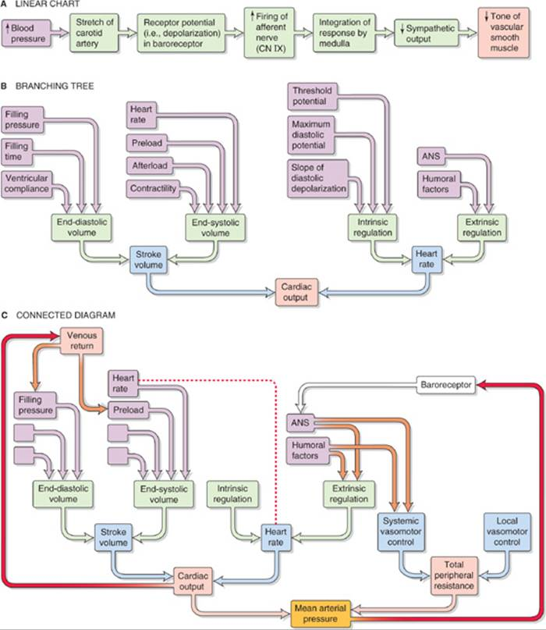

Q4. what is the difference between active and passive immunity?
ACTIVE IMMUNITY:
The CDC explains that lively immunity "results when exposure to a disorder organism triggers the immune system to produce antibodies to that disease," and can appear one of two ways: Through infection with the genuine disease, which is recognized as natural immunity; or thru a vaccination (essentially, a killed or weakened shape of the disorder that might not make any person ill, however will set off the physique to make antibodies), which is acknowledged as vaccine-induced immunity.
Active immunity that consequences from both situation—natural immunity or vaccine-induced immunity—will permit a person's immune system to understand the unique disease, if they ever come into contact with it again, which will then set off the physique to produce the antibodies wanted to battle it off.
Per the CDC, active immunity is frequently longer-lasting and can also now and again even furnish life-long protection—but this is absolutely based totally on the disorder itself. Immunity to the varicella virus (aka, chickenpox)—either with the aid of obtaining the contamination as a infant or thru a vaccine—can furnish lifelong immunity or long-lasting safety for up to 10 to 20 years, in accordance to the CDC. Whereas a every year flu shot should be repeated annually, as it gives the most safety inside the first three months, and starts off evolved to lose most effectiveness after six months.
PASSIVE IMMUNITY:
While active immunity takes place when an man or woman produces antibodies to a disease thru his or her personal immune system, passive immunity is supplied when a man or woman is given antibodies. This can show up in utero or thru antibody-containing blood products—such as immune globulin, or a substance made from human blood plasma—administered when instant safety from a particular ailment is needed. “For example, when a mother’s antibodies pass the placenta to the fetus or when humans are given antibodies as therapy for rabies,” explains Dr. Meyer. Immune globulin can additionally supply safety in opposition to hepatitis A in situations when a hepatitis A vaccine is now not recommended, per the CDC.
The major advantage to passive immunity—and the motive why it is occasionally used as a cure in opposition to diseases—is that it affords immediately protection. But passive immunity does not ultimate as lengthy as active immunity, and loses effectiveness inside a few weeks or months, per the CDC.

Q5. write a note on lymphatic system in detail?

The lymphatic system is a community of tissues, vessels and organs that work collectively to pass a colorless, watery fluid referred to as lymph again into your circulatory device (your bloodstream).
Some 20 liters of plasma go with the flow via your body’s arteries and smaller arteriole blood vessels and capillaries each and every day. After handing over vitamins to the body’s cells and tissues and receiving their waste products, about 17 liters are back to the circulation through way of veins. The last three liters seep via the capillaries and into your body’s tissues.
The lymphatic system consists of many parts. These include:
Lymph: Lymph, additionally referred to as lymphatic fluid, is a series of the more fluid that drains from cells and tissues (that is no longer reabsorbed into the capillaries) plus different substances. The different resources consist of proteins, minerals, fats, nutrients, broken cells, most cancers cells and overseas invaders (bacteria, viruses, etc). Lymph additionally transports infection-fighting white blood cells (lymphocytes).
Lymph nodes: Lymph nodes are bean-shaped glands that screen and cleanse the lymph as it filters thru them. The nodes filter out the broken cells and most cancers cells. These lymph nodes additionally produce and save lymphocytes and different immune system cells that assault and wreck micro organism and different dangerous components in the fluid. You have about 600 lymph nodes scattered at some point of your body. Some exist as a single node; others are intently linked corporations referred to as chains. A few of the extra acquainted places of lymph nodes are in your armpit, groin and neck. Lymph nodes are linked to others through the lymphatic vessels.·
Lymphatic vessels: Lymphatic vessels are the community of capillaries (microvessels) and massive community of tubes positioned at some point of the physique that transport lymph away from tissues. Lymphatic vessels acquire and filter lymph (at the nodes) as it continues to go towards large vessels known as amassing ducts. These vessels function very a whole lot like your veins do: they work beneath very low pressure, have a sequence of valves in them to hold the fluid transferring in one direction.
Collecting ducts: Lymphatic vessels empty the lymph into the proper lymphatic duct and left lymphatic duct (also referred to as the thoracic duct). These ducts join to the subclavian vein, which returns lymph to your bloodstream. The subclavian vein runs under your collarbone. Returning lymph to the bloodstream helps to keep ordinary blood quantity and pressure. It additionally prevents the extra buildup of fluid round the tissues (called edema)

