Name ^{UBAID ULLAH}
Id 13994
Program BS (MLT)
Paper Clinical Parasitology
Submitted To Maam Huma Imtiaz

Q2: What are the clinical findings and laboratory diagnosis of Trypanosoma?
Ans:
Clinical Findings:
In spite of the fact that both species cause resting ailment, the advance of the illness differs T. gambiense–induced malady runs a low-grade inveterate course over a number of years T. rhodesiense causes a more intense, quickly dynamic infection that, in case untreated, is usually fatal within a few months The introductory injury may be a skin ulcer at the location of the fly bite After the life forms enter the blood, discontinuous week by week fever and lymphadenopathy develop Enlargement of the back cervical lymph hubs is commonly seen The encephalitis is characterized at first by migraine, a sleeping disorder, and disposition changes, taken after by muscle tremors, slurred discourse, and lack of concern that advance to drowsiness and coma Untreated malady is as a rule fatal
Laboratory Diagnosis:
During the early stages, minuscule examination of the blood (either damp movies or thick or lean smears) uncovers trypomastigotes An suction of the injury or broadened lymph hub can moreover illustrate the parasites The nearness of trypanosomes within the spinal liquid, coupled with an hoisted protein level and pleocytosis, shows that the persistent has entered the late, encephalitic stage Serologic tests, particularly the ELISA for IgM counter acting agent, can be helpful

Q1: How does Trichrsis cause disease?
Ans:
DEFENTITON:
The disease is usually spread when people eat food or drink water that contains the eggs of these worms. This may occur when contaminated vegetables are not fully cleaned or cooked. Often these eggs are in the soil in areas where people defecate outside and where untreated human feces is used as fertilizer
INFECTION:
A whipworm contamination, too known as trichuriasis, is an contamination of the huge digestive system caused by a parasite called Trichuris trichiura. This parasite is commonly known as a “whipworm” since it takes after a whip. ive in a locale with a hot, sticky climate live in an range with destitute sanitation and cleanliness practices work in an industry where they come into contact with soil that contains manure eat crude vegetables that are developed in soil fertilized with fertilizer

CAUSES:
A whipworm contamination, too known as trichuriasis, is an contamination of the huge digestive system caused by a parasite called Trichuris trichiura. This parasite is commonly known as a “whipworm” since it takes after a whip.
Somebody might unwittingly ingest the whipworm parasites or their eggs when they: touch the earth and after that put their hands or fingers in or close their mouth eat natural products or vegetables that haven’t been completely washed, cooked, or peeled
CAUSE DISEASE:
sort of helminth) that causes trichuriasis (a sort of helminthiasis which is one of the dismissed tropical illnesses) Trichuris trichiura, Trichocephalus trichiuris or whipworm, could be a parasitic roundworm (a when it contaminates a human huge digestive tract.
Q3: Explain the transmission and life cycle of plasmodium in your own words.
Ans:
PLASMODIUM:
TraJungle fever is transmitted fundamentally by mosquito chomps, but transmission over the placenta, in blood transfusions, and by intravenous medicate manhandle moreover occursnsmission:
Life Cycle:
The vector and authoritative have for plasmodia is the female Anopheles mosquito There are two stages within the life cycle: the sexual cycle, which happens fundamentally in mosquitoes, and the abiogenetic cycle, which happens in people, the middle of the road hosts The sexual cycle is called sporogony since sporozoites are created, and the abiogenetic cycle is called schizogony since schizonts are made
The life cycle in people starts with the presentation of sporozoites into the blood from the spit of the gnawing mosquito The sporozoites are taken up by hepatocytes inside 30 minutes. This "exoerythrocytic" stage comprises of cell increase and separation into merozoites Merozoites are discharged from the liver cells and contaminate ruddy blood cells
Amid the erythrocytic stage, the life form separates into a ring-shaped trophozoite The ring frame develops and after that separates into a schizont filled with merozoites After discharge, the merozoites infect other erythrocytes This cycle within the ruddy blood cell rehashes at customary interims ordinary for each species The intermittent discharge of merozoites causes the commonplace repetitive indications of chills, fever, and sweats seen in jungle fever patients
The gametocyte-containing ruddy blood cells are ingested by the female Anopheles mosquito and, inside her intestine, create a female macrogamete and eight sperm like male microgametThe cycle starts within the human ruddy blood cells when a few merozoites create into male and others into female gametocytes
After fertilization, the diploid zygote separates into a motile ookinete that burrows into the intestine divider, where it develops into an oocyst inside which numerous haploid sporozoites are produced The sporozoites are discharged and move to the salivary organs, prepared to total the cycle when the mosquito takes her another blood meal
LIFE CYCLE OF PLASMODIUM:

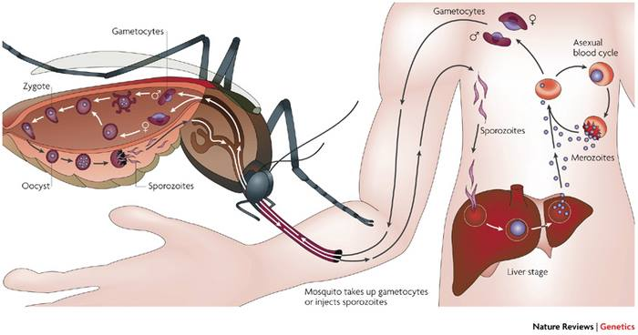

End.

