NAME: Arsalan Khan
ID: 14819
DEPARTMENT: BBA
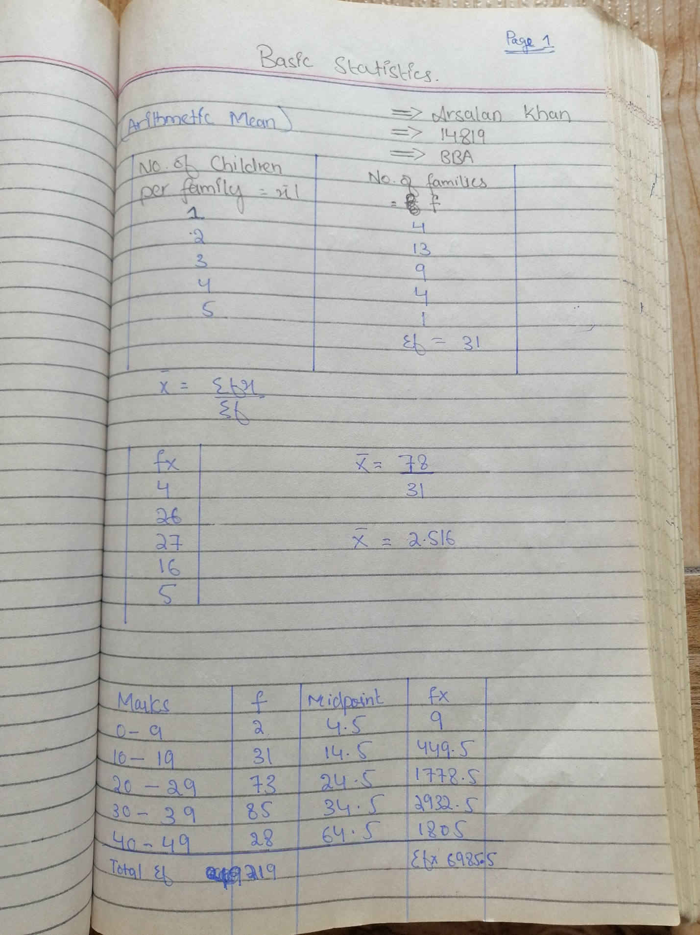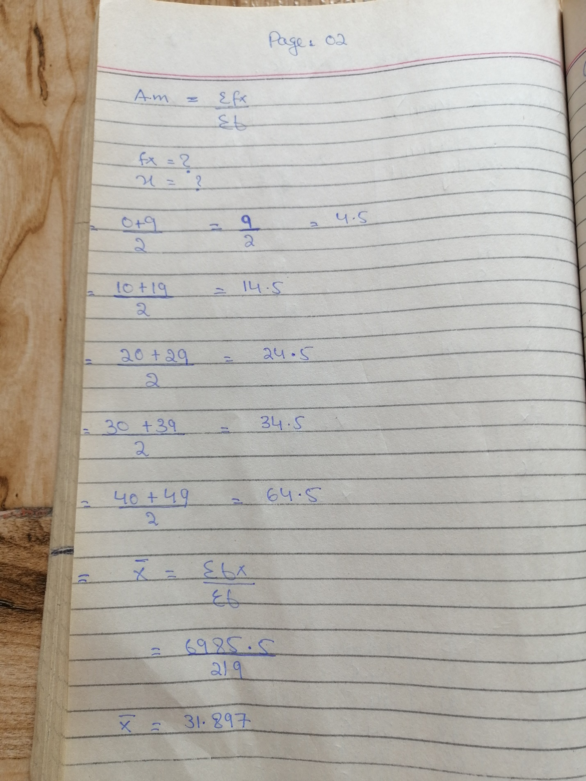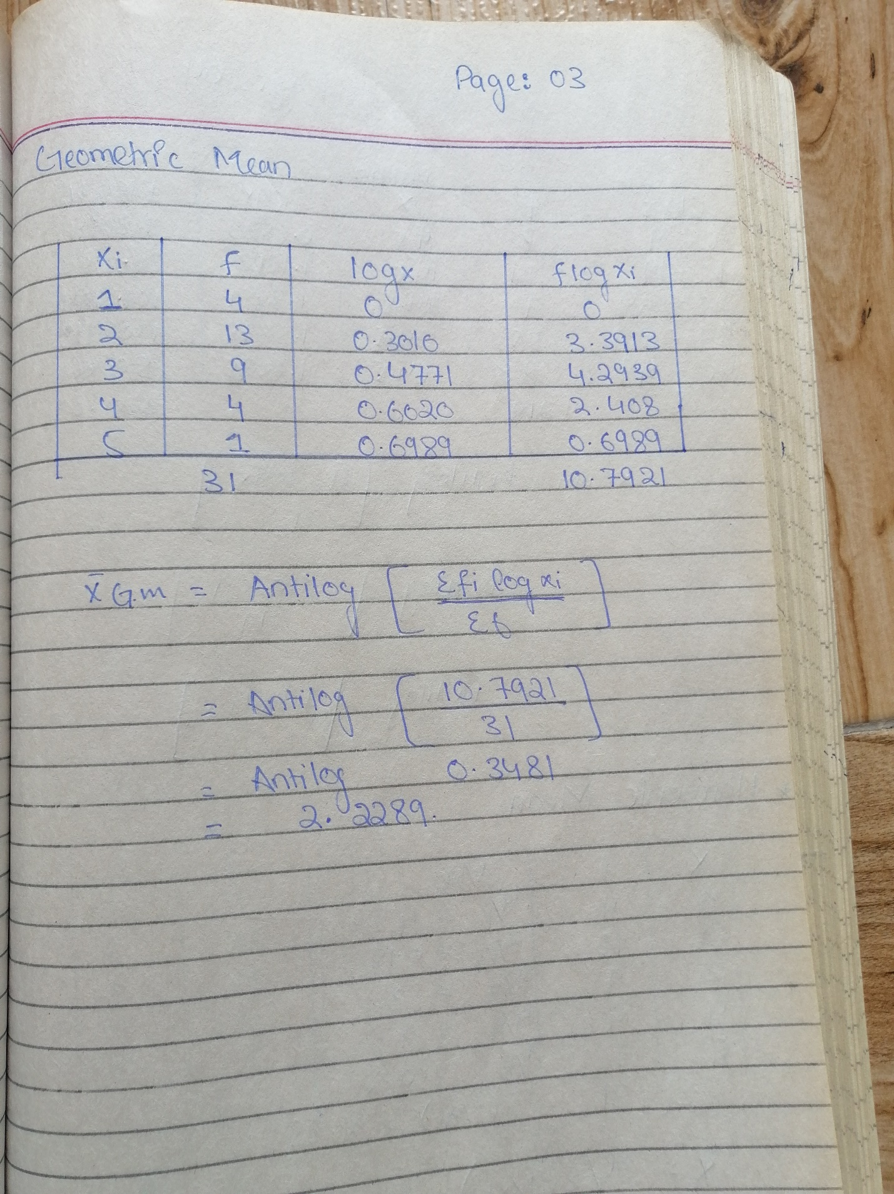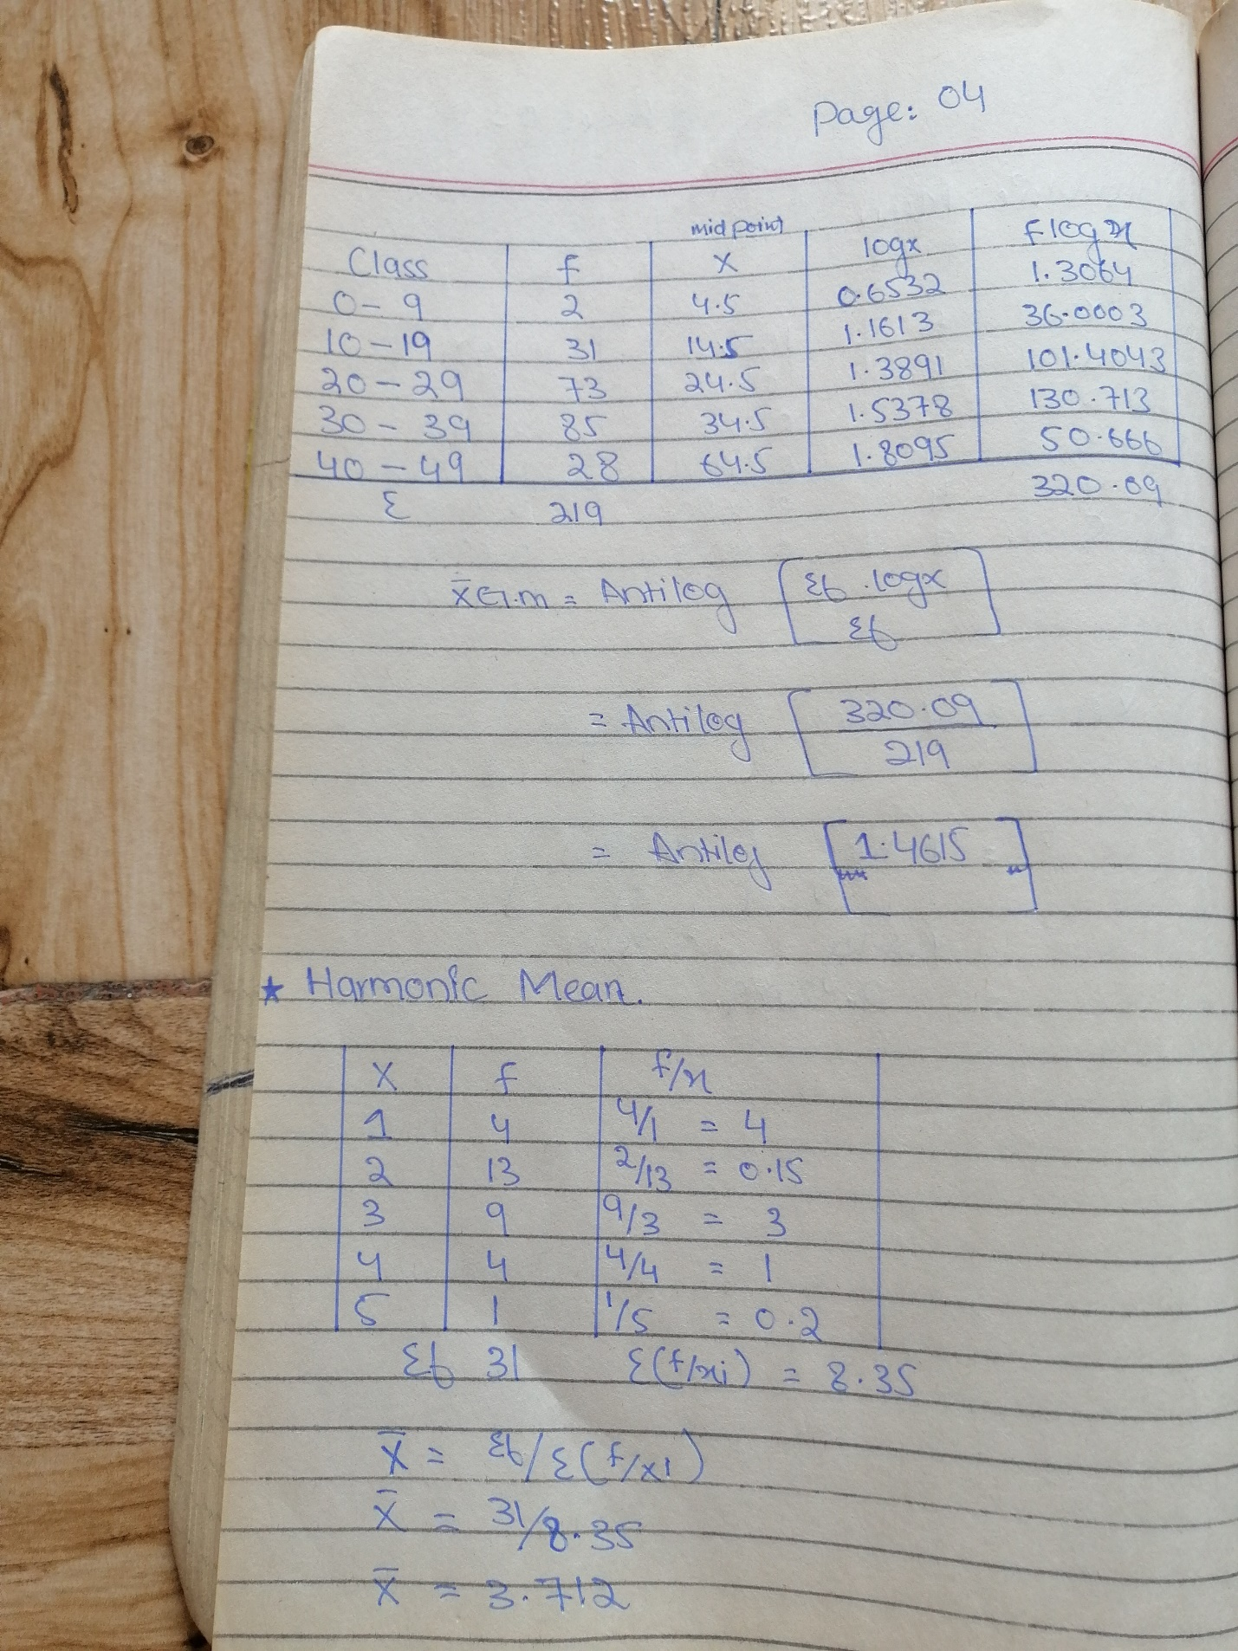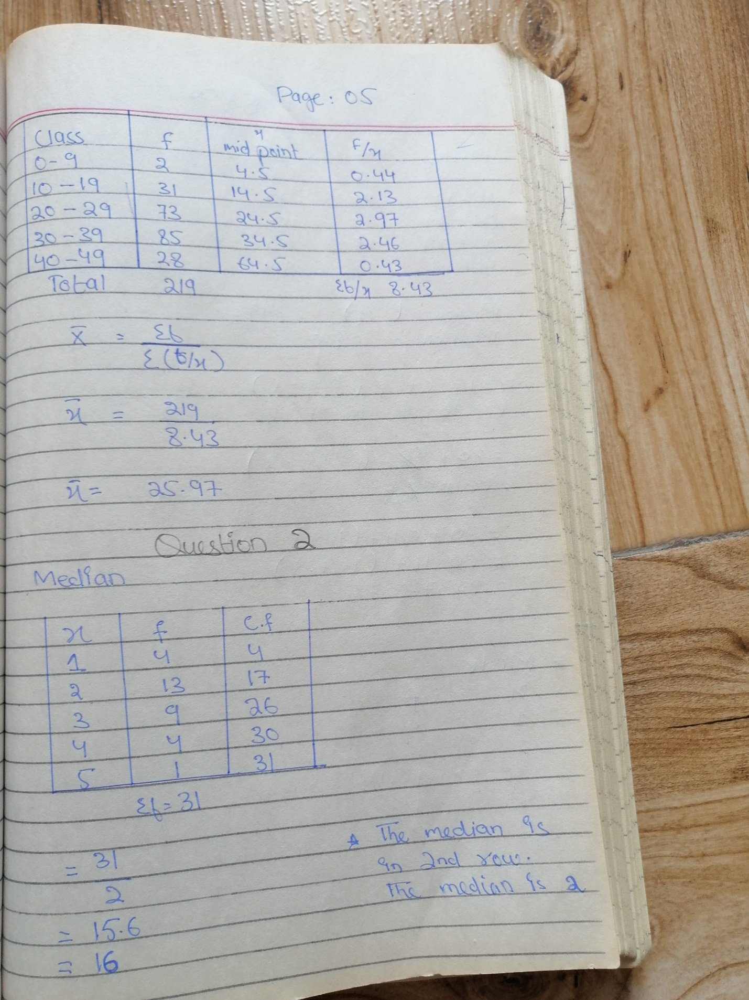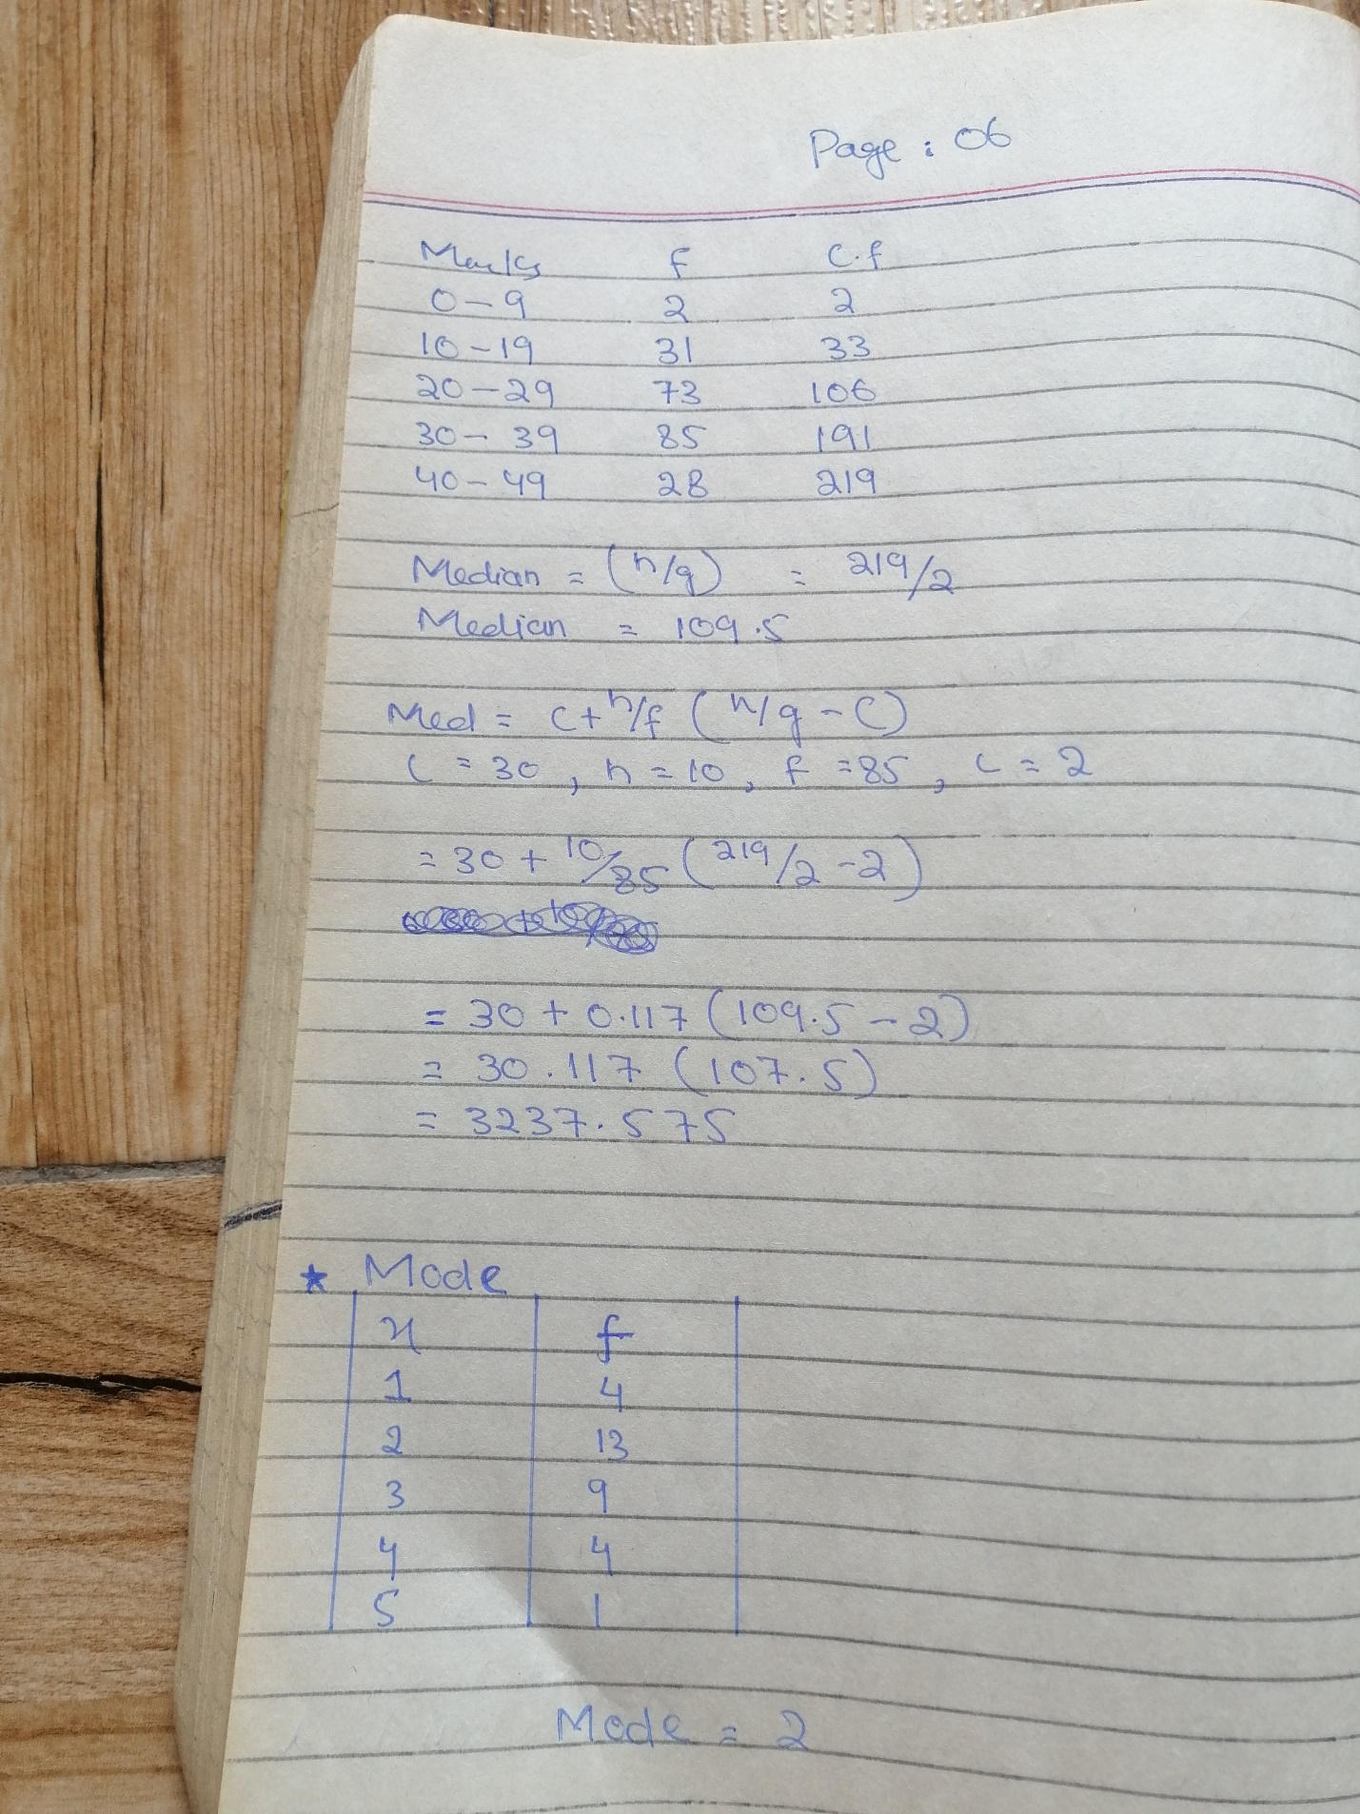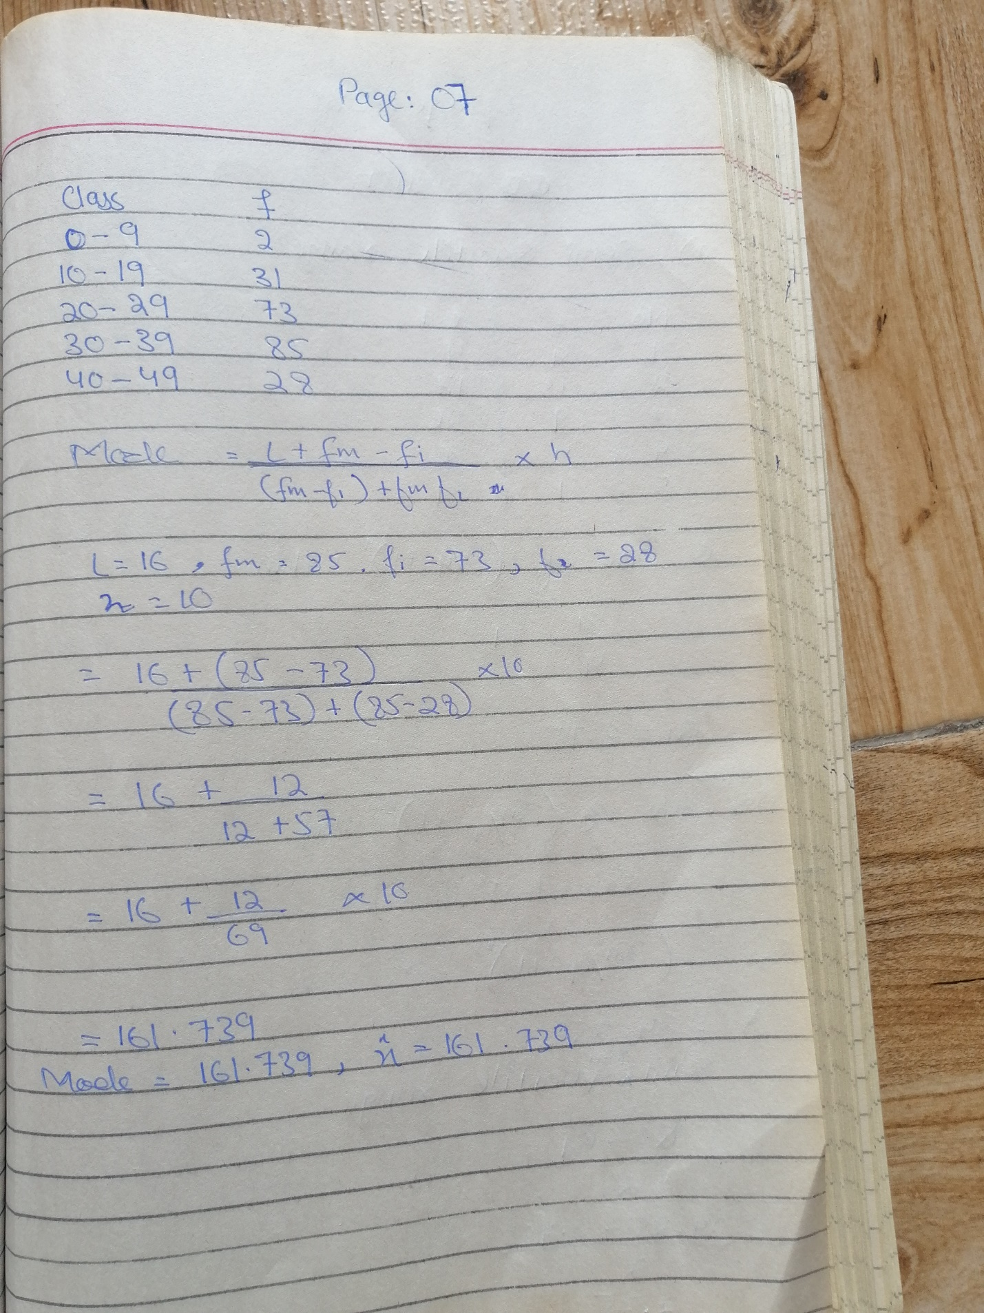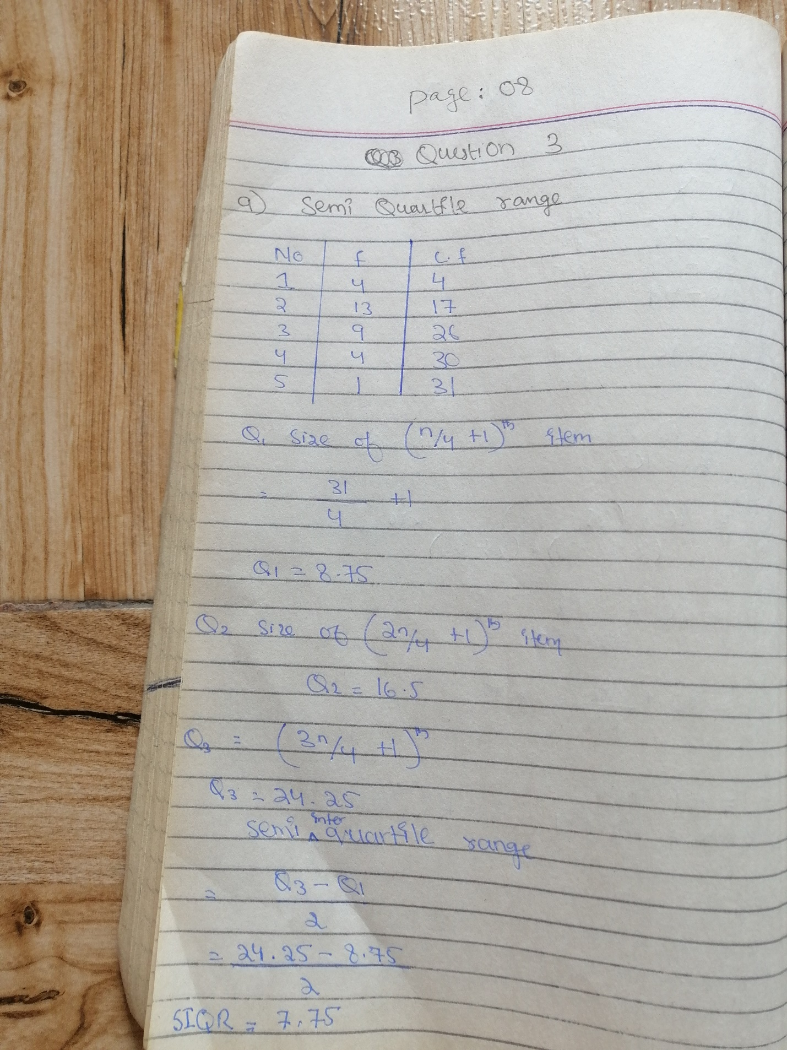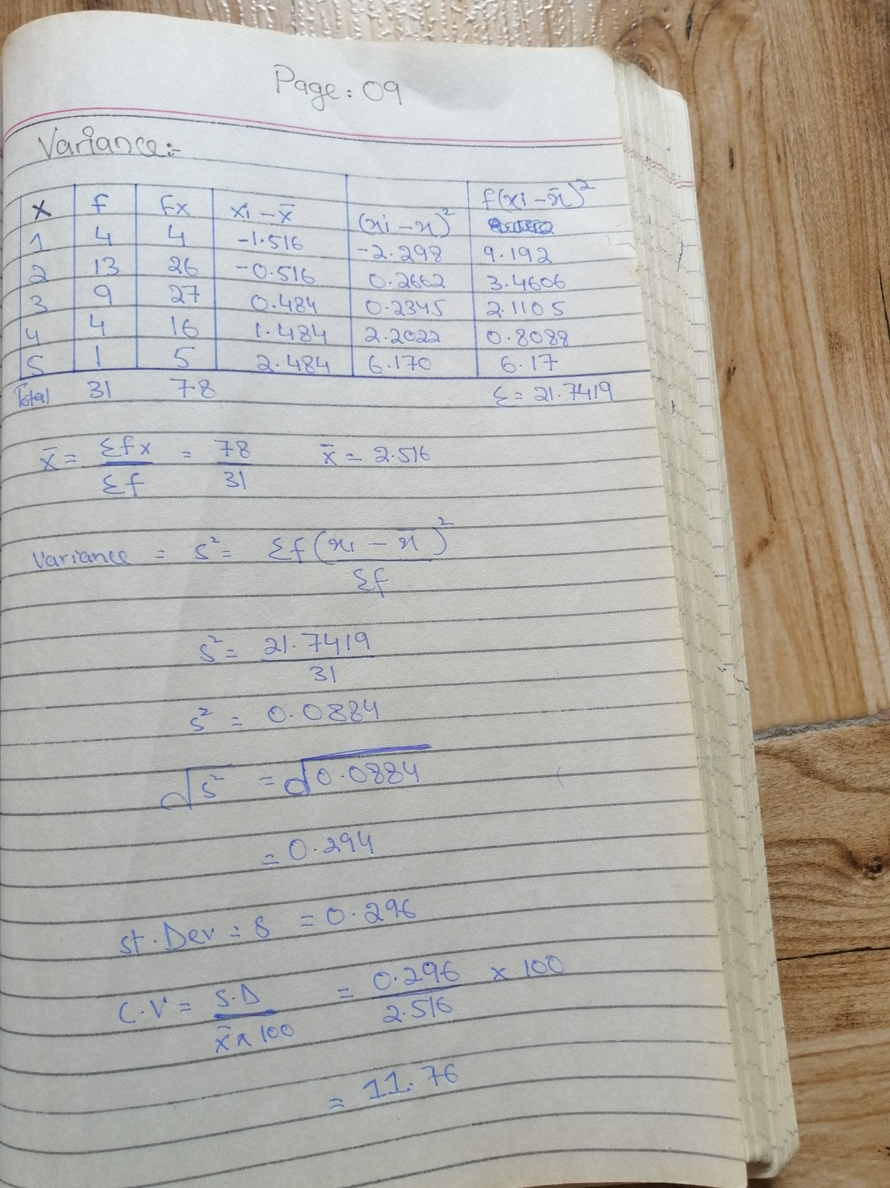
Q4: Write short notes on the following.
1. RANGE
The range of a distribution with a discrete random variable is the difference between the maximum value and the minimum value for a distribution with a continuous random variable the range is the difference between the two extreme points on the distribution curve where the value of the function falls to zero for any value outside the range of distribution, the value of the function is equal to 0.
2. QUARTILE RANGE
In statistics Quartiles are the set of values which has three points dividing the data set into four identical parts. Quartiles are the values that divide a list of numerical data into three quarters. The middle part of the three quarters measures the central point of distribution and shows the data which are near to the central point. The lower part of the quarters indicates just half information set which comes under the median and the upper part shows the remaining half, which falls over the median. In all, the quartiles depict the distribution or dispersion of the data set.
3. SEMI QUARTILE RANGE
The semi-interquartile range is defined as the measure of dispersion. Semi interquartile range also is defined as half of the interquartile range. It is computed as one half the difference between the 75th percentile (Q₃) and the 25th percentile (Q₁). The semi-interquartile range is one-half of the difference between the first and third quartiles. The Formula for Semi Interquartile Range is
Semi Interquartile Range = (Q₃– Q₁) / 2
4. VARIANCE
In statistics, a variance is also called the mean squared error. The variance is one of several measures that statisticians use to characterize the dispersion among the measures in a given population. To calculate the variance, it is necessary to first calculate the mean or average of the scores. To measure the amount that each individual score deviates or is different from the mean. You square that deviation by multiplying the number by itself. Numerically the variance equals the average of the squared deviations from the mean
5. STANDARD DEVIATION
Standard deviation is the measure of dispersion of a set of data from its mean. It measures the absolute variability of a distribution; the higher the dispersion or variability, the greater is the standard deviation and greater will be the magnitude of the deviation of the value from their mean. It is by far the most important and widely used measure of dispersion. Its significance lies in the fact that it is free from those defects which afflicted earlier methods and satisfies most of the properties of a good measure of dispersion. Standard Deviation is also known as root-mean square deviation as it is the square root of means of the squared deviations from the arithmetic mean.
6. COEFFICIENT OF VARIATION
The coefficient of variation (CV) is the ratio of the standard deviation to the mean. The higher the coefficient of variation, the greater the level of dispersion around the mean. It is generally expressed as a percentage. Without units, it allows for comparison between distributions of values whose scales of measurement are not comparable. When we are presented with estimated values, the CV relates the standard deviation of the estimate to the value of this estimate. The lower the value of the coefficient of variation, the more precise the estimate.

