Introduction to Architecture and Town Planning

Abrar Nasib Afridi
ID 16137 Sec A 2nd Semester

Q1: Take any building from internet, put its picture in Microsoft Word and explain its positive and negative points according to the principles of design. What could be done to make the building more attractive? Answer must be at least 200 words. (CLO1-PLO7)
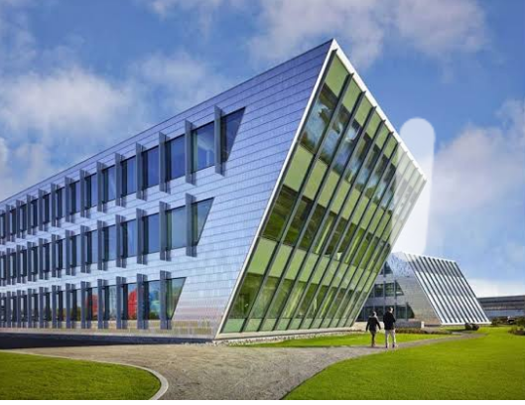

Principles of Design
The principles of design tells the rules a designer must follow to create an affective and attractive composition, the fundamental principles are:
- Emphasis.
- Balance.
- Proportion.
- Movement.
- Alignment.
- Contrast.
- Repetition.
- White Spaces.

Positive Points
The most positive point in the building is:
- It has an excellent focal point, which helps the viewer to navigate through the overall structure highlighted with black color.
- The little dots in the black area make the focus more attractive. The focus point also emphasized with the help of top Eves (chajja), which engage the viewer more likely.
- The color combination between red and black with the negative spaces (which is white) is more pleasing to see.
- If we look up the overall design, it seems like it has applied a golden ratio between the right and left sides, which attract the viewers to spend more time.
- The combination of black and red colors also creates a minor contrast.
- If we look at the neighborhood building and its color, which is almost matched to the structure, we have studied.
- It also seems like it has followed a specific pattern, May be according to the commercial building bylaws.

Negative Points.
- No doubt the building is outstanding, but if we clarify it look more attractive and add some more details.
- If we look at the window glasses, we can see that it is an unmanaged colors variation which damages the golden ratio.
- If we see the windows of focal points and compare with each other, we can see how the golden ratio is damaged and also the window glasses have rough management.
- Yes, it is the minor detail which is not very much important, but the professional designers care about their design and make them as mistake-free as they can.

Q2. Design and sketch an ideal single story house on the site shown below. The design should be free hand and can be drawn on graph paper. If a graph paper is not available then make a grid of 5’x5’ on a separate white A4 size paper. The house should be naturally ventilated and have natural lighting. Also, it should be free of noise. The site is located in Peshawar. Label or explain the Plan neatly. (CLO1-PLO7)
Ans.
The house should be natural lighting because Natural lighting will reduce the production of harmful bacteria and organisms that can grow in any house.
Natural light actually provides measurable health benefits such as:
- Wards of seasonal depression.
- Improves sleep.
- Reduce health risks of fluorescent lighting.
- Color wisely.
- Boosts vitamin D.
Natural ventilation also promotes a healthier lifestyle.
For Instance, the Oxygen from fresh air can enhance your heart rate, blood pressure, and Energy levels. It also makes you feel relaxed and strengthens your immune system.
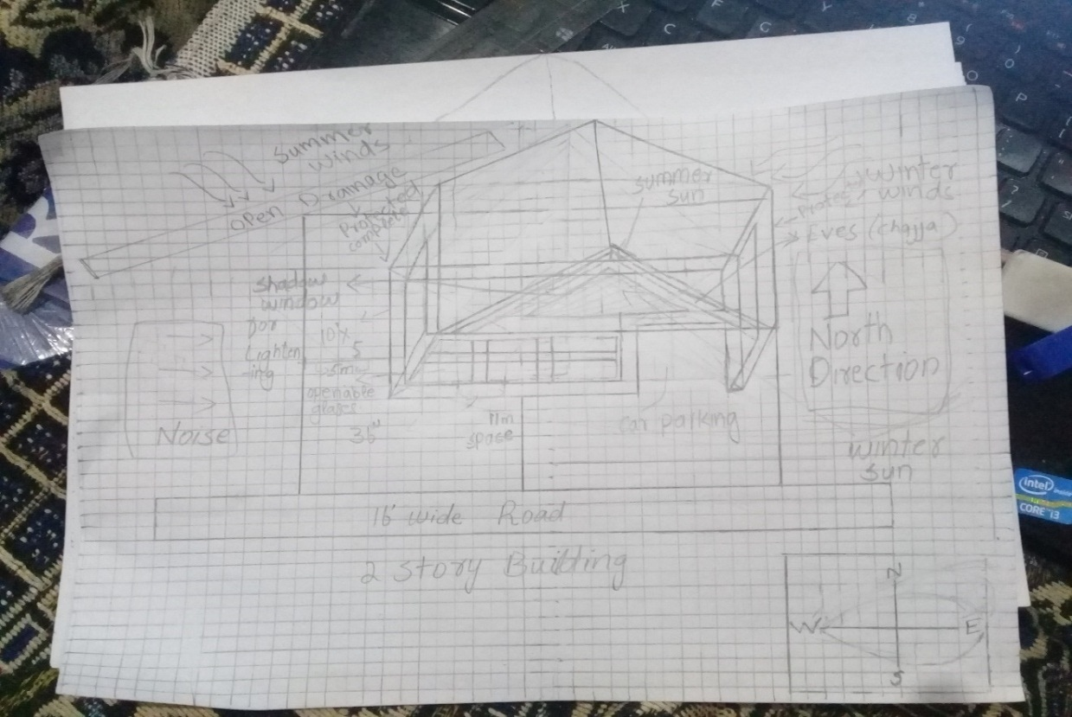
Related House picture

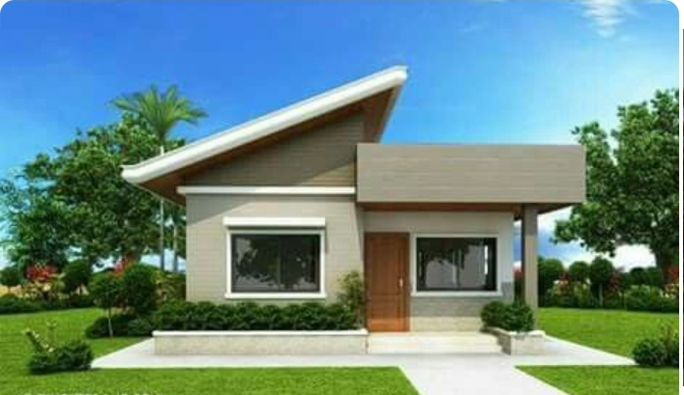

Q3. Select a site at the place where you live. Do Micro site analysis of Site and make its sketch on another A4 paper and write about it in detail. You can take your own lawn as a site for analysis or any other site in the neighborhood. Additionally, make a solar path diagram for your area on a separate piece of paper to find the exact sun angles for both winter and summer. Watch videos on YouTube to understand and make Solar Path diagram. Use these sun angles to make a rough sketch of a room. Show window height, type of fixed sun shade used, angle and height of shade as well as its depth and width by keeping sun angles in mind. The purpose for the sketch is to show how winter sun is allowed and summer sun is blocked.
Ans.

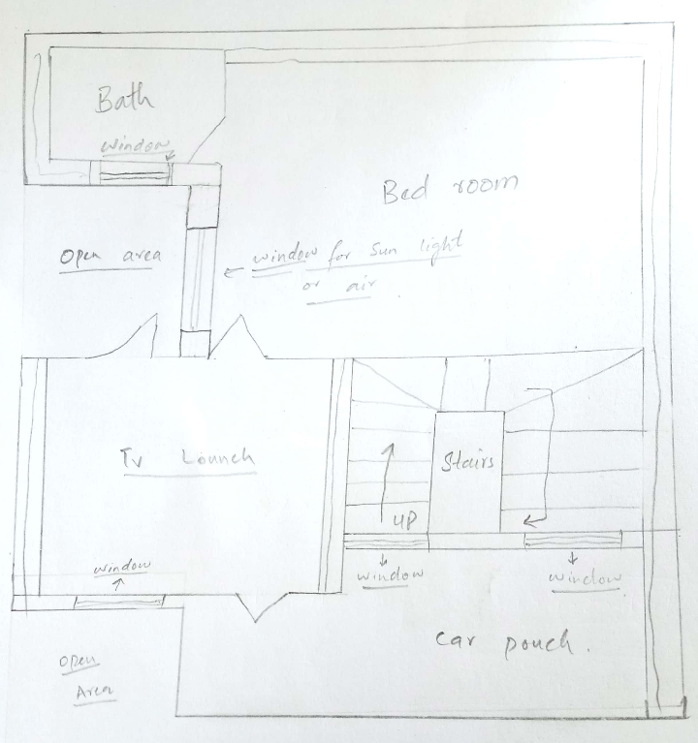

Windows for sun rays and air
If you wants to block the sun lights in summer puts a large sheet of woods in front of open area to block the sun rays entering the room directly
Open area

Open area
Windows for sun rays and air

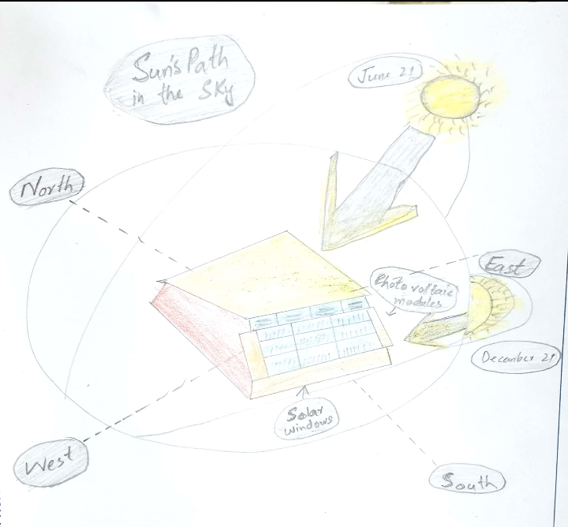

Sun path diagrams can tell you a lot about how the sun will impact your site and building throughout the year. Stereographic sun path diagrams can be used to read the solar azimuth and altitude for a given location

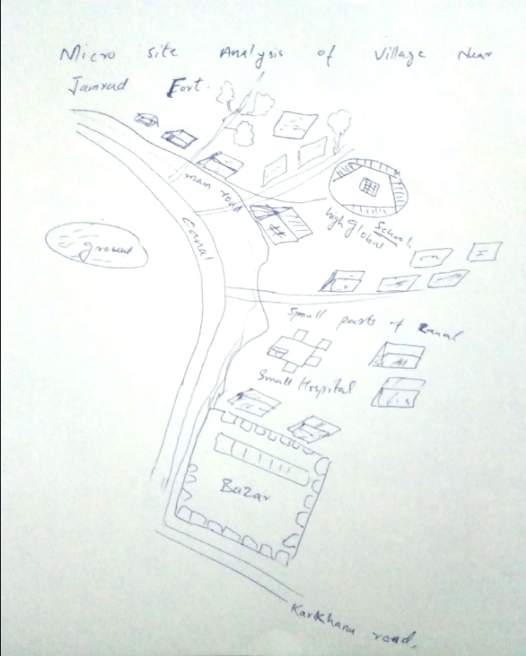

Micro site analysis:
- Location from different areas:
Ghariza is a small village situated linked with Jamrud Fort, and about 5km from Peshawar.
- Population:
About 1,00,000 of population living in ghariza.
- Climate and weather:
Its weather is almost all over the year is hot, about 9 months are hot and remaining three months are cold. Mostly hot months are June, July, August, and December and January are the cold months.
- Geology:
Ghariza is mostly plain area and no mountains are there and most of the earth is soil because of the canal.
- Education:
About 60% people are educated and 40% are uneducated.
- Circulation:
Ghariza is a rough roaded system, people ca travel to other by this faces many difficulties.
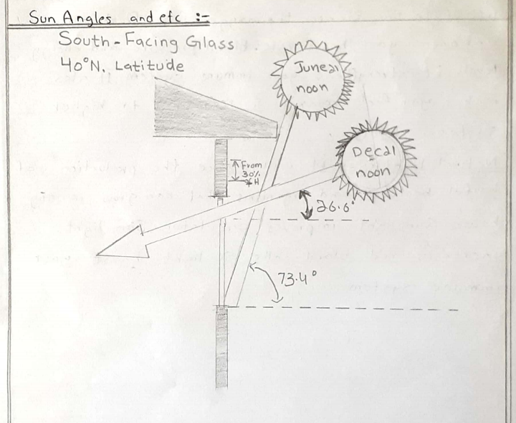

Sun path diagrams can tell you a lot about how the sun will impact your site and building throughout the year. Stereographic sun path diagrams can be used to read the solar azimuth and altitude for a given location

The end.

