IQRA NATINAL UNIVERRSITY

NANE NADIA
CLASS ID 6927
DEPARTMENT DPT
SEMESTER 8TH
TEACHER DR.SARA
PAPER SURGERY

QUESTION NO.1
Q1. Differentiate between communicating and non- communicating hydrocephalus. Give prognosis of hydrocephalus
ANSWER:
COMMUNICATING NON-COMUNICATING
1: Communicating hydrocephalous occur 1:non-communicating hydrocephalous also call
When the flow of CSF is blocked obstructive hydrocephalous, occurs when the
After it exist the ventricles .this flow of CSF is blocked along one or more narrow
Form is called communicating. Pathways connecting the ventricles.
Because CSF can still flow between
The ventricle which remain open.

2: Causes are due to: 2: causes are due to:
Post-heammorgh congenital
Bacterial meningitis acquired
Malignant meningitis
Increased venous pressure.

3: usually present itself a 3: can happen to people at any age
Birth or soon thereafter. But it is most common among eldarly.

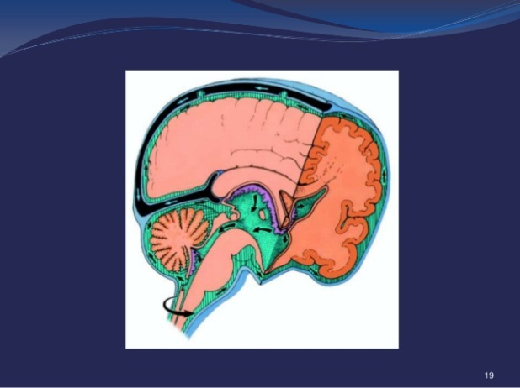
Communicating
Non-communicating
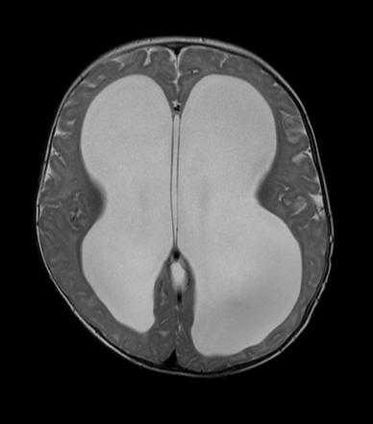

PROGNOSIS:
Prognosis depends on the causes, extent of symptoms and timelines of diagnosis and treatment. Some patient shoe dramatic improvement with treatment while other do not. In some instance normal pressure hydrocephalus, dementia can be reversed by shunt placement.
Failure to catch hydrocephalous on time and treat it accordingly may lead to long-term neurological deficit that require multidisciplinary medical teams to assist patient with developmental and last cognitive impairment .neurological damaged that may have occurred prior to treatment is unfortunately irreversible and can have a significant impact on functional social outcomes such a social integration ,schooling, and marriage.
Most hydrocephalous pt lead long, problem-free lives. However, left untreated, progressive hydrocephalous is generally fatal.

Q2. Identify population at risk of developing nephrolithiasis. Give surgical management of kidney stones.

NEPHROLITHIASES MEANS KIDNEY STONE OR RENAL CALCULI
RISK OF DEVELOPING NEPHROLITHIASES:

SUMMARY OF CONFUNDING RISK FACTORS (DIET INTAKE, OBESITY,AND ENVIRONMENT ) FOR EACH COUNTRY.

Country | Diet[15] | Obesity[16] | Climate
United State | High in sugar and meat | Highly obese (30%-40%) | Varies, Southern states tend to have on average warmer temperatures than the north; though the eastern states tend to have more tropic conditions[17]
Scotland | High in sugar and meat | Highly obese (27.7%) | Temperate[18]
British Isles | High in sugar and meat | Highly obese (14%-27.7%) | Mild winter, warm summers
Australia | High in sugar, meat, and dairy | Highly obese (20%-30%) | Warmer climates
Malayan Peninsula | High in meat and fish | Moderate obesity (16.3%) | Equatorial climate
Spain | Moderate in sugar High in meat | Moderate obesity (15.6%) | Mediterranean climate[19]
Germany | Very high in sugar | Moderate obesity (12.9%) | Temperate

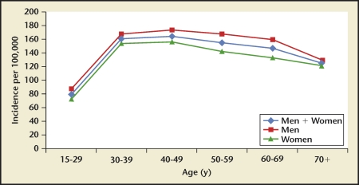

2005 Iran kidney stone incidence by age group. A rise-and-fall pattern is observed for reported incidence rates in Iran during 2005. Peak incidence is observed in the 40- to 49-year-old age group

Reported Regional Kidney Stone Prevalence Rates per Country and Year
Region | Year | Population | Prevalence
Buenos Aires, Argentina | 1998 | Age ≥ 19 y | 5.14%
 | 1998 | All | 3.96%
Thebes, Greece | 2005 | Age ≥ 14 y | 15.2%
Iceland | 1991 | All | 3.9%
Milan, Italy | 1986 | Age ≥ 25 y | 5.9%
 | 1998 | Age ≥ 25 y | 9.0%
Northeast Thailand | 1997 | Age 17–80 y | 16.9%
Seoul, Korea | 1998 | Age 40–79 y | 5.0%
Balearic Islands, Spain | 1990 | All | 14.3%
Hellion, Spain | 1996 | All | 0.26%
Taiwan, China | 2002 | All | 9.6%
Eastern Tennessee | 1986 | Uranium-exposed workers | 18.5%

GIVE SURGICAL MANAGEMENT OF KIDNEY STONES?

ANSWER:

SURGICAL MANAGEMENT OF KIDNEY STONES
Unenhanced helical computed tomography is the best radiographic technique for diagnosing urolithiasis
- Shock wave lithotripsy, ureteroscopy, and percutaneous nephrolithotomy have replaced open surgery for treating urolithiasis
- Most simple renal calculi (80-85%) can be treated with shock wave lithotripsy
- Percutaneous nephrolithotomy is the treatment of choice for complex renal calculi
- Staghorn calculi should be treated, and percutaneous nephrolithotomy is the preferred treatment in most patients
- Ureteroscopy is the preferred treatment in pregnant, morbidly obese, or patients with coagulopathy
- Most ureteral calculi <5 mm in diameter will pass spontaneously within four weeks of the
onset of symptoms
SOME OTHER TREATMENT
Shock wave
Pain relief –NSAIDS, OPOIDS
DIET THERAPY
PHARMACOLOGICAL THERAPY.

Q3. Give lab and radiological investigations for intestinal obstruction. what can be possible surgical management of intestinal obstruction.
ANSWER:
LAB TEST

FBC
ABGs
BUSE
ESR & CRP are optional

RADIOLOGICAL:

AXR➡ air fluid level & masses
Shadow
CT ➡ level, extent & cause of
Obstruction
Colonoscopy & endoscopy are optional.

SURGICAL MANAGEMENT OF INTESTINAL OBSTRUCTION
- Surgery is indicated for perforation or hemmorgh (emergency) or for small –bowel obstruction ,crohns colitis ,abscess (intra-abdo and perianal), fistulas and inflammation unresponsive to medical therapy
- Approximately 80% of pt. with CD will require surgery at some point.
- The principle of surgery is to conserve as much bowel as possible as 60% of pt need further surgery.
- Surgical is not curative
- I small bowel CD-resection is likely to be beneficial whereby discreet section are removed and an end to end anastomosis created. The benefits of strictureplasty to widen a narrow lumen are unknown at this time.
- In colonic CD-segmental and subtotal colectomy is likely to be beneficial.in a segmental colectomy the part of the colon affected is removed and an end to end anastomosis created in remaining colon and a subtotal colectomy the ileum is stapled to the sigmoid colon .
The obstruction is removed to relieve pain and improve the patient quality of life.
Stent: A metal tube is inserted into the intestine to open the area that is blocked.
Gastrostomy tube: a tube inserted through the wall of the abdomen directly in to the stomach.

Q4. What are the clinical manifestations of subarachnoid hemorrhage? Explain GCS
ANSWERR:
CLINICAL MANISFISTATION:
- NAUSEA
- VOMITING
- NUCHAL RIGIDITY
- PHOTOPHOBIA
- BLURRED VISION
- LOSS OF VISION
- NEUROLOGICAL DEFICIT
- LOSS OF CONSCIOUSNESS
- APROXMATALY 30 -40 OF PT ARE AT REST AT THE TIME OF SA
- EVIDENCE OF MENINGISM

GCS :

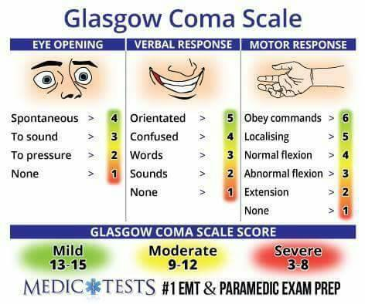
DOMAIN RESPONS SCORE
- Eye opening spontaneous 4
To speech 3
To pain 2
None 1
- Best verbal response oriented 5
Confused 4
Inappropriate 3
Incomprehensible 2
None 1
- Best motor response obeying 6
Localizing 5
Withdrawal 4
Flexing 5
Extending 3
None 1
- Total score deep coma or death 3
Fully alert and oriented 15

Q5. Enumerate vital clinical signs for confirmation of appendicitis. How can you manage a patient with acute appendicitis?
ANSWER:
VITAL SIGN OF APPENDICITIS”
- Lower right quadrant pain (Mcburneys points)
- Low-grade fever
- Nausea
- Vomiting
- Constipation or diarrhea
- Rebound tenderness
- Loss of appetite
- Roving’s sign (pain in right lower quadrant with palpation of left lower quadrant)
- Ruptured appendix causes abdominal distention develops from paralytic ileus.
- Inability to pass fetus
- Painful urination
- Severe cramps
- DUnghy’s sign (increased pain with cough)
- Obturator sign (pain on internal rotation right
- Paso’s sign (pain on extension of right thigh)
- pyrexia

MANAGE APPENDICITIS

Early /simple
Appendectomy ---------obese female ----------laparoscopic
--Open/lapar

LATE
Colonoscopy---------interval appendices’

Antibiotics (reduce the incidence of postoperative wound infection)
(When peritonitis is suspected, therapeutic intravenous antibiotics to cover
Gram-negative bacilli as well as anaerobic cocci should be given).
Intravenous fluids (to establish adequate urine output)
Salicylates
THANK YOU!

