NAME SALMAN AHMED
BE CIVIL ENGINEERING
SUBJECT ARCHEDTECTURE AND TOWN PLANNING
ID 6864

IQRA NATIONAL UNIVERSITY PESHAWAR

Indo-Islamic and Mughal Architecture
Introduction
Indo-Islamic architecture is the architecture of the Indian subcontinent produced by and for Islamic patrons. Different ruling dynasty ruled over subcontinent at successive intervals. The main reason for Muslim conquest was nation wealth and preaching and spreading of Islam. Arab was present in Sindh from Before in 700 AD but the development of Indo-Islamic architecture began in earnest with the establishment of Delhi as the capital of the Ghurid dynasty in 1193. Succeeding the Ghurids was the Delhi Sultanate, a series of Central Asian dynasties that consolidated much of North India, and later the Mughal Empire by the 15th century. Both dynasties [Indo-Islamic and Mughal] introduced Persianate, Turkic and Islamic architecture and art styles from Western Eurasia into the Indian subcontinent.
Time Duration of Indo-Islamic and Mughal Architecture
As the presence of Muslim and Arab was from 700 Ad but its actual time duration started from 1193 Ad and end when Mughal exhale from Subcontinent in 1857 AD.
Location of Indo-Islamic and Mughal Architecture
Indo-Islamic architecture has left a large impact on modern Indian, Pakistani, and Bangladeshi architecture. Most of Architecture developed and found in Delhi and prominent centers of Mughal culture such as Agra, Lahore and Allahabad, a variety of regional styles developed in regional kingdoms like the Bengal, Gujarat, Deccan, Jaunpur and Kashmir Sultanates.
Materials of construction used by Indo Islamic and Mughal Architecture for their homes and building
The architecture developed under Mughal and Indo-Islamic Architecture is built with qualitative building materials. Some of them are;
- Red sandstone
- White Marble
- Mortar Prepared with Lime [basic ingredients of mortar were lime, water and surkhi]
- Different Types of bricks like burnt bricks, half burns & Unburn.
- 72 Different kinds of wood among them famous are, Shisham, Nazhu, Dasang or kari, Ber,Mughilan[Babul],Sirs,Dayal and Bakayin etc.
- Cementing agent was clay mix with water
- Metals were also used like Iron Cramps, Iron door knockers, Screw and Nuts, rings etc.
Both Mughal and Indo-Islamic Architecture are distinctive pattern of each other encompasses a wide variety of architecture both religious and scholars. The mosque is the main building under Islam, and it was necessary to construct a mosque for establishing religious and social significance of new Islamic Empire of new sultanate periods. The actual journey of Islamic architecture began in India with the construction of Mosque at Qila Rai Pithora known as Qubbat-ul-Islam which was built over the ruins of 27 Indian temples in presence of local workmanship. Although, the plans and fundamental features were Islamic but used materials were remains of temples. Thus, the new compilation included Islamic, Indian and local elements introduced Indo-Islamic architecture. . So architectural elements were created by fundamental Islamic features, but decorative part mostly remained same as in Indian architecture. When Babur laid the foundation of Mughal Empire in Hindustan, Hindustan had made a lot of progress in the field of architecture. Babur was much passionate about the garden craft rather than building construction and he loved terraced garden of Persia. He built artificial terraces with water chutes and cascade. Though, he built Kabulibagh mosque at Panipat, Jama Masjid at Sambhal and mosque at Ayodhya which were made over the demolition of preexisting monuments. Thus, building materials were obtained from the remains of the buildings and the surrounding areas. During the reign of Humayun, architecture has mostly been ruined. The magnificent architectural work has been occurred during Akbar’s reign. Mughal architecture gained recognition throughout the world and he established a fresh construction of red sandstone at the site of Badalgarh known as Agra Fort and built many palaces and mosque at Fatehpur Sikri and also constructed forts and places in different parts of his territory. The magnificent edifice the tomb of Humayun was also constructed in Delhi during his reign. Thus, the architecture developed under Mughal is built with qualitative building materials in which red sandstone and white marbles were principle and mortar were prepared with source of lime. The basic ingredients of mortar were lime, water and surkhi. Apart from this, various type of colored stones, precious and semi-precious gems were also used for decoration of monuments.
Way of building Homes
The drawing or plan of the building was the main part of construction after choosing the site. Chief architect and other planners would prepare the plan of the building then it was shown to ruler or emperors who finally passed the map. The symmetry of the plan and drawing were prepared through exact measurement of each section and apartments and accurate figures followed during digging up of foundation. Architects also calculated the expenditure and estimate of the building.
The first work to construct a building was digging the foundation trench. It was done by beldars, the spade and digging were done deep to rock or water level as required for monument. Abul Fazl records the foundation of Agra fort which was carried through the seven strata of earth. Taj Mahal was digging up very deep to the water level of river Yamuna. The next work was to lay the foundation by using stones and plaster mortar. Lahauri uses saruj for mortar and Abul Fazl describes it sang-o-gach which was used to the moat of Agra fort with stones. The main function of plaster mortar was to protect the building foundation damaged by flood. Stone masons and brick layers work known as raj which is corruption of Arabic word Raz which means a builder or architect. He used trowel (karni or kanni) for spreading mortar and wooden rectangular object applied for smoothness and levelled the mortar.
Stone cutter or sangtarash was another important worker to construction of the building. There were three categories of stone cutter i.e.1. Sangbar (man who work in quarry), 2. munabbatkar and naqqash (embosser and tracer) and parchinkari (inlayer) 3. sadakar (plain stone cutter). They used two types of nails; thick and small to cut the stone into the pieces according to size. The nail was set on the slab by one hand and hit with double headed hammer by other hand. The tracery made with chisel then polished and burnish was applied on the surface of stone to get shining and smoothness. Iron work was done generally by ironsmith who manufactured nails, screw, nuts, clamps, knockers and other equipment’s. He fixed iron clams and iron string to adjoining stones together. Father Monserrate records “The stones of these buildings are so cunningly fitted that the joints are scarcely visible, although no lime was used to fix them together. The beautiful color of the stone, which is all red, also produced the same effect of uniform solidity”. The wooden work was done by carpenter using different tools like saw (arra), auger (barma), adze (basoola), axe (kulhari), plane (randa), chisel (sumba/tesha), hammer, and hand saw (arri).
Gypsum or lime was common bonding agent of mortar and was used in foundation and wall of the building. Generally, the mortar of earth and straw were used in laying of unbaked bricks and gypsum for burnt. The deep foundation of the building was filled with rough uneven blocks or stones and mortar, and inner walls were prepared by roughly shaped blocks and fixed together with gypsum mortar then thick plaster applied onto the walls to make smoothness. Gypsum was also cementing agent of plaster and it was used as waterproof component. After that it was clad with red sandstone or other marble required. If uneven blocks were not covered with stones or marble, then thick plaster was applied on them and made the white wash to decorate the building. During the construction, the windlass consisting stone blocks, rubble and mortar were carried on the top level using the lever, the pulley, the wedge and screw. These all five members the windlass, the lever, the pulley, the wedge and screw worked together. Large sections of stone were brought to site by animals where they split to the required size.
Most of Mughal buildings at Agra during the reign of Akbar were constructed with flat lintel and ceilings, yet arch was the fundamental architectural feature of Islamic architecture and frequently observed in Mughal architecture at Agra and Fatehpur Sikri. An arch is the structural element which spans a space and supports structure and weight below it. A space between two walls or piers spans a space at lintel level. The Centre of hemisphere space was made by framework of timber and bamboo and temporarily the space between silhouette of arch and lintel was filled with layer of bricks. The voussoirs were laid on it until the arch is completed and self-supporting. Major three types of domes appeared in the Mughal architecture, but various types of dome were developed in different period in different parts of the world. The earliest construction was ribbed dome which was originally associated from Buddhist architecture in India. Most of Indian temples had corbelled dome with square ground plan in pyramid form often reduced to an octagonal shape by architraves set diagonally across the corner and the circular course rested over the octagonal base. The Indian architectural tradition did not include arches, but flat corbels were used to transition from the corners of the room to the dome, rather than squinches. The pre-Muslim roofs were constructed with ribbed dome prepared by a framework of bamboo canes tied together at the vertex. A dome was constructed by a framework which silhouette took on the shape of circular arch.
The domes were prior construction of Hindus and there were two methods of construction, ribbed dome and corbelled dome. But after advent of Islam in India, a dome constructed in addition to the straight architrave, there is appeared the Islamic pointed arch and joins point towards the center of hemisphere so called ‘true dome’. The Persian architects proceeded from the fact that by changing a square ground plan into an octagon, the dome could rest upon eight points. Thus Indo-Islamic architecture comprises three domes. The domes were constructed with stone, brick and mortar, and iron dowels and cramps. The dome is composed of eight intersecting arches which span across the corners of the square to support the dome and rise to the vault. The technique uses arches to span the corners support for more weight called ‘squinches’. The squinch can be a single arch or more projecting nested arches placed diagonally over an internal corner. The arch to a gateway is built up with two piers of bricks and timber lintel to support the centering used to construct the structural arch. The lintel allows access through the gate while it is being built. Above the gate, a small brick dome is being constructed with the bricks laid in concentric rings to eliminate the need for centering. Thus, number of timbers and bamboos were required for the centering to support the arches during the construction. Use of brick centering was an alternative temporary support to the arches. Once the permanent arches and pendentives were formed in the vertical base then the dome could be built. The temporary framework of timber, bamboo and other required materials were supported on the balcony around the base of the dome. After the main domed roof built from brickworks or rough blocks then it could be plastered and could be clad with sandstone and marble. The marble blocks attached to the core by alternating wide and narrow layers secured by use of iron cramps. Iron cramps may also help form a tension ring at the base of the dome and used to improve the strength of the building.
Form of Indo Islamic and Mughal Architecture and difference from other Architecture Style
Some of the most popular features of this Indo- Islamic architecture include;
- high domes with pillars around it
- large open courtyards
- high minarets
- Use of Red sandstone
- Islamic geometric pattern
- pointed arch
- multifoil arch
- onion dome

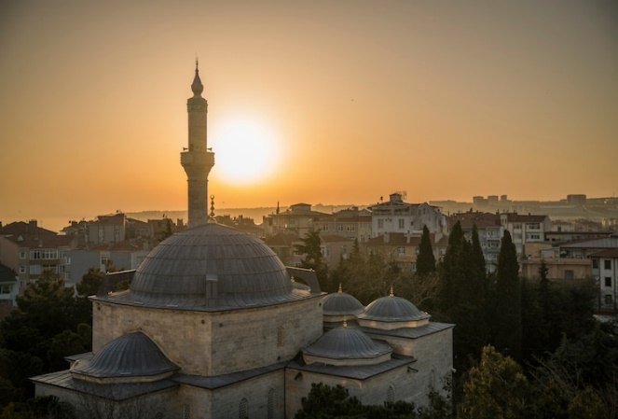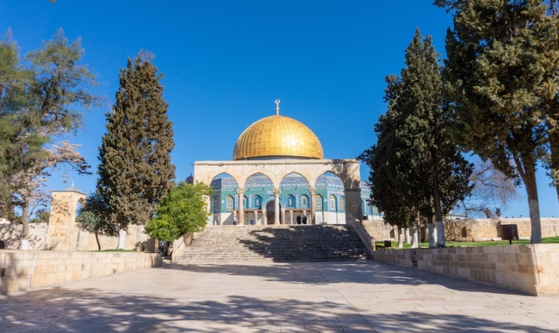
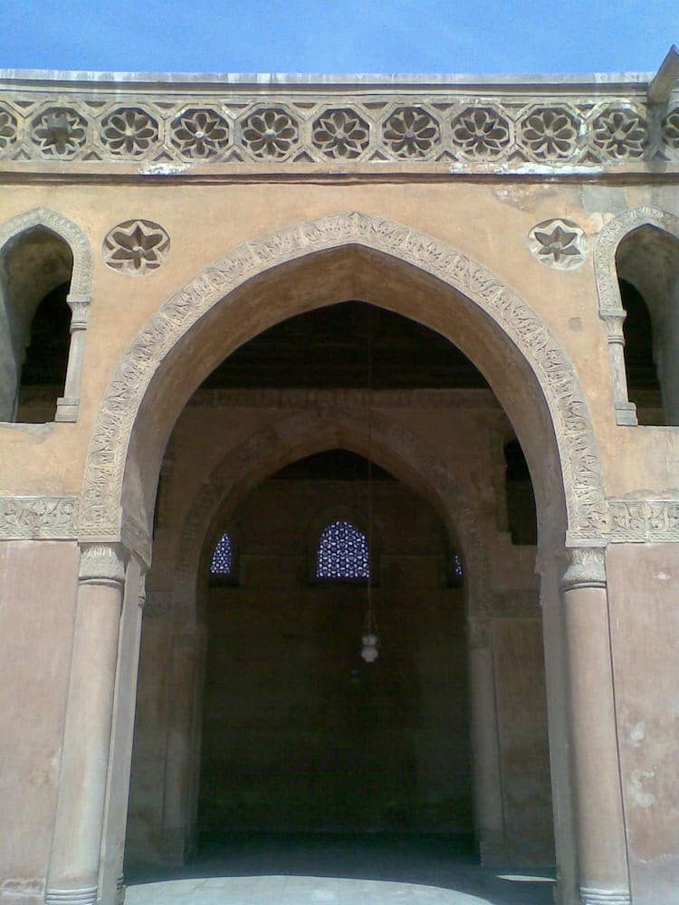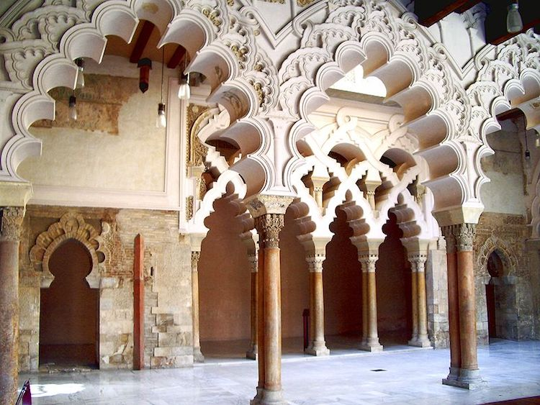
Common Feature of Indo-Islamic and Mughal Architecture
The most common feature are;
- The most important factors common to both forms of architecture, especially in respect of mosques and temples, were that to both styles, ornamental decoration was very vital and that the open court in many cases was surrounded by colonnades.
- The prayer chamber of the mosque was spacious, whereas the shrine of the temple was comparatively small.
- The mosque was light and open, whereas the temple was dark and closed.
- The difference between the lay-out of a temple and a mosque is explained by the essential difference between the Hindu and Muslim forms of worship and prayer.
- A cell to house the image of the deity, garbha-griha, and often small halls in front for the worshippers was regarded adequate for a simple Hindu temple. But the Islamic form of worship, with its emphasis on congregational prayer, requires a spacious courtyard with a large prayer hall, pointed towards Mecca, as its western end that is, to the West of India.
- In the rear wall of the prayer-hall, the center is occupied by a recess or alcove, called mihrab; and indicates the direction of prayer (qibla). A pulpit (mimber) at its right is meant for the imam who leads the prayer. A tower or minaret, originally intended for the muezzin to call the faithful to the prayer, later assumed a mere architectural character. A gallery or compartment of the prayer hall or some other part was screened off to accommodate the ladies who observed purdah. The main entrance to a mosque is on the east, and the sides are enclosed by cloisters (liwans). A tank is provided for ablutions usually in the courtyard of a mosque.

Taj Mahal
The Taj Mahal, a World Heritage Site was built between 1630–49 by the emperor Shah Jahan in memory of his wife Mumtaz Mahal. Its construction took 22 years and required 22,000 laborers and 1,000 elephants, at a cost of 32 million rupees. (corresponding to US$ 827 million in 2015) It is a large, white marble structure standing on a square plinth and consists of a symmetrical building with an iwan (an arch-shaped doorway) topped by a large dome and finial.
The building's longest plane of symmetry runs through the entire complex except for the sarcophagus of Shah Jahan, which is placed off center in the crypt room below the main floor. This symmetry is extended to the building of an entire mirror mosque in red sandstone, to complement the Mecca-facing mosque placed to the west of the main structure. Parchin Kari, a method of decoration on a large scale-inlaid work of jewels and Jali work has been used to decorate the structure.

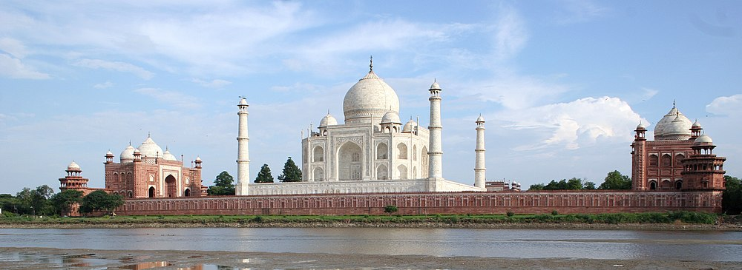

Mughal Gardens

Mughal gardens are gardens built by the Mughals in the Islamic style. This style was influenced by Persian gardens. They are built in the char Bagh structure, which is a quadrilateral garden layout based on the four gardens of Paradise mentioned in the Qur'an. This style is intended to create a representation of an earthly utopia in which humans co-exist in perfect harmony with all elements of nature.[24]

The quadrilateral garden is divided by walkways or flowing water into four smaller parts. Significant use of rectilinear layouts are made within the walled enclosures. Some of the typical features include pools, fountains and canals inside the gardens.

Some famous examples of Mughal gardens are the Bagh-e-Babur at Kabul, Mehtab Bagh gardens at the Taj Mahal, gardens at Humayun's Tomb, Shalimar Gardens at Lahore, Khusro Bagh at Prayagraj, as well as Pinjore Gardens at Haryana.

The ensemble of six Mughal Gardens of Jammu and Kashmir (Pari Mahal, Nishat Bagh, Shalimar Bagh, Chashme Shahi, Verinag Garden, Achabal Gardens) are on the tentative list of UNESCO World Heritage Sites in India.

