ID:16076 Section: "A"
Paper: Architecture
Semester: 2nd
Submitted to: MAM'M Aleena Babar
Q1:Take any building from internet, puts it picture in microsoft word and explain it positive and negative points according to the principle of design. what could be done to make a building more attractive? answer must be at least 200 words?
Answer:The Principles of design describe the ways an artist use different elements of design in a composition. These ways or Principles are:
Balance
Rhythm
Emphasis
Contrast
Movement
Harmony
Proportion and scale

Example
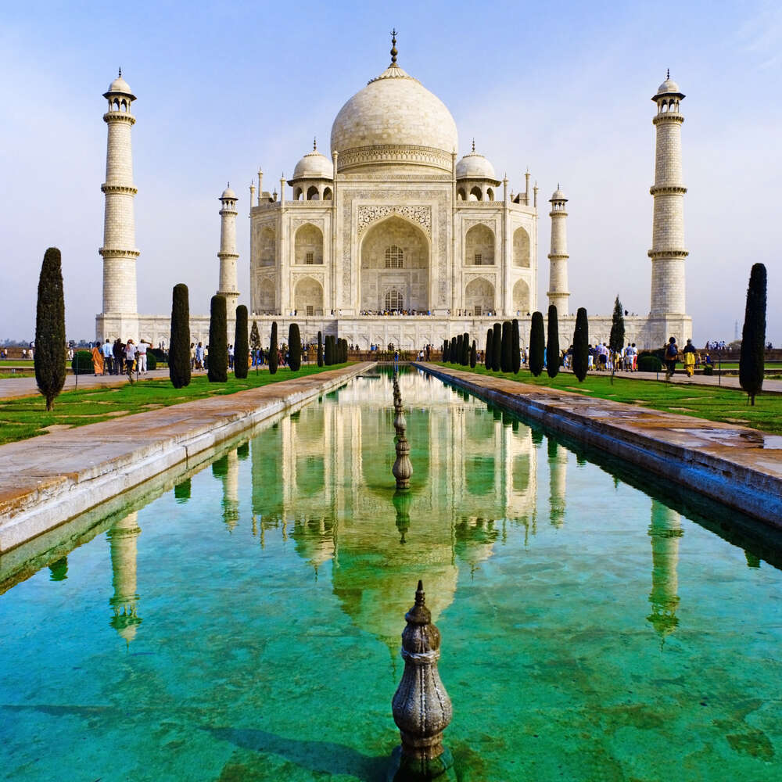
Positive Points
- The four sides of the Taj Mahal are perfectly identical which uses the principles of design such as symmetry of architectural elements. The building is in symmetry, which is the simplest type of balance to create and recognize. Symmetrical balance appeals to us because of the awareness of our bodies and our own symmetry.

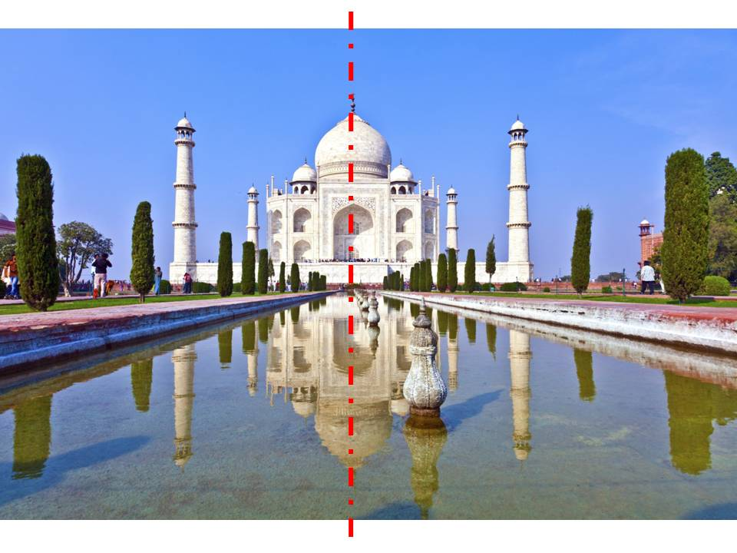

- It takes a pinkish hue in the morning, milky white in the evening and golden at night when illuminated by moonlight following element of design i-e value.

- All the rectangles used in the tom building and its main arch are all golden rectangle with height to width ratio equal to 0.618, which means that it followed a proper proportion.

- In taj mahal, rhythm is achieved by the use of multiple domes and the repetitive use of arches with the colossal arch at the center and smaller arches on either sides.

- The rhythm is also achieved by the use of minarets on all the plinth corners.

- The most recognizable feature or we can say the emphasis of Taj Mahal is the white dome at the peak of the mausoleum. Often called the 'onion dome', it rises to about 35 meters (115 feet) and is surrounded by four other domes.

- The translucent white marbles is making the architecture more eye pleasing.

Negative Points

- The grave site is one place which doesn’t conform to the rest of the symmetry.

- The massive scale of Taj Mahal creates a distressing moment at first sight.

No doubt that The Taj Mahal is widely considered one of the most beautiful buildings ever created. But the building could be made more attractive if there was use of some other color at the main entrance to make the building more emphasizing and eye catching because the use of single color might be boring sometimes.
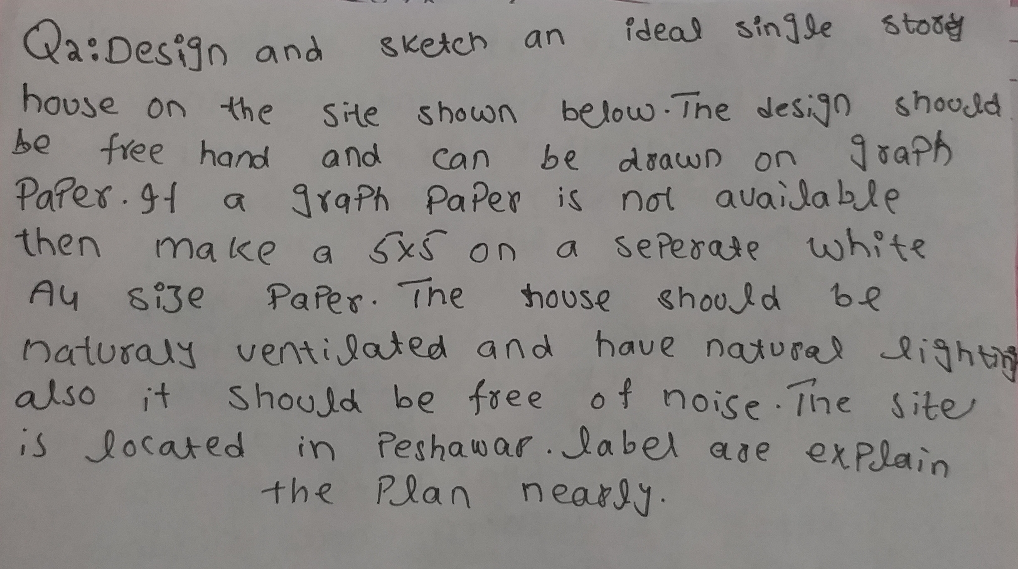8

