- IQRA NATIONAL UNIVERSITY Peshawar Due Date 25th June 2020
Department | Radiology
Subject | Human physiology II
Final term paper Marks | 50
Semester | -II
Final Term Examination | Spring 2020, Section (A)
Instructor | Dr. M. Shahzeb Khan (PT)
- Fill below blocks.
Student Full Name | Farhan Ali
Student Father Name | Shaukat Ali
University ID Card Number | 15859

Note:
- Attempt all questions, all questions carry equal marks.
- Answer Briefly and to the point, avoid un-necessary details

Q1: (A) How stimulus of smell moves from nostril to brain? Make a Diagram as well?
Answer (A):
Stimulus of smell moves from nostril to brain;
Introduction:
The olfactory system is responsible for our sense of smell. This sense, also known as olfaction, is one of our five main senses and involves the detection and identification of molecules in the air.
Once detected by sensory organs, nerve signals are sent to the brain where the signals are processed. Our sense of smell is closely linked our sense of taste as both rely on the perception of molecules. It is our sense of smell that allows us to detect the flavors in the foods we eat. Olfaction is one of our most powerful senses. Our sense of smell can ignite memories as well as influence our mood and behavior.

Olfactory System Structures:

Our sense of smell is a complex process that depends on sensory organs, nerves, and the brain. Structures of the olfactory system include:
- Nose: It is an opening containing nasal passages that allows outside air to flow into the nasal cavity. Also a component of the respiratory system, it humidifies, filters, and warms the air inside the nose.
- Nasal cavity: cavity divided by the nasal septum into left and right passages. It is lined with mucosa.
- Olfactory epithelium: specialized type of epithelial tissue in nasal cavities that contains olfactory nerve cells and receptor nerve cells. These cells send impulses to the olfactory bulb.
- Cribriform plate: a porous extension of the ethmoid bone, which separates the nasal cavity from the brain. Olfactory nerve fibers extend through the holes in the cribriform to reach the olfactory bulbs.
- Olfactory nerve: nerve (first cranial nerve) involved in olfaction. Olfactory nerve fibers extend from the mucous membrane, through the cribriform plate, to the olfactory bulbs.
- Olfactory bulbs: bulb-shaped structures in the forebrain where olfactory nerves end and the olfactory tract begins.
- Olfactory tract: band of nerve fibers that extend from each olfactory bulb to the olfactory cortex of the brain.
- Olfactory cortex: area of the cerebral cortex that processes information about odors and receives nerve signals from the olfactory bulbs.
Stimulus of smell moves from nostril to brain;
How it all works/Physiology of smell:
- Like the sense of taste, it's a chemical sense.
- They are called chemical senses because they detect chemicals in the environment,
- 1. Vaporized odour molecules (chemicals) floating in the air reach the nostrils and dissolve in the mucus (which is on the roof of each nostril).

- 2. Underneath the mucus, in the olfactory epithelium, specialized receptor cells called olfactory receptor neurons detect the odour.

- These neurons are capable of detecting thousands of different odours.

- 3.The olfactory receptor neurons transmit the information to the olfactory bulbs, which are located at the back of the nose.

- 4. from the olfactory bulbs, the sensations are carried through olfactory tract to olfactory area in the temporal lobe of cerebral cortex.

- 5. These brain centres perceive odours and access memories to remind us about people, places, or events associated with these olfactory sensations.

Diagram Showing how stimulus of smell moving from Nostrils to the brain:
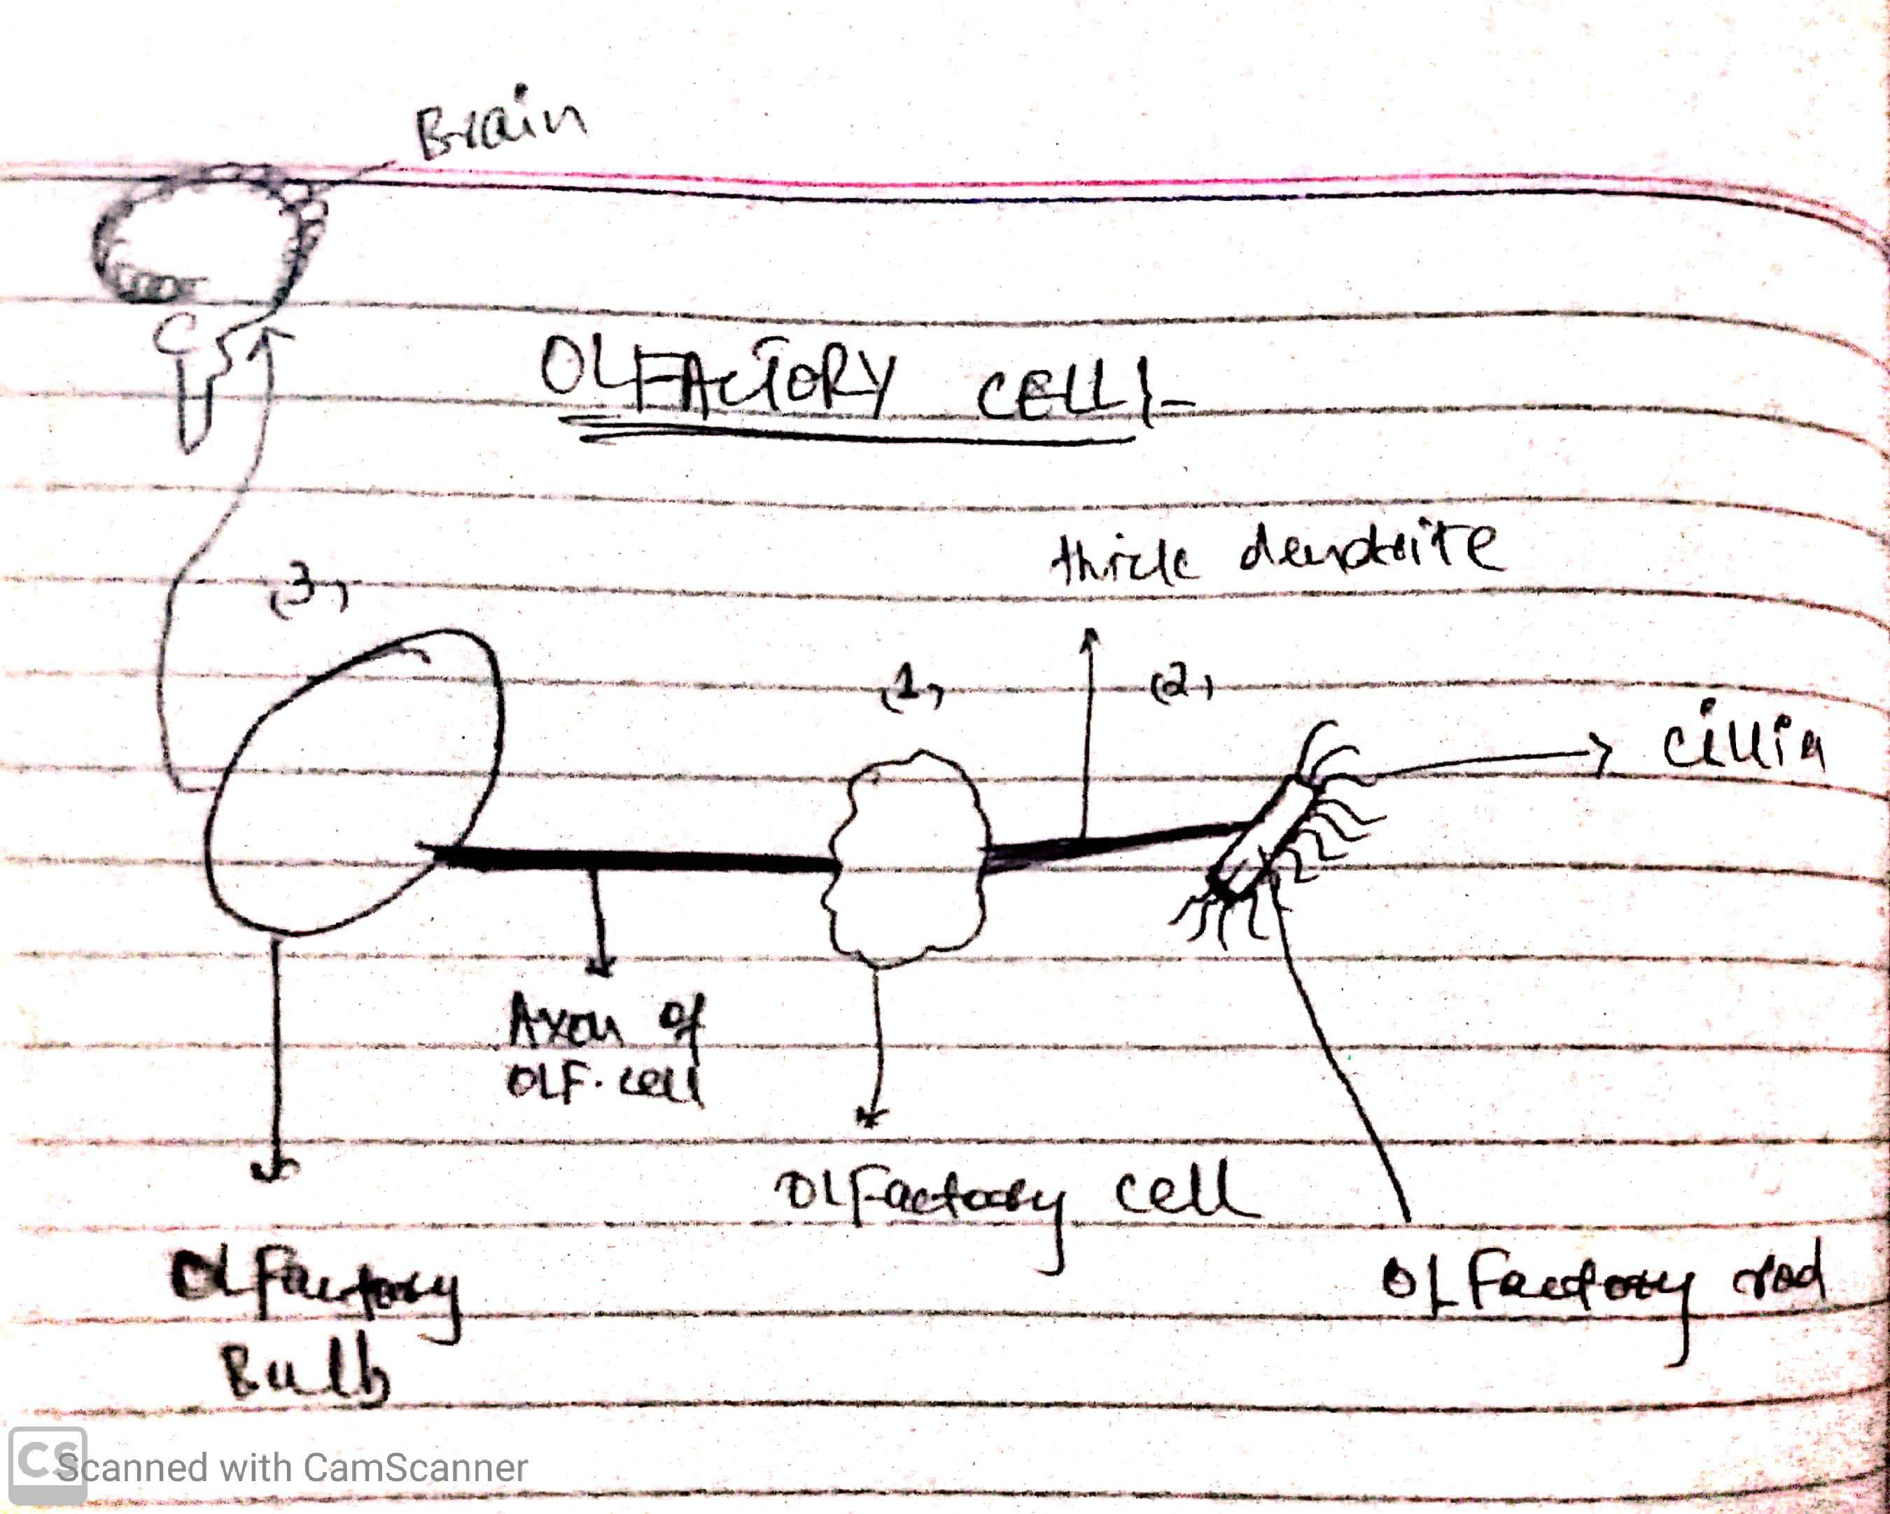

Q 2: (A) What is difference between Haemostasis, Haematopoiesis and Homeostasis?
(B) What is Erythroblastosis fetalis?

Answer: (A) Difference between Haemostasis, Haematopoiesis and Homeostasis:
Homeostasis:
Definition:
The term “homeo-” refers to a similar (as opposed to “homo- “, meaning equal) and the term “-stase” refers to condition. The ability to keep the internal environment in constant balance, working against changes in the external environment, is called as Homeostasis.
The concept of homeostasis was first used by Walter Cannon in 1926.
The Nervous and Endocrine systems play an important role in maintaining homeostasis. It is also believed that the immune system plays an important role in maintaining homeostasis. Changes in the external environment that affect an organism are considered stressful as physical or chemical stress, as well as biological, for example by exposure to bacteria.
Haemostasis:
Definition:
It is a complex series of biological phenomena that occurs in response to injury of a blood vessel in order to stop bleeding. The haemostatic mechanism includes three processes; Primary haemostasis, coagulation (secondary haemostasis) and fibrinolysis. These processes have together the purpose of maintaining the necessary fluidity of blood, without extravasation by the vessels or obstruction of the flow by the presence of thrombi.
Here, blood vessels, platelets, pro coagulant factors and anti-coagulant factors are involved. All in balance to stop the bleeding and then dissolve the clot formed.
Haematopoiesis:
Definition:
Haematopoiesis is the production of all of the cellular components of blood and blood plasma. It occurs within the hematopoietic system, which includes organs and tissues such as the bone marrow, liver, and spleen.
The growth and maturation of the blood cells and other formed blood elements in the bone marrow. Haematopoiesis normally occurs in the flat bones, such as the pelvis, breastbone and shoulderblades, but in times of extra demand may extend to other bones or even other tissues such as the liver. All haematopoiesis, including both red and white cells, develops from a single type of stem cell.
(B) Erythroblastosis fetalis:
Definition:
It is defined as “a haemolytic disease of the foetus and new-born that occurs when the immune system of a Rh-negative mother produces antibodies to an antigen in the blood of a Rh-positive foetus which cross the placenta and destroy foetal erythrocytes and that is characterized by an increase in circulating erythroblasts and by jaundice”.

Symptoms of Erythroblastosis Fetalis:

Symptoms that may occur before the baby is born:
- Swelling of the baby’s body
- Rapid heart rate
- Enlarged organs such as the spleen, liver, or heart
- Symptoms that may occur after the baby is born:
- Difficulty breathing
- Jaundice or the yellowish discoloration of the baby’s skin or the whites of the eyes
- Swelling of the baby’s body
- Purple blotches on the baby’s skin
- Small brown or red spots

Diagnosis:

The precise diagnosis of Erythroblastosis fetalis will vary if there is a blood group present or incompatibility of blood type. Before the baby is born, the following tests may be done:
- Ultrasound:

- This is an imaging test that can produce images of the baby inside the uterus. A Doppler ultrasound could also be used to check the baby’s blood flow. Caregivers might perform this test to evaluate if the baby has anaemia.

- Amniocentesis:

- This test is used of checking problems in the mother’s amniotic fluid such as increased bilirubin level. A sample of the amniotic fluid will be taken which will be sent to the laboratory for evaluation. This test can be done over again to monitor the baby’s risk of anaemia.

- Fetal blood sampling:

- This test is used for checking the baby’s risk of anaemia and blood type. A blood sample is taken from the baby’s umbilical cord which will be studied inside the laboratory.

Treatment:

During pregnancy

Treatment for erythroblastosis fetalis may include:
Treatment for Erythroblastosis may include:
Preterm delivery:
In some cases, the mother may need a preterm labor wherein the baby is born earlier than expected.
Blood transfusions:
Some babies may need blood transfusions given through the umbilical cord.

After delivery
Exchange transfusion:
A method that involves the removal of some bilirubin and those antibodies that are attacking the baby’s erythrocytes.
Phototherapy:
A treatment procedure that makes use of light to change bilirubin into a form that the body of the newborn can remove.
Immune globulin:
It is given through an IV or IVIG. This medication can help the baby’s erythrocytes from being harmed by the mother’s antibodies. This can help prevent the need for exchange transfusion.

Q3: (A) What is Immunity? Explain different types of immunity
(B) What is difference between Antigen and Antibody?
Answer:
(A)Immunity and different types of immunity:
Immunity:
Definition:
Immunity can be defined as a complex biological system endowed with the capacity to recognize and tolerate whatever belongs to the self, and to recognize and reject what is foreign (non self).
Immunity refers to the body’s ability to prevent the invasion of pathogens. Pathogens are foreign disease-causing substances, such as bacteria and viruses, and people are exposed to them every day. Antigens are attached to the surface of pathogens and stimulate an immune response in the body. An immune response is the body’s defense system to fight against antigens and protect the body.
There are several types of immunity, including innate immunity, passive immunity, and acquired/active immunity. Image 1.1 is a visual showing active immunity as a process of exposing the body to an antigen to produce an adaptive immune response, while passive immunity “borrows” antibodies from another person.
Image 1.1: Active vs. Passive Immunity
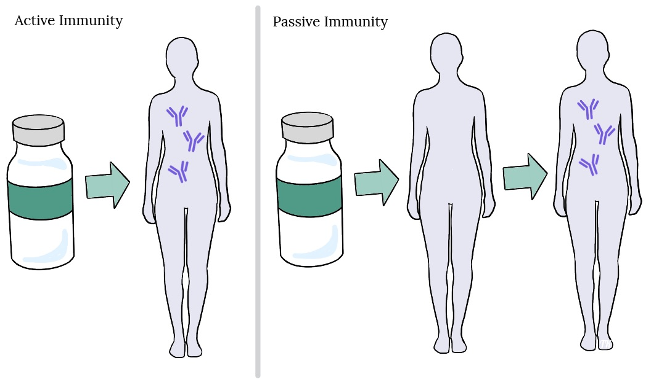

Different types of the immunity:
- Innate immunity:
It is general protection that a person is born with, including physical barriers (skin, body hair), defense mechanisms (saliva, gastric acid), and general immune responses (inflammation). This type of immunity is considered non-specific. Although the immune system does not know exactly what kind of antigen is invading the body, it can respond quickly to defend against any pathogen.
- Passive immunity:
It is the body’s capacity to resist pathogens by borrowing antibodies. For example, antibodies can be transferred to a baby from a mother’s breast milk, or through blood products containing antibodies such as immunoglobulin that can be transfused from one person to another. The most common form of passive immunity is that which an infant receives from its mother. Antibodies are transported across the placenta during the last one to two months of pregnancy. As a result, a full-term infant will have the same antibodies as its mother. These antibodies will protect the infant from certain diseases for up to a year, and act to defend against specific antigens. Although beneficial, passive immunity is temporary until the antibodies are gone (wane), since the body has not produced the antibodies.
- Acquired (adaptive) immunity or immunological memory:
It is a type of immunity that develops from immunological memory. The body is exposed to a specific antigen (which is attached to a pathogen) and develops antibodies to that specific antigen. The next time said antigen invades, the body has a memory of the specific antigen and already has antibodies to fight it off. Acquired immunity can occur from exposure to an infection, wherein a person gets a disease and develops immunity as a result. Acquired immunity also occurs from vaccination wherein the vaccine mimics a particular disease, causing an immune response in the vaccinated individual without getting them ill.
(B) What is difference between Antigen and Antibody:
Antibodies:
Antibodies, also called immunoglobulins, Y-shaped molecules are proteins manufactured by the body that help fight against foreign substances called antigens.
Antigens:
Antigens are any substance that stimulates the immune system to produce antibodies. Antigens can be bacteria, viruses, or fungi that cause infection and disease.
Following are some of the differences between Antigen and Antibody:
S.no | Antigen | Antibodies
01 | Generally proteins but can be lipids, carbohydrates or nucleic acids. | Antibodies are proteins.
02 | Triggers the formation of antibodies. | Variable sites has the antigen binding domain.
03 | There are three basic kinds of antigens. (Exogenous, Endogenous and Autoantigens) | There are five basic kinds of antibodies. (Immunoglobulins M, G, E, D and A)
04 | The region of the antigen that interacts with the antibodies is called epitopes. | The variable region of the antibody that specially binds to an epitope is called Para tope.
05 | Cause disease or allergic reactions. | Protects the body by immobilization or lysis of antigenic material.

Q (04):
(A) Write down different functions of Antibody?
(B) Write difference between Primary and secondary Immune response to an antigen?
Answer (04):
(A): Different Functions of Antibodies:
Antibodies:
Definition:
Antibodies are also called as the immunoglobulin, a protective protein produced by the immune system in response to the presence of the foreign substance called as an antigen. Antibodies recognize and latch onto antigens in order to remove them from the body.
Examples of antibodies:
IgG, the most common antibody is present mostly in the blood and tissue fluids while IgA is found in the mucous membrane lining the respiratory and gastro intestinal tract.
Five main classes of antibodies:
IgG, IgA, IgD, IgE, IgM.
Different functions of antibodies:
It having three main functions which are;
- Neutralization of infectivity
- The antibodies are secreted into the blood and mucosa when it binds to inactivate foreign substances such as pathogens and toxins.
- Phagocytosis:
- Phagocytosis in mammalian immune cells is activated by attachment to pathogen-associated molecular patterns (PAMPS), which leads to NF-κB activation. Opsonins such as C3b and antibodies can act as attachment sites and aid phagocytosis of pathogens.
- Antibody dependent cellular cytotoxicity:
- Antibody-dependent cellular cytotoxicity (ADCC), also referred to as antibody-dependent cell-mediated cytotoxicity, is a mechanism of cell-mediated immune defense whereby an effector cell of the immune system actively lyses a target cell, whose membrane-surface antigens have been bound by specific antibodies. It is one of the mechanisms through which antibodies, as part of the humoral immune response, can act to limit and contain infection.
- Complement-mediated lysis of the pathogens or of infected cells:
- These studies indicate that non neutralizing antibodies capable of directing complement-mediated lysis of HIV and/or HIV-infected cells could represent an underappreciated, vaccine-inducible immune correlate of protection against HIV infection.

(B): Difference between primary and secondary immune response:
Primary Immune response:
Introduction:
The primary immune response occurs when an antigen comes in contact with the immune system for the first time.
During this time the immune system has to learn to recognize antigen and how to make antibodies against it and eventually produced memory lymphocytes.
Definition:
Primary immune response is the reaction of the immune system when it contacts with an antigen for the first time.
Appearance:
It appears mainly in the lymph nodes and spleen.
Occurrence:
This occurs in response to the primary contact of an antigen.
Antibody peak:
The antibody level reaches its peak in 7-10 days.
Affinity of antibody:
It shows low affinity to their antigens.
Responding cells:
The responding cells are: Naïve B cells and T cells.
Antibodies:
Both thymus dependent and thymus independent antibodies are involved in the primary immune response.
Lag phase:
It has long lag phase of 4-7 days.
Types of antibodies:
A large amount of IgM and a small amount of IgG are produced during the primary immune response.
Amount of antibodies:
Few antibodies are produce in the primary immune response.
Strength of the response:
The primary immune response is usually weaker than the secondary immune response.
Antibody level:
Antibody level declines to the point where it may be undetectable.
(B): Secondary Immune response:
Introduction:
The secondary immune response occurs when the second time, third, fourth etc. the person is exposed to the same antigen at this point the immunological memory has been established and the immune system can start making antibodies immediately.
Definition:
Secondary immune response is the reaction of the immune system when it contacts with an antigen for the second and subsequent times.
Appearance:
It appears mainly in the bone marrow and then it the spleen and lymph nodes.
Occurrence:
This occurs in response to the second and subsequent exposure to the same antigen.
Antibody peak:
The antibody level reaches its peak in 3-5 days.
Affinity of antibody:
It shows higher affinity to their antigens.
Responding cells:
The responding cells are: memory B cells.
Antibodies:
Only thymus dependent antibodies are involved in the secondary immune response.
Lag phase:
It has short lag phase of 1-4 days.
Types of antibodies:
A large amount of IgG and a small amount of IgM. IgA, IgE are produced during the secondary immune response.
Amount of antibodies:
100-1000 times more antibodies are produced in the secondary immune response.
Strength of the response:
The secondary immune response is usually stronger than the primary immune response.
Antibody level:
Antibody level tends to remain higher for longer.

Q5: Write difference between cell mediated and Antibody Mediated Immunity?
Answer (05):
Difference between cell mediated and Antibody Mediated Immunity:
Basis for comparison | Humoral Immunity | Cell mediated Immunity
Meaning | The humoral immunity is associated with B-lymphocytes and is responsible for destroying the pathogens by producing antibodies against it. | The cell-mediated immunity is associated with the T-lymph nodes and is responsible for destroying the pathogens or microorganism which have invaded the cells.
Mediated by | It is associated with B-lymphocytes and T-lymphocytes and macrophages. | These are associated with T-lymph nodes, helper T cells, and macrophages.
Antibodies | Present | Absent
Function | - It plays a major role in recognizing antigens or any foreign particle and is producing antibodies against it.  - It is known for working against extracellular pathogens. | - It is related to the T-lymphocytes which worked by identifying viruses and micro- organisms and thus destroying them by the cell lysis or phagocytosis or pinocytosis.  - It is known as for working against the intracellular pathogens.
Secretes | It secretes antibodies. | It secretes cytokines.
Action against pathogens | It is rapid or quick in their response. | It shows delay though permanent actions against any pathogens.
Hypersensitivity | It mediates hyper sensitivity type I, II, III. | It is the delayed in response and mediates hyper sensitivity type IV.
Rejections | It is involved in the early stage of graft rejections due to the formation of antibodies. | It is involved in the rejections of the organs transplants.

End

