:: MID TERM EXAM ::

ID: 11533
Name: Ashir Ali Khan
Subject: Web Technologies lll
Teacher: Sir Ayub

Iqra National University

Question no.1
- What are the advantages of OOP in PHP?
Answer:
The advantages of OOP in PHP:
1. Code Reusability:
Code reusability is one of the characteristics of object-oriented programming. The feature that explains this point is inheritance. In inheritance, the class and subclasses or parent and child classes can be derived and its data member and member functions can be used as such. This feature saves times and the user do not need to code again and again, if similar features or functionality is required. Long programs can be cut short and the lot of time can be saved and also lowers the cost of development. More effort is put into the object-oriented analysis and design, which lowers the overall cost of development.
2. Easy Management and Maintenance:
This feature is more of a necessity for any programming languages, it helps users from doing re-work in many ways. It is always easy and time-saving to maintain and modify the existing codes with incorporating new changes into it. Maintenance of code also becomes easy in object oriented programming because of easy management of the code if the code is to be used by another programmer, still it will not create any ambiguity of correct guiding of coding is used.
3. Security and Abstraction:
Abstraction means making something hidden. With the use of data hiding and abstraction mechanism, we are filtering out limited data to exposure which means we are maintaining security and providing necessary data to view.
4. Polymorphism:
It is another feature of the object oriented programming. Polymorphism simply means that a function has many forms. Even in the programming one function can be written, this function can be used in different forms depending on its arguments. It is called function overloading. Just like the functions even the operator can be overloaded. It is called operator overloading.

5. Molecularity:
You can create separate class for each module then you will have to change only in their business logic part. This process is known as molecularity.

- Write the output of the following code. Find the error if any.
<?php
class Subject {
public $subject=”Web Technologies lll”;
}
$obj=new Teacher();
echo $obj->Subject;
?>

Answer:
After running this code for the first time we found some errors like in line 5 and 6 , after removing the errors the code looks like this

<?php
class Subject {
public $subject="Web Technologies III";
}
$obj=new subject(); “creating a new object”
echo $obj->subject; “Printing the subject”
?>
OUTPUT:
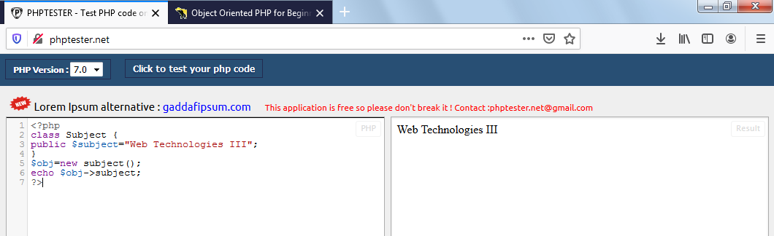

Question no.2
a) What is $this keyword in PHP OOP? Explain with example
Answer:
$this pseudo-variable has the Current Object's methods and properties and it is very useful because it lets you access all member variables and member methods inside the class.
Example:
$this is reference to a PHP Object that was created by the interpreter for us that contains an array of variables. If you call $this inside a normal method in a normal class, $this returns the Object to which that method belongs. It's possible for $this to be undefined if the context has no parent Object.
<?php
class Student {
public $name;
function __construct( $name ) {
$this->name = $name; // Using 'this' to access the student's name }};
$ashir = new Student('Ashir');
echo $ashir->name;
>?
Output:
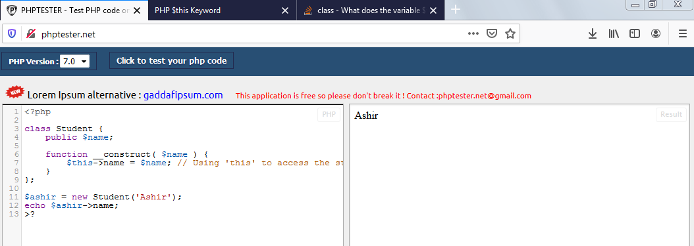

b) Write the output for the program given below.
<?php
class test {
public function abc($param1,$param2){
echo “$param1,$param2”;
}}
Test::abc(“John”,”Steward”);
?>
Answer:
The output of this program is
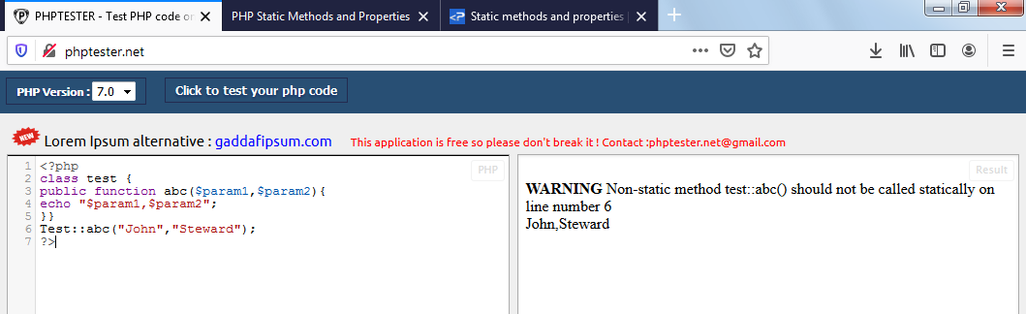
This program works fine with a warning. We were trying to use a static method in a non-static function. If we change the function into static then we can run this program without a warning I have tried it and its output and code is:
<?php
class test {
public static function abc($param1,$param2){
echo “$param1,$param2”;
}}
Test::abc(“John”,”Steward”);
?>
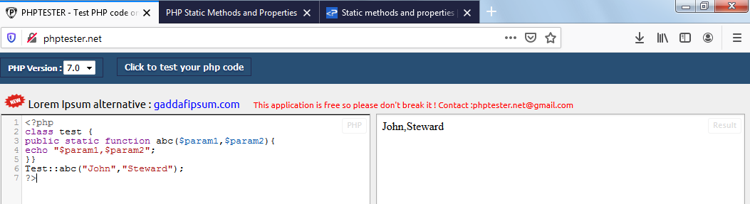

Question No: 3
What are the static properties and methods and how can we access the static properties and methods, explain with suitable examples?
Answer:
Static Properties:
Static properties are properties that can be used without creating objects from classes.Static properties are declared with the static keyword.Static properties can be accessed from outside the class using the class name and Scope Resolution Operator “ :: ”.
Syntax for static properties is classname::staticProperty;
Example:
<?php
class myname {
public static $name = 'Ashir Ali Khan';
public function __construct() {
echo 'My Cast is' . self::$name;
}}
echo myname::$name . '<br>';
myname::$name = ' Shinwari'; new myname();
?>
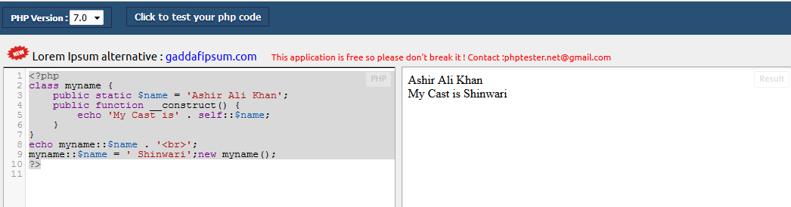
In the class, we declare a static property named $name and the constructor function.
Then, we echo the $name from outside the class. Then, we change the value of the $name static property.
Finally, we create a new instance from “myname”. So, the constructor function will be called. We access the static $name from the constructor using the self-keyword and “::”.
Static Methods:
Static methods can be called directly - without creating an instance of a class. They are declared with the static keyword. Static methods can be accessed from outside the class using the class name and Scope Resolution Operator “ :: ”.
Syntax for static methods is classname::staticMethod();
Example:
<?php
class House{
static function getColor(){
return "yellow";
} }
echo (House::getColor());
?>
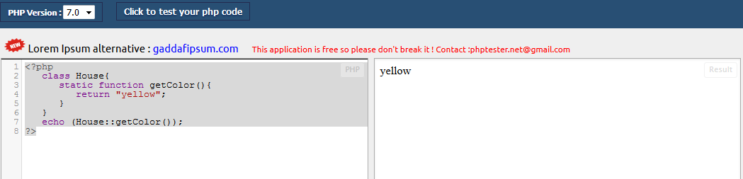
In the above program we get information about a House and in that you have a House class and have a function getColor() that defines the color of the House.
Each object that needs getColor() function that returns the similar color for all objects of the Class House,
So in this case we made getColor() method as static.

END OF PAPER

