IQRA NATIONAL UNIVERSITY
ARCHETICTURE ASSIGHMENT

Name taimur bacha
ID 16456
Department civil engineering
Section B
Assighment archeticture and town plaining
Instructor miss alina

*- Pre Columbian archeticture (inca archeticture)
1- pre columbian archeticture
Pre Columbian archeticture is the work of art and the structure created In the central and the south America before the arrival of europian in the westan hemisphere.there are many archeticture which are free Columbian like that,
1-meso America archeticture
2-inca archeticture
3-ancient archetictue of north America

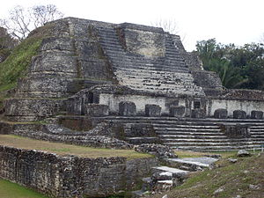

2-Pre columbic archeticture(inca)
Inca archeticture is the most significant archeticture in the pre-columbian archeticuture.the inca archeticture enhireted legaly from tiwanako.,founded in the second century B.C.E. a characteristic of inca archeticture style was use the tophography and the existing material of land that was use in the inca archeticture of pre Columbian archeticture.the incas also developed the extensive road systems. Although many wall of inca masonry have been incorporated into spainish colonial structure.

3-Characteristics
1-Inca building were made out of fieldstone or semi word stone block and dirt set in morter.
2- the material use in inca building depend on the region.
3- The most common building shape of archeticture was rectangular building without any internal wall and roofed with wooden beam.
4- there were several variation of the basic design including gabled roofs,the room are open with one or two long side
5-r ectangular building was used for quite different function in almost all inca building almost for temples
6- in incas construction door niches and windows usually was a trapezoidal shape, they could be fitted with double or triple japs.
7- the most common inca archeticture was the kancha, three or more rectangular building place symmetrical around a central courtyard.
8- incha architecture is widely known for its fine masonry

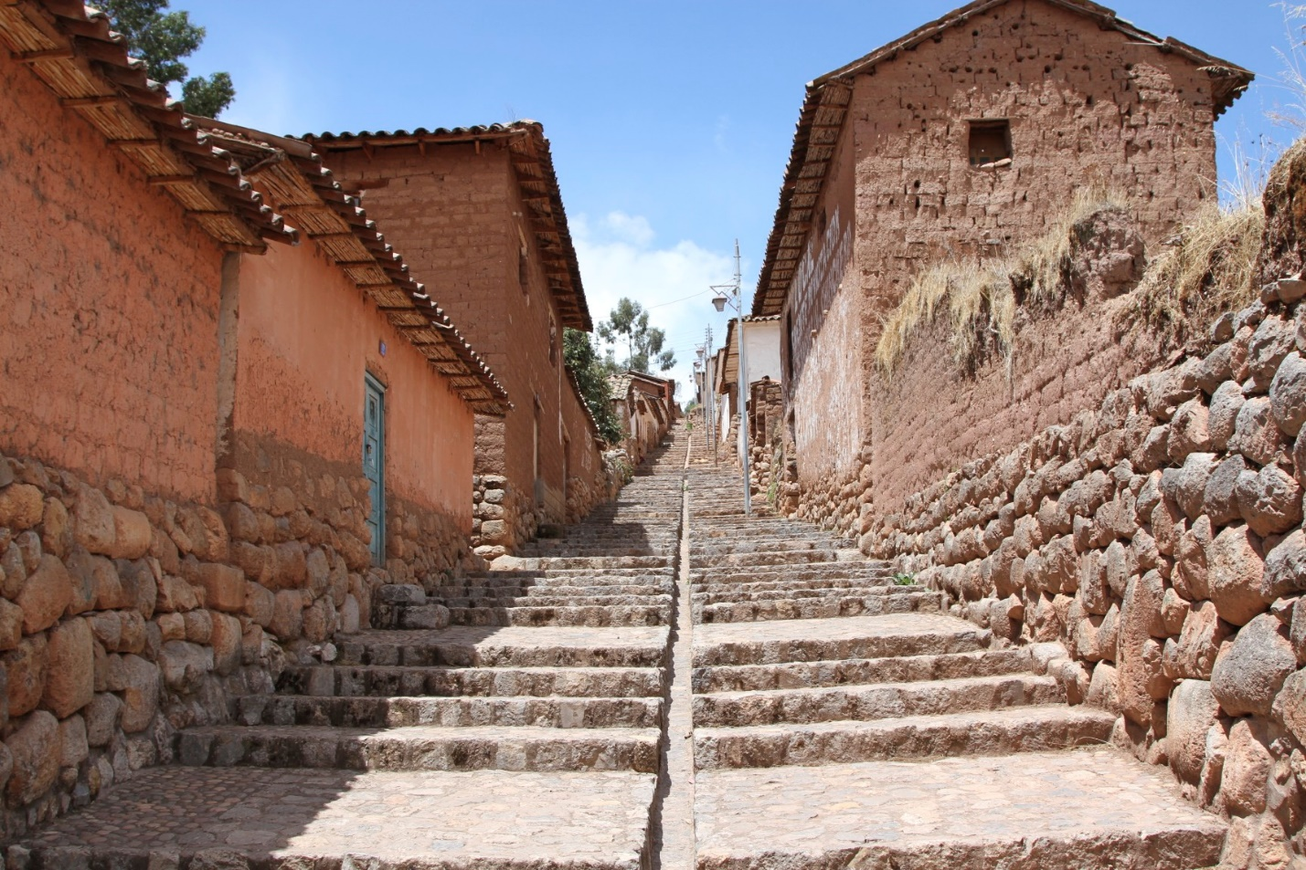

According to American archeologist john H.row in 1940 classified the inca fine masonry into two type.
- cource= which feather rectangular shape stone.
- polygonal= which feather block of irregular shape

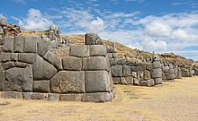

40 year later the archeologist perovian architect sentiago agarto establish four sub type of dividing the category as
- cellular polygonal masonry with small block
- ashlar polygonal masonry with latge stone
- encased stone masonry in which stone block are not align
- sedimentary cource masonry in which stone laid out in masonry row
the first two type were used in perameter wall or important wall while the last two were used in river callization.

3-Masonry and construction method
Of inca archeticture
- Water engineer ken wright estimate that 60 percent of inca construction effort was underground.
- inca build there cities with locally available material , usually contain lime stone or granite.
- To cut there hard stone the inca used stone,bronze and copper tools usually spilling the stonealong the natural fracture line. Without the wheel the stone were rolled up with wood beams on earth ramps. Man power would have been necessary.
- Usually the wall of inca building were slightly inclined inside and the corner were rounded
- Another building methdod was called pillow-faced archeticture. The incas would sand large,finally shaped stone which they would fit together with jigsaw like pattern. Pillow-faced archeticture was typically used in tempes and royal place like macho picchu.
- Ashlar masonry was used in the most sacred,elite inca structure, for example , house for the choosen women.
- The coricancha( golden enclosure) in cuzco and the sun temples at macho picchu , thus it seems that the ashlar may have beenmore greatly valued by the inca

