Name: Zeeshan Aurangzeb

ID: 14052

Department: BS MLT

Assignment: Blood Bank

Q:Write down a short summary of how blood components are separated and prepared?
Ans:
A single whole blood donations can be separated into different components to provide treatment to more than one patient.one unit of whole blood can be broken down into one unit of platelet, one unit of packed red cells, and one unit of fresh frozen plasma/cryoprecipitate.This things avoids wastage of collected whole blood and also avoids transfusion of unnecessary blood elements that are not required by the patient.

Blood components separation and Preparation

Blood components separation and preparation occurs in five steps
Step 1:
Whole blood is in Bag A ( primary bag). Bag B (platelet bag) and Bag C ( plasma bag) are also known satellite bags.

Step 2:
Bags are spun in centrifuge, separating components within primary bag. Platelet-rich plasma rises to the top red blood cells sink to the bottom.

Step 3:
Platelet-rich plasma (PRP) is forced into Bag B red blood cells (RBC) remain in the bottom of Bag A. Bag A is separated from Bags B and C. Red blood cells are stored at 4 to 6 c.

Step 4:
Bags are spun again longer and harder then initial spin. Plasma and platelets are separated in Bag B. Plasma rises to the top and platelet sink to the bottom.

Step 5:
Plasma is forced into Bag C. Bags B and C are separated. Bags B contains a platelet concentrate in 40 to 70ml of plasma. Plasma in Bag C can be made into fresh frozen plasma or other products.

Blood Component Separation and Preparation

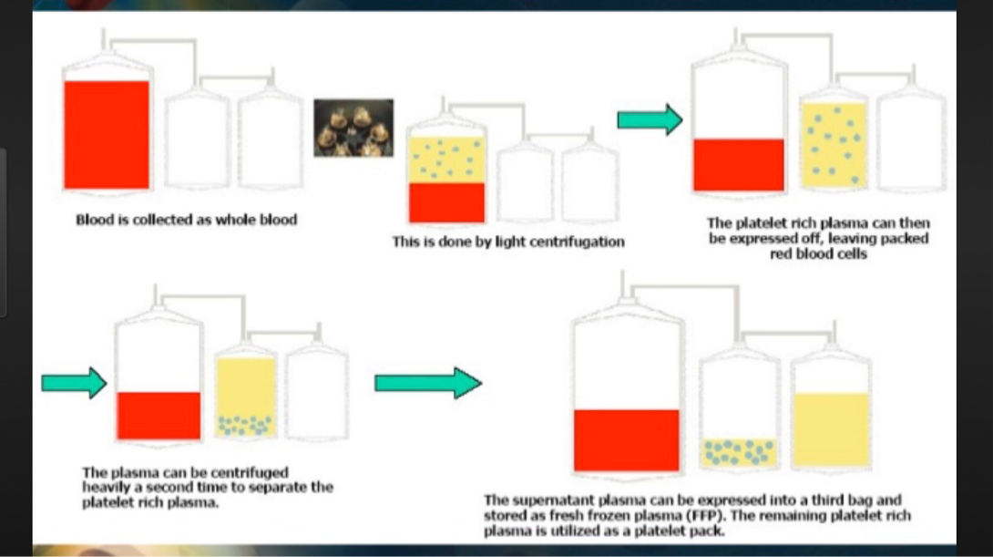
Preparation of blood components is possible due to:

- Multiple plastic packs system
- Refrigerated centrifuge
- Different specific gravity of cellular components
1.Red cells specific gravity 1.08 - 1.09
2.platelet specific gravity 1.03 - 1.04
3.plasma specific gravity 1.02 - 1.03
Due to different specific gravity of cellular components they can be separated by centrifuging at different centrifugal force in g for different time.

