Mid Term Assignment (2020)
Course Title: Basic Physiology (DT– 2nd) Instructor: Dr. Irfan Ali Khan

Multiple Choice Questions Time: 48 hours
Class Code. ________16398__________________ Name/Class Rollno: _______AbdurRahman_ 16398____________________
Note:
- Attempt all questions from this section. Select the best answer from given choices.
- Use Blue / Black Ink only. Do not use red color.
- Tick or encircle only one option in each given question.
It’s an open book Conceptual Assignment paper. Time to Use your brain now.

- A short Gap in the myelin sheath around a nerve fiber is called
- Dendrite
- Axon terminal
- Node of Ranvier
- None of these
- The maximum amount of carbon dioxide in the human body is transported as:_______________
- Bicarbonate
- Carbide
- Amylase
- None of the above
- The lungs are protected by___________
- Ribcage
- Sternum
- Backbone
- All of the above
- The three different cells found in the stomach
a) Chief cells, renal cells, nephron
b) Renal cells, mucous cells, hepatic cells
c) Nephrons, hepatic cells, parietal cells
d) Chief cells, parietal cells, mucous cells
- For action potential to occur,
- The stimulus should reach or exceed threshold
- Na+ influx must exceed K+ efflux
- Both A & B
- None of these
- During rising phase of action potential,
- Voltage gated Na+ channels open
- Voltage gated K+ channels open
- Voltage gated Na+ channels close
- Voltage gated K+ channel close

Stay home, stay Safe

- The movement of an esophagus to help the food down the GI tract __________
a) Mastication
b) Emulsification
c) Peristalses
d) Ejection
- Simple diffusion is ________.
- Movement of molecules against the conc. gradient
- Movement of molecules down the conc. gradient
- Both A & B
- None of these
- 97% of Oxygen is carried in blood from lungs is __________________
- Bound to Sulphate ion
- Bound to Hemoglobin
- Dissolved in plasma
- All of these
- Intrinsic factor secreted in stomach helps in
- Absorption of vitamin D
- Absorption of vitamin K
- Absorption of vitamin B12
- Removal of vitamin B12

Midterm Assignment(2020)
Course Title: Basic Physiology (DT- 2nd) Instructor: Dr. Irfan Ali Khan

Time: 72 Hours Section 2

Name: ……………………..…………………… Class/Roll.no …………………………………….
Note:
- Attempt all questions from this section.
- Use only Blue / Black Ink other than diagrams
- Answer Briefly and to the point, avoid un-necessary details

- Draw and Label the Action Potential in a large myelinated nerve fiber. Which ion channels are involved in its different stages?
Key points:
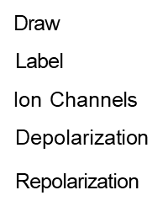

ANS= (1) Resting potential.
(2) Threshold.
(3) Depollarization (V.Rise)
(4) Repolorization(voltages)
(5) Hyperpolorization(refractory period)

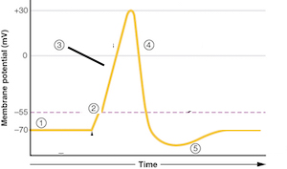

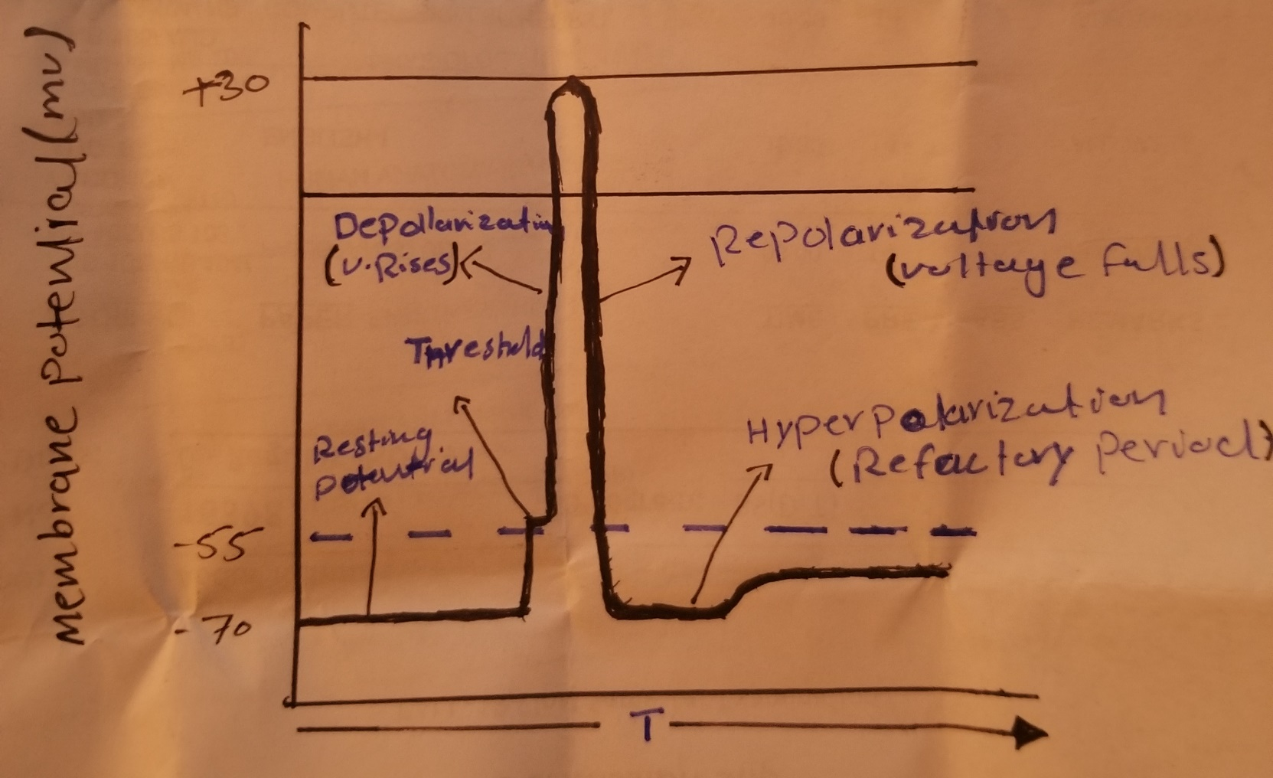

Stay home, stay Safe
- What is the role of oxygen, carbon dioxide and hydrogen ions in control of respiration? Marks 10
ANS
Respiratory System
The human respiratory system is one of the most vital organ system of the body we breath about 16000 to 29000 per day which exchange 11000 t of air with atmosphere . IN the process the oxygen of the atmosphere is delivered to the human body which is then utillzed by all the tissues and the carbon dioxide which is produced by the human body is exposed to the lung and then exchange with atmosphere.
Respiratory system and circulatory system
The respiratory and circulatory system bring oxygen and nutrients to the cell. The respiratory system work togather to maintain homeostasis. The respiratory system moves gases into the bronchi ; bronchules and aveoli

GASES EXCHANGE
ROLE OF OXYGEN
THE most important function of breathing is supply oxygen to the and the removel of its waste product of co2 under most condition the partial pressure of co2 (PCO2) control the respiration rate . THE peripheral chemoreceptor that detect changes in the level of oxygen and carbon dioxide are located in the arterial aortic and the carotid bodies.
ROLE OF HYDROGEN
EXCESS hydrogen in blood act directly on the respiration centre cause increase respiration blood flow through these bodies is extreme so the percentage of o2 removed from the blood

R0LE OF CO2
WHEN it combine with water its form carbonic acid making the blood acidic . so co2 in blood stream lower the ph of blood breathing rate increase and kidney bicarbonate production in order of hydrogen

