Aiman imdad I’d no 16923. Spring semester 2020 BBA 2 years
Paper: principal of economics. Zero semester

Question 1) Gross domestic product:
Gross domestic product (GDP) is the total value of everything produced within a country's borders. When economists talk about the "size" of the economy, they are referring to GDP.
Included in GDP:
- Final goods and services sold for money. Only sales of final goods are counted, because the transaction concerning a good used to make the final good (for example, the purchase of wood used to build a chair) is already incorporated in the final good total value (price at which the chair is sold).
Not included in GDP:
- unpaid work: work performed within the family, volunteer work, etc.
- non-monetary compensated work
- goods not produced for sale in the marketplace
- bartered goods and services
- black market
- illegal activities
- transfer payments
- sales of used goods
- intermediate goods and services that are used to produce other final goods and services
- Nominal GDP (or "Current GDP") = face value of output, without any inflation adjustment
- Real GDP (or "Constant GDP") = value of output adjusted for inflation or deflation. It allows us to determine whether the value of output has changed because more is being produced or simply because prices have increased. Real GDP is used to calculate GDP growth.
2.Gross National Product (GNP) is a measure of the value of all goods and services produced by a country’s residents and businesses. It estimates the value of the final products and services manufactured by a country’s residents, regardless of the production location.
GNP can be calculated by adding consumption, government spending, capital spending by businesses, and net exports (exports minus imports) and net income by domestic residents and businesses from overseas investments. This figure is then subtracted from the net income earned by foreign residents and businesses from domestic investment.
3.Inflation and exchange rate
Inflation is a general increase in prices. It is measured by the consumer price index. To calculate inflation within a country or geographical area, the percentage change in the index between 2 given periods is calculated. This is how we obtain the monthly and annual inflation rate.
Inflation originates from money creation. This money creation is measured by the level of the money supply, which is constantly increasing. But an increase in the money supply does not necessarily mean that there is inflation. What leads to inflation is a faster increase in the money supply in relation to the wealth produced (measured with GDP). Effectively, this generates pressure of demand on a supply that does not increase at the same rate. The consumer price index then increases, generating inflation.
Exchange rate: In finance, an exchange rate is the rate at which one currency will be exchanged for another. A higher-valued currency makes a country's imports less expensive and its exports more expensive in foreign markets. A lower-valued currency makes a country's imports more expensive and its exports less expensive in foreign markets. A higher exchange rate can be expected to worsen a country's balance of trade, while a lower exchange rate can be expected to improve it.

How the exchange rate affects inflation
- If there is a depreciation in the exchange rate, it is likely to cause inflation to increase. – (Import prices more expensive)
- An appreciation in the exchange rate will tend to reduce inflation. (Import prices cheaper)
Why a depreciation causes inflation
A depreciation means the currency buys less foreign exchange, therefore, imports are more expensive and exports are cheaper. After a depreciation, we get:
- Imported inflation. The price of imported goods will go up because they are more expensive to buy from abroad
- Higher domestic demand. Cheaper exports increases demand for UK exports. THere is also a reduction in demand for imported goods, shifting consumption to domestic goods Therefore, there is an increase in domestic aggregate demand (AD), and we may get demand-pull inflation.

4.Government expenditures:
Government expenditure refers to the purchase of goods and services, which include public consumption and public investment, and transfer payments consisting of income transfers (pensions, social benefits) and capital transfer.
A government spends money towards the supply of goods and services that are not provided by the private sector but are important for the nation’s welfare. Government spending goes to the nation’s defense, infrastructure, health and welfare benefits.
5.Aggregate demand:
Aggregate demand (AD) is the total demand for final goods and services in a given economy at a given time and price level.

Aggregate Demand Formula
Aggregate Demand is the total of Consumption, Investment, Government Spending and Net Exports (Exports-Imports). Aggregate Demand = C + I + G + (X – M). It shows the relationship between Real GNP and the Price Level.

Factors that Affect Aggregate Demand

Net Export Effect
  - Real balances
  - Interest rate
  - Inflation expectations

Aggregate Supply is the total of all final goods and services which firms plan to produce. during a specific time period. It is the total amount of goods and services that firms are willing to sell at a given price level in an economy. There are two views on Long Run Aggregate Supply, the Monetarist view and the Keynesian view. The curve is upward sloping in the short run and vertical, or close to vertical, in the long run.

1. Supply Shocks

.2 Resource Price Changes

3. Changes in Expectations for Inflation

4. Capacity Increase

6.Consumption Expenditure Definition
Consumption Expenditure is the spending by households on goods and services, excluding new housing. In developed countries it has become the largest component of Gross Domestic Product

Question 2) Discuss the following
1.Natural rate if unemployment:
The natural rate of unemployment, when an economy is in a steady state of "full employment", is the proportion of the workforce who are unemployed'.
any consider a 4% to 5% unemployment rate to be full employment and not particularly concerning.
2. Frictional unemployment:
Frictional unemployment is when workers are jobless and looking for work in a healthy economy. It doesn't matter if they leave voluntarily or are fired. Others may be returning to the labor force. It's differentiated from other types of unemployment because it's part of normal labor turnover.
3. Structural unemployment
Structural unemployment occurs because workers lack the requisite job skills or live too far from regions where jobs are available and cannot move closer. Jobs are available, but there is a serious mismatch between what companies need and what workers can offer.
  - Cyclical unemployment
Cyclical unemployment is the component of overall unemployment that results directly from cycles of economic upturn and downturn. Unemployment typically rises during recessions and declines during economic expansions. Moderating cyclical unemployment during recessions is a major motivation behind the study of economics and the goal of the various policy tools that governments employ to stimulate the economy.
  - Minimum wage law:
A minimum wage is the lowest wage per hour that a worker may be paid, as mandated by federal law. It is a legally mandated price floor on hourly wages, below which non-exempt workers may not be offered or accept a job.
In the 2019-20 budget, the federal government and the provincial governments of Khyber Pakhtunkhwa and Balochistan have raised the minimum wage for unskilled workers from Rs 15,000 to Rs 17,500 a month.
The government of Sindh has raised the minimum wage from Rs 16,200 to Rs 17,000 a month
  - Efficiency wage theory:
The efficiency wage theory is that increasing wages can lead to increased labour productivity because workers feel more motivated to work with higher pay.
Therefore if firms increase wages – some or all of the higher wage costs will be recouped through increased staff retention and higher labour productivity.

Question 3) pay off matrix using Nash equilibrium:
Water boosting pump

- B
On. Off
On. (7,7) (15,5)
Off. ( 5 ,15) (10,10)

And according to game theory predicts both will switch on their water booster pump.

Question 4) Aggregate demand (AD) is the total amount of goods and services consumers are willing to purchase in a given economy and during a certain period. Sometimes aggregate demand changes in a way that alters its relationship with aggregate supply (AS), and this is called a "shift."
Since modern economists calculate aggregate demand using a specific formula, shifts result from changes in the value of the formula's input variables:
consumer spending, investment spending, government spending, exports, and imports.

The Formula for Aggregate Demand
AD=C+I+G+(X-M)
​AD=C+I+G+(X−M)
where:C=Consumer spending on goods and service
I=Investment spending on business capital goodsG=Government spending on public goods and
X=Exports M=Imports​
Aggregate economic phenomena that cause changes in the value of any of these variables will change aggregate demand. If aggregate supply remains unchanged or is held constant, a change in aggregate demand shifts the AD curve to the left or right.

macroeconomic models, right shifts in aggregate demand are typically viewed as a good sign for the economy. Shifts to the left are typically viewed negatively.
Aggregate demand sloping downwards.
- Real Balances Effect
  - Because higher prices reduce real spending power, prices and output are negatively related.
- Foreign Purchases Effect
  - When domestic prices are high, we will export less to foreign buyers and we will import more from foreign producers. Therefore higher prices leads to less domestic output.
- Interest Rate Effect
higher prices lead to inflation which leads to less borrowing and a lowering of RGDP

Shifting the AD Curve
The aggregate demand curve tends to shift to the left when total consumer spending declines. Consumers might spend less because the cost of living is rising or because government taxes have increased.
Consumers may decide to spend less and save more if they expect prices to rise in the future. It might be that consumer time preferences change and future consumption is valued more highly than present consumption.
Contractionary fiscal policy can also shift aggregate demand to the left. The government might decide to raise taxes or decrease spending to fix a budget deficit. Monetary policy has less immediate effects. If monetary policy raises the interest rate, individuals and businesses tend to borrow less and save more. This could shift AD to the left.
The last major variable, net exports (exports minus imports), is less direct and more controversial. A country that runs a current account is always balanced by the capital account. The corresponding capital account surplus might raise government spending if foreign agents use their dollars to buy Treasury bonds (T-bonds). If they use those dollars to invest in U.S. businesses, the investment spending on capital goods might rise.
or every possible cause of a leftward shift in the AD curve, there is an opposite possible rightward shift. Increased consumer spending on domestic goods and services can shift AD to the right. It is possible that a declining marginal propensity to save (MPS) can also shift AD to the right. An expansionary monetary and fiscal policy might increase aggregate demand.

Aggregate supply
Aggregate supply is the total value of goods and services produced in an economy.
- The aggregate supply curve shows the amount of goods that can be produced at different price levels.
- When the economy reaches its level of full capacity (full employment – when the economy is on the production possibility frontier) the aggregate supply curve becomes inelastic because, even at higher prices, firms cannot produce more in the short term
- The aggregate supply curve is related to a production possibility frontier (PPF). Both show the productive capacity of an economy.
Variables that shift aggregate demand.
Taxes
Interest Rates
Confidence
Strength of the Dollar
Government Spending

Factors determining LRAS
- Available land and raw materials
- Quantity and productivity of labour
- Quantity and productivity of capital
- Technological improvements which affect productivity and output.
- The level of entrepreneurship in the economy.

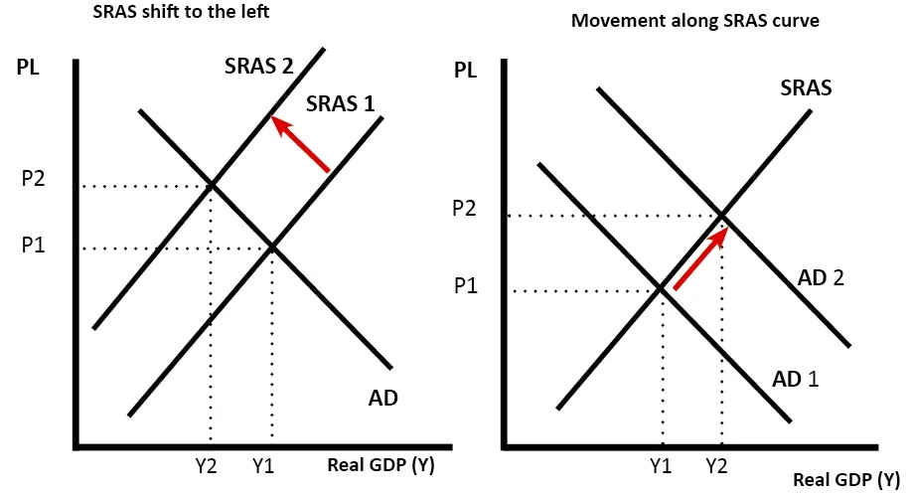

Short run aggregate supply
- In the short-run, capital is fixed. Firms can alter variable factors of production, such as labour.
- The SRAS is viewed as elastic, because in the short-run firms can increase output by getting workers to do overtime.

- Government can influence economic activity with aggregate supply side policies affecting
  - input costs (labor and wage)
  - reducing regulation
  - Increase incentives to
    - Work
    - Take Risks

