Course Title: Medical Biochemistry II
RAD 2nd, Sec A
Student Name:Fizza
Student ID: 16684
Bs Radiology 2nd sem
Sec A Max Marks: 50

Note: There are FIVE questions, each carry 10 marks with grand total of 50 marks.
ATTEMPT all questions.
Avoid copy paste material, as it may deduct your marks.

Q1. Explain the process of “ATP synthesis coupled with electron flow”.
Q2. Write the reactions that are catalyzed by the following enzymes.
    - Acyl CoA dehydrogenase
    - Adenosine deaminase
    - Nucleotidase
    - Gluconolactonase
    - Enoyl-CoA hydratase
Q3. Define nucleotide, nucleoside and differentiate between DNA and RNA.
Q4. Why Dickens and Horecker’s Pathway is called HMP pathway. Enlist the enzymes used in PPP Pathway.
Q5. What is the function of carnitine shuttle system? Write down the stages and steps involved in Beta oxidation of Lipids.
Answer no 1:
ATP:
Energy is the capacity to do work. ATP supplies this energy to all living cells for performing work. That is why ATP acts as energy currency if living organisms.
ATP synthesis:
In eukaryotic cells, the vast majority of ATP synthesis occurs in the mitochondria in a process called oxidative phosphorylation.
Even plants, which generates ATP by photophosphorylation in chloroplasts, contain mitochondria for the synthesis of ATP through oxidative phosphorylation.
Oxidative phosphorylation is linked to a process known as Electron transport system, located in the inner mitochondrial membrane, transfer electrons donates by the reduced electron carriers NADH and FADH2 ( obtained from glycolysis , the citric acid cycle or fatty acid oxidation) through a serious of electrons acceptors, to oxygen. The movement of electrons through complexes of the electron through complexes of the electron transport system “ charges" a battery that is used to make ATP in oxidative phosphorylation. In this way, the oxidation of sugar and fatty acid is coupled to the synthesis of ATP effectively extracting energy from food.
ATP Synthase:
ATP synthesis moves H+ ions that were pumped out of the matrix by the electron transport chain back into the matrix. The energy from the influx of proteins into the matrix is used to generate ATP by the phosphorylation ( addition of a phosphate) of ADH . The movement of ions across the selectively permeable mitochondrial membrane and down their electrochemical gradient is called chemiosmosis.
Importance
NADH generates more ATP than FADH2. For every NADH molecule that is oxidized, 10 H+ ions are pumped into the intermembrane space. This yields about three ATP molecules. Because FADH2 enters the chain at a later stage( Complex II) , six H+ ions are transferred to the intermembrane space. Thus account for about two ATP molecules.
Electron Transport chain:
The electron transport Chain is a serious of protein complexes found in the inner membrane of the mitochondria. Electron are passed from one membrane of the transport chain to another in a serious of redox reactions.
Chemiosmosis:
It is the movement of ions across a semipermeable membrane , down their electrochemical gradient. An example of this would be the generation of adenosine triphosphate ( ATP) by the movement of hydrogen ions H+ across a membrane during cellular respiration .
Oxidative phosphorylation:
Oxidative phosphorylation is made up of two closely connected chain and chemiosmosis.
Diagram:
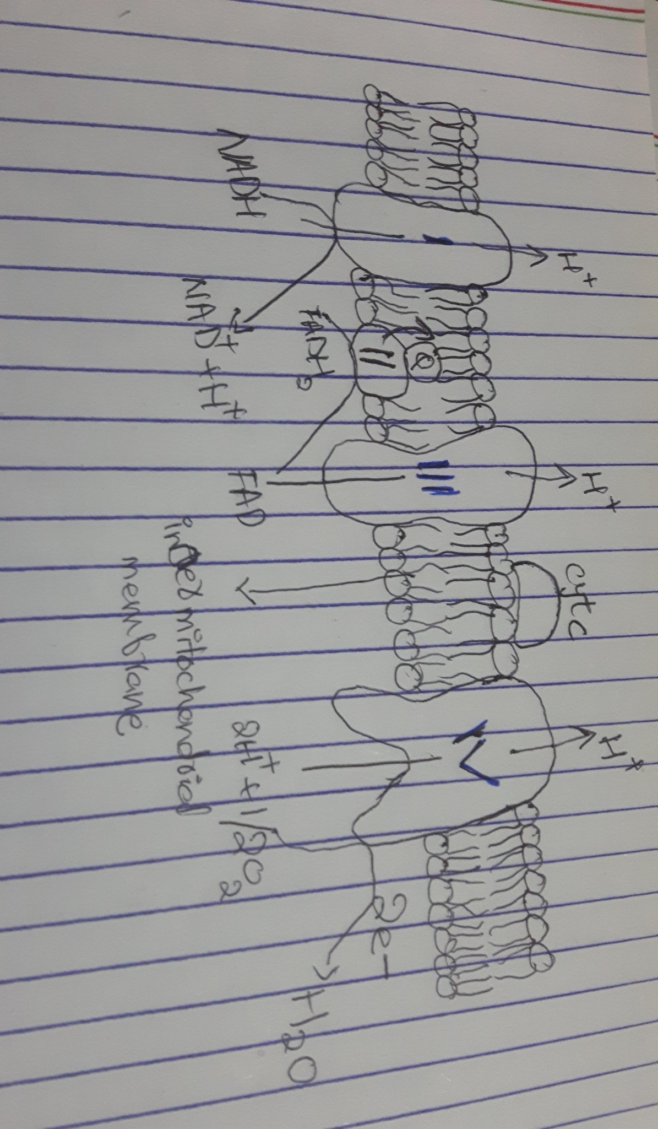
Answer no 2:
Write the reactions that are catalyzed by the following enzymes?
1. Acyl CoA dehydrogenase
Acetyl-CoA ----> trans◇2-Enoyl - CoA
In this reaction Acteyl CoA Dehydrogenase use a catalyst
2. Adenosine deaminase:
Adenosine +H2O -----> Inosone + NH3
in this reaction Adenosine Deaminase use as a catalyst.
3.Nucleotidase
Ribose-5- phosphate------>Adenosine
In this reaction Nucleotidase use as a catalyst
4. Gluconolactonase:
6-PD-Gluconalaton------> 6-p- Gluconate
In this reaction Gluconolactonase is use as a catalyst
5. Enoyl-CoA hydrates:
Trans-◇2-Enoyl-CoA-----> 1-3 hydroxyacl-CoA
In this reaction Enoyl CoA hydrates is use as a catalyst.

Answer no 3:
Nucleotides:
It is the building unit of nucleic acid which is composed of three chemical i.e pentosesugar, phosphoric acid and nitrogenous bases.
Components of nucleotide:
Each nucleotide composed of three chemicals
Pentose sugar:
- It is five carbon sugar i.e ribose
- In case of RNA it is ribose C5H10O5 while in case of DNA it is Deoxyribose C5H10O4.
Phosphoric acid: ( H3 po4)
- Phosphoric acid has ability to develop “Ester linkage" between two nucleotides or sugar
- Phosphoric acid are always attached to carbon number five of a pentose sugar.
Nitrogenous bases: ( organic bases)
Nitrogenous base are cyclic compounds of nitrogen and carbons which are always attached to carbon number one of a pentose sugar.
Types of Nitrogenous bases:
They are of two types
- Purine bases:
- They are cyclic compounds of carbon and nitrogen
- They are large and double ring in structure
- It has two types on the basis of their side group i.e Adenine (A) and Guanine(G)
Structure:
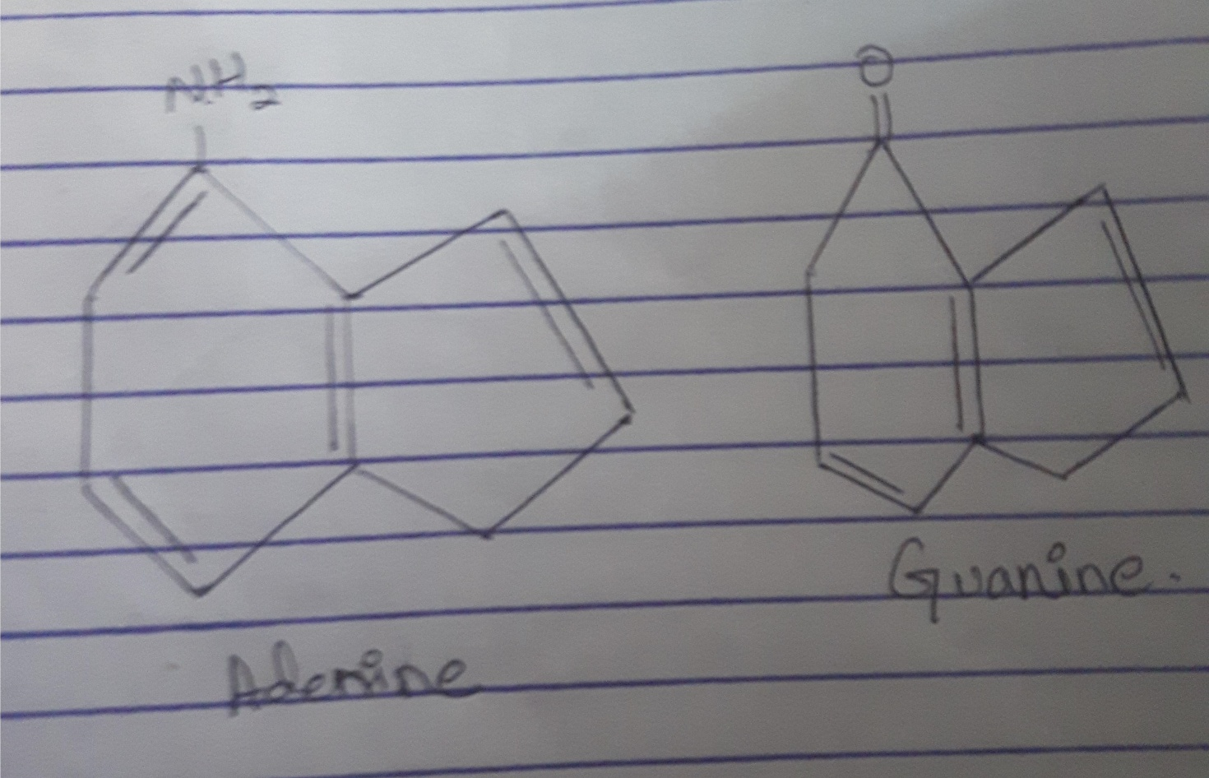
- Pyrimidine bases:
- They are cyclic compounds of carbon and nitrogen
- They are small having single ring structure
- They are three types on the basis of their side group
Structure:

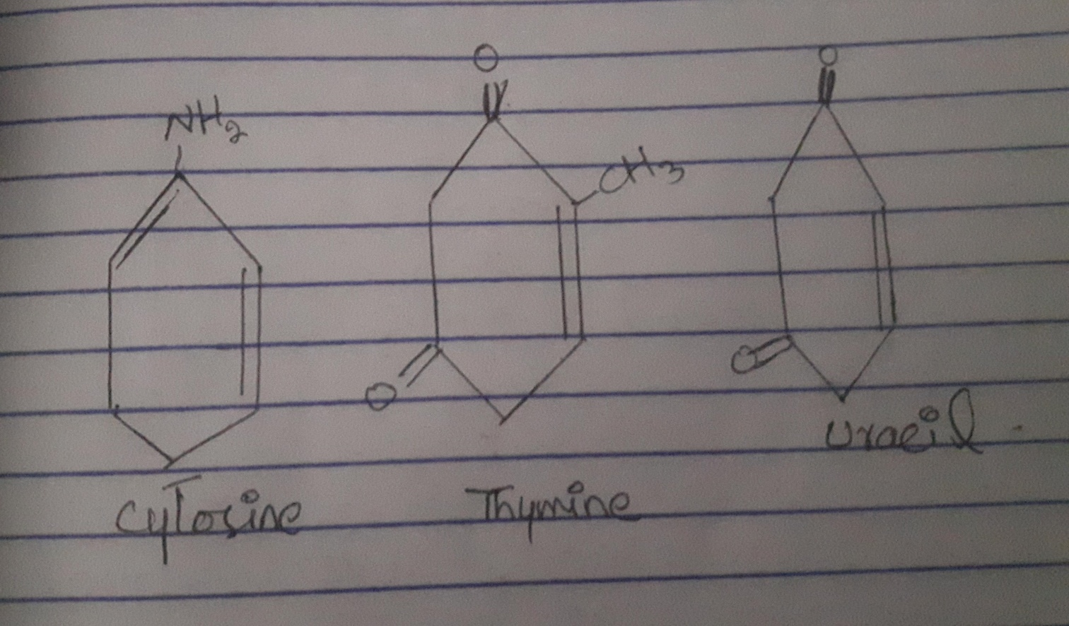

Types of Nucleotide:
Nucleotides has three types
- Mononucleotides
- Dinucleotides
- Polynucleotide.
Nucleoside:
It is a nitrogenous base with sugar
Example:
Adenine + sugar ------ Adenosine
Guanine +sugar --------- Guanosine
Thymine + sugar--------- Thymidine
Uracil + sugar ----------- Uridine
Difference between DNA and RNA
- Deoxyribonucleic Acid (DNA)
- DNA molecule is composed of two polynucleotide chains called Strands.
- Each strand is further composed of pentose sugar and phosphoric acids.
- Each strand has a side chain made up of nitrogenous bases ( A, G, C , T)
- The two strand are held together by weak hydrogen bonds which are formed between the nitrogenous bases
- There are two hydrogen bonds between adenine and Thymine and three hydrogen bonds between cytosine and Guanine
- In DNA molecules the nucleotides in a chain are linked together by phosphodiester bond
- The helix of DNA has diameter of 2nm
- The distance between the two nucleotide in each strand is o.34 nm
- The two stands are antiparallel
- Four type of nucleotide are used as building blocks of DNA molecules. i.e. Adenine , Guanine , and thymine , cytosin nucleotide.
- Ribonucleic Acid (RNA)
- It is the type of nucleic acid which has single stranded structure and contain ribose sugar C5 H10 O5
- RNA is produced from DNA by a process called Transcription
- It is mostly present in cytoplasm
- RNA contain Adenine, cytosine, uracil containing nucleotides.
- RNA is having pentose sugar called ribose C5H10O5
- It is single stranded structure
- This single strand is made up of pentose sugar and phosphoric acid
- Pentose sugars and phosphoric acids are linked with each other by phosphodiester bond
- The strand has side chains which are made up of nitrogenous based
- The RNA strand is also made up of four types of nucleotides i.e. Adenine , Guanine, cytosin, and uracil nucleotide.
Types of RNA
- Messenger RNA
- Ribosomal RNA
- Transfer RNA.
Question no 4:
Why Dickens and Horecker's pathway is called HMP pathway? Enlist enzymes used in PPP pathway.
Answer:
Dickens and Horecker's pathway called HMP pathway:
- The pentose phosphate pathway are also called Hexose monophosphate pathway is a metabolic pathway parallel to glycolysis.
- This pathway is also called Dickens and Horecker's pathway
- It generates NADPH and pentose( 5 carbon sugars) a precursor for the synthesis of nucleotide
This pathway is also called the oxidative pentose pathway and the hexose monophosphate pathway or shunt. It has been called the latter because it involves some reactions of the glycolytic pathway and therefore has been viewed as a shunt of glycolysis.
Phases of HMP pathway:
There are two distinct phases in the pathway
- In first the oxidative phase, in which NADPH is generated
- And the second is the non oxidative synthesis of 5 carbon sugar.
- For most organism the pentose phosphate pathway take place in the cytosol. In plants most steps take place in plastids.
Occurrence:
It is occur in cytoplasm of cell
- Oxidative phase occurs in liver, adipose tissues, testes , ovary RBCs and lactating mammary glands
- Non oxidative phase occurs in all tissues , as in this phase pentose sugar is formed which is used in DNA synthesis.
- Phases involved:
- Glucose -6-phosphate - 6- phosphogluconolactone
- 6- phosphogluconolactone 6 phosphogluconate
- 6 phosphogluconate Ribulose – 5 - phosphate
Enzymes involved in oxidative phase:
Enzymes are as follow
- Glucose 6 phosphate dehydrogenase
- 6 phosphogluconolactone hydrolase / Gluconolactonase
- 6 phosphogluconate dehydrogenase.

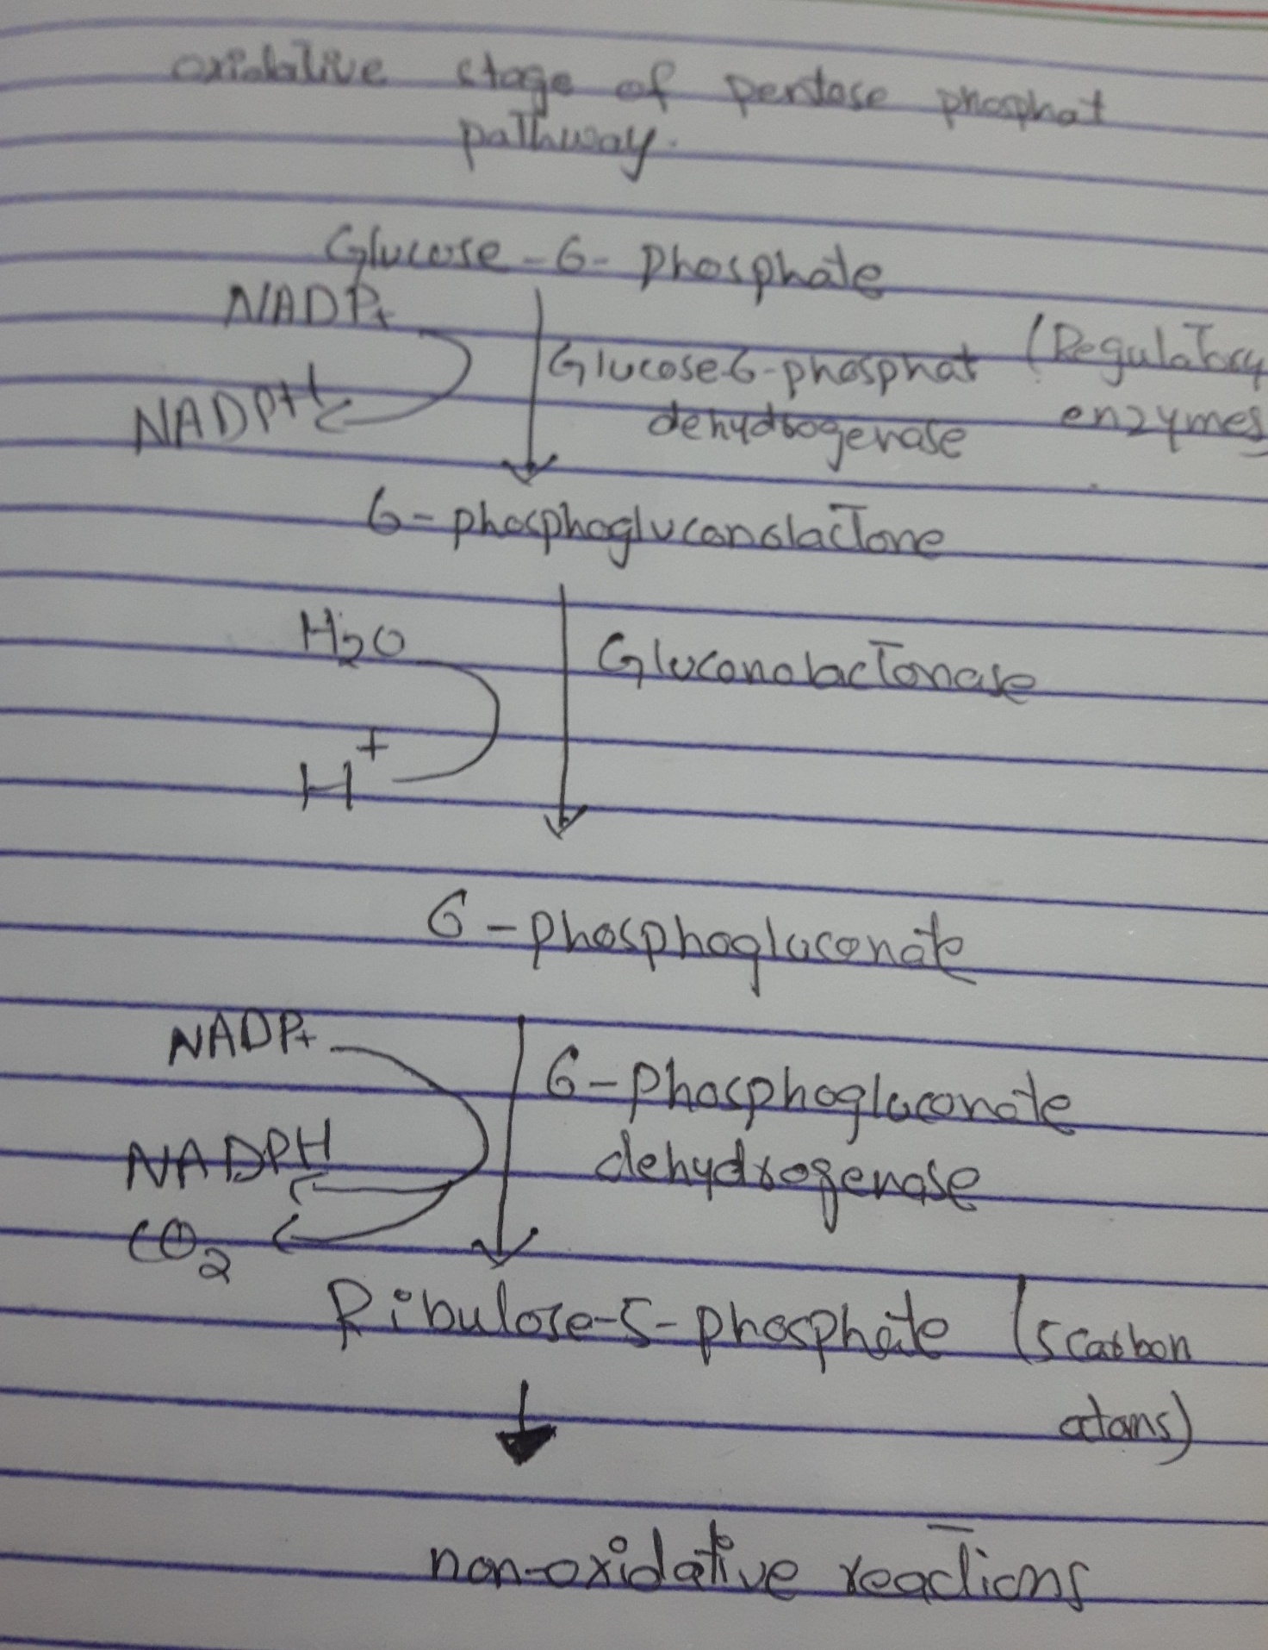
Answer no 5:
Carntine shuttle system:
It is a small milecule, carntine serves as a carrier across the mitochondrial mambrane. This pathway requires no chemical energy supply rather the fact that fattyacid in the mitochondria matrix is being broken down by oxidation drives the process.
Functions of carnitine shuttle system:
The main function is to represent a long chain fatty acids which are impermeable tbe mitochondrial membrane are transported into the mitochondrial matrix for the purpose beta oxidation and energy production.
The fatty acid carnitine is transported into the matrix by a transporter protein in the inner mitochondrial membrane
Stages and steps involved in Beta oxidation of lipids:
The stages and steps are as folloe
. Activation of fatty acid occuring in the cytoplasm
. Transport of fatty acids into mitochondria
. Beta oxidation in the mitochondrialmatrix
1.Activation of fatty acid into mitochondria:
. In the cytoplasm of the cell, long chains fatty acida are activated byATP coenzyme A , and fatty acyl Co A is formed
. The ATP is converted to AMP andp pyrophosphate ( PPi)
.AMP will attached with fatty acid and will convert into Fatty acyl adenylate
.while the pyrophosphate is cleaved by pyrophosphatase to two inorganic phosphates ( 2pi) whilewill help in the production of ATP if required anywhere.
. In next step the fatty acyl adenylatewill react with coenzyme A in the presence of Fatty acyl CoA synthetase enzyme.
. From Fatty acyl adenylate the AMP group will removed abd CoA will attach to form fatty acyl CoA an activated from of Fatty acid.
B. Transportation of Fatty Acyl CoA from cytoplasm to mitochondria:
Fatty acid CoA from the cytosol reacts with carnitine in the outer mitochondrialmembrane, forming fatty acyl carnitine.The enzyme used inthis is transferase I ( CATI)
. Fatty acyl carnitine easily passes from the inner membrane to mitochondrialmatrix.
.inside the mitochondrial matrix the fatty acyl CoA undergoes beta oxidation.
C. Beta oxidation ofActivated Fatty Acids:
Beta oxidation ( in which all reactions involve the Beta carbon of a fatty acyl COA ) will 4 steps.
.Dehyrogenation
.Hydration
.Dehydtogenation
.Cleavage
