Sessional Assignment
Name: Abdul Basit
Id#: 11218
Subject: Data Communication and Network
Submitted to: Ghassan Hussain
Date: 9/6/2020

Question 1:
- What is an Internet Draft?
During the development of a specification, draft versions of the document are made available for informal review and comment by placing them in the IETF’s "Internet-Drafts" directory, which is replicated on a number of Internet hosts. This makes an evolving working document readily available to a wide audience, facilitating the process of review and revision. An Internet-Draft that is published as an RFC, or that has remained unchanged in the Internet-Drafts directory for more than six months without being recommended by the IESG for publication as an RFC, is simply removed from the Internet-Drafts directory. At any time, an Internet-Draft may be replaced by a more recent version of the same specification, restarting the six-month timeout period. An Internet-Draft is NOT a means of "publishing" a specification; specifications are published through the RFC mechanism described in the previous section. Internet-Drafts have no formal status, and are subject to change or removal at any time.
- What are the differences between a Proposed Standard, Draft Standard, and Standard?
Proposed Standard:
The entry-level maturity for the standards track is "Proposed Standard". A specific action by the IESG is required to move a specification onto the standards track at the "Proposed Standard" level. A Proposed Standard specification is generally stable, has resolved known design choices, is believed to be well-understood, has received significant community review, and appears to enjoy enough community interest to be considered valuable. However, further experience might result in a change or even retraction of the specification before it advances. Usually, neither implementation nor operational experience is required for the designation of a specification as a Proposed Standard. However, such experience is highly desirable, and will usually represent a strong argument in favor of a Proposed Standard designation. The IESG may require implementation and/or operational experience prior to granting Proposed Standard status to a specification that materially affects the core Internet protocols or that specifies behavior that may have significant operational impact on the Internet. A Proposed Standard should have no known technical omissions with respect to the requirements placed upon it. However, the IESG may waive this requirement in order to allow a specification to advance to the Proposed Standard state when it is considered to be useful and necessary (and timely) even with known technical omissions.

Draft Standard:
A specification from which at least two independent and interoperable implementations from different code bases have been developed, and for which sufficient successful operational experience has been obtained, may be elevated to the "Draft Standard" level. For the purposes of this section, "interoperable" means to be functionally equivalent or interchangeable components of the system or process in which they are used. If patented or otherwise controlled technology is required for implementation, the separate implementations must also have resulted from separate exercise of the licensing process. Elevation to Draft Standard is a major advance in status, indicating a strong belief that the specification is mature and will be useful. The requirement for at least two independent and interoperable implementations applies to all of the options and features of the specification. In cases in which one or more options or features have not been demonstrated in at least two interoperable implementations, the specification may advance to the Draft Standard level only if those options or features are removed. The Working Group chair is responsible for documenting the specific implementations which qualify the specification for Draft or Internet Standard status along with documentation about testing of the interoperation of these implementations. The documentation must include information about the support of each of the individual options and features. This documentation should be submitted to the Area Director with the protocol action request. (see Section 6) A Draft Standard must be well-understood and known to be quite stable, both in its semantics and as a basis for developing an implementation. A Draft Standard may still require additional or more widespread field experience, since it is possible for implementations based on Draft Standard specifications to demonstrate unforeseen behavior when subjected to large-scale use in production environments.
Internet Standard:
A specification for which significant implementation and successful operational experience has been obtained may be elevated to the Internet Standard level. An Internet Standard (which may simply be referred to as a Standard) is characterized by a high degree of technical maturity and by a generally held belief that the specified protocol or service provides significant benefit to the Internet community. A specification that reaches the status of Standard is assigned a number in the STD series while retaining its RFC number.

Question on 2
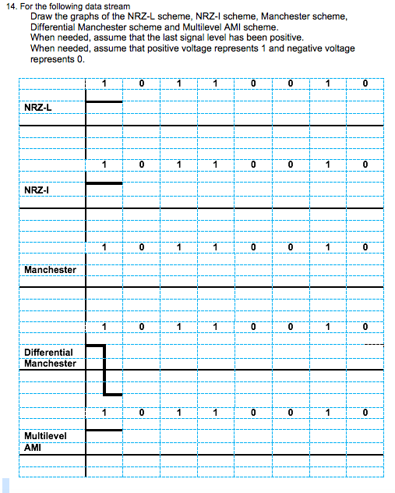

Question 3
Common Wireless Network Challenges: Symptoms
Wi-Fi Dead Spots
Whether it’s a snazzy brick wall or a 300 gallon fish tank, environmental interference and poorly placed access points can lead to certain spaces struggling to connect to the wireless network.
Slow And Intermittent Connectivity
Signal interference is likely the cause of slow wireless speeds. Users usually establish a connection, but then lose connectivity – especially during large workload activities.
Bandwidth Overload
A common occurrence in large environments – like hospitals or university campuses – where the number of users and devices easily number in the thousands, bandwidth efficiency and management can be difficult to manage.
Network Security
While you want the wireless network to be easily accessible, you also want to protect your users and the network itself from malevolent intent. Implementing security controls can negatively affect network connectivity, which is why it is important to have an information security expert deploy these technologies.
Common Wireless Network Challenges: Causes
A poorly configured wireless network is one of the number one causes of wireless network downtime. If the wireless network was installed incorrectly – either via misaligned settings or initial set-up challenges – examining the wireless network configuration often provides insight into why the network is not performing correctly.
In addition to environmental factors – like walls and outside interference (i.e. RF interference), network security concerns should also be addressed. A DDoS attack or rogue AP might be the culprit.
Common Wireless Network Challenges: Solutions
There are some immediate steps you can take to address common wireless network challenges.
Physical Relocation: If environmental factors are affecting your wireless connectivity, adjusting the actual location of WLAN hardware might reduce issues.
WLAN Upgrade: Ensure hardware is set to the latest standards and the hardware is up-to-date.
Deploy Network Monitoring Tools: Sometimes visibility into network activity can provide insights into the actual causes of the most common wireless network challenges. Cisco Prime is one great tool for improving network visibility and management.
If you are experiencing wireless network downtime, let our team of expert engineers diagnose and solve your wireless networking issues. Reach out today to discuss any wireless challenges with our engineers

