Iqra national university

Department if civil engineering

Final assessment

Discipline: Ms civil engineering
Course title: Water Demand Supply and distribution
Date: JUNE 25 /2020
Submitted by: Azad khan
Id: 15034
Submitted to: ENGR Nadeem ullah

QUESTION NO 1
Answer 1: Desalination: It is the removal of salts and other minerals from the saline water to make it suitable for drinking, industrial and agricultural purposes.
Following are the methods for desalination;
- Distillation(evaporation)
- Electro dialysis
- Freezing
- Reverse osmosis

DISTILLATION: Salt water is heated in one container to make the water evaporate leaving the salt behind.
The desalinated vapor is then condensed to form water in a separate container.
It has found limited applications in water supply because of fuel costs involved in converting salt water to vapor is very high. 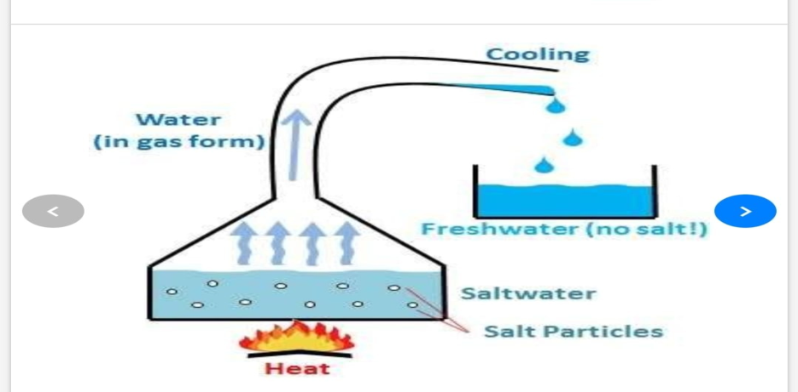

ELECTO DIALYSIS: Electro dialysis utilizes a membrane and sends an electric charge through the solution. It draws metal ions to the positive plate on one side and other ions (like salt) to the negative plate on other side.
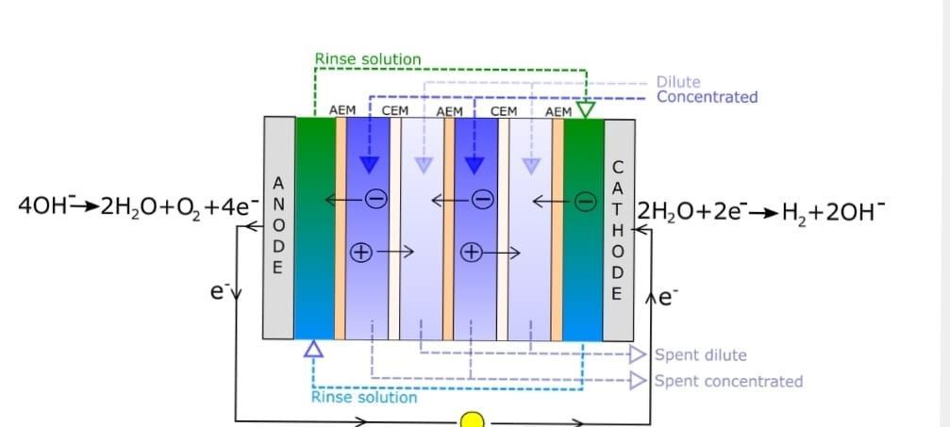
Freezing method: It is based on the principles that water excludes salts when it crystallizes to ice. It consists of three steps ice formation, ice washing and ice melting with subsequent removal of contaminants. 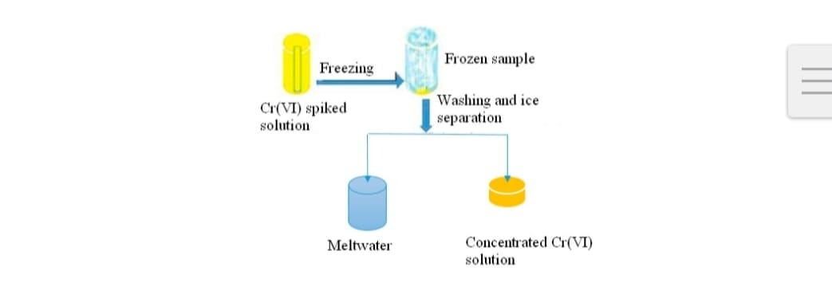
REVERSE OSMOSIS: Reverse osmosis is a type of filtration process that uses a semi permeable, thin membrane with pores small enough to pass pure water through while rejecting larger molecules such as dissolved salts and other impurities such as bacteria. It significantly decreases the salts and other potential impurities in water. 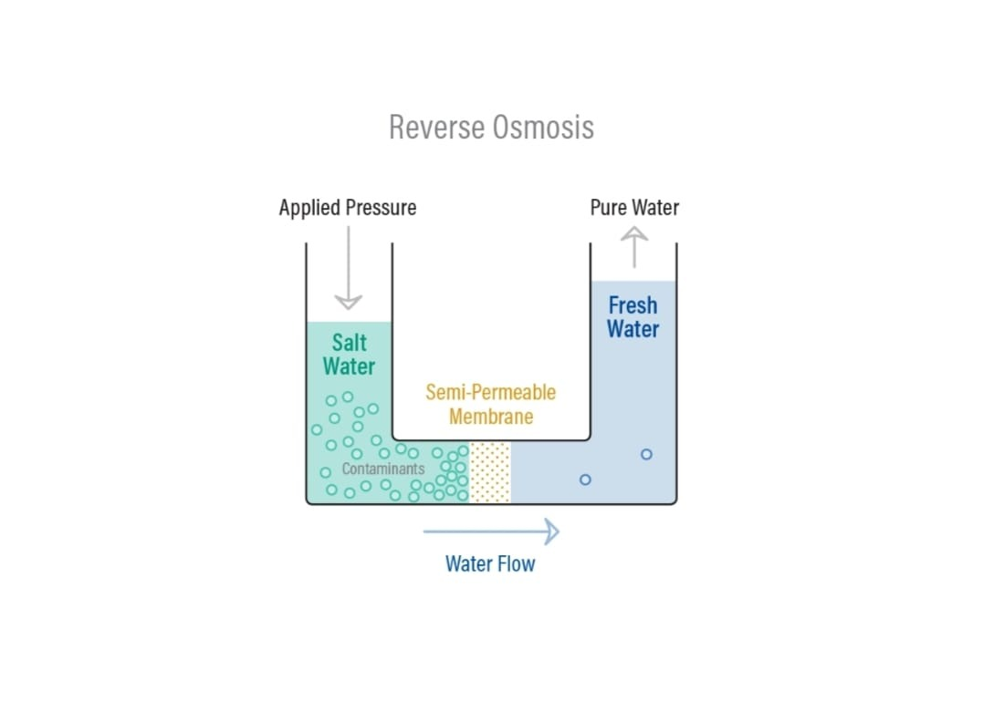
How it work?
Reverse osmosis is a continuously operating treatment technology that uses pressure to pass source water through a thin membrane and thereby separate impurities from water.
RO works by reversing the principle of osmosis, the natural tendency of water with dissolved salts to flow through a membrane from lower to higher salt concentration. This process is found throughout nature. Plants use it to absorb water and nutrients from the soil. In humans and other animals, kidneys use osmosis to absorb water from blood.
In an RO system, pressure (usually from a pump) is used to overcome natural osmotic pressure, forcing feed water with its load of dissolved salts and other impurities through a highly sophisticated semi permeable membrane that removes a high percentage of the impurities. The product of this process is highly purified water.
The rejected salts and impurities concentrate above the membrane and are passed from the system to drain or onto other processes. In a typical commercial industrial application, 75% of the feed water is purified. In applications in which water conservation is important, 85% of the feed water is purified.
An RO system uses cross-filtration, where the solution crosses the filter with two outlets: the filtered water goes one way and the contaminated water goes another way. To avoid buildup of contaminants, cross-flow filtration allows water to sweep away contaminant buildup and enough turbulence to keep the membrane surface clean.

Which method is more effective?
Answer: The most effective method of desalination is reverse osmosis.
Reverse osmosis is simple to operate .it is does not require any hazardous chemical. ​
Reverse osmosis is energy efficient, especially when used instead of distillation to produce high-purity water.
​It can be integrated with an existing membrane filtration system or ion exchange system to achieve up to 80% rinse water cycle
Reduce water and sewage use costs. Reverse osmosis is used to produce highly purified water for drinking water systems, industrial boilers, food and beverage processing, cosmetics, pharmaceutical production, seawater desalination, and many other applications. It has been a recognized technology for more than a century and commercialized since the 1960’s.
END OF QUESTION 1

QUESTION NO 2?
Merits and demerits of four types of distribution layouts:
- Dead End system:
Merits:
Pipes in this network can be laid easily.
The pressure and discharge in each pipe can be determined very easily and accurately which makes design calculations very simple.
The diameter of the pipes of main, sub mains and branches can be designed based on the required demand of population.
Dead end system requires less number of cut of valves.
Demerits:
The pressure is not constant and is very less at remote parts.
Because of dead ends water stagnation takes place which results in deposition of sediment. To remove this sediments, more number of scour valves are to be provided at the dead ends which increase economy.
If there is any damage occurs in the branch line, the whole portion should be stopped to repair that which creates discomfort to the other users in that sub main line.
In this system, Limited discharge is available for firefighting.
- Radial system:

Merits:
The water distributed with high velocity and high pressure.
Head loss is very small because of quick discharge.
It gives quick service.
Demerits:
Cost of the project is more because of number of individual distribution reservoirs.
- Grid Iron system:

Merits:
Water will flow continuously without any dead ends or sediment deposits.
Head loss is minimum in this case because of interconnection of pipes.
The discharge will meet the required discharge for firefighting.
Repair works can be easily done just by closing cutoff valve in that line which do not affect the other users.
De merits:
Because of circulating flow from all directions, the pipes used in this system should be of large diameters and longer lengths.
We cannot determine the accurate discharge, velocity or pressure in a particular pipe. So, design is difficult.
Laying of pipes will be done by skilled workers which consume more cost.
Cutoff valves required should be more in this system.

- Ring system:

Merits:
No stagnation of water
Repair works can be done without affecting larger network.
Large quantity of water is available for firefighting.
Demerits:
Longer length and large diameter pipes are required.
More number of cutoff valves are necessary.
Skilled workers are necessary while laying pipes.

Which layout will you suggest for newly proposed township in hilly areas?
Answer: Hilly areas consist of continuous mountainous areas with a gradient difference thus it is more difficult to divide water supply system reasonably than it is in flat areas .Many factors such as slope differences, water pressure, imbalancing etc so by recommending the radial system the area will be divided into different zones in which one main storage tank on higher level will provided and thus the gravity distribution is provides from that main tank and and water will reach to low areas under gravity without any energy required. A typical distribution is given below.

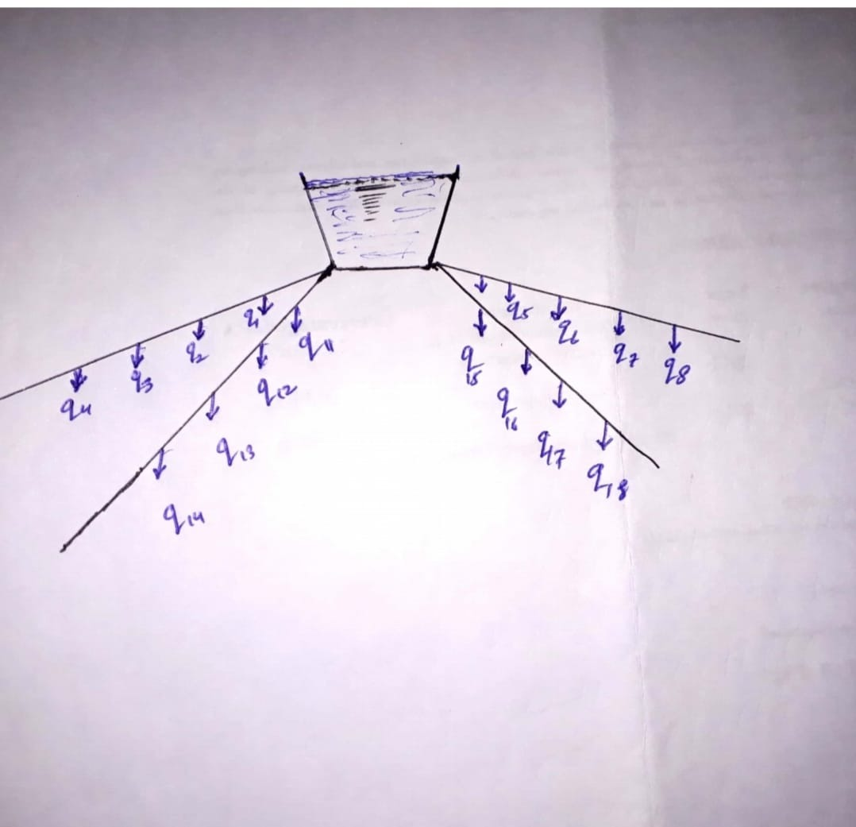
QUESTION NO 3
Different types of water reservoirs used in water supply system? Briefly describe its importance and how its storage capacity is calculated?
Answer:
TYPES OF RESERVOIRS: Types of reservoir depending upon the elevation with respect to ground are the following;
  - Surface reservoir
  - Elevated reservoir

Surface reservoir:
Surface reservoirs are circular or rectangular in shape. These reservoirs are constructed at ground level or below ground level and hence these are also called ground reservoirs or non-elevated reservoirs. The treated water stored in these reservoirs is pumped to elevated reservoirs from which it is supplied to the consumers.
if surface reservoirs are located at high points in the distribution system then water may be supplied to the consumers directly from these reservoirs by gravity, as far as possible surface reservoirs should be located at high points in the distribution system.
It is usual practice to construct a surface reservoir in two compartments, so that one can be used while the other is being cleaned or repaired. The two compartments are connected with each other by control valves. Overflow pipes are provided at full supply level so as to maintain a constant level of water in the reservoir.

The side walls are designed to take up the pressure of the water when the reservoir is full and the earth pressure when it is empty.
The position of the ground water table is also considered while designing these reservoirs.
The floors of these reservoir may be constructed with RCC slab or stone blocks with sufficient water proofing.

Elevated storage reservoir:
Elevated reservoirs are constructed at an elevation from ground level. These reservoirs are also known as overhead tanks. These reservoirs may be rectangular, circular or elliptical in shape.

Water is pumped to elevated reservoirs from surface reservoirs and then supplied to the consumers.

The total storage capacity of a distribution reservoir is the summation of:

Balancing storage:
The quantity of water required to be stored in the reservoir for balancing fluctuating demand against constant supply is known as balancing storage.

Break down storage:
It is also called as emergency storage .it is the storage preserved in order to tide over the emergencies posed by the failure of pumps electricity or any other mechanism driving the pumps.

Fire storage:
The third component is the fire storage.this provision take cares of the requirement of water for extinguishing fires.

END OF QUESTION NO 3

QUESTION NO 4

Why pumps are used in water supply schemes and how to calculate pump curves to meet water demand?
Answer:
Many kinds of pumps are used in water supply schemes for various purposes. Some pumps lifts surface water and move it to near by treatment plant called low lift pump.These moves large volume of water at relatively low discharge pressures.
Some pumps discharge treated water into arterial mains called high lift pumps. These operate under higher pressures.
Some pumps increases the pressure within the distribution system or raise water into an elevated storage tank are called booster pumps.
Another kind of pump known as positive displacement pump delivers a fixed quantity of water with each cycle of a piston or rotor.

(b) Calculation of pump curve:

A pump performance curve is simply a graph that represent the performance capabilities of a given water pump.

A pump curve will typically show not just the maximum capability of a pump but just as important many pumps curves will give information helpful in determining the best efficiency point for flow rates as well as reflecting the preferred operating range .

By knowing the pump curve you will be able to determine what to expect from water pump,how many feet it is capable of pumping how many gallons per minute and what will be the ideal operating performance.

The most common information pump curve provide is total dynamic head, flow rate.





