9Name : Maria
Id : 14704
Question 1
Clinical significance of cholestrole
Normal range 150- 200mg/dl Hypercholesterolemia : Diabets mellitus
Nephrotic syndrome ( is a kidney disorder thhat cause your body to pass to much protein in your urine.
Hypothyroidism : is a condition in which your thyroid gland do not produce enough of certain crucial hormones.
Atherosclerosis: buildup of fats cholesterol and other substance in and on your artery wall plaque which can restrict blood flow.
Additional factors for coronary artery disease include lifestyle
Cigarette smoking coffee drinking emotinal stress obesity lack of exercise high blood pressure etc
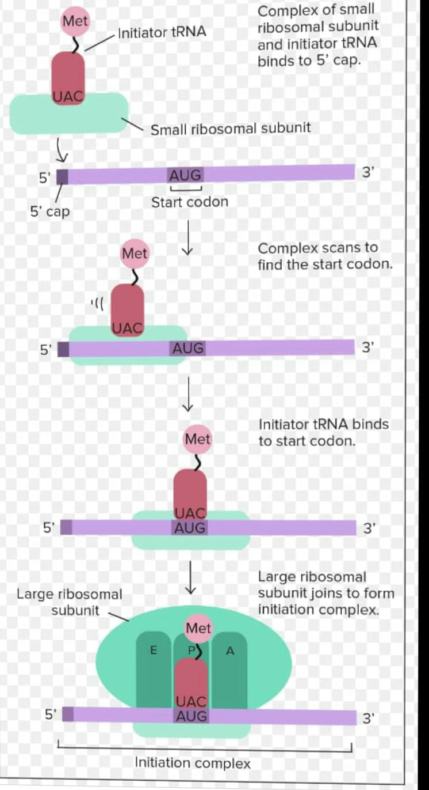
- .

Question 2
Write brief note on steroid hormone ?
Hormones : are the chemical messenger which produce from endocrine gland and reach their target
Organ through blood to perform an specific function.

Steriod hormone : Derived from cholesterol the hormone produce in adrenal cortex and the sex hormone they have important function like water balance sexual development stress response ets.
Example: Testosterone , progesterone , glucocorticosteriods mineralocorticosteroids
Any of a group of hormone that belongs to the class of chemical compound knowns as steriods they they are secreted by three steriod gland the adrenal cortex testes and overies and during pregnancy by the placenta. ALL steroid hormone are derived from cholesterol they are transported through blood stream to the cell of varies target organ where they carry out the regulation of wide rang of physiological functuon .these hormone often are classified according to the organ that synthesize them the adrenal steriod are so called because they are secreted by adrenal cortex and the sex hormone are those produce by the testes and overies.The adrenal cortex produce adrenocortical hormone which consist of the glucocorticoide and the mineralocorticide .Glucocorticoid such as cortisol control or influence many metabolic processes including the formation of glucose form amino acid and glucose and deposition of glycogen in the liver .also maintance normal blood pressure and their anti inflammatory action.
Mineralocorticoids: such as aldosterone help maintain the balance between water and salt in the body predominantly exerting their within the kidney.
Function :steroid hormon hepl contr metabolism inflammation immune function saalt and water balance development of sexual charactrristic and the ability to withstand illness and injury.
Androgens: are the male sex hormone the princple androgen testosterone is produce primarily by the testes and in lesser amounts by the adrennal cortex by the ovaries androgen are primarly responsible for the devepment and maintance of reproductive function and stimulation of the secondary sex characteristics in th3 male.Endrogen are one of the two tyoes of female sex hormone they secreted mainly by the ovaries and small amount by the adrenal gland and by the testes estradiol is the most potent of the estrogen functioning similarly to androgens the estrogens promote the development of th3 primary and secondary femal sex gland they also stimulate linear 9growth and skeletal maturation in other mammals these hormones have have been shown to precipitate estrus .the ovarian production of estrogen plummets during menopause.
Progestins , the most important of which is progesterone are other tyoe of female sex hormone and are named for their role in maintaining pregnancy .estrogens are progestins are secreted cyclically during menstruation during the menstrual cycle the ruptured ovarian follicle of the ovaries products progesterone which renders the uterine lining receptive to the implantation of a fertilized ovum.prigesterone led to the develpment of structurally modifief progestins and estrogensq
Question 3 what is deamination and transanimatio?
Definition : Deamination is the removal of the amino group as ammonia NH3
Enzyme: enzymes that catalyse this reaction are called deaminases.
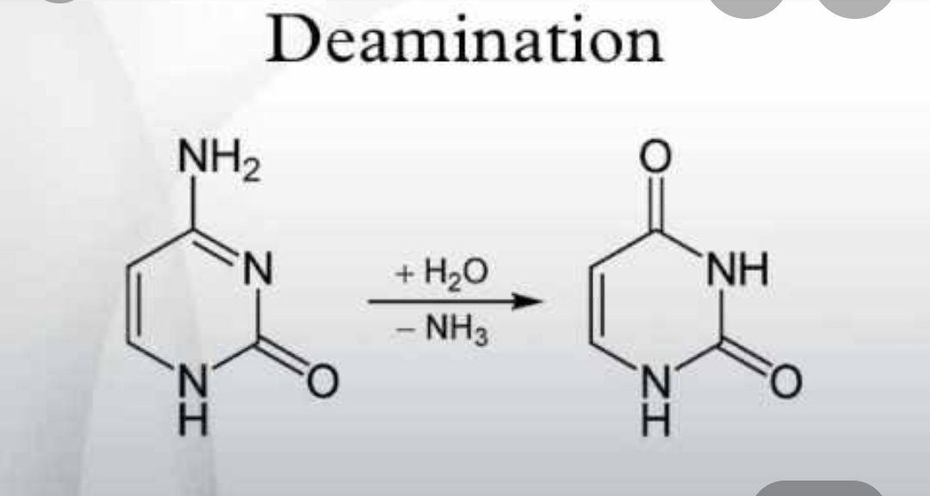
- Explanation : in the human body deamination takes primarily in the liver however it can also occure in the kidney in situation of excess protein intake deamination is used to break down amino acid for energy the amino acid is removed from the amino acid and converted to ammonia. The rest of amino acid is made up of mostly carbon and hydrogen and is recycle .ammonia is toxic to the human system and enzyme convert it to urea or uric acid by addition of carbon dioxide ( which is not considered a deamination process ) in the urea cycle with also takes place in the liver .urea and uric acid can safely diffuse into the blood and then excreted in urine.

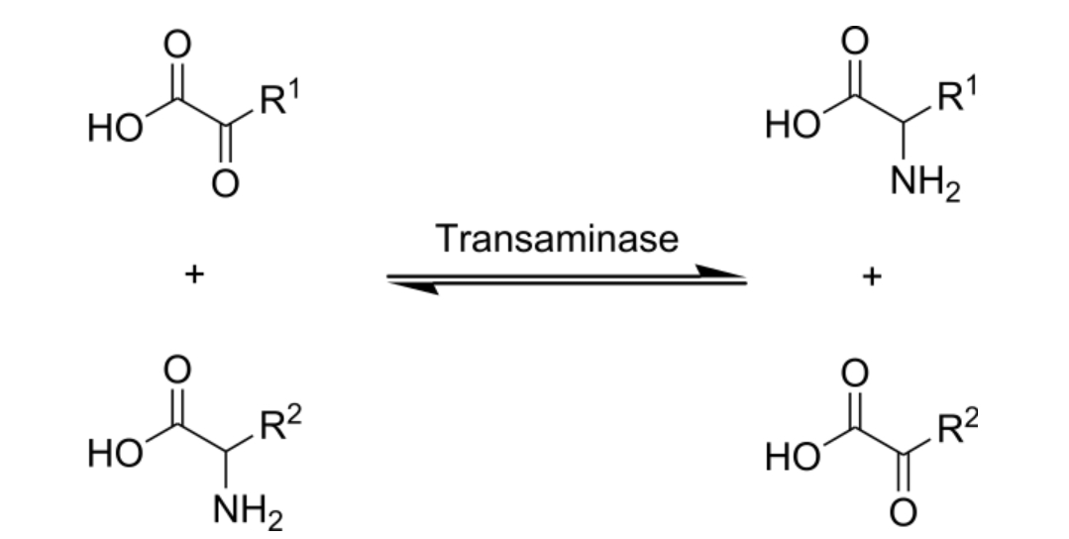

Definition : Transamination is the transfer of an amino group from an amino accid to a keto acid ( amimo acid without an amino group ) thus creating a new acid and keto acid.
Explanation : Transmination a chemical reaction tjjat transfer an amino group to a ketoacid to fromanew amino acid this pathway is responsible for the deamination of most amino acid tjid is the one of the major degradation pathway which convets essential amino acid to non essential amino acid ( amino acid that be synthesized by the organism.
ENZYME : Transamination in biochemistry is accomplished by enzyme called Transaminass ot Aminotransferases.
- QUESTION 4
Metabolism of protein
Dietary protein are very complex moblecules that can not be absorbed form the intestine
● To be absorbed dietary protein must be digested to small simple molecules ( amino acid )
Which are easily
● absorbed from intestine juice
Digestion in the stomach
Protein digestion begins in the stomach in the small intestine by proteolytic enzyme present in pancreatic and intestine juice.
Gastrin which has the following action
- Stimulate the chief cells gastric mucosa to secret the inactive zymogen pepsinogen
- Stimulate the paretial cells of gastric mucosa to secret HCL which
In pancreatic Juice : pancreas secret several proenzTrypsin chymotrypsin elastase caroxpepyodase enzyme are present with convert trypsinogen into active chymotrypsin and pro carboxypeptidase into carboxypeptidase these enzyme hyrolyze polypeptides .
Ans: Metabolism of protein;
Protein metabolism denotes the various biochemical processes responsible for the
synthesis of protein and amino acid and the break down of protein by catabolism.
The step of protein synthesis include
Transcription
Translation
Post translation modifications
During transcription RNA polymerase transcribes a coding region of the DNA in a
cell producing a sequence of RNA. Specifically massenger RNA (mRNA). This
mRNA sequence contains codons 3 nucleotide long segments that code for a
specific amino acid. Ribosome translate the codons to their respective amino acids
in human non essential amino acid are synthesized from intermediate in major
metabolic pathways such as the citric acid cycle essential amino acid must be
consumed and are made in other organisms.
The amino acids are joined by peptide bonds making a polypeptide chain this
polypeptide chain then goes through post transitional modifications.
Protein breakdown: Proteolysis
Protein catabolism is the process by which proteins are broken down to their amino
acids. This is also called proteolysis and can be followed by further amino acid
degradation.
Protein catabolism via enzymes
ProteasesOriginally thought to only disrupt enzymatic reactions, proteases (also known as
peptidases) actually help with catabolizing proteins through cleavage and creating
new proteins that were not present before. Proteases also help to regulate metabolic
pathways. One way they do this is to cleave enzymes in pathways that do not need
to be running (i.e. gluconeogenesis when blood glucose concentrations are low).
This helps to conserve as much energy as possible and to avoid futile cycles. Futile
cycles occur when the catabolic and anabolic pathways are both in effect at the
same time and rate for the same reaction. Since the intermediates being created are
consumed, the body makes no net gain gains. Energy is lost through futile cycles.
Proteases prevent this cycle from occurring by altering the rate of one of the
pathways, or by cleaving a key enzyme, they can stop one of the pathways.
Proteases are also nonspecific when binding to substrate, allowing for great
amounts of diversity inside the cells and other proteins, as they can be cleaved
much easier in an energy efficient manner.
Possible mechanism for Aspartyl Protease cleaving a peptide bond. Only the
peptide bond and active site
Because many proteases are nonspecific, they are highly regulated in the cell.
Without regulation, proteases will destroy many essential proteins for
physiological processes. One way the body regulates proteases is through protease
inhibitors. Protease inhibitors can be other proteins, small peptides, or molecules.
There are two types of protease inhibitors: reversible and irreversible. Reversible
protease inhibitors form non-covalent interactions with the protease limiting its
functionality. They can be competitive inhibitors, uncompetitive inhibitors, and
noncompetitive inhibitors. Competitive inhibitors compete with the peptide to bind
to the protease active site. Uncompetitive inhibitors bind to the protease while the
peptide is bound but do not let the protease cleave the peptide bond.
Noncompetitive inhibitors can do both. Irreversible protease inhibitors covalently
modify the active site of the protease so it cannot cleave peptides.
Exopeptidases
Exopeptidases are enzymes that can cleave the end of an amino acid side chain
mostly through the addition of water.[3] Exopeptidase enzymes exist in the small
intestine. These enzymes have two classes: aminopeptidases are a brush border enzyme and carboxypeptidases which is from the pancreas. Aminopeptidases are
enzymes that remove amino acids from the amino terminus of protein. They are
present in all lifeforms and are crucial for survival since they do many cellular
tasks in order to maintain stability. This form of peptidase is a zinc metalloenzyme
and it is inhibited by the transition state analog. This analog is similar to the actual
transition state, so it can make the enzyme bind to it instead of the actual transition
state, thus preventing substrate binding and decreasing reaction
rates.Carboxypeptidases cleave at the carboxyl end of the protein. While they can
catabolize proteins, they are more often used in post-transcriptional modifications.
Intestinal Juice :
Aminopeptidase tripeptidase depeptiase enzyme are present.
Aminopeptidase
Amino peptides which hydrolyse N Terminal of amino acid to give free amino acid dipetides and tripeptides.
Dipeptidase and Tripeptidase
Hydrolyse dipeptides and tripeptides into free amino acid so the final product of digestion is amino acid .
The end product of protein digestion in the small intestine are amino acid.
QUESTION 5
ANSWER

- Transcription of DNA in Eukaryotes;
- Transcription is the elaborate process that eukaryotes cells use to copy genetics information stored in DNA into units of transportable complementary RNA replica. Gene transcription occurs in both prokaryotic and eukaryotic cells. Unlike prokaryotes RNA polymerase that initiate the transcription of all different types of RNA, RNA polymerase in eukaryotic (including humans) comes in three variations, each translation a different type of gene. A eukaryotic cell has a nucleus that separates the processes of transcription and translation. eukaryotic transcription occurs within the nucleus where DNA is packaged into nucleosomes and higher order chromatin structure. The complexity of gene expression control.
- The eukaryotic transcription proceeds in three sequential stages:
- Initiation, elongation, and termination.
- Initiation;
- The initiation of gene transcription in eukaryotes occurs in specific steps. first, an RNA polymerase along with general transcription factors binds to the promoter region of the gene to form a closed complex called the preinitiation complex. The subsequent transition of the complex from the closed state to the open state result in the melting or separation of the two DNA strands and the positioning of the template strand to the active site of the RNA polymerase. without the need of a primer, RNA polymerase can initiate the synthesis of a new RNA chain using the template of DNA strands to guide ribonucleotide selection and polymerization chemistry. However, many of the initiated synthesis are aborted before the transcripts reach a significant length. during these abortive cycles, the polymerase keeps making and releasing short transcripts until it is able to produce a transcript is attained, RNA polymerase passes the promoter and transcription proceed to the elongation phase.
- Elongation;
- The transcription elongation is a processive process. Double stranded DNA that enters from the front of the enzyme is unzipped to avail the template strands for RNA synthesis. For every DNA base pair separated by the advancing polymerase, one hybrid RNA: DNA base pair is immediately formed. DNA strands and nascent reunite exit from separate channels ; the two DNA strands reunite at the trailing end of the transcription bubble while the single strands RNA emerges alone.
- Elongation factors:
- The polymerase are elongation factors thus called because they stimulate transcription elongation.
- Termination;
- The last stage of transcription is termination, which leads to the dissociation of the complete transcript and the release of RNA polymerase from the template DNA.The process differs for each of the three RNA polymerases. mechanism of termination is the least understood of the three transcription stages.

- Translation;
- It is the process in which the protein is synthesized from the information contained in a molecule of messenger RNA (mRNA).
- Translation Process;
- In a eukaryotic cell, the translation occurs in the cytoplasm. Translation involves three major steps
- INITIATION 2. ELONGATION 3. TERMINATION
- 1:INITIATION;
- The initiation of translation in eukaryotes is complex, involving at least 10 eukaryotic initiation factors (eIFs) & divided into 4 steps:
- a. Ribosomal dissociation.
- b. Formation of 43S preinitiation complex.
- c. Formation of 48S initiation complex.
- d. Formation of 80S initiation complex.
- a. Ribosomal Dissociation
- The 80S ribosome dissociates to form 40S & 60S subunits. Two initiating factors namely elF-3 & elF-1A bind to the newly formed 40S subunit & thereby block its reassociation with 60S subunit.
- b. Formation Of 43S Preinitiation Complex
- A ternary complex containing met-tRNA′ & elF-2 bound to GTP attaches to 40S ribosomal subunit to form 43S preinitiation complex. The presence of elF-3 & elF-1A stabilizes this complex.
- c. Formation Of 48S Initiation Complex
- The binding of mRNA to 43S preinitiation complex results in the formation of 48S initiation complex through the intermediate 43S initiation complex. elF-4F complex is formed by the association of elF-4G, elF-4A with elF-4E. The elF-4F (referred to as cap binding protein) binds to the cap of mRNA.
- 9. Then elF-4A & elF-4B bind to mRNA & reduce its complex structure. This mRNA is then transferred to 43S complex. For the appropriate association of 43S preinitiation complex with mRNA, energy has to be supplied by ATP. The ribosomal initiation complex scans the mRNA for the identification of appropriate initiation codon. 5'-AUG is the initiation codon.
- d. Formation Of 80S Initiation Complex
- 48S initiation complex binds to 60S ribosomal subunit to form 80S initiation complex. The binding involves the hydrolysis of GTP (bound to elF- 2). This step is facilitated by the involvement of elF-5. As the 80S complex is formed, the initiation factors bound to 48S initiation complex are released & recycled.

- 2. ELONGATION :
- Ribosomes elongate the polypeptide chain by a sequential addition of amino acids. The amino acid sequence is determined by the order of the codons in the specific mRNA. Elongation, a cyclic process involving certain elongation factors (EFs). Elongation may be divided into three steps.
- a. Binding of Aminoacyl t-RNA to A-site.
- b. Peptide bond formation.
- c. Translocation.
- a. Binding of Aminoacyl t-RNA to A- site
- The 80S initiation complex contains met tRNA′ in the P- site & A-site is free. Another Aminoacyl-tRNA is placed in the A-site. This requires proper codon recognition on the mRNA & involvement of elongation factor 1a (EF-1a) & supply of energy by GTP. The Aminoacyl-tRNA is placed in the A-site, EF-1a & GDP are recycled to bring another Aminoacyl-tRNA.
- b. Peptide bond formation
- The enzyme Peptidyl transferase catalyzes the formation of peptide bond. The activity of this enzyme lies on 28S RNA of 60S ribosomal subunit. It is therefore the rRNA (and not protein) referred to as ribozyme that catalyzes peptide bond formation. Net result of peptide bond formation is the attachment of the growing peptide chain to the tRNA in the A-site.
- c. Translocation
- The ribosome moves to the next codon of the mRNA (towards 3'-end). This process called translocation, involves the movement of growing peptide chain from A-site to P-site. Translocation requires EF-2 & GTP. GTP gets hydrolyzed and supplies energy to move mRNA. EF-2 & GTP complex recycles for translocation. About six amino acids per second are incorporated during the course of elongation of translation in eukaryotes.
- 3. TERMINATION;
- One of the stop or termination signals (UAA, UAG and UGA) terminates the growing polypeptide. When the ribosome encounters a stop codon, - there is no tRNA available to bind to the A site of the ribosome, - instead a release factor binds to it. In eukaryotes, a single release factor- eukaryotic release factor 1 (eRF1)-recognizes all three stop codons, and eRF3 stimulates the termination events. once the release factor binds, the ribosome unit falls apart, - releasing the large and small subunits, - the tRNA carrying the polypeptide is also released, freeing up the polypeptide product. Ribosome recycling occurs in eukaryotes.
- 16. RIBOSOMAL RECYCLING
- After the release of polypeptide and the release factors the ribosome is still bound to the mRNA and is left with two deacylated tRNA (in the P and E sites). To participate in a new round of polypeptide synthesis, these mRNA and the tRNA must be released and the ribosome must dissociate into small subunit and large subunit. Collectively these events are termed as ribosome recycling

