Name : Naila
I.D : 15260
DPT 4 ^{th} Semester
Submited to : Sir Jaffer
Qno 1: What is stretching and what are types of stretching ?

- Stretching :
- Stretching :General term used to describe any therapeutic maneuver designed to increase the extensibility of soft tissues, there by improving flexibility by elongating structures that have adaptively shortened and have become hypo mobile over time.

- Preparation for stretching:
- Free the area to be stretched of any restrictive clothing, bandages, or splints.
- Explain to the patient that it is important to be as relaxed as possible or assist when requested
- Stretching exercises should upto tolerance level
- After stretching :
- Apply to the soft tissues that have been stretched and allow these structures to cool in a lengthened position. Cold may minimize poststretch muscle soreness that can occur as the result of microtrauma during stretching
- Regardless of the type of stretching intervention used, the patient should perform active ROM and strengthening exercises through the gained range immediately after stretching.
Adjacent to stretching intervention :
(1)HEAT
- Warming up prior to stretching is a common practice
- Stretching is associated with less muscle guarding and is more comfortable for the patient.
- Warming up prior to exercise reduces the risk of injury to soft tissues.
- Superficial heat (hot packs,) or deep-heating
- modalities (ultrasound, shortwave diathermy) may be applied prior to or during the stretching procedure.
(2)COLD
- Cooling soft tissues in a lengthened position after stretching promote more lasting increases in soft tissue length and minimize post stretch muscle soreness.
(3) MASSAGE
- massage has been shown to increase circulation to muscles and decrease muscle spasm, it is a useful adjunct to stretching exercises
4)RELAXATION TRAINING
Relaxation training, using methods of general relaxation (total body relaxation), is used to relieve or reduce pain, muscle tension, anxiety or stress, and associated physical impairments including tension headaches, high blood pressure, and respiratory distress
Types of Stretching :
- Static stretching.
- Cyclic /Intermitted stretching.
- Ballistic stretching.
- Propioceptive Neuromuscular stretching
- Facilitation Stretching stretching procedure (PNF stretching)
- Manual stretching
- Mechinical stretching
- Self stretching
- Passive stretching
- Active stretching

Mechanical /Passive or Assisted Stretching:
- A sustained or intermittent external, end-range stretch force, applied with overpressure and by manual contact or a mechanical device, elongates a shortened muscle tendon unit and periarticular connective tissues by moving a restricted joint just past the available ROM
- If the patient is as relaxed as possible, it is called passive stretching.

Self Stretching:
- If the patient assists in moving the joint through a greater range, it is called assisted stretching Any stretching exercise that is carried out independently by a patient after instruction and supervision by a therapist is referred to as self-stretching.

Neuromuscular facilitation and inhibition technique:
- Active stretching is another term sometimes used to denote self-stretching procedures Neuromuscular facilitation and inhibition procedures are designed to relax tension in shortened muscles reflexively prior to or during muscle elongation
- Because the use of inhibition techniques to assist with muscle elongation is associated with an approach to exercise known as proprioceptive neuromuscular facilitation (PNF)
- Combination of active and passive technique
Passive stretching :
- It is a type of stretching in which partner provide force for stretching
- It may be a trained professionalist or any colligue .
Bassistic or dynamic:
- These are quick movements or bouncing using momentum
- Best for those above 15 years
Static stretching :
- These are slow unsustained stretches held for 10 -30 sec.
- Authors called such stretches as PNF stretching 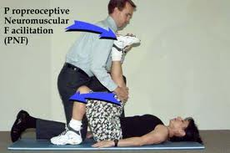
Joint mobilization and manipulating method:
- Joint mobilization/manipulation methods are manual therapy techniques specifically applied to joint structures and are used to stretch capsular restrictions or reposition a subluxed or dislocated joint 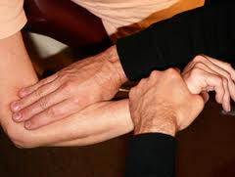
- M anual Stretching:
- Application of Manual stretching:
- Move the extremity slowly through the free range to the point of tissue restriction.
- Firmly stabilize the proximal segment and move the distal segment.
- To stretch a multijoint muscle, stabilize either the proximal or distal segment to which the range-limiting muscle attaches.
- Consider incorporating a prestretch, isometric contraction of the range-limiting muscle (the hold–relax procedure) to relax the muscle prior to stretching it.
- Apply a low-intensity stretch in a slow, sustained manner.
- Remember, the direction of the stretching movement is directly opposite the line of pull of the range-limiting muscle
- The patient should experience a pulling sensation, but not pain,
- Maintain the stretched position for 30 seconds or longer.
- Gradually release the stretch force.
Ans no 2 :(A ) Flexibility:
- Ability to move a single joint or series of joints smoothly and easily through an unrestricted, pain-free ROM.
- 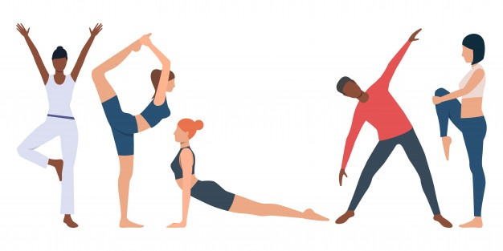
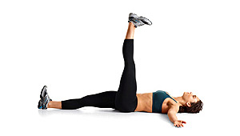
Types of flexibility :
Passive flexibility:
“This aspect of flexibility, also referred to as passive mobility or passive ROM, is the degree to which a joint can be passively moved through the available ROM and is dependent on the extensibility of muscles and connective tissues that cross and surround a joint.”

Dynamic flexibility:
“This form of flexibility, also referred to as active mobility or active ROM, is the degree to which an active muscle contraction moves a body segment through the available ROM of a joint. 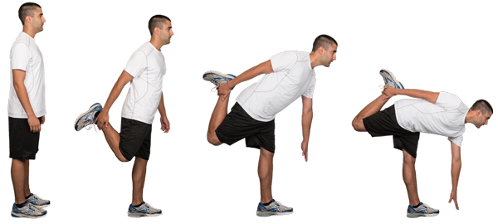
( b)Mobility:
It is often defined as the ability of structures or segments of the body to move and allow the presence of range of motion for functional activities (functional ROM)”
It can also be defined as:
- “The ability of an individual to initiate, control, or sustain active movements of the body to perform simple to complex motor skills” 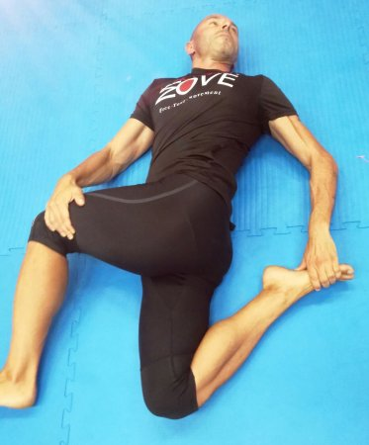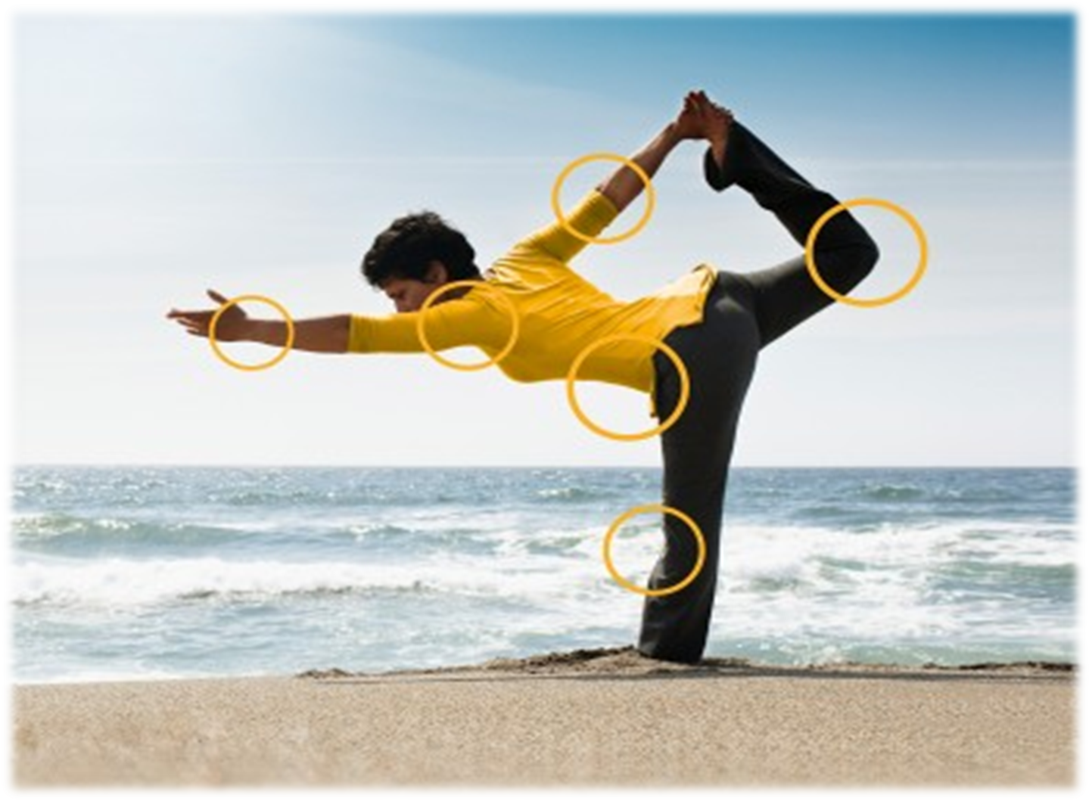
- 3) Indication for use of Stretching :
- ROM is limited because of soft tissue have lost their extensibility as thr result adhesion ,contracture , and scar tissue formation , causing functional limitation or disabilities .
- Restricted motion may lead to structural deformities that are otherwise preventible
- There is muscles weekness and shortnening of opposing tissues
- May be used as a part of a total fitness program designed to prevent musculoskeletal injuries .
- May be used prior to and after vigorous excerices potentially to minimized post excerise muscles soreness . 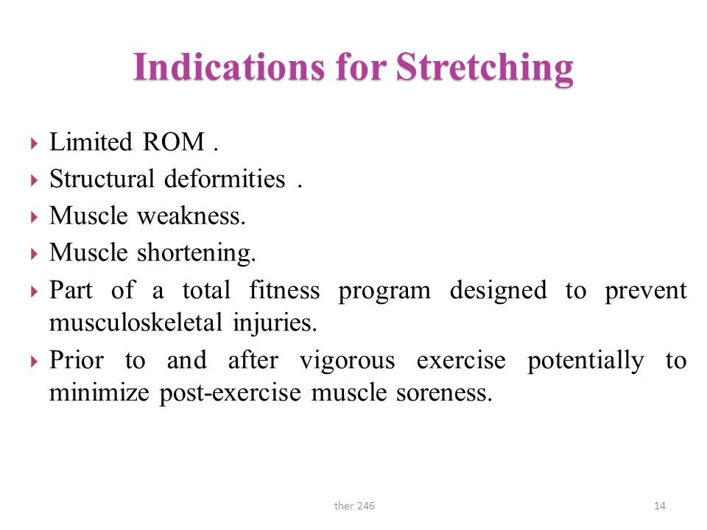
- Containdication of stretching :
- Bony block limit joint motion
- Recent fracture and incompleate bony union .
- There is evidence of acute inflamationh or infectious processes ( heat and swelling) or soft tissue healing couldbe disrupted in the tight tissue and surrounding regions
- There is sharp acute pain with joint movement or muscles elongations
- A hematoma or other indication of tissue trauma is observed
- Hypermobility already exist .
- Soften soft tissue provide necessary joint stability or neuromuscular control .
- 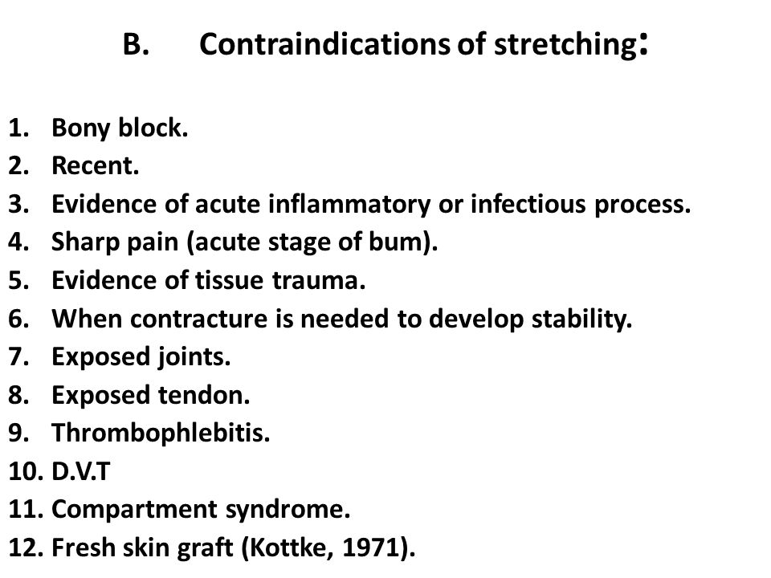
Isometric contraction | Isotonic contraction
- Definition :  - Isometric means same length .the contraction during which muscles length remains same and does not change | - Defination :  - Isotonic means same tension .The conhtraction in which the tone of muscle remain constant and tension im muscle do not changes while the length changes
- Muscle length remains same | - Muscles shortens in length
- Muscle tone changes | - Muscle tone do not change
Carying bucket in hands is the example of isometric contractio | - Dumbel in hands with flexed elbow is the example of isotonic contraction

- Ans no 3) Contracture :
- Adaptive shortening of the muscle , tendon and other soft tissues that cross or surround a joint resulting in significant resistance to stretch and limitation of ROM.
- Can be reversible or irreversible
- 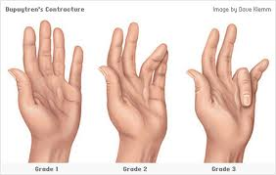
- Types of contracture :
- Myostatic Contracture
- Pseudomyostatic Contracture
- Arthrogenic Contractures
- Fibrotic Contracture
- ” 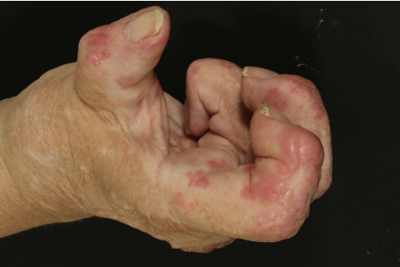n
- 1)Myostatic contracture :
- no specific muscle pathology.
- a reduction in the number of sarcomere units in series, there is no decrease in individual sarcomere length.
- resolved in a relatively short time with stretching. 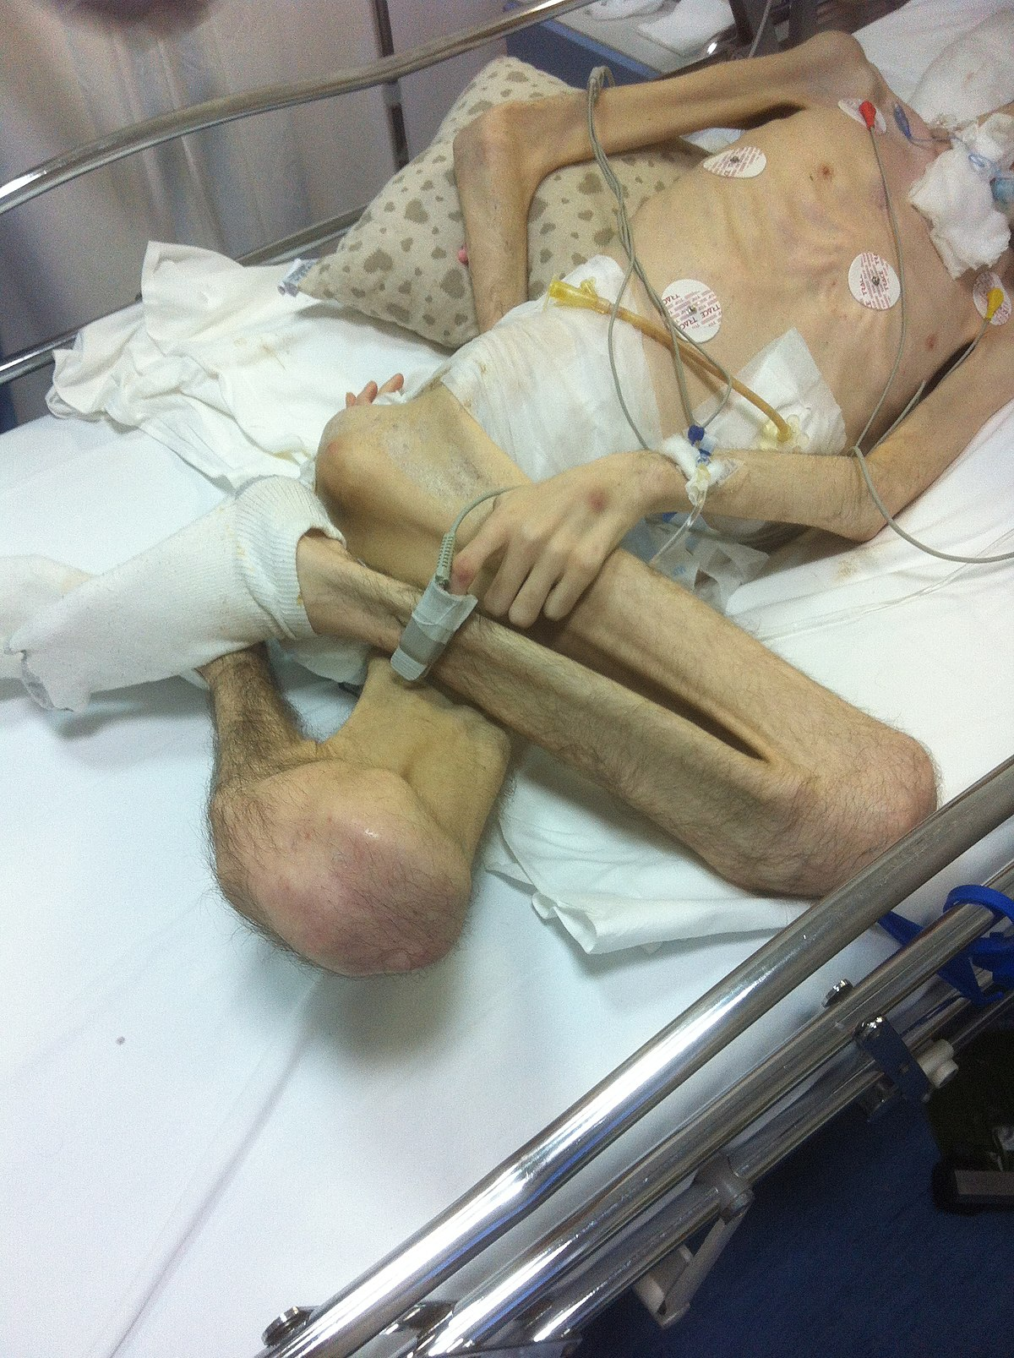
- 2)Pseudomyostatic contracture :
- Muscle in a constant state of contraction,
- Hypertonicity (i.e., spasticity or rigidity) associated with a CNS lesion such as a CVA a spinal cord injury.
- Muscle spasm and pain
- Can be resolved with stretching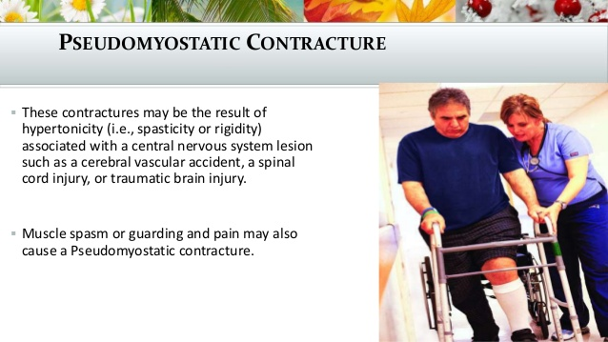
- 3)Arthrogenic contracture :
- An arthrogeneic contractures is intra-articular pathology.
These changes may include:
- adhesions,(band of scar like tissues, Adhesions cause tissue and organs to stick togather)
- synovial proliferation, (is the enlargement of the fibrocartilaginous pad)
- joint effusion,
- irregularities in articular cartilage,
- osteophyte formation.
Restricted arthrokinematics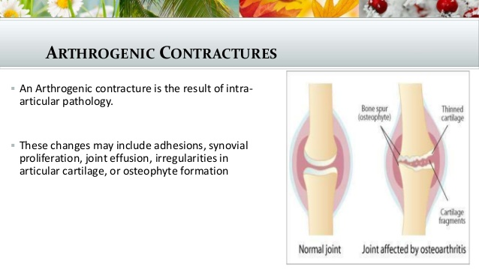
4) Fibrotic / Irreversible contracture :
It may occur when normal muscles tissue and sometime connective tissue are replaced with a large or no extensible fibrotic adhesion and scar tissue or even hetrotrophic bones .
Permanent loss of extensibility of soft tissue occurs that cannot be reversed by non surgical inertvention .
It is healed by stretching ,and surgical intervention . 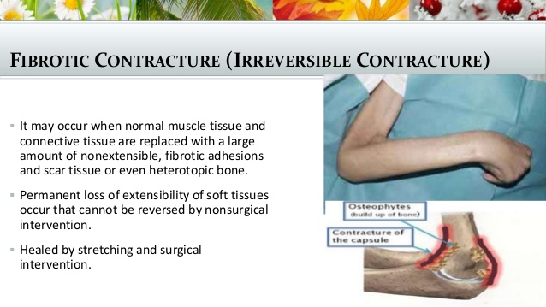
Ans no 4:Areobic exercises :
Areobic exercises is sometime known as cardio exercises that require pumping of oxygenated blood by the heart to deliver oxygen to working muscles .
Aerobic exercises stimulate the heart rate and breathing rate to increase in a way that can be sustained for the exercise session .
Example of aerobic exercises include :
- Cardiomachine
- Spinning
- Running
- Swimming
- Walking
- Hiking
- dancing
- sking
aerobic exercises can become anaerobic if performed at a level of intensity yhat is very high .
Areobic exercises not only include fitness it also has known benefits for both physical and emotional health.
Areobic exercises can help prevent or reduce the chance of developing some :
- cancers
- Daibetes
- Depression
- Cardiovascular diseases
- Osteoporosis
Aerobic exercises for age group 6-9:
- Games that involve running and chasing
- Hiking
- Jumping rope
- Karate
- Cycling
- Running
- Skateboarding
Aerobic exercises for older age :
- Experts recommended 150 min of exercises a week . approximately 20 min a day
- Cycling or walking every week
- Strength exercises on two or more days a week
- That work at major muscles like hip, legs ,back ,abdomen , chest ,shoulder and arms .
Principles of aerobic exercises :
- Intensity
- Duration
- Frequency
- Modes
Intensity :
Intensity of exercise means how hard is the exercise or how hard your body is working .
Example
An example of intensity is how quickly a trademill is moving .
Types on the basic of intensity :
On the basic of intensity aerobic exercises are of two types :
- Moderate intensity aerobic exercises .
- Vigorous intensity aerobic exercises / high intensity aerobic exercises .
Moderate intensity aerobic exercises :
As its name indicate those aerobic exercises which required less effort these exercises are mostly for older age people .
Its example include doing trademill at slow speed .
Vigerous intensity aerobic exercises :
These are hard aerobic exercises that require more effort and energy .
An example of vigerous intensity aerobic exercises include trade mill at high speed.
Duration :
It means for how much time the exercise is being performed or how long the performance is .
20 -30 min is optimal for a particular exercise .
If high intensity exercises are performed the lower will be the duration of that exercises .
Frequency :
- How much times the exercises should be repeated indicates the frequency of that exercise 3-4 times a week or may depond on your goal .
- Ans no 5 ) Disablement:
- Disablement is a term that refers to the impact(s) and functional consequences of acute or chronic conditions, such as disease, injury, and congenital or developmental abnormalities, on specific body systems that compromise basic human performance and an individual’s ability to meet necessary, expected, and desired societal functions and roles. The alteration of the body’s homeostasis as the result of acute or chronic diseases, disorders, or conditions characterized by a set of abnormal findings that are indicative of alterations or interruptions of structure or function of the body primarily identified at the cellular level
- Impairment :
- Impairments are the consequences of pathological conditions; that is, they are the signs and symptoms that reflect abnormalities at the body system, organ, or tissue level.
- Types of impairment:
- Musculoskeletal
- Neuromuscular
- Cardiovascular/pulmonary
- Integumentary

Disability models
The concept of disability .
social role resulted .Nagi`s concept of disability or the ICF `S Nagi reserved the term disability for patterns of behaviours that emerged over long periods of time during which an individual experience functional limitation to an extent of inability to fulfill desired participation restriction is characterized by discordance between the actual performance of an individual in a particular role and the expectations of the community for what is normal or typically expected behaviour for an adult .
NAGI
- It was clear that disability was not strictly medical concept nor a strictly social concept there was movement towards biopsychological model , In 1980 the world health organization (WHO) released the first internationally shared conceptual model of disability e international classification of impairment ,Disability ,and Handicap (ICIDH ) Nagi Model
- International Classification of Impairments, Disabilities and Handicaps (ICIDH)
International Classification of Functioning, Disability and Health (ICF)
Analysis Level | NAGI | ICIDH | ICF
 |  |  | Activity (Limitation)
 |  |  | Participation (Restriction)

ICF Model :
A good clinical question focuses on the outcome that is most relevant to the patient care situation at hand .The Nagi model of disablement or the World Health Organization International Classification of Function (ICF) model provides a frame work for clinicians to define the outcome that are most interested in : pathology or disease at the cellular level , impairment of the physiological system , functional limitation at the level of individual ,or disability or handicap that interferes with the normal social role . The ICF MODEL provides a unified and standared language and frame work for describing health and health related states that can be used as a frame work to measure health outcomes
In the ICF disablement model , health domains are described from the corporal , personal and societal perspective in term of body structure , function , activity and participation . Disability is the umberalla term that refers to all body functions , activities and participations .Disability is the umbrella term for impairment , activity limitation ,and participation restriction . Body structures are the anatomical parts of body , such as organs , limbs and their components .
Body functions refers to functions of the body systems including both physiological and pshchological functions .
Impairment are problems in body structures or function .
Activity is the execution of tasks or actions by an individual person ,and participation is involvement in life situation . The ICF model of functioning and disability provides a detailed description of body structures and functions , activity and participation .

The World Health Organization Disability Assessment Schedule 2.0 (WHODAS-2)was created in 1998 as WHODAS II in line with the ICF conceptual model and to be used in assessing the disability based on this model.
There are 36 items (self-administered and covering the past 30 days) on functioning and disability covering seven domains under WHODAS-2, which are the following (and explicit):
- Understanding and Communicating (6 items)
- Getting around (5 items)
- Self-care (4 items)
- Getting along with others (5 items)
- Life activities: Household (4 items)
- Life activities: Work/School (4 items)
- Participation in society (8 items)
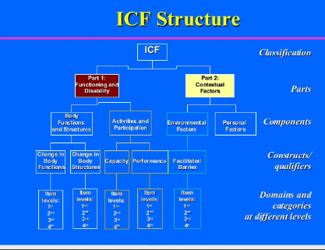
ICIDH MODEL:
IN 1980 ,THE WHO developed the international classification of impairment ,Disability ,and Handicap (ICIDH ) to provide a standardized mean of classifying the consequences of disease and injury for the collection of data and the development of social policy . This document provided a framework for organizing information about the consequences of diseases . however it is focused solely on the effect of pathological processes on the individual activities level . Disability was viewed as a result of an impairment and considered a lack of ability to perform an activity in a normal manner . In 1993 , the WHO began a revision of ICIDH disablement framework that gave rise to the concept that a person handicap was less related to the health condition that created a disadvantage for compleating the necessary life role but rather to a level of participation that a person with a health condition was able to engage in within the environment . the concept of being handicap was change to be seen as a consequence of the level of participation for the person and interaction with in an environment .
In 2001 the ICIDH was revised to ICIDH 2and renamed “ International Classification of Functioning ,Disability and Health and is commonly referred to as ICF .
.

