IQRA NATIONAL UNIVERSITY, PESHAWER
final-term Online exams

NAME: Muhammad Usman
ID: 13105
Dep: Business Administration
Subject: statical infreance

Instructor: Ms. Wajiha Amin
Module: 9th semester
Date: 25/09/2020

Q1: (a) Suppose a sample of 50 obese patients on a low fat diet lost a mean of 5.5 pounds with a variance of 9 pounds, while another sample of 28 patients on low carb. diet lost a mean of 6.7 pounds with a variance of 16 pounds. Construct 80 % confidence interval for the mean difference of patients on two different diets.

I have skipped some steps due to limited time kindly check answer:
N1 = 50 , n2= 28 x̅1 =5.5 x̅2= 6.7 S $1^{2}$ = 9 S$2^{2}$ = 16 C>I = 80% α= 20% =0.2
S.P$\sqrt{\frac{\left(49\right)\left(9\right)+ (27)(16)}{76}}$
S.P $\sqrt{\frac{441+432}{76}}$
S.P 3.38
-2.23 < µ1 - µ2 < - 0.17

(b) Differentiate between z test and t test.

Definition of T-test:
A t-test is a hypothesis test used by the researcher to compare population means for a variable, classified into two categories depending on the less-than interval variable. More precisely, a t-test is used to examine how the means taken from two independent samples differ.
T-test follows t-distribution, which is appropriate when the sample size is small, and the population standard deviation is not known. The shape of a t-distribution is highly affected by the degree of freedom. The degree of freedom implies the number of independent observations in a given set of observations.
Assumptions of T-test:
- All data points are independent.
- The sample size is small. Generally, a sample size exceeding 30 sample units is regarded as large, otherwise small but that should not be less than 5, to apply t-test.
- Sample values are to be taken and recorded accurately.
The test statistic is:
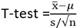
x ̅is the sample mean
s is sample standard deviation
n is sample size
μ is the population mean
Paired t-test: A statistical test applied when the two samples are dependent and paired observations are taken.

Definition of Z-test
Z-test refers to a univariate statistical analysis used to test the hypothesis that proportions from two independent samples differ greatly. It determines to what extent a data point is away from its mean of the data set, in standard deviation.
The researcher adopts z-test, when the population variance is known, in essence, when there is a large sample size, sample variance is deemed to be approximately equal to the population variance. In this way, it is assumed to be known, despite the fact that only sample data is available and so normal test can be applied.
Assumptions of Z-test:
- All sample observations are independent
- Sample size should be more than 30.
- Distribution of Z is normal, with a mean zero and variance 1.
The test statistic is:
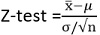
x ̅is the sample mean
σ is population standard deviation
n is sample size
μ is the population mean.
Q2: :(a) A survey of 250 students indicated that 107 preferred coffee to tea. Determine 90% confidence interval for the proportion of students who preferred coffee.

N = 250 , x = 107 C.I = 90 % , confidence = 10% = 0.0 α/2=0.05
1-0.05=0.95
P=x/n = 107/250 = 0.428
P- 2 α/2 < π < P+ 1 α/2
0.428- (1.56) (0.0312) <π < 0.428+ (1.65)(0.0312)
0.376 < π < 0.479
(b) Briefly discuss point estimate and interval estimate.

Point estimation
In statistics, the process of finding an approximate value of some parameter—such as the mean (average)—of a population from random samples of the population. The accuracy of any particular approximation is not known precisely, though probabilistic statements concerning the accuracy of such numbers as found over many experiments can be constructed.

Interval estimate
An interval is a range of values for a statistic. For example, you might think that the mean of a data set falls somewhere between 10 and 100 (10 < μ < 100). A related term is a point estimate, which is an exact value, like μ = 55.

As an example, let’s say you wanted to find out the average cigarette use of senior citizens. You can’t survey every senior citizen on the planet (due to time constraints and finances), so you take a sample of 1000 senior citizens and find that 10% of them smoke cigarettes. Although you’ve only taken a sample, you can use that figure to estimate that “about” 10% of the whole population smoke cigarettes. In reality, it’s unlikely to be exactly 10% (as you only sampled a small percentage of people), but it’s probably somewhere around there, perhaps between 5 and 15%. That “somewhere between 5 and 15%” is an interval estimate.

Q3: (a) given sigma = 1000, n= 100 sample mean(x) = 870,000, determine the confidence interval for 90% and 98% for mean.
Σ = 1000, n= 100, x= 70,000

C.I = 90%, C.I = 98%
= 0.05

- 0.05 = 0.95

= 1.6 + 0.05 = 1.65) < 870165

= 2% = 0.02

= 0.01

1 – 1.01 = 0.99

= 2.33

< 870,000 + 2.33 (100) < 870233

b) State what happens to the size of confidence interval as level of confidence increases?
When we create a confidence interval, it's important to be able to interpret the meaning of the confidence level we used and the interval that was obtained.
The confidence level refers to the long-term success rate of the method, that is, how often this type of interval will capture the parameter of interest.
A specific confidence interval gives a range of plausible values for the parameter of interest.
EXAMPLE: A political pollster plans to ask a random sample of 500500500 voters whether or not they support the incumbent candidate. The pollster will take the results of the sample and construct a 90\%90%90, percent confidence interval for the true proportion of all voters who support the candidate.
Q4: :(a)The management of a company is trying to determine annual family medical expenses of its employees. The company wishes to be 95% confident that the mean expenses to be correct within +$50. A previous study indicates the standard deviation of $400. How large the sample size is required for the study?

With the shortage of time I uploaded this picture maam kindly consider my marks.
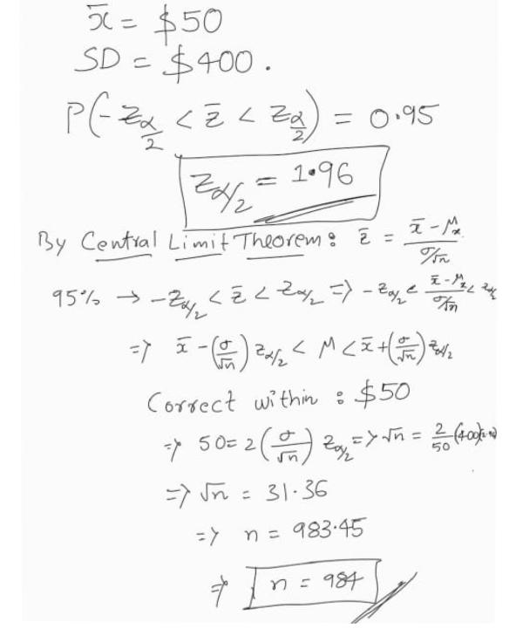
(b) A sample of 12 items has a mean of 7.3 and standard deviation of 2.4.Compute 99% confidence interval for population mean.
N=12, X =7.5 sigma= 2.4 C.I = 99% , alpha = 1% = 0.01
5.51 less then U less then 9.09

Q5: Fill in the blanks:
- Zero and one
- Decrease
- T-Test
- A confidence interval, in statistics, refers to the probability that a population parameter will fall between two set values for a certain proportion of times. ... A confidence interval can take any number of probabilities, with the most common being a 95% or 99% confidence level.
- x¯ -- (0.1)
σ -- (20)
n -- (2.2)
- – n= 81
X bar = 4
Sx= 8
N-1= 80
- Point estimator
- Standard error
- True
- 95%

